Road Mind: Ai enabled platform for adaptive traffic control
Pallavi B P, Keerthi A H , Manasa C S , Nagarathna M , Marimuthu K
Presidency School of Computer Science and Engineering Presidency University Bengaluru, Karnataka, India

Abstract

This work suggests a Machine Learning-based solution to improve Intelligent Transportation Systems (ITS) through predictive analytics. The suggested system combines traffic prediction and parking slot prediction based on real-time information and image processing methods. The system is divided into two major modules: an administrative module to manage parking infrastructure and a user module to book and navigate. Our solution integrates real-time traffic conditions, emergency vehicle priority, and road clearance estimates to minimize congestion and enhance urban mobility. Experiments show enhanced efficiency and response times compared to conventional systems.

Keywords
Traffic Prediction, Machine Learning, Intelligent Transportation Systems, Parking Slot Management, Real-Time Traffic Forecasting, Urban Mobility.

I. Introduction

Urban transport networks are increasingly confronted with traffic congestion and parking shortages. Conventional traffic management techniques cannot handle the dynamic behavior of urban traffic and emergency situations. This research tackles these challenges through the use of machine learning for predictive analysis and real-time decision-making in traffic and parking management.

A. Problem Statement

Urban traffic jams and ineffective parking space allocation are critical problems caused by non-adaptive conventional systems. These shortcomings result in longer travel time, fuel usage, and safety hazards, particularly in emergency situations.

B. Objectives

Forecast traffic movement and parking space availability in real-time.

Enhance urban mobility and emergency response effectiveness.

Offer real-time traffic information through image-based data analysis.

C. Scope
The system can be used in smart city infrastructures with admin-based parking management and user-based slot reservation and navigation. It has emergency routing, road clearance estimation, and real-time traffic prediction.

D. Motivation
Increased urban population and vehicular density require adaptable and scalable ITS. The necessity for emergency situations to be catered to and for real-time traffic updates is the driving force behind this smart system..

II. Literature Survey
Y. Lv et al. presented a deep learning method with stacked autoencoders for predicting traffic flows with better performance compared with ARIMA and SVR.
X. Ma et al. put forward an LSTM-based approach with microwave sensor data to predict short-term traffic speeds with excellent accuracy.
J. Zhang et al. applied deep spatio-temporal networks to predict city-scale flows, focusing on spatial-temporal dependencies.
Y. Yuan et al. proposed a CNN-based parking detection system that performed well under varying conditions.
M. Bui et al. utilized SVM for real-time traffic forecasting, emphasizing the advantages of feature selection and preprocessing.

III. System Analysis
A. Existing System
The existing traffic management systems are static and manually controlled, without predictive knowledge, and real-time adaptability.

B. Proposed System
Our system uses ML algorithms for traffic condition forecasting and parking slot availability prediction. Admins control slots, and users enjoy smooth booking and live status updates. The system gives priority to emergency vehicles and dynamically re-calculates optimal routes.

C. Advantages
- Real-time and predictive features
- Emergency handling and route clearance
- Richer user experience through smarter interface

IV. System Architecture and Requirements
A. Functional Requirements
- Admin login, slot management, and approval of bookings
- User registration, viewing of slots, and traffic prediction

B. Non-functional Requirements
- Scalability to handle urban growth
- Security via encryption and authentication
- Performance: Response time less than 3 seconds

C. Technical Specifications
- Frontend: ReactJS
- Backend: ExpressJS with TypeScript
- Database: MongoDB
- Platform: Windows OS (7/8/10), VS Code

V. Design and Implementation
A. Module Overview
- Admin: Login, Add Slots, Approve Requests
- User: Book Slot, Emergency Handling, Register, Live Traffic View

B. Prediction Techniques
Image processing APIs integrated with ML algorithms predict traffic and parking situations.

VI. Testing and Results
A. Testing Types
- Unit Testing
- Integration Testing
- Functional Testing
- Black Box & White Box Testing
- Acceptance Testing

B. Key Test Cases
All user registration, login, slot booking, and emergency traffic prediction test cases passed successfully.

VI. Test and Results
A. Type of Tests
- Unit Test
- Integration Test
- Functional Test
- Black Box & White Box Testing
- Acceptance Test

B. Important Test Cases
All tests for user sign-up, sign-in, booking slot, and emergency traffic predictions were successful.VII. Conclusion
The proposed system greatly increases the conventional traffic management by employing predictive and real-time decision-making. By implementing machine learning and image processing, it provides a high-performance adaptive ITS for applications in contemporary cities.

C. Outputs
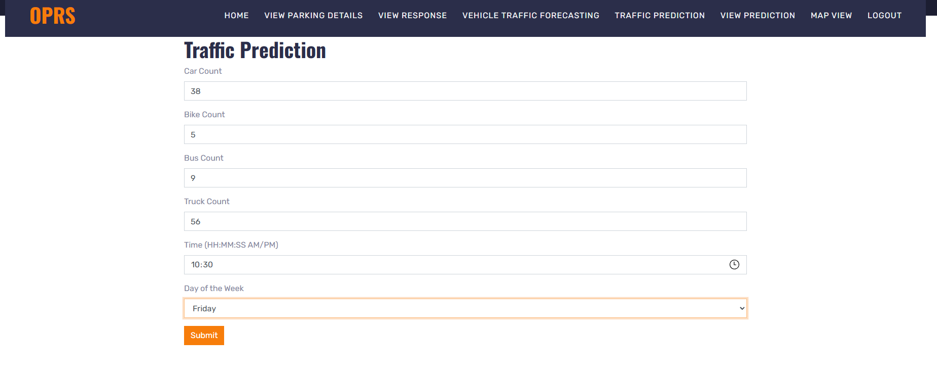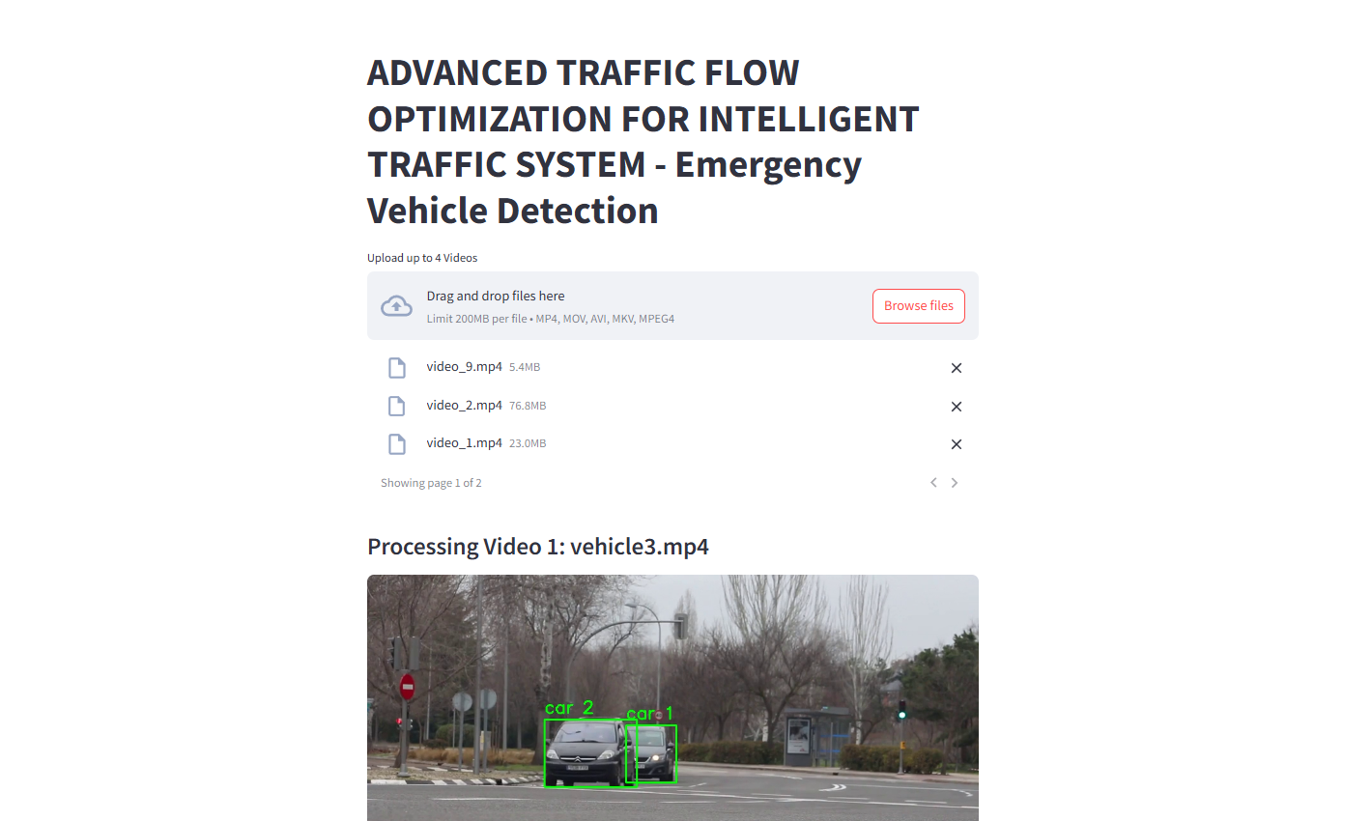
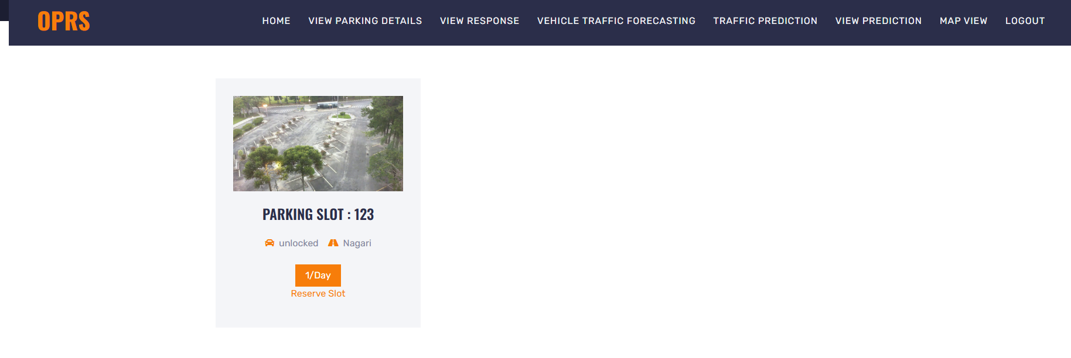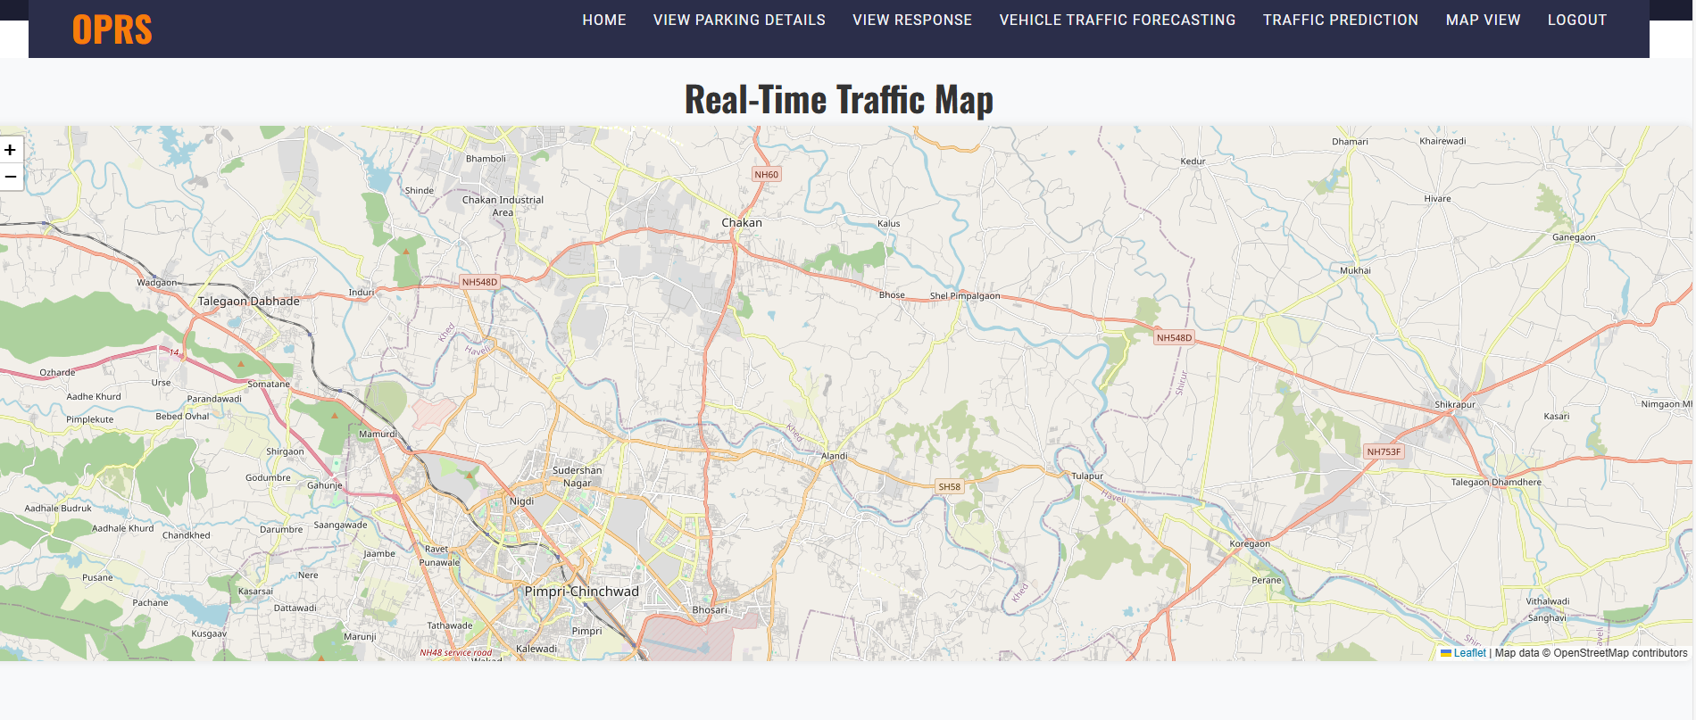

VIII. Future Improvement
Future versions can be integrated with IoT sensors, predictive maintenance on roads, voice command, multilingual enablement, and mobile app deployment.

Acknowledgement
We would like to extend our sincerest gratitude to all who helped make the "Road mind : Ai enabled platform for adaptive traffic control" project a success.
We are grateful to our project Guide and faculty members at Presidency University for their invaluable guidance and support throughout the development process. Their expertise, encouragement, and constructive feedback were crucial in shaping the direction of the project and ensuring its technical and practical rigor.
We are also very grateful to the farmers who shared their experiences and insights, which allowed us to better understand the challenges faced in the agricultural sector and design solutions that are both relevant and impactful.
Finally, we would like to acknowledge the institutions, researchers, and organizations working towards the advancement of AI-driven solutions in agriculture, whose contributions continue to inspire innovative efforts like ours.

References
- S. M. Metev and V. P. Veiko, Laser Assisted Microtechnology, 2nd ed., R. M. Osgood, Jr., Ed. Berlin, Germany: Springer-Verlag, 1998.
- J. Breckling, Ed., The Analysis of Directional Time Series: Applications to Wind Speed and Direction, ser. Lecture Notes in Statistics. Berlin, Germany: Springer, 1989, vol. 61.
- S. Zhang, C. Zhu, J. K. O. Sin, and P. K. T. Mok, “A novel ultrathin elevated channel low-temperature poly-Si TFT,” IEEE Electron Device Lett., vol. 20, pp. 569–571, Nov. 1999.
- M. Wegmuller, J. P. von der Weid, P. Oberson, and N. Gisin, “High resolution fiber distributed measurements with coherent OFDR,” in Proc. ECOC’00, 2000, paper 11.3.4, p. 109.
- R. E. Sorace, V. S. Reinhardt, and S. A. Vaughn, “High-speed digital-to-RF converter,” U.S. Patent 5 668 842, Sept. 16, 1997.
- (2002) The IEEE website. [Online]. Available: http://www.ieee.org/
- M. Shell. (2002) IEEEtran homepage on CTAN. [Online]. Available: http://www.ctan.org/tex-archive/macros/latex/contrib/supported/IEEEtran/
- FLEXChip Signal Processor (MC68175/D), Motorola, 1996.
- “PDCA12-70 data sheet,” Opto Speed SA, Mezzovico, Switzerland.
- A. Karnik, “Performance of TCP congestion control with rate feedback: TCP/ABR and rate adaptive TCP/IP,” M. Eng. thesis, Indian Institute of Science, Bangalore, India, Jan. 1999.
- J. Padhye, V. Firoiu, and D. Towsley, “A stochastic model of TCP Reno congestion avoidance and control,” Univ. of Massachusetts, Amherst, MA, CMPSCI Tech. Rep. 99-02, 1999.
- Wireless LAN Medium Access Control (MAC) and Physical Layer (PHY) Specification, IEEE Std. 802.11, 1997.

