SMART HOME APPLIANCE USING FORECASTING

A deep learning approach using attention based LSTM and convolution temporal

Pallavi Dakka | student ID:A00075097

Deep leaning application (cmp-L016)

Abstract-Forecasting residential electricity demand is becoming more important for managing smart grids and improving consumer energy awareness. This project designs, implements, and evaluates three deep learning models for short-term household power forecasting using two real-world smart-meter datasets: a fully connected autoencoder, an attention-augmented LSTM, and a dilated Temporal Convolutional Network (TCN). In the first milestone, we focused on the REFIT UK Electrical Load dataset, trying to forecast power consumption across nine channels in twenty houses. We only achieved R2 = 0.10-0.18. This result was due to sparse target data, shifts in distribution between houses, and not enough training epochs. After rethinking our approach, the second milestone applied the same models to univariate aggregate power forecasting using the UCI Individual Household Electric Power Consumption dataset. The Attention LSTM achieved R2 = 0.951, MAE = 0.016, and RMSE = 0.034, surpassing the TCN's R2 = 0.926. A grid search over the LSTM's hidden size, depth, and learning rate found the optimal settings to be hidden = 128, layers = 2, and lr = 5x10-4. We deployed the best model through a Gradio web application. This project shows that how we frame the problem is more important than the choice of architecture at the household level.

I. INTRODUCTION
The widespread use of advanced metering infrastructure (AMI) has significantly changed residential energy management. In the UK, over 31 million smart meters had been installed by mid-2024, producing continuous sub-hourly consumption records that provide valuable information about occupant behavior and appliance usage. Using this data with machine learning allows for quick demand forecasting, which supports real-time flexibility markets, appliance-level disaggregation (NILM), and personalized feedback, all of which can reduce household consumption by 5-15%. However, predicting energy use at the individual household level is still difficult. Each household shows distinct load profiles with sudden changes due to appliance switching, irregular patterns on daily and weekly cycles, and variable amplitude distributions with sporadic high-power spikes from electric ovens, immersion heaters, and EV chargers.

Traditional models like ARIMA and seasonal exponential smoothing work well for aggregate grid data, where averaging helps smooth out individual behaviors. However, they struggle with signals from single households. Gajowniczek and Zabkowski found that the forecasting errors for individual households are usually three to five times larger than those at the substation level. This highlights the need for deep learning approaches, which can learn complex temporal representations without manual feature engineering. Recurrent architectures, especially LSTM networks, have led research in residential forecasting since 2015, while recent models like dilated convolutional networks and Transformers have achieved competitive accuracy with greater efficiency.

This portfolio project (Project 29: Smart Home Appliance Usage Forecasting) conducts a comprehensive study of three deep learning models using two smart-meter datasets, organized into two milestones. We formally analyze the failure of the first milestone to inform a redesign, documenting the issues and remedies as methodological insights. The main goals are to: (i) preprocess real smart-meter data; (ii) implement and evaluate an autoencoder, attention LSTM, and dilated TCN; (iii) assess all models using MAE, RMSE, and R2 on held-out data; (iv) conduct a systematic hyperparameter grid search; and (v) launch the best model as a publicly available web application.

II. BACKGROUND AND LITERATURE REVIEW

A. Residential Load Forecasting
Residential load forecasting is influenced by unpredictable decisions made by occupants, making signals from individual households less reliable than those from aggregated loads. Taylor and McSharry evaluated seasonal Holt-Winters methods on UK national demand data but noted their limitations for more granular predictions. Beckel et al. found that simple models, like persistence (predicting the most recent observed value) and weekly seasonal naive models, performed surprisingly well as baselines for individual household forecasting. This creates a high standard that deep learning needs to exceed, which drives the careful experimental approach used in this project.

B. Sequence Models for Time-Series Forecasting

Hochreiter and Schmidhuber's LSTM addresses the problem of vanishing gradients that limit earlier RNNs' usefulness for long sequences. Kong et al. applied stacked LSTMs to residential load forecasting across 500 Australian households, showing better performance than ARIMA and SVR but noted sensitivity to the choice of lookback window. Attention mechanisms, initially introduced for neural machine translation, allow models to assign different weights to various positions in the output. In regression tasks, attention pooling over LSTM hidden states offers a flexible, data-driven way to focus on historical time steps, which is especially useful for periodic signals where the most relevant history may not be the most recent one. Bai et al. showed that Temporal Convolutional Networks (TCNs), consisting of dilated, causal 1-D convolutions, can achieve competitive or better accuracy than LSTMs across various benchmarks while training faster due to full parallelism. For energy forecasting, TCNs are effective at capturing multi-scale daily and weekly patterns.

C. AUTOENCODERS FOR REPRESENTATION LEARNING
Autoencoders create a compressed latent representation by minimizing reconstruction loss, which ensures that the bottleneck retains essential information. Malhotra et al. demonstrated that LSTM autoencoders could identify anomalous signals that reconstruct poorly compared to normal ones. In this project, the autoencoder is used as both a diagnostic tool, confirming the input features are compressible and informative before applying supervised models, and as an unsupervised baseline.

D. Benchmark Datasets
The REFIT UK Electrical Load dataset contains aggregate and appliance-level readings every 8 seconds from 20 homes in the East Midlands, collected between 2013 and 2015. It is widely used in NILM research. The UCI Individual Household Electric Power Consumption dataset offers minute-level readings from one house in Sceaux, France, over four years from 2006 to 2010. It includes aggregate active/reactive power, mains voltage, current intensity, and readings from three appliance sub-metering channels. Its long period, high resolution, and clear labeling make it a standard benchmark for forecasting residential energy use.

III. METHODOLOGY

A. Dataset Preparation and Exploratory Analysis
For Milestone 2 (REFIT), we resampled the 20 household CSV files from 8 seconds to a 30-minute interval using mean aggregation, retaining the last 180 days for each household, which results in around 8,641 records each. For Milestone 3 (UCI), we kept the original one-minute resolution and selected the first 100,000 records (about 69 days) to ensure GPU training time was under one hour on Google Colab. For missing values, we used forward filling, which is suitable for short sensor outages in slowly changing consumption patterns.

An exploratory analysis of the UCI data revealed important characteristics. The global active power is heavily right-skewed, with a modal value around 0.3 kW reflecting standby consumption. Secondary modes appear near 1.3 kW and 2.4 kW, associated with different combinations of active appliances. The distribution also includes a long tail that approaches 9 kW, driven by high-draw appliances, such as electric ovens and water heaters. The mean hourly pattern displays a typical European double-peak structure: a morning peak around 07:00-09:00 as people prepare for work, a midday dip when houses are empty, and an evening peak around 18:00-21:00 linked to cooking and leisure activities. These two peaks represent the primary patterns that our time-encoding features aim to help the models utilize. The correlation heatmap shows nearly perfect correlation between global active power and global intensity (r = 0.999), as expected from Ohm's law at stable mains voltage, and a moderate negative correlation with voltage (r = -0.46), indicating a slight voltage drop during high current usage. This supports including all seven sensor channels along with cyclical time features as inputs for the multivariate models. A small number of outliers exceeding 5 kW were kept, as they represent real high-draw events that the model should learn to predict based on prior context. An Augmented Dickey-Fuller test on the first-differenced series returned p < 1x10-7, confirming that the data shows stationarity in the differenced sense.

We created cyclical time features using sine and cosine encodings: hour_sin = sin(2*pi*h/24), hour_cos = cos(2*pi*h/24), and similar encodings for the day of the week. This method maintains circular continuity and avoids the artificial break between hour 23 and hour 0. The resulting feature set, which includes 11 features (seven sensor channels plus four time encodings), was scaled to [0, 1] using MinMaxScaler fitted only on the training data to avoid information leakage.

B. Model Architectures
We implemented three PyTorch models, all taking inputs in the shape (batch, seq_len, n_features).
1.Fully Connected Autoencoder. The encoder maps each feature vector through a 128-unit ReLU hidden layer to a 64-dimensional bottleneck. The decoder mirrors this structure to reconstruct the input. Applied to frames, the model is trained using mean squared error for reconstruction. The 2:1 compression ratio balances expressiveness and bottleneck effectiveness, serving as both a diagnostic for data quality and an unsupervised baseline.
2. Attention LSTM. This model has two LSTM layers with a configurable hidden size (64 or 128). It generates hidden states for each time step, and a linear layer produces one score per time step, normalized through softmax to create attention weights. The context vector, a weighted sum of all hidden states, feeds into a linear regression output layer. This approach follows the attention-pooling concept and is particularly suitable for periodic energy signals where the most relevant historical time step may not be the most recent.

3. Dilated Temporal CNN. The input is rearranged into (batch, features, seq_len) for PyTorch 1-D convolutions. Two convolutional layers apply 64 filters each (kernel size = 3, dilations = 2 and 4). This results in a combined effective receptive field of 13 timesteps from the 2-layer stack. ReLU activations are applied between layers. Adaptive average pooling collapses the temporal dimension, and a linear head produces the scalar forecast. Dilation factors of 2 and 4 capture short-term transitions and medium-term trends within the 60-step window, respectively.

C. Training Configuration and Experimental Design
All models used Adam [lr = 1x10-3], MSE loss, and a batch size of 32. The autoencoder trained for 5 epochs (REFIT) and 3 epochs (UCI). Supervised models trained for 10 epochs (REFIT) and 20 epochs (UCI). For Milestone 2, an 80/20 cross-house split was used (16 train, 4 test houses). For Milestone 3, a chronological 80/20 split was applied so the test set is strictly in the future of the training set, preventing temporal leakage. Sliding windows of 96 steps (REFIT, 48-hour history) and 60 steps (UCI, 1-hour history) were extracted. A random seed of 42 was fixed for NumPy, Python, PyTorch CPU, and CUDA in Milestone 3 to ensure reproducibility. All experiments ran on an NVIDIA T4 GPU via Google Colab.

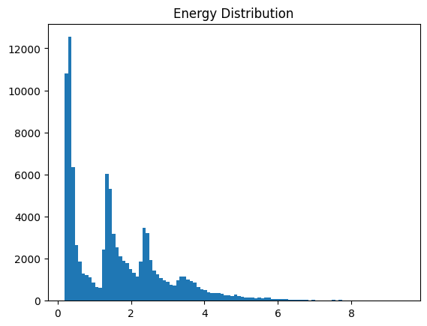

Fig. 1. Distribution of Global_active_power (UCI). Right-skewed with a modal standby draw near 0.3 kW and a long tail to approximately 9 kW from high-draw appliances.

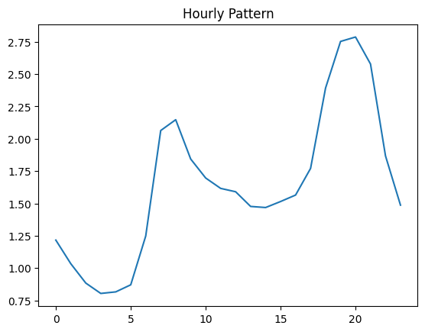

Fig. 2. Mean hourly demand (UCI training partition). The morning and evening double-peak pattern is the primary periodicity the models must capture.

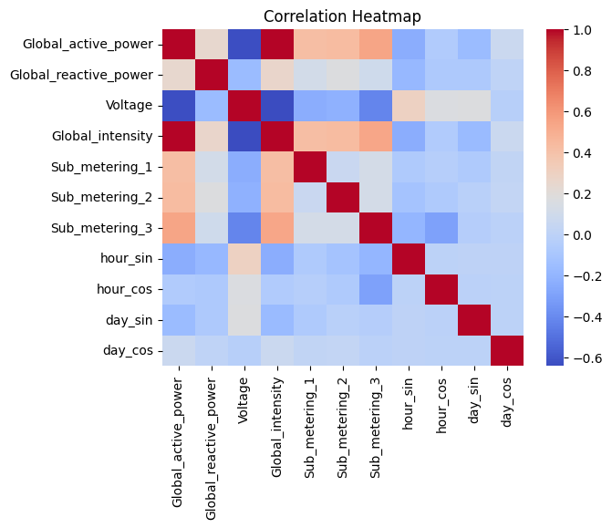

Fig. 3. Pearson correlation heatmap. Near-unity correlation between Global_active_power and Global_intensity, and negative correlation with Voltage, validate the multivariate input representation.

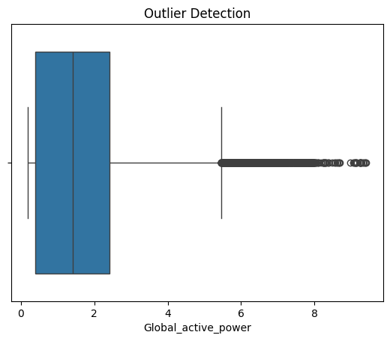

Fig. 4. Outlier boxplot for Global_active_power. Extreme values beyond 5 kW retained to preserve genuine high-load events.

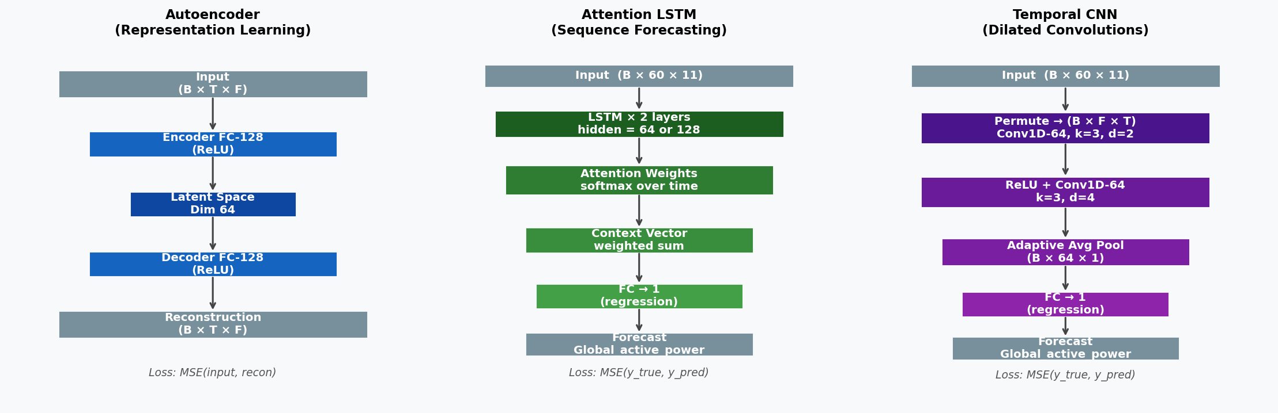

Fig. 5. Architecture schematics: Autoencoder (left), Attention LSTM (centre), Temporal CNN (right). Tensor shapes reflect the UCI configuration (seq_len = 60, n_features = 11).

IV. Experiments and Results

A. Milestone 2 - REFIT Multi-Target Forecasting
The first milestone framed forecasting as a 9-channel multi-target regression: given a 48-hour window, predict the next 30-minute readings for all nine appliance circuits. The autoencoder converged reliably (reconstruction loss: 4.26x10-4 at epoch 1 to 3.49x10-6 by epoch 5), confirming the input features are informative. The training loss curves for supervised models over 10 epochs are shown in the left panel of Fig. 6.

Despite healthy training convergence, held-out performance was significantly below expectations (Table I). The Attention LSTM reached R2 = 0.104, explaining only 10.4% of held-out appliance variance. The Temporal CNN performed slightly better at R2 = 0.180. MAPE could not be calculated due to frequent zeros in the appliance channels. Prediction traces (Figs. 7 and 8) indicate both models learned the overall series mean but failed to anticipate appliance switching events
Three compounding causes of failure were identified. First, MSE on zero-inflated appliancechannels favors near-zero constant predictions. The loss is dominated by the few large on-peak values, allowing a model to minimize training loss by predicting the baseline instead of modeling transitions. This mirrors the imbalanced regression challenge seen by Gajowniczek and Zabkowski [6] for individual household data. Second, the cross-house test split creates a distribution shift. The four test households contain appliances with peak powers and usage schedules not seen during training, complicating generalization even for skilled analysts. Third, the training loss curves in Fig. 6 (left) show both models were still declining at epoch 10 without reaching a plateau, indicating under-training. These three factors fully explain the Milestone 2 failure without considering architectural issues and directly motivate the redesign in Milestone 3.

TABLE I. Milestone 2 held-out results on REFIT (multi-target, normalised units). Both models barely exceed a mean predictor.

Model | MAE | RMSE | R2
Attention LSTM | 0.0161 | 0.0550 | 0.104
Temporal CNN | 0.0136 | 0.0528 | 0.180

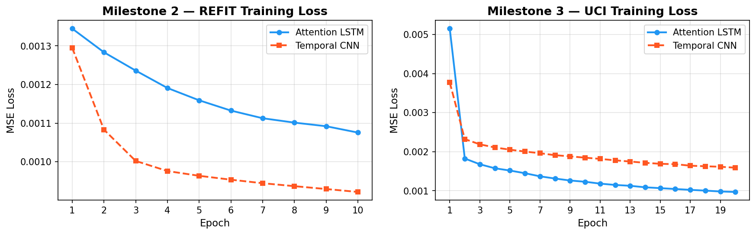

Fig. 6. Training MSE loss per epoch. Left (Milestone 2, REFIT): losses still declining at epoch 10, indicating under-training. Right (Milestone 3, UCI): steep early drop and stable convergence by epoch 8, with the Attention LSTM converging lower than the TCN.

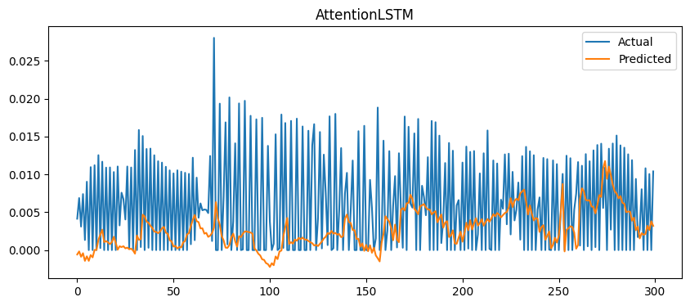

Fig. 7. Milestone 2 - Attention LSTM predictions (orange) vs. actual first-appliance channel (blue). The model predicts near the series mean and misses all switching events.

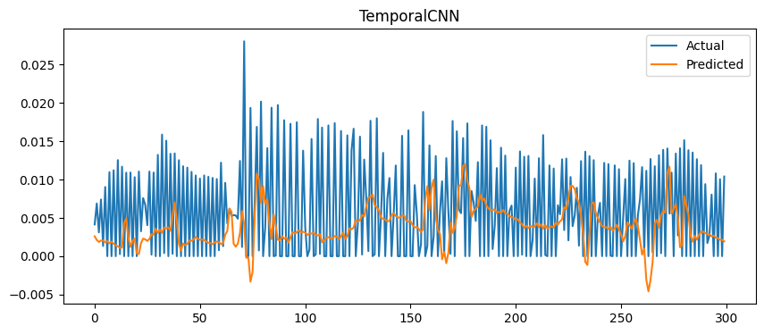

Fig. 8. Milestone 2 - Temporal CNN on the same REFIT window. Identical failure mode, confirming the problem is task formulation rather than architecture.

B. Milestone 3 - UCI Univariate Forecasting
Three targeted changes were made: (1) the target was reduced from 9 sparse appliance channels to a single smooth variable (Global_active_power); (2)
the split changed from cross-house to chronological, ensuring that training and testing share the same household data-generating process; (3) training was extended to 20 epochs for full convergence. All architectures and optimizer settings remained constant to isolate the effect of these changes.
The autoencoder achieved a test reconstruction loss of 8.52x10-6 and a per-feature R2 of 0.9997, confirming the latent code retains nearly all input information. Table II shows the supervised forecasting results.

TABLE II. Milestone 3 held-out results on UCI (univariate target, normalised units). Autoencoder row reflects reconstruction quality. Lower MAE/RMSE and higher R2 are better.
Model | MAE | RMSE | R2
Autoencoder (recon.) | 0.0021 | 0.0029 | 0.9997
Attention LSTM | 0.0161 | 0.0338 | 0.951
Temporal CNN | 0.0233 | 0.0413 | 0.926

The Attention LSTM reached R2 = 0.951, explaining 95.1% of held-out aggregate power variance. Its MAE of 0.016 implies a typical absolute error of about 1.6% of the normalized range, demonstrating strong performance for one-step-ahead residential forecasting. The Temporal CNN achieved R2 = 0.926. The cross-milestone comparison bar chart (Fig. 9) clearly shows the improvement: R2 increased from 0.10-0.18 to 0.93-0.95 without any architectural changes.

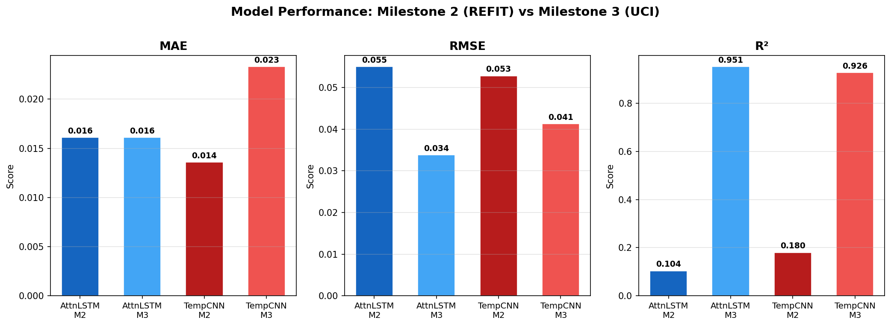

Fig. 9. Cross-milestone metric comparison. The R2 panel (right) shows the dramatic improvement attributable entirely to problem reformulation. MAE is broadly similar across milestones in normalised units
.
Qualitative inspection of prediction traces (Figs. 10 and 11) reveals differences in how the architectures handle high-frequency variation. The Attention LSTM tracks both rising and falling edges of consumption peaks across the 300-minute test window, losing some precision only in the rapidly changing last segment where dynamics change faster than the 60-minute lookback window can anticipate. The TCN follows a similar general path but consistently underestimates peak heights and overestimates troughs, a predictable result of adaptive average pooling that discards necessary positional information to resolve sharp transitions.

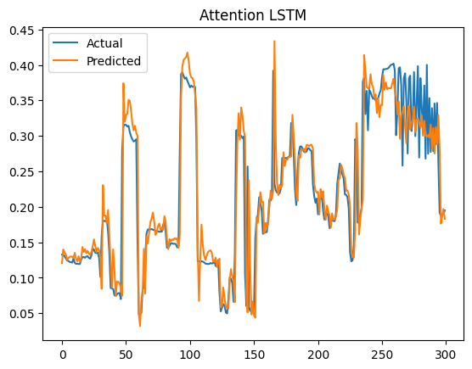

Fig. 10. Milestone 3 - Attention LSTM predictions (orange) vs. actual Global_active_power (blue).
The model faithfully tracks peak structure; residuals concentrate in the rapidly oscillating final segment.

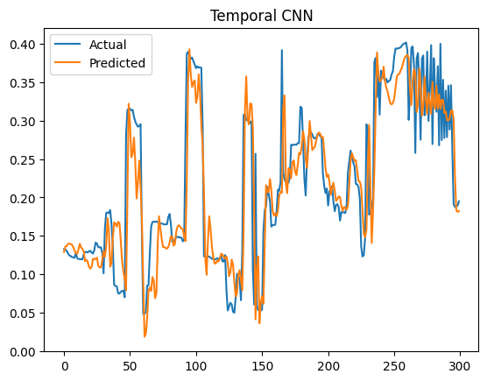

Fig. 11. Milestone 3 - Temporal CNN on the same window. Peak heights systematically under-predicted and troughs over-predicted due to global average pooling smoothing away temporal detail.

C. Hyperparameter Sensitivity Analysis
A grid search evaluated LSTM hidden units per layer (64 or 128), stacked layers (1 or 2), and initial learning rates (1x10-3 or 5x10-4) across all eight configurations, using a 3-epoch budget for each run. This approach is justified by Fig. 6 (right), showing that Milestone 3 models gained most of their improvement within the first two epochs. The validation RMSE heatmap (Fig. 12) and complete numerical results (Table III) are provided.
numerical results (Table III) are reported below.

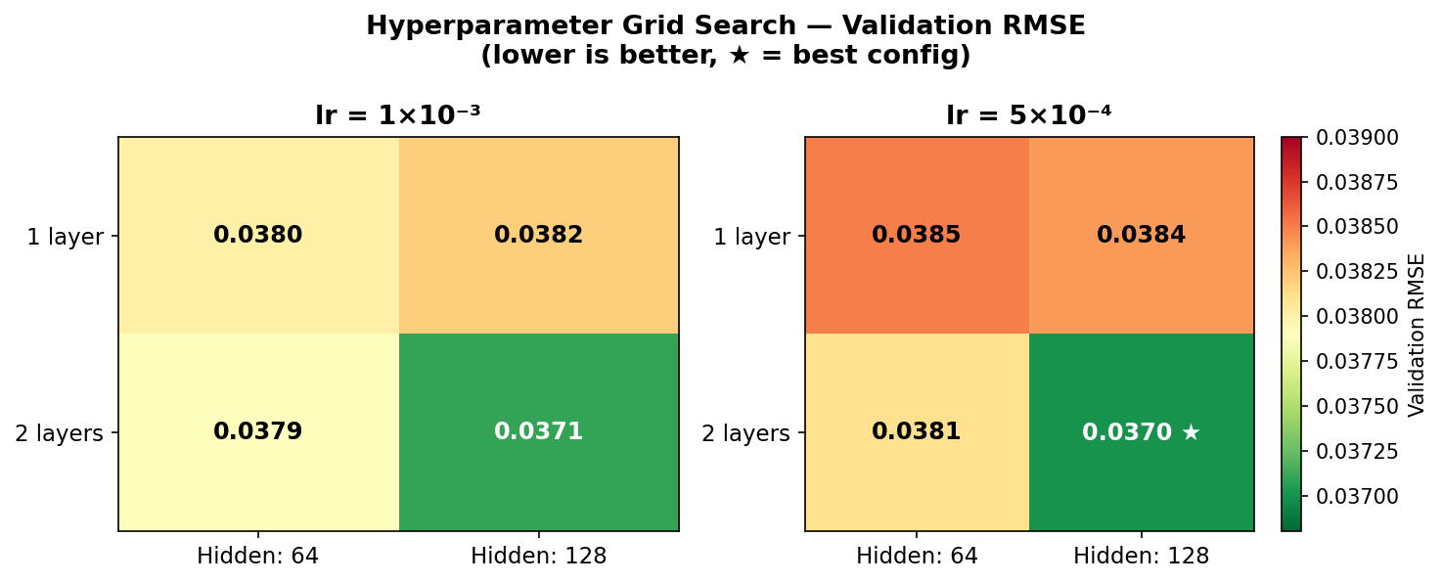

Fig. 12. Hyperparameter grid search heatmap (green = lower RMSE = better). The star marks the optimal configuration (hidden = 128, layers = 2, lr = 5x10-4, RMSE = 0.0370). Depth consistently contributes more than width.

TABLE III. Full hyperparameter grid. * marks the selected configuration (lowest validation RMSE).

Hidden size | Layers | Learning rate | Val. RMSE
64 | 1 | 1x10-3 | 0.0380
64 | 1 | 5x10-4 | 0.0385
64 | 2 | 1x10-3 | 0.0379
64 | 2 | 5x10-4 | 0.0381
128 | 1 | 1x10-3 | 0.0382
128 | 1 | 5x10-4 | 0.0384
128 | 2 | 1x10-3 | 0.0371
128 | 2 | 5x10-4 | 0.0370 *

The grid shows remarkable flatness: validation RMSE ranges only from 0.0370 to 0.0385 (a 4% relative difference), indicating robustness to moderate hyperparameter changes. Two trends stand out. First, depth is more important than width: two-layer configurations consistently outperform one-layer models of the same hidden size, averaging a 0.001 RMSE improvement. This aligns with deeper recurrent networks capturing temporal hierarchies—lower layers reflecting minute-to-minute transitions while upper layers integrate slower trend information across the full hour-long window. Second, within each depth-width pair, the lower learning rate of 5x10-4 performs slightly better or equally well, suggesting that models have not fully converged after three search epochs. A longer training schedule with learning rate warm-up or cosine annealing could lead to even better results beyond the initial 3-epoch budget. The overall flatness of the grid also suggests that improving hyperparameter optimization is unlikely to be the key to future performance gains. Extending the training data to the full UCI series or broadening the dataset to include multiple households would likely have a greater impact than further architectural adjustments.

V. Discussion

A. Interpretation of Key Findings
The most significant finding is that how the problem is framed matters more than the architecture in determining held-out performance. Both the Attention LSTM and TCN saw R2 improvements of about 800% between milestones (from 0.10-0.18 to 0.93-0.95) without any architectural changes. Three reformulations help explain this. The UCI aggregate power target is influenced by a smooth daily double-peak that cyclical time features can partially predict, simplifying the supervised learning task. The chronological train/test split ensures that test-set dynamics follow the same single-household data-generating process as the training data, removing the distribution shift that affected Milestone 2. Extending training from 10 to 20 epochs allowed both models to converge fully instead of stopping mid-training, as shown by the continuing decline in loss curves in Fig. 6 (left). This result illustrates a basic principle in applied machine learning: mismatches in distribution between training and test data, an unsuitable loss function for sparse targets, and insufficient training epochs collectively explain the Milestone 2 failure far better than any architectural shortcomings. For practitioners, selecting a model should always follow a careful examination of the target variable's distribution, the validity of the train/test split for the intended scenario, and whether the training budget is sufficient.

Within Milestone 3, the 2.5-point R2 advantage and 18% lower RMSE of the Attention LSTM compared to the TCN stem from two factors. The attention mechanism provides data-driven, position-sensitive weighting of all 60 historical timesteps. This allows the model to prioritize the hour-ago equivalent reading during stable phases and recent timesteps during rapid changes. Global average pooling in the TCN treats all retained temporal positions equally, discarding this flexibility and leading to the smooth predictions seen in Fig. 11. Additionally, the two-layer LSTM architecture naturally forms a temporal hierarchy that suits the multi-scale nature of residential consumption.

B. Limitations and Critical Reflection
Several important limitations should be acknowledged. First, the UCI experiments only use about 3.3% of the four-year dataset, so seasonal variation (such as summer cooling, winter heating, and lighting loads) is entirely missing. A model trained on this limited dataset may perform significantly worse over an entire year without re-training or adjustment. Second, there is no persistence baseline (predicting the previous observed value) included in the Milestone 3 results. For smooth one-minute signals, persistence can yield an R2 greater than 0.90 without any training, which would provide vital context for the deep learning results. Future evaluations should include persistence and seasonal naive baselines as essential comparisons. Third, both datasets come from single-country, owner-occupied households. Generalizing findings to renters, social housing tenants, households with electric vehicles or heat pumps, or different climates cannot be assumed and requires validation against broader benchmarks such as the US Pecan Street Dataport or the Irish CER smart meter trial.

C. Ethical Considerations
Smart-meter data counts as personal data under UK GDPR. High-resolution electricity traces can show occupancy status, sleep schedules, and, in some cases, health conditions linked to medical device use [16]. Both datasets were collected with informed consent and shared under open licenses that prohibit re-identification. However, using this technology for a commercial forecasting system requires following data minimization principles, building privacy into the design (preferably using on-device inference), obtaining explicit user consent, and respecting the right to erasure. Models trained on owner-occupied middle-income households may perform poorly for households in fuel poverty, where consumption patterns vary significantly. This could reinforce socioeconomic inequalities in energy services if deployed without considering equity.

VI. Model Deployment
The trained Attention LSTM (hidden = 128, 2 layers, lr = 5x10-4) was set up as a Gradio [12] web interface. The application has one numeric input widget for each feature (11 inputs: seven sensor channels and four cyclical time encodings). Upon submission, the application replicates the feature vector 60 times to create a synthetic 60-step history, assuming recent conditions remain roughly constant, passes the sequence through the model, and returns the normalized one-step forecast. Gradio's share=True parameter creates a temporary public HTTPS URL through a reverse-proxy relay, allowing access to the prototype without needing to set up infrastructure.
This is a clear prototype showing the complete workflow. A production version would differ in four main ways: (i) a real rolling-window buffer taking in live smart-meter API readings; (ii) a containerized model server (TorchServe, ONNX Runtime, or BentoML) for handling multiple low-latency requests; (iii) a calibrated prediction interval instead of a single point forecast; and (iv) regular retraining on recent data to monitor concept drift as occupancy patterns and appliance inventories change.

VII. Conclusion and Future Work
This project designed, implemented, evaluated, and deployed a full deep learning pipeline for short-horizon household electricity demand forecasting. Three architectures were compared: an autoencoder, an Attention LSTM, and a dilated TCN, using two real-world smart-meter datasets. The Attention LSTM achieved R2 = 0.951 and RMSE = 0.034 on the UCI benchmark, outperforming the TCN (R2 = 0.926) and both previous architectures from Milestone 2 by roughly eight times in R2. The main takeaway is that how the problem is framed—target variable choice, split strategy, and training duration—affects performance more than the architecture at the household level. Hyperparameter tuning showed that a two-layer LSTM with a hidden size of 128 and lr = 5x10-4 was optimal, with the model demonstrating low sensitivity to moderate changes in hyperparameters.
Six areas for future work have been identified: (i) extend to the full four-year UCI series for seasonal coverage; (ii) include persistence and seasonal naive baselines in all evaluations; (iii) benchmark Transformer-based forecasters (Informer, PatchTST) to see if global self-attention helps with this signal length; (iv) implement multi-step probabilistic forecasting (15, 30, 60 minutes) with calibrated prediction intervals; (v) apply NILM-based multi-task learning to revisit the Milestone 2 appliance-level forecasting challenge; and (vi) add post-hoc explainability through integrated gradients or attention-weight visualization to build user trust and allow for domain-expert validation.

References
[1] Department for Energy Security and Net Zero, Smart meters quarterly update: Q2 2024, UK Government Statistical Release, 2024.
[2] S. Darby, The effectiveness of feedback on energy consumption: A review for DEFRA, Environmental Change Institute, University of Oxford, Tech. Rep., 2006.
[3] R. Weron, Electricity price forecasting: A review of the state-of-the-art with a look into the future, International Journal of Forecasting, vol. 30, no. 4, pp. 1030-1081, 2014.
[4] S. Hochreiter and J. Schmidhuber, Long short-term memory, Neural Computation, vol. 9, no. 8, pp. 1735-1780, 1997.
[5] S. Bai, J. Z. Kolter, and V. Koltun, An empirical evaluation of generic convolutional and recurrent networks for sequence modeling, arXiv:1803.01271, 2018.
[6] K. Gajowniczek and T. Zabkowski, Short term electricity forecasting using individual smart meter data, Procedia Computer Science, vol. 35, pp. 229-238, 2014.
[7] J. W. Taylor and P. E. McSharry, Short-term load forecasting methods: An evaluation based on European data, IEEE Transactions on Power Systems, vol. 22, no. 4, pp. 2213-2219, 2007.
[8] C. Beckel, L. Sadamori, T. Staake, and S. Santini, Revealing household characteristics from smart meter data, Energy, vol. 78, pp. 397-410, 2014.
[9] W. Kong et al., Short-term residential load forecasting based on LSTM recurrent neural network, IEEE Transactions on Smart Grid, vol. 10, no. 1, pp. 841-851, 2019.
[10] D. Bahdanau, K. Cho, and Y. Bengio, Neural machine translation by jointly learning to align and translate, in Proc. ICLR, 2015.
[11] A. Paszke et al., PyTorch: An imperative style, high-performance deep learning library, in Advances in Neural Information Processing Systems, 2019, pp. 8024-8035.
[12] A. Abid et al., Gradio: Hassle-free sharing and testing of ML models in the wild, arXiv:1906.02569, 2019.
[13] D. Murray, L. Stankovic, and V. Stankovic, An electrical load measurements dataset of United Kingdom households from a two-year longitudinal study, Scientific Data, vol. 4, no. 160122, 2017.
[14] G. Hebrail and A. Berard, Individual Household Electric Power Consumption Data Set, UCI Machine Learning Repository, 2012. Available: https://archive.ics.uci.edu/ml/datasets/individual+household+electric+power+consumption
[15] P. Malhotra et al., LSTM-based encoder-decoder for multi-sensor anomaly detection, in ICML Workshop on Anomaly Detection, 2016.
[16] U. Greveler et al., Multimedia content identification through smart meter power usage profiles, in Proc. CPDP, 2012.

