**Searching for a Specific User and Updating the User Information : Source Code**

1. Customer Entity

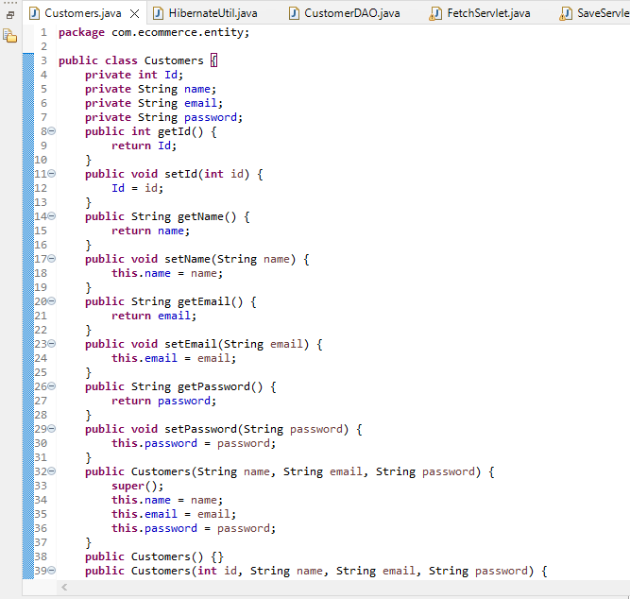

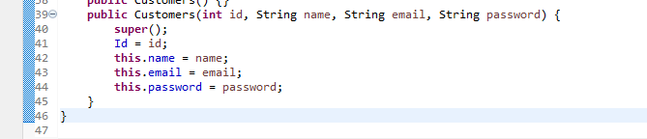

1. Hibernate Util Class

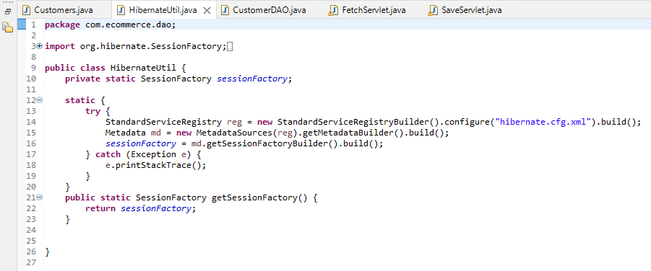

1. Index.jsp file

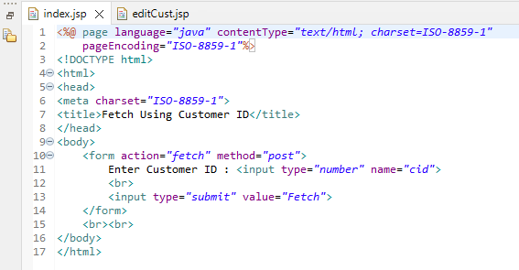

1. Fetch Servlet to fetch data of customer id which user enters in index.jsp

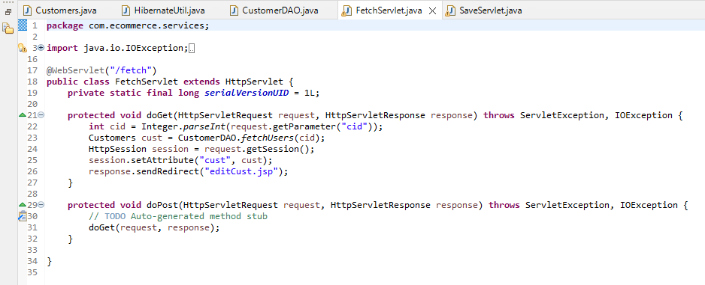

1. EditCust.jsp page which displays form for editing

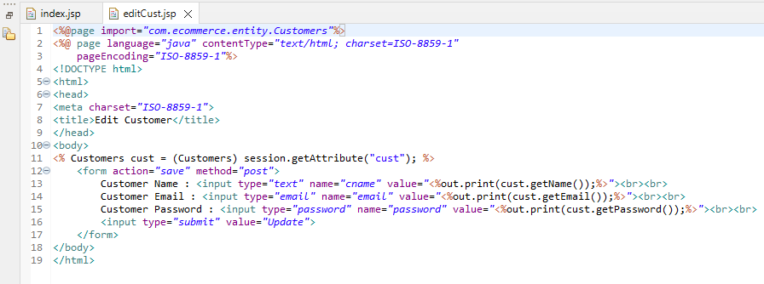

6. Save Servlet executed after user clicks save button on editCust.jsp page

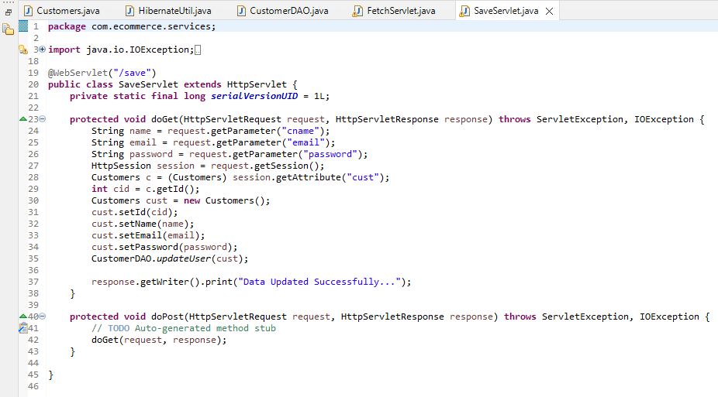

7. Customer DAO class for database operations

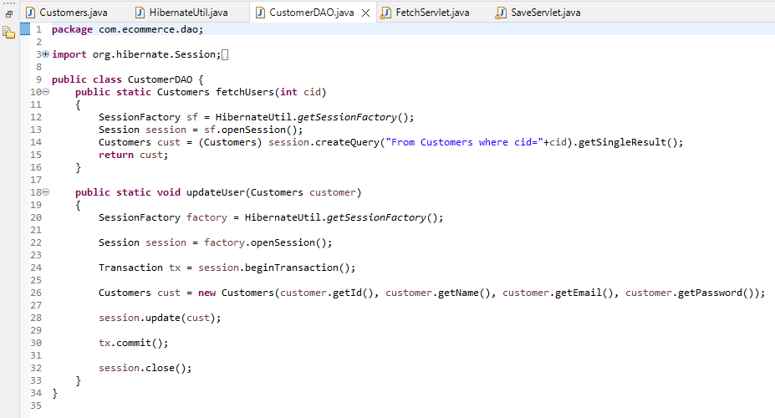

8. Hibernate.cfg.xml(Hibernate Configuration File)

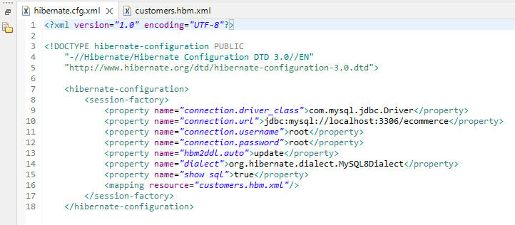

9. customer.hbl.xml(Customer Hibernate File)

