LLM Benchmarks Are Broken
Visualizing the Gap Between AI Scores and Real-World Performance
UC Berkeley MIDS | W209 Data Visualization | Final Project Exploratory Analysis
Pallavi | Gunhui Kim | Mehek Bhargava | Sahana Venkatesh

Project Overview
The AI industry runs on benchmarks. Every model launch leads with a headline score like '88% on MMLU,' and everyone accepts the assumption that a higher benchmark score means a better model. This project challenges that assumption.
The key insight driving this work: we have two independent measures of model quality that should agree. Benchmark scores (fixed tests like MMLU) and Arena ELO (real humans blind-voting on which model gave a better answer). Arena ELO is our ground truth because it cannot be gamed — you cannot memorize the answer key when the test is whether a real person preferred your response. When the two measures disagree, the benchmark is what is broken.

Dataset & Preprocessing

Primary Dataset
Kaggle LLM Benchmark Tracker 2020–2026: 286 models spanning 2020 to 2026, with 9 benchmark scores plus Arena ELO, cost, release dates, and model metadata. All data sourced from published or official materials — nothing synthetic or estimated.

Why This Dataset
Several live data sources failed during collection. The HuggingFace Leaderboard Space timed out repeatedly. The LMSYS Chatbot Arena Space threw runtime errors when queried programmatically. The Arena ELO GitHub repository lacked sufficient historical depth for time-series analysis. The Kaggle dataset, supplemented by Arena AI GitHub ELO snapshots, was the only source that held up to systematic verification.

Raw Files
- Frontier models (80): the only tier with both Arena ELO and cost data
- Research models (106): academic and open-source, no ELO or cost
- Community fine-tunes (100): HuggingFace derivative models

Preprocessing Steps (Python/Pandas, Google Colab)
Step 1: Loaded and inspected all three raw files - schemas, null counts, date coverage.
Step 2: Verified hypotheses were testable before building any charts. Quick numerical checks confirmed all three signals were real.
Step 3: Merged three files into one unified table with a category column for frontier/research/community toggling.
Step 4: Derived variables - rank columns for MMLU and ELO, rank_gap for H2, cost ratios for H3, and release dates cleaned into years and quarters.
Step 5: Wrote three output files.

Output Files
- llm_unified.csv - master table, 286 models, 43 columns
- llm_long.csv - 1,649 tidy model-benchmark rows (wide-to-long reshape for multi-benchmark charts)
- mmlu_saturation_by_year.csv - pre-aggregated saturation curve

Note on H3 pivot: The original H3 plan used model size (parameters_b). That column was 71% null within the 56-model frontier core - precisely the models H3 needed. Output cost (cost_output_per_1m_usd) was fully populated for the same tier and told a stronger story. The pivot was driven entirely by data availability.

Hypotheses
Before visualizing, we ran numerical checks to confirm each hypothesis was testable:

H1 - Saturation: MMLU standard deviation collapsed from σ=19.0 (2023, n=92 models) to σ=0.9 (2026, n=3 models). The signal was present.
H2 - Frontier Gap: MMLU-to-ELO correlation is 0.841 overall but drops to 0.666 among the top-20 ELO models. The divergence was present.
H3 - Cost Disconnect: Output cost correlates with MMLU at 0.31 but with Arena ELO at only 0.066. The disconnect was present.

Usable core for H2 and H3 analysis: 56 models with both MMLU score and Arena ELO (all frontier category).

Hypothesis 1: Benchmark Saturation
LLM benchmark scores (MMLU) are rapidly approaching the 100% theoretical ceiling, suggesting the benchmark is becoming saturated and will soon lose its ability to differentiate model quality.

Initial Exploration
We began by inspecting the satByYear dataset - mean MMLU scores aggregated by release year from 2020 to 2026. Before visualizing, we noticed the mean jumped from 33% in 2020 to over 93% in 2026. This immediately suggested a saturation effect. We chose to explore this with three progressive chart types: a simple line chart, a banded line with standard deviation, and finally a beeswarm showing individual model scores.
Chart progression: Line chart → Banded line → Beeswarm

View 1 - Line Chart: Mean MMLU Climbing Toward the Ceiling
What is informative about this view
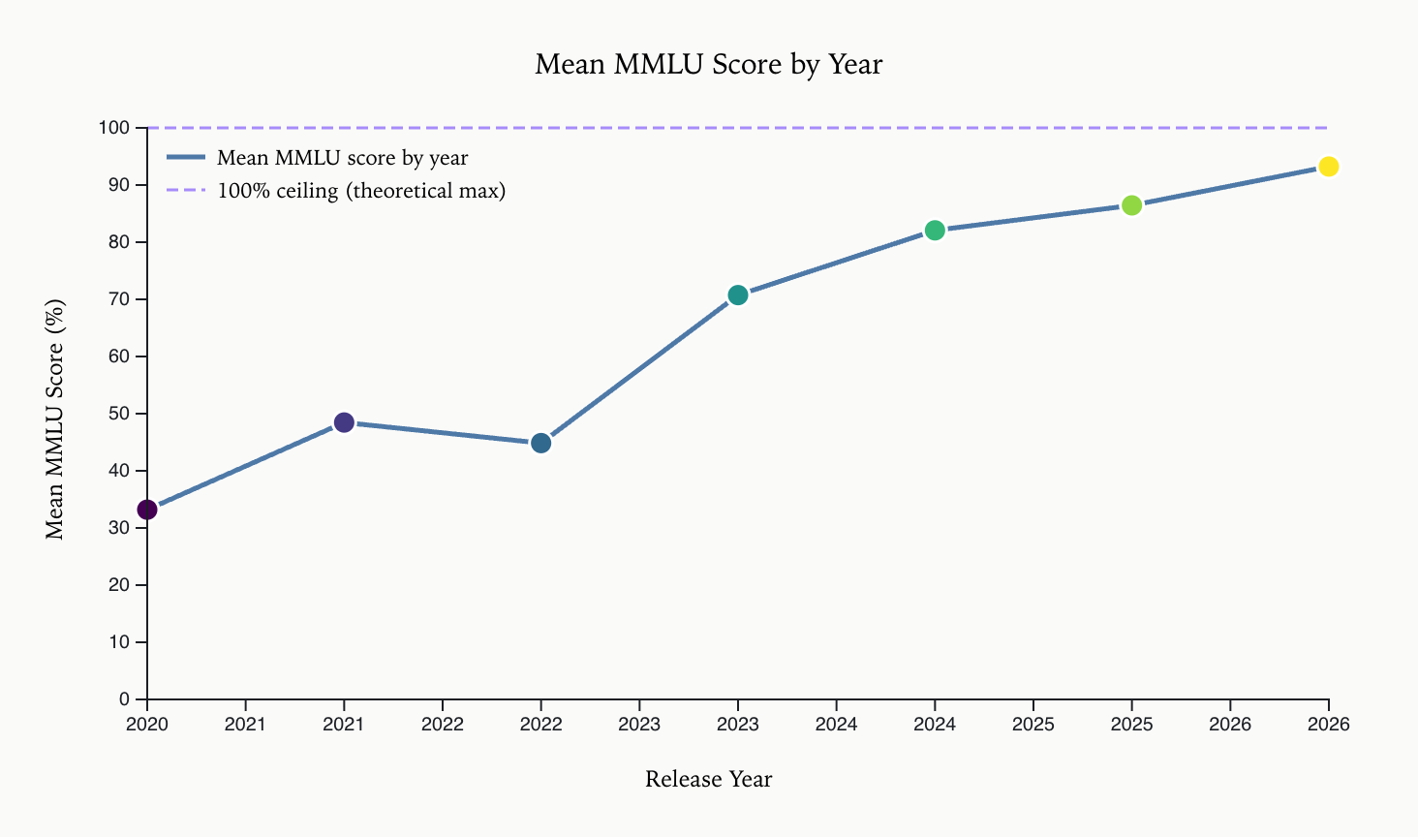
The simple line chart immediately makes the saturation trend visible. Mean MMLU score rises from 33% in 2020 to 93% in 2026 - a 60-point jump in just 6 years. The dashed 100% ceiling line shows how close models are getting to the theoretical maximum. The steep slope in 2022–2023 coincides with the release of GPT-4 class models.
What could be improved
This view only shows the mean - it hides the spread across models within each year. A single aggregate line does not tell us whether all models improved uniformly or if a few frontier models are pulling the average up. We need to add uncertainty bands.

View 2 - Banded Line Chart: Adding Uncertainty (±1σ)
What is informative about this view
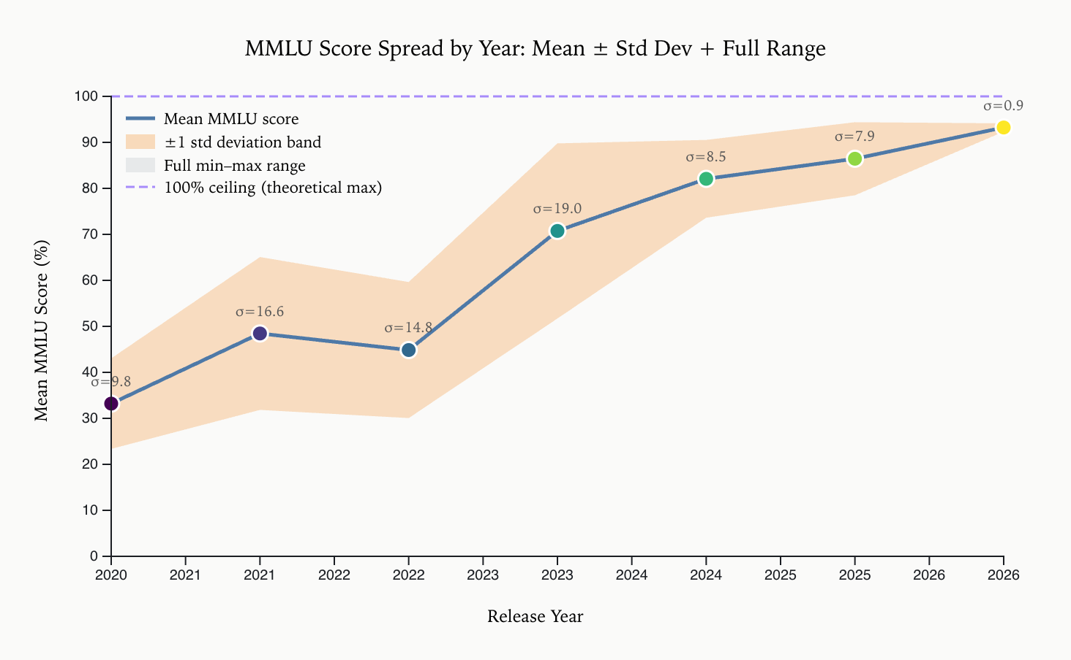
Adding the ±1 standard deviation band reveals that model performance within each year varies dramatically. The spread actually peaks in 2023 (σ=19.0, n=92 models) as a wave of mid-tier models entered the field, then collapses sharply. The 2022 band is already wide (σ=14.8), meaning some models score 30% while others score 70% in the same year. By 2026, the band narrows to σ=0.9, confirming saturation: models are clustering at the ceiling with almost no variance remaining. The sigma labels on each data point make the compression immediately legible.
What could be improved
The line chart still aggregates by year and does not show where individual models sit relative to each other. The year bucketing hides sub-year trends and does not distinguish frontier vs. community models. We need to break down to the individual model level.

View 3 - Beeswarm: Every Individual Model as a Dot
What is informative about this view
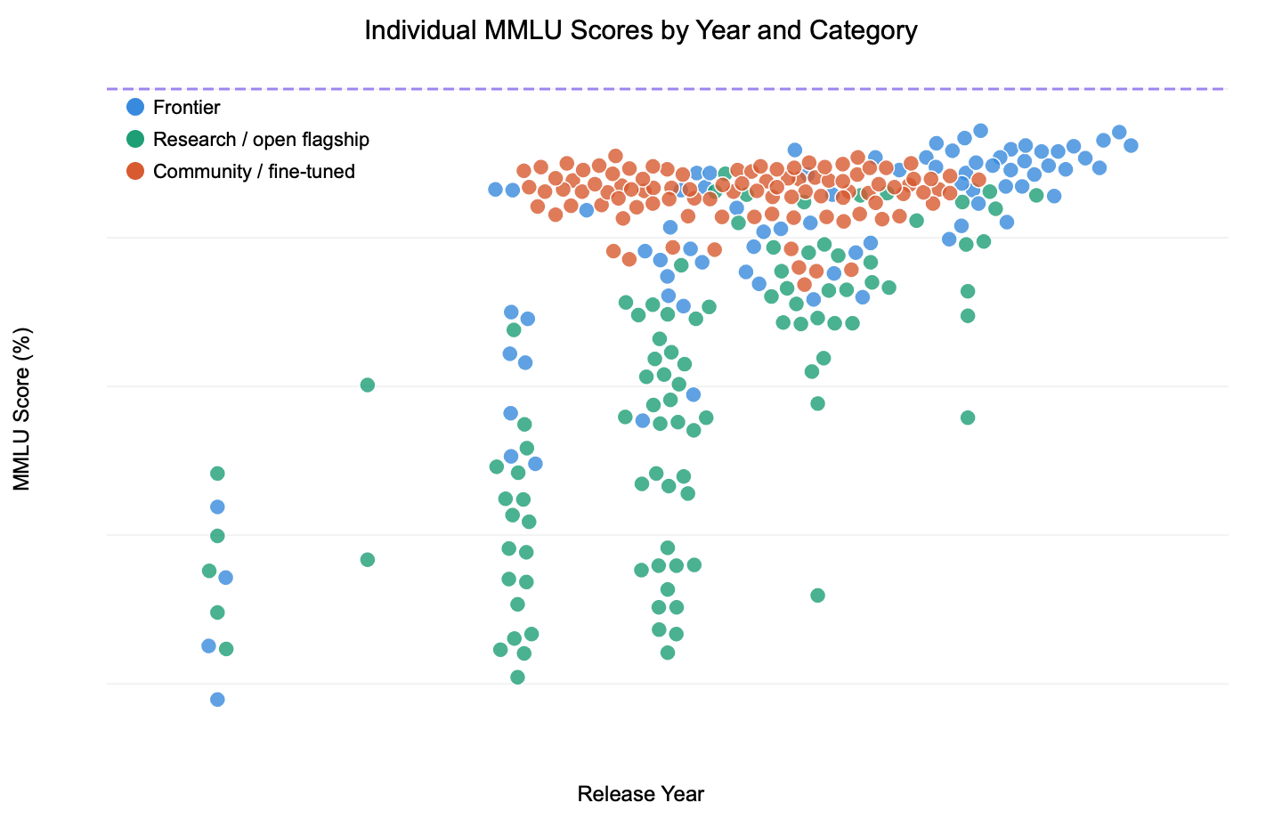
Switching from aggregated lines to a beeswarm of individual models reveals the full distribution. Each dot is one model, color-coded by category (blue = frontier, green = research, orange = community). The rightward and upward drift of dots across years is visually compelling: frontier models cluster near the top, while community models spread more widely. The force-simulation layout prevents overplotting while preserving the true MMLU y-position for each model. Hover tooltips show model name, provider, year, score, and category.
What could be improved
The beeswarm is dense and could benefit from a frontier-only filter toggle to isolate the saturation story for the models that matter most to benchmark consumers. Sub-year release timing is also hidden by the discrete year bucketing.

Conclusion — H1
The data strongly supports Hypothesis 1. MMLU mean scores rose from 33% in 2020 to 93% in 2026, a 60-point climb in just 6 years. Standard deviation collapsed from σ=19.0 in 2023 to σ=0.9 in 2026, confirming models are converging at the ceiling. The beeswarm confirms this is not driven by outliers: nearly all 2026 models score above 90%. MMLU is becoming an insufficient differentiator for frontier models.

Hypothesis 2: Frontier Gap
Models that score highest on MMLU do not necessarily rank highest in real-world human preference (Arena ELO), suggesting benchmark gaming or that MMLU tests a different skill than conversational quality.

Initial Exploration
We filtered to frontier models (frontier_core = True) and plotted MMLU score on the x-axis against Arena ELO on the y-axis. Before visualizing, we noted the correlation between the two metrics was not obvious from the data alone - some models with high MMLU appeared mid-range on ELO leaderboards. Usable core: 56 models with both MMLU and Arena ELO.
Chart progression: Scatter → Dual-trend scatter → Slope chart

View 1 - Basic Scatter: MMLU Score vs Arena ELO
What is informative about this view
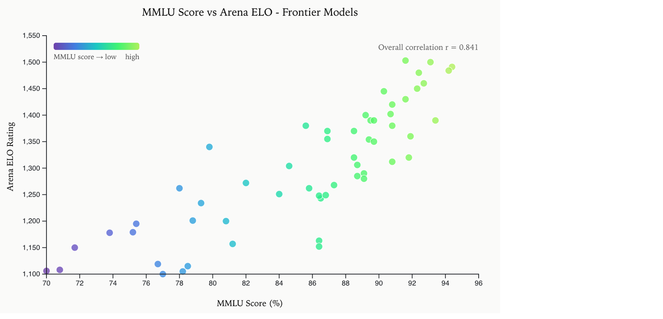
Even the basic scatter reveals a positive but noisy correlation. Models with very high MMLU (>90%) tend to cluster in the upper Arena ELO range, but there are clear exceptions - some models score 85%+ MMLU yet land below 1,300 ELO, while others with moderate MMLU appear in the top ELO tier. The overall correlation annotated directly on the chart (r=0.841) suggests a moderate relationship. Dots are colored by MMLU score using a Cool gradient for additional encoding. This suggests MMLU score alone is not a reliable predictor of conversational quality.
What could be improved
The scatter treats all frontier models equally with no distinction between the overall field and the top tier specifically. The overall correlation (r=0.841) looks reasonably strong, but it may be masking a weaker relationship at the frontier where model selection actually matters. A trend line and top-tier isolation would expose whether the relationship holds at the top or breaks down.

View 2 - Dual-Trend Scatter: Highlighting Top-20 ELO Models
What is informative about this view
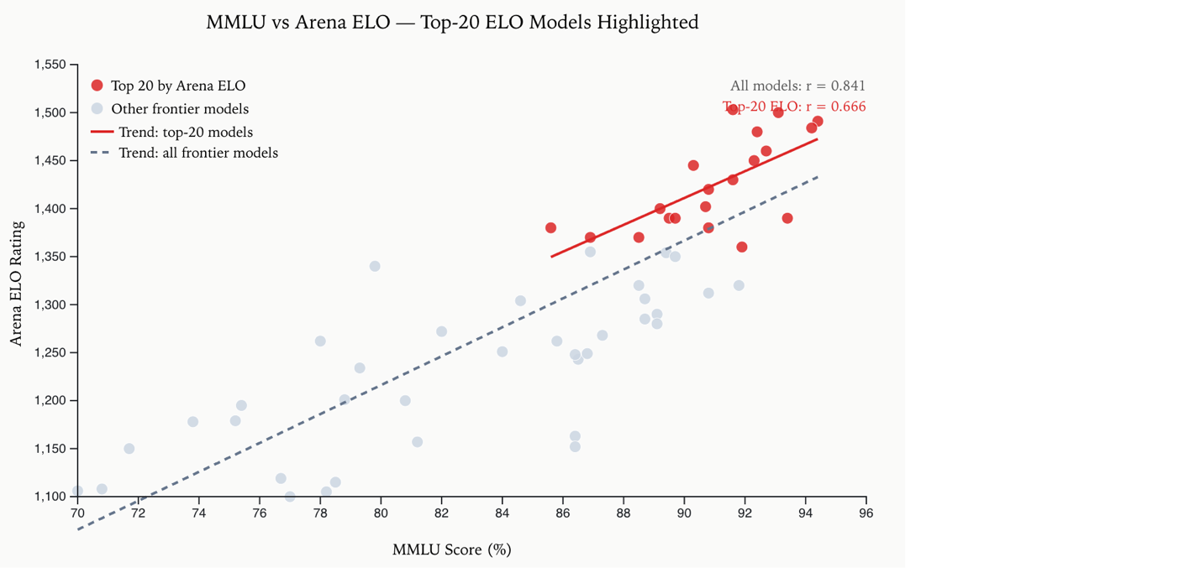
Color-coding the top 20 Arena ELO models red reveals a striking pattern: top-ELO models cluster in the 85–95% MMLU range, not at the very top of MMLU. The two trend lines tell different stories - the red line (top-20 models) is nearly flat (r=0.666), while the grey dashed line (all models) slopes upward (r=0.841). This means that among truly top-performing models (by ELO), more MMLU score does not predict more ELO - the relationship flattens at the frontier where model selection actually matters. Both correlation values are annotated directly on the chart in matching colors.
What could be improved
The scatter chart does not show individual model identities, making it hard to name specific outliers. A slope chart mapping MMLU rank vs ELO rank would more directly visualize inversions - cases where a model ranks high on one metric but low on the other.

View 3 - Slope Chart: MMLU Rank vs Arena ELO Rank (Inversions)
What is informative about this view
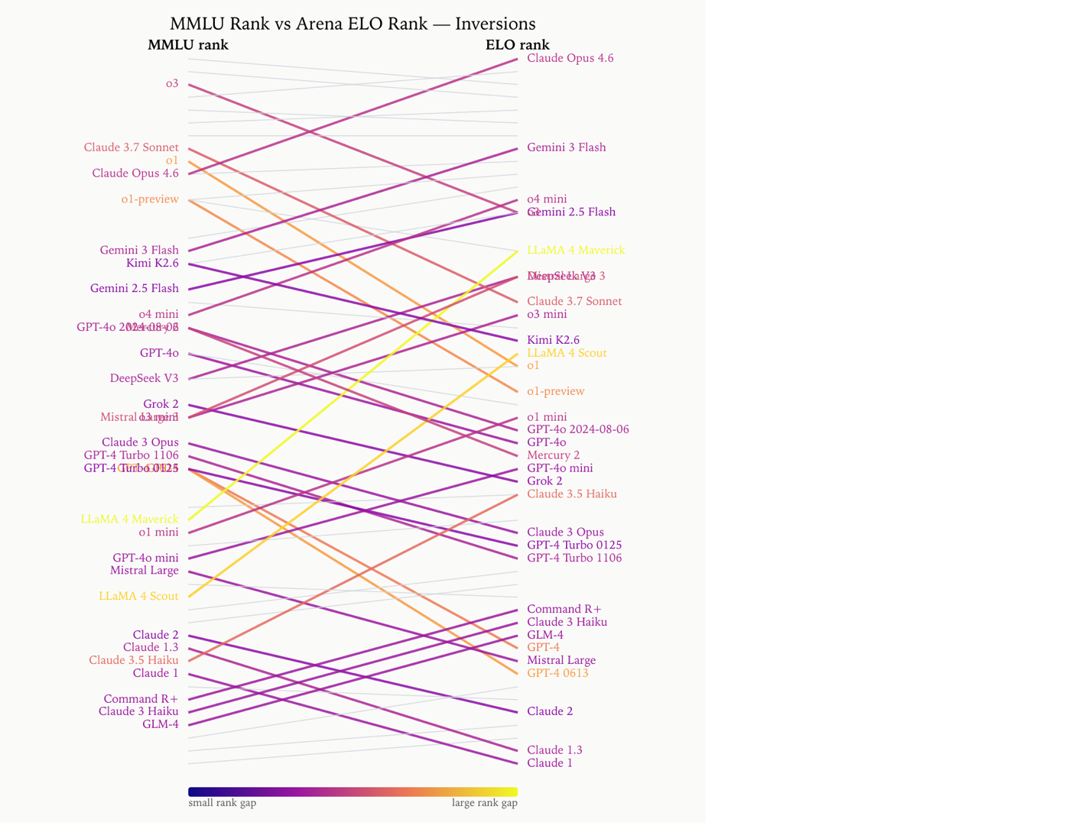
Building on View 2's finding that the MMLU-to-ELO correlation drops from 0.841 overall to 0.666 at the top tier, the slope chart makes individual rank inversions visible at the model level. Lines that cross dramatically reveal models where benchmark rank and human-preference rank diverge sharply. The plasma color gradient, scaled to rank gap magnitude, draws the eye to the most extreme mismatches. Several models that score in the top 10 by MMLU sit outside the top 20 by ELO, and vice versa. Model names are labeled at both ends of each crossing line. Hover tooltips show MMLU rank, ELO rank, and rank gap for every line. A live Pearson correlation calculation confirms r=0.87 between MMLU rank and ELO rank (n=56).
What could be improved
The chart becomes visually cluttered with overlapping lines at similar rank positions. A toggle to filter by rank gap threshold would let viewers isolate only the most extreme inversions for the polished final build.

Conclusion - H2
The scatter plots and slope chart together confirm that MMLU score and Arena ELO correlate across the full frontier field (r=0.841), but that relationship weakens meaningfully at the top tier (r=0.666 among top-20 ELO models). The trend line for top-20 ELO models is nearly flat, meaning additional MMLU score does not predict additional human preference at the frontier. Several models with near-perfect MMLU scores rank surprisingly low in human preference evaluations. MMLU saturation is masking meaningful quality differences at the frontier, confirming our hypothesis that the benchmark is losing discriminative power where it matters most.

Hypothesis 3: Cost Disconnect
There is no strong correlation between model output cost and real-world performance (Arena ELO), meaning higher-priced models are not always better — but cost does correlate with MMLU score, suggesting expensive models over-optimize for benchmarks.

Initial Exploration
We examined the cost_output_per_1m_usd field against both Arena ELO and MMLU score. Before visualizing, the cost range was striking: from under $0.01 to over $100 per million tokens. This large range suggested a log scale would be necessary to avoid the data being crushed against one end of the axis.
Chart progression: Scatter → Two-panel scatter → Horizontal cost bar chart

View 1 - Scatter: Output Cost (Log Scale) vs Arena ELO
What is informative about this view
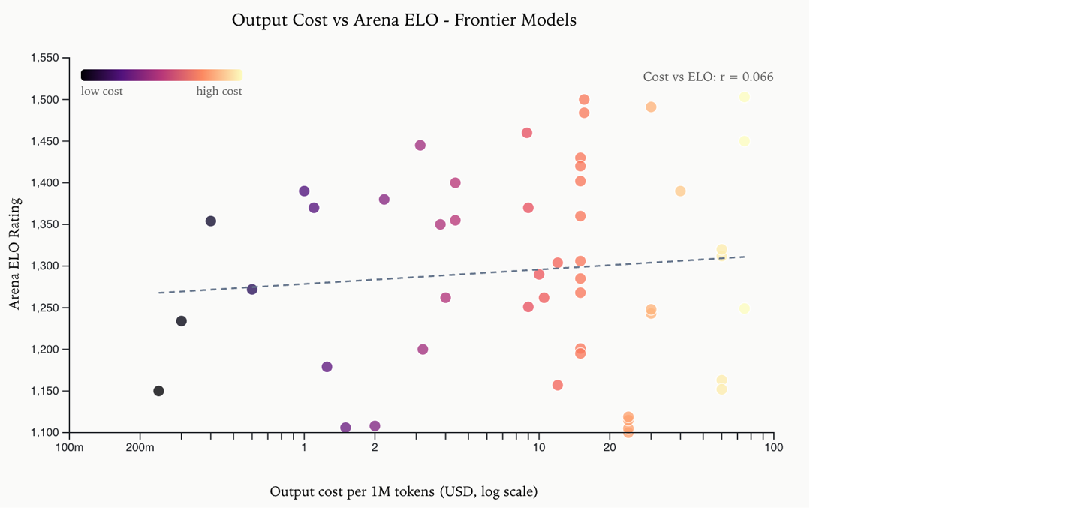
The log-scale scatter reveals that the cost-ELO relationship is essentially flat (r=0.066). Models priced at $0.10/M tokens have nearly the same ELO range as models at $10/M tokens. The dots are spread vertically across the full ELO range at every cost level, and the trend line confirms the near-zero slope. This is a striking finding - paying more does not reliably buy better conversational performance.
What could be improved
The single panel only shows cost vs ELO. Showing cost vs MMLU side-by-side would allow direct comparison of the two relationships and reveal whether cost tracks the benchmark better than it tracks real preference.

View 2 - Two-Panel Scatter: Cost vs ELO Side-by-Side with Cost vs MMLU
What is informative about this view
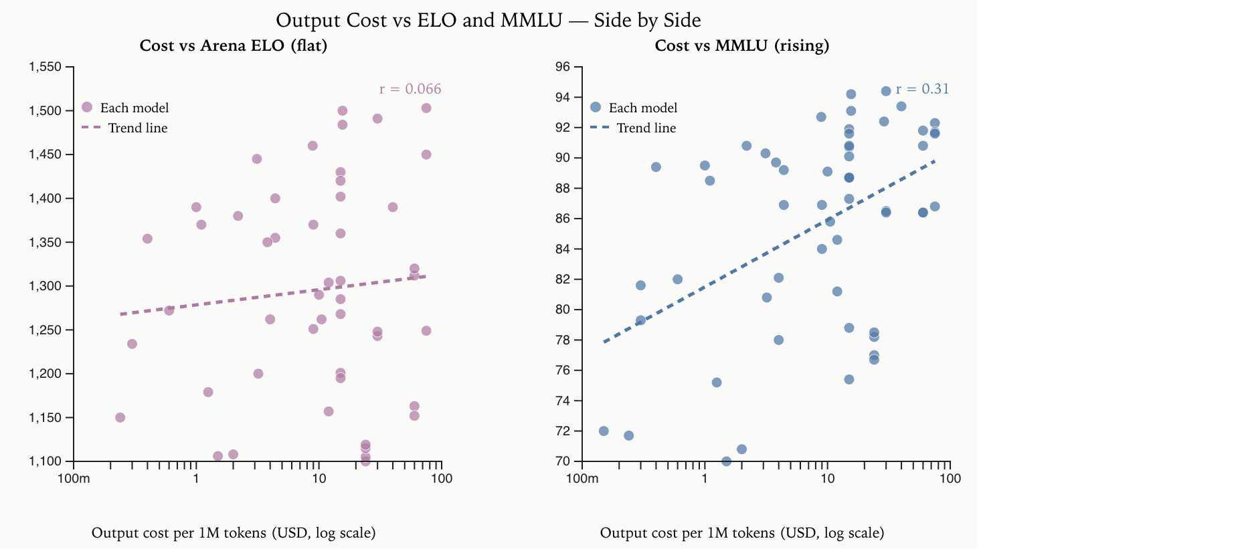
Placing both panels side-by-side makes the contrast unmistakable. The left panel (cost vs ELO, r=0.066) shows an almost flat trend line - confirming that spending more does not meaningfully improve Arena ranking. The right panel (cost vs MMLU, r=0.31) shows a rising trend: pricier models tend to score higher on MMLU. This directly tests both parts of the hypothesis in one view: cost tracks the benchmark, not real-world preference.
What could be improved
The dual-panel scatter still does not show which specific models offer the best value. Among models with similar Arena ELO (comparable real-world quality), which are the cheapest? A horizontal bar chart sorted by cost among top-ELO models would answer this directly.

View 3 - Cost Bar Chart: Models Within 25 ELO of the Top Ranked by Cost
What is informative about this view
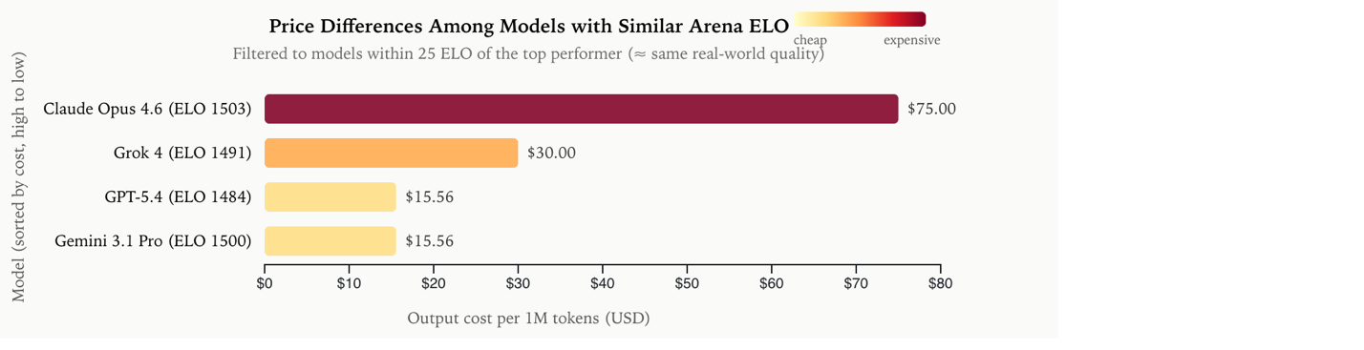
This is the most actionable view. By filtering to models within 25 ELO points of the top performer (approximately equivalent real-world quality), we can directly compare their prices. The horizontal bar chart reveals extreme price variation among near-equal performers. The YlOrRd color gradient reinforces cost visually: yellow bars are cheap, red bars are expensive. The model name, ELO score, and dollar amount make it easy to identify the best-value options. Hover tooltips show model name, cost, ELO, MMLU, and provider.
What could be improved
The 25 ELO threshold is somewhat arbitrary. A slider to adjust the band width would let viewers explore how the price spread changes as the quality filter tightens or loosens.

Conclusion - H3
The data strongly supports Hypothesis 3. Cost and Arena ELO have nearly no relationship (r=0.066, confirmed by flat trend line across both views). However, cost does weakly correlate with MMLU score (r=0.31), meaning pricier models tend to benchmark higher but not necessarily perform better in human preference. The cost bar chart delivers the most actionable insight: among models of equivalent Arena ELO quality, prices vary dramatically, meaning cost is largely a business decision rather than a quality signal.

Unexpected Finding
The most surprising discovery was the variance collapse after 2023: standard deviation peaked at σ=19.0 in 2023 then dropped to σ=0.9 by 2026. This means frontier models have all converged on the same MMLU ceiling simultaneously. Combined with the finding that top-ELO models cluster in the 85–95% MMLU range rather than at 100%, this suggests MMLU has already lost its ability to differentiate elite models — a new benchmark is needed.

Appendix A - Exploratory Network Visualization
An exploratory force-directed network visualization grouping models by MMLU and ELO proximity. Nodes represent individual models (size = Arena ELO, color = provider), with edges connecting models within 3% MMLU and 50 ELO points of each other. All 56 nodes are frontier models since only frontier models have Arena ELO data. This view surfaces which providers' models cluster together in the MMLU/ELO space, and was not part of the core hypothesis testing.
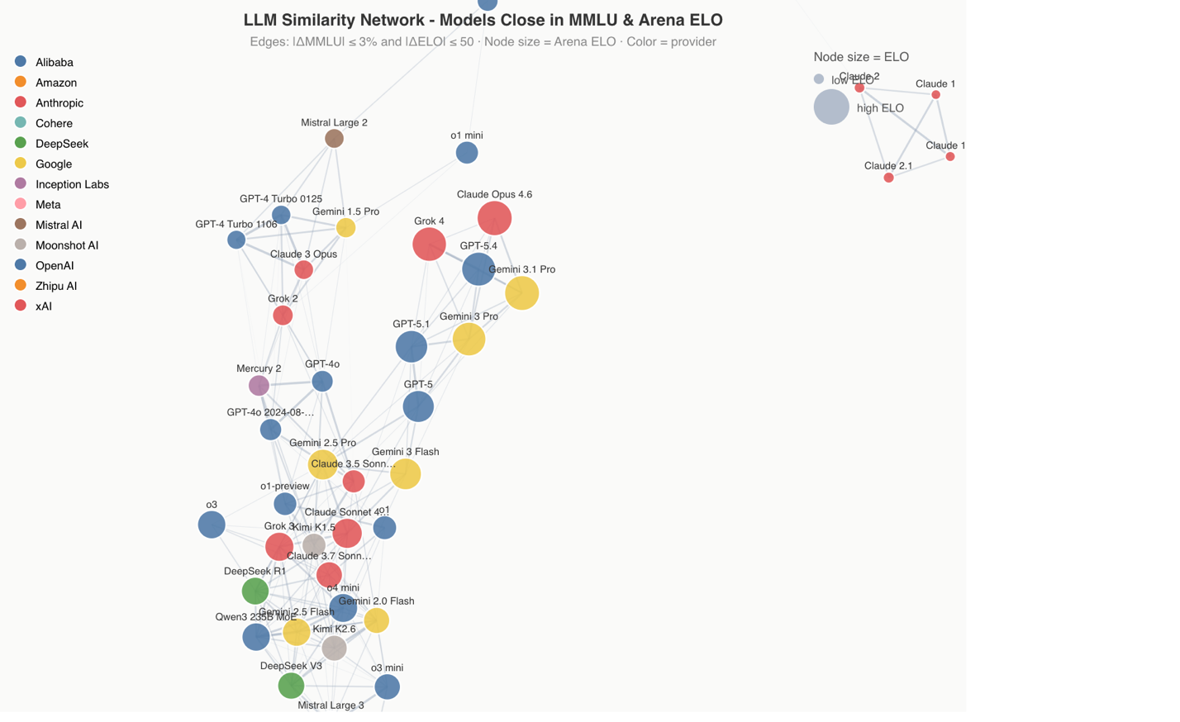

Tools & Data Sources
Visualization tool: D3.js inside Observable notebooks
Data engineering: Python, Pandas, Google Colab
Deployment target: Vercel
Primary dataset: Kaggle LLM Benchmark Tracker 2020–2026 (286 models, 43 columns)
Supplementary data: Arena AI GitHub ELO snapshots
Usable analysis core: 56 frontier models with both MMLU score and Arena ELO
D3 Observable link : https://observablehq.com/d/f52de3b8ff1fb482

