SYSTEM ARCHITECTURE DESIGN & MOCKUP
SmartAttend
A Web-Based Student Attendance Management System
Item | Details
Task | Week 2: System Architecture Design & Mockup
Prepared by | Pallavi R
Role | Junior Software Developer Intern
Organization | YuvaIntern
Date | October 2026
Version | 1.0
Builds on | Week 1: Project Planning & Requirements Analysis (FR1-FR10, NFRs, O1-O6)

Table of Contents
1. System Overview
2. Architecture Diagrams
3. Module Description
4. Data Design and Interface Mockup
5. Data Flow and Integration
6. Scalability, Security and Maintainability
7. Conclusion
8. References

1. System Overview

1.1 Purpose and Context
In Week 1 the SmartAttend project was planned and its requirements were analysed. The problem was clear: paper registers and scattered spreadsheets make attendance slow to record, error-prone, and difficult to monitor against the 75% minimum rule. This document takes the next step. It translates those requirements into a high-level system architecture that shows what the main building blocks are, what each one is responsible for, and how data moves between them.
The design deliberately stays at the architectural level. It does not contain source code. Its purpose is to give the whole team (and any reviewer) a shared picture of the system before development starts in Week 3, so that the backend, frontend and database work fit together without rework.

1.2 Architectural Style
SmartAttend uses a three-tier layered architecture (presentation, application, data) built as a modular monolith. The application layer is a single deployable Node.js and Express service, but internally it is divided into independent modules (authentication, users, classes, attendance, reports and notifications), each with its own routes, business logic and data access. This choice was made for three reasons:
- Fits the constraints. The project is built by a small team within eight weeks using free tools. A monolith is far simpler to build, test and deploy than a set of microservices.
- Keeps the door open. Because the modules have clear boundaries, any one of them (for example reports or notifications) can later be extracted into a separate service without redesigning the system.
- Matches the workload. Attendance marking is a simple create-and-read workload. A well-indexed relational database handles this comfortably, which supports the target of 500 concurrent users.

1.3 Main Components
Component | Role in the system
Web client | Responsive HTML5, CSS3 and JavaScript pages for teachers, students and administrators, running in the browser.
REST API server | Node.js with Express. Receives HTTPS requests, applies security and validation middleware, and routes them to the correct module.
Auth & RBAC middleware | Verifies the JWT on every request and checks that the user's role is allowed to perform the action.
Business modules (M1-M6) | Authentication, User, Class & Subject, Attendance, Report and Notification modules containing the application logic.
Database | MySQL or PostgreSQL relational database holding users, classes, subjects, attendance records and the audit log.
Email service | External SMTP provider used to send low-attendance alerts to students and parents.
Backup storage | Receives automated daily database dumps so data can be restored after a failure.

1.4 Design Goals Derived from the Requirements
Design goal | Architectural decision | Requirement addressed
Fast attendance marking | One bulk API call submits the whole class; the client sends only status changes | O2, FR4, US1
Real-time student view | Percentages are recalculated by the Attendance module on every save and served from indexed queries | O3, FR6
Accountability | Every create or edit is written to an audit_log table by a dedicated Audit Logger | FR5, Section 1.4 benefits
Security and privacy | JWT, bcrypt, HTTPS, role-based access, parameterised SQL | NFR Security, DPDP Act 2023
Extensibility | Independent modules and a versioned REST API (/api/v1) | NFR Scalability, Maintainability
Timely alerts | Notification module runs after each save and as a nightly scheduled check | O5, FR8, US5

2. Architecture Diagrams

2.1 Layered System Architecture
Figure 1 gives the big picture. The browser (presentation layer) talks to the Express API (application layer) only through HTTPS and JSON. The application layer is the only part of the system that can read or write the database, and it is also the only part that contacts the external email service. No client ever connects to the database directly, which keeps all business rules and security checks in one place.
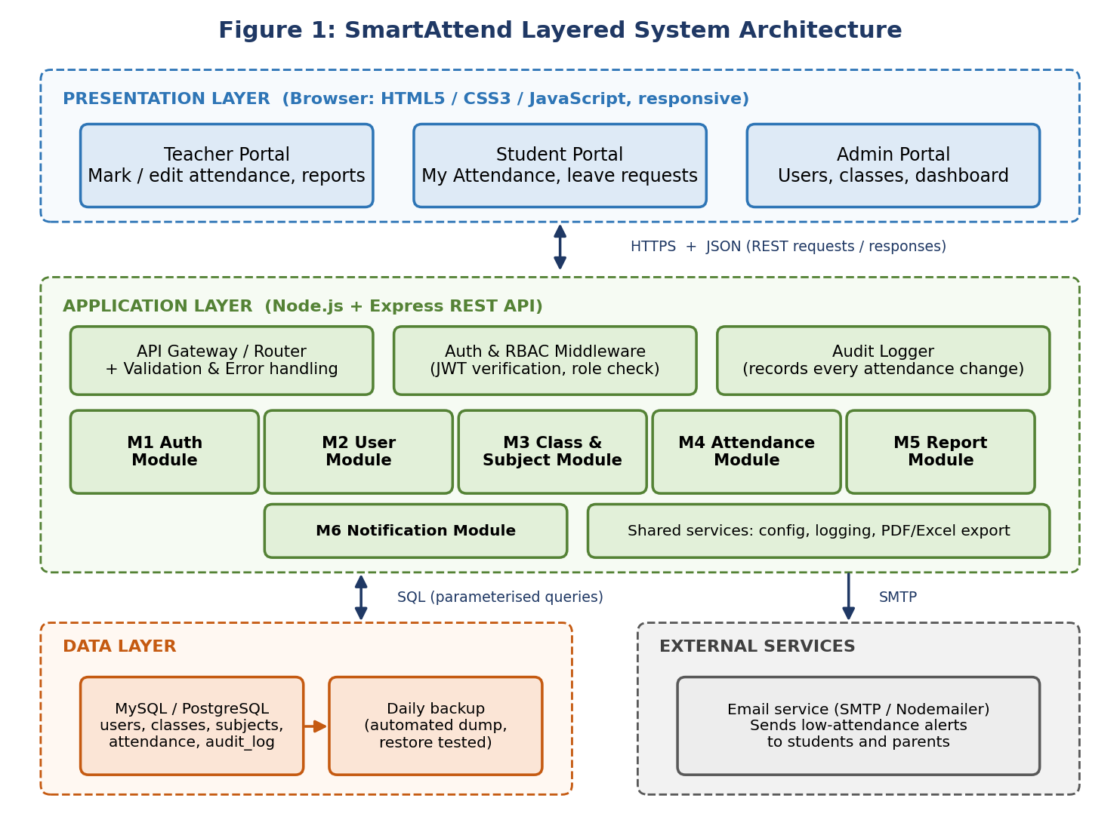

How to read the diagram. The three dashed regions at the top are the layers a request passes through, from top to bottom. The double-headed arrows show request and response traffic; the single arrow to the email service shows a one-way outgoing message. The labels on the arrows name the protocol used for that connection.

2.2 Component Diagram and Module Dependencies
Figure 2 zooms into the application layer. Every request first passes through the Express router and the Auth and RBAC middleware. Only authorised requests reach the six business modules. The orange arrows show the dependencies between modules: the Authentication module needs the User module to look up credentials, the Attendance module needs the Class and Subject module to know which students belong to a class, and the Report module reads attendance data produced by the Attendance module.
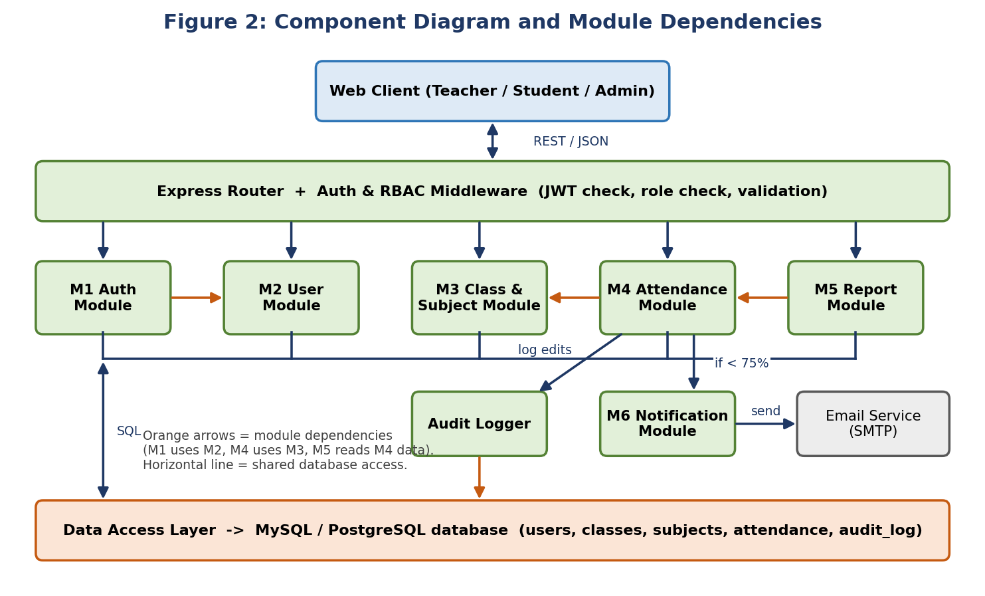

2.3 Deployment View
Figure 3 shows where the pieces run in the first release. A reverse proxy (Nginx) terminates HTTPS and forwards traffic to the Node.js application server, which also serves the static frontend files. The database runs on its own server or managed instance, and daily dumps are copied to separate backup storage. Keeping the database off the public network is a key security decision.
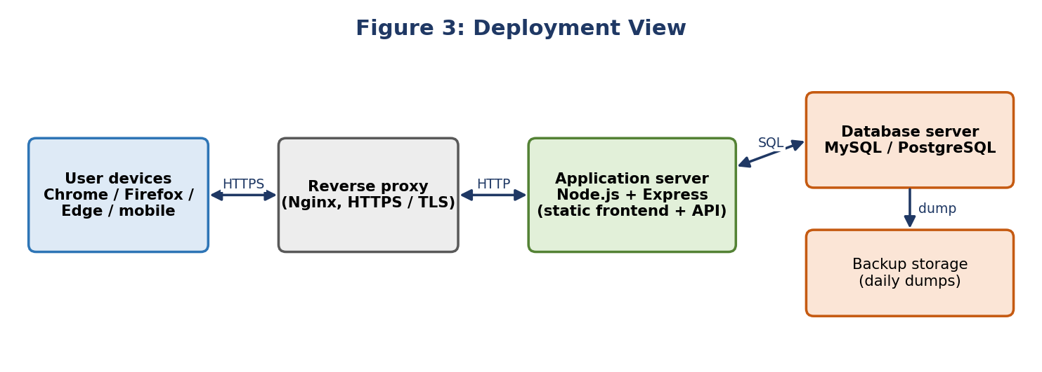

3. Module Description
Each module owns one area of the business logic. The table summarises the modules, and the sections that follow describe their responsibilities, how they interact, and the technologies planned for each.
ID | Module | Core responsibilities | Requirements
M1 | Authentication | Login, JWT issue and refresh, logout, password hashing and verification | FR1
M2 | User Management | Create, edit, deactivate students, teachers and admins; role assignment | FR2, US3
M3 | Class & Subject | Create classes and subjects; assign teachers; enrol students | FR3
M4 | Attendance | Mark and edit sessions; calculate percentages; student history | FR4, FR5, FR6
M5 | Reports | Daily, monthly and subject-wise reports; PDF and Excel export; dashboard data | FR7, FR10
M6 | Notification | Detect students below 75%; compose and send email alerts | FR8

3.1 M1 - Authentication Module
Responsibilities: validates the email and password at login, issues a signed JSON Web Token containing the user id and role, and rejects expired or tampered tokens. Passwords are never stored in plain text; only bcrypt hashes are saved.
Interacts with: M2 (reads the stored hash for the user) and the Auth and RBAC middleware (which uses the same token secret to verify every later request).
Technologies: jsonwebtoken, bcrypt, express-rate-limit to slow down repeated login attempts.

3.2 M2 - User Management Module
Responsibilities: lets the administrator add, edit and deactivate accounts. Deactivation is a soft delete (is_active = false), so historical attendance is never lost. It also links each student to a class and each teacher to subjects.
Interacts with: M1 for credentials, M3 for class links, and the Audit Logger for account changes.
Technologies: Express routers, express-validator for input checks, MySQL or PostgreSQL through a query builder or ORM such as Knex or Sequelize.

3.3 M3 - Class and Subject Module
Responsibilities: stores the academic structure. An administrator creates a class, adds its subjects, and assigns a teacher to each subject. This module is the source of truth for the question 'which students should appear on this teacher's attendance sheet?'
Interacts with: M2 for the student and teacher lists, and M4, which calls it before every marking operation to confirm that the teacher is assigned to the chosen class and subject (the precondition of use case UC1).
Technologies: Express, relational tables with foreign keys and indexes on class_id and teacher_id.

3.4 M4 - Attendance Module
Responsibilities: the heart of the system. It accepts a whole class sheet in a single request, rejects duplicates for the same session (switching to edit mode instead, as in UC1), enforces the 24-hour correction window for teachers, and recalculates subject-wise percentages after every change. Students use it to read their percentage and date-wise history (UC2).
Interacts with: M3 for validation, the database for storage, the Audit Logger for every edit, and M6, which it triggers whenever a student's percentage falls below 75%.
Technologies: Express, database transactions so that a class sheet is saved completely or not at all, and indexes on (student_id, subject_id, session_date).

3.5 M5 - Report Module
Responsibilities: builds daily, monthly and subject-wise reports and the administrator dashboard figures. Users preview a report on screen and export it as PDF or Excel (UC3). Access is limited to the classes a teacher is assigned to, while administrators can see all classes.
Interacts with: M4 and M3 for data, and the middleware for permission checks.
Technologies: PDFKit for PDF files, ExcelJS for Excel files, and Chart.js on the client for dashboard charts.

3.6 M6 - Notification Module
Responsibilities: decides who needs an alert and sends it. It runs in two ways: immediately after an attendance save, and as a nightly scheduled check that catches any student who slipped through. A record of sent alerts prevents the same student receiving the same warning repeatedly.
Interacts with: M4 (trigger), the database (alert history), and the external email service.
Technologies: Nodemailer over SMTP, node-cron for the scheduler, and simple HTML email templates.

3.7 Cross-Cutting Components
- Auth and RBAC middleware. Runs before every protected route. It verifies the token, loads the role, and refuses the request if the role is not allowed. Roles are admin, teacher and student.
- Audit Logger. Records who changed which attendance entry, the old and new status, and the time. This gives the secure, auditable history promised in Week 1.
- Validation and error handling. A shared layer that checks every input and returns consistent error messages with correct HTTP status codes.
- Configuration and logging. Environment variables hold secrets and connection strings; a logger records errors and security events.

4. Data Design and Interface Mockup

4.1 Core Data Model
Figure 4 shows the five main tables. The users table holds all three roles, which keeps login simple and lets the role column drive access control. A student is linked to a class, and each subject belongs to a class and is taught by a teacher. Every attendance row records one student's status (Present, Absent or Late) for one subject on one date, and every later change creates a row in audit_log.
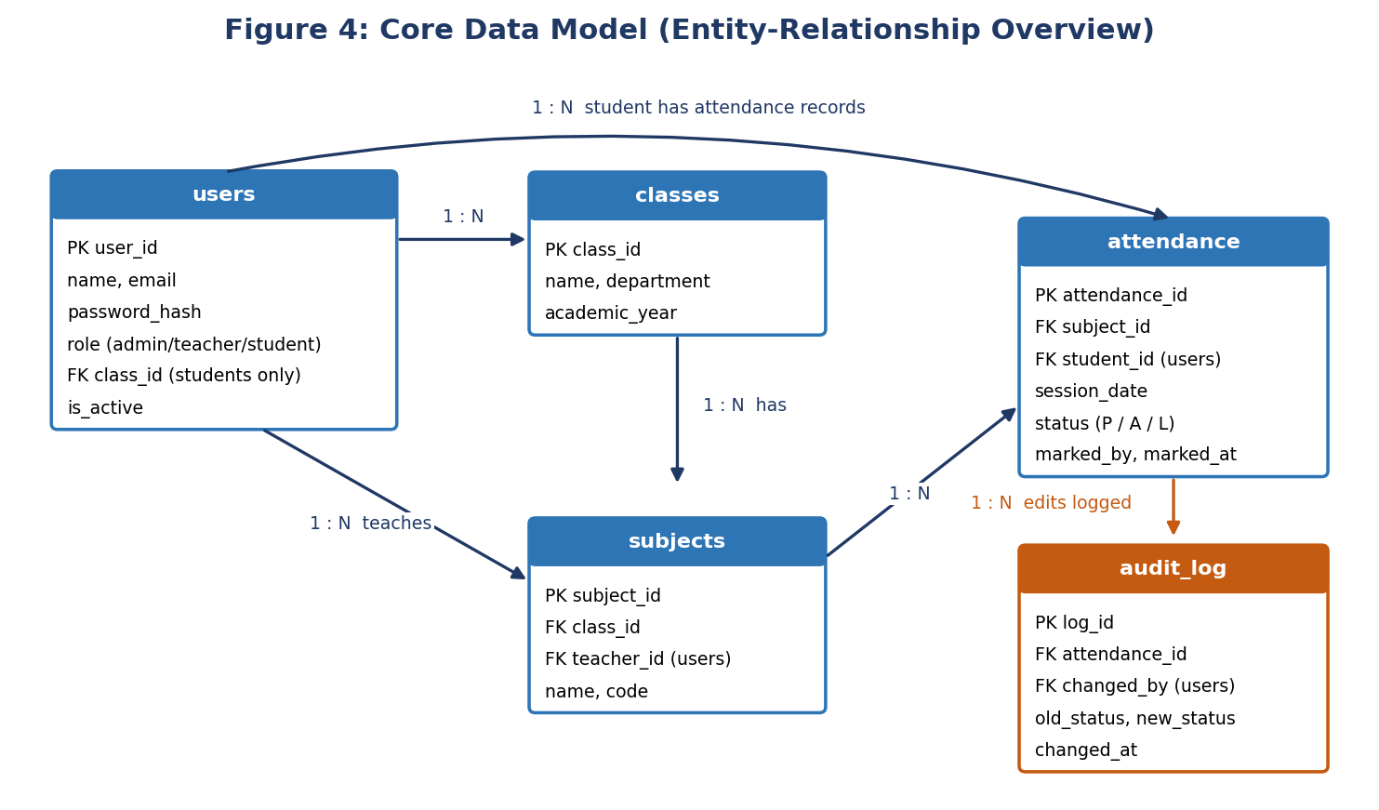

A unique constraint on (student_id, subject_id, session_date) prevents duplicate records at the database level, so even a faulty client cannot create two entries for the same session. Indexes on the same columns keep percentage calculations fast as the table grows.

4.2 Interface Mockup
Figure 5 presents wireframes of the two most important screens. The teacher screen is designed for speed (objective O2): the class, subject and date are chosen once, every student defaults to a clear one-tap choice, a Mark all present shortcut handles the common case, and a live summary confirms the totals before submission. The student screen (objective O3) shows the overall percentage against the 75% limit and highlights any subject that is in shortage so the student can act early.
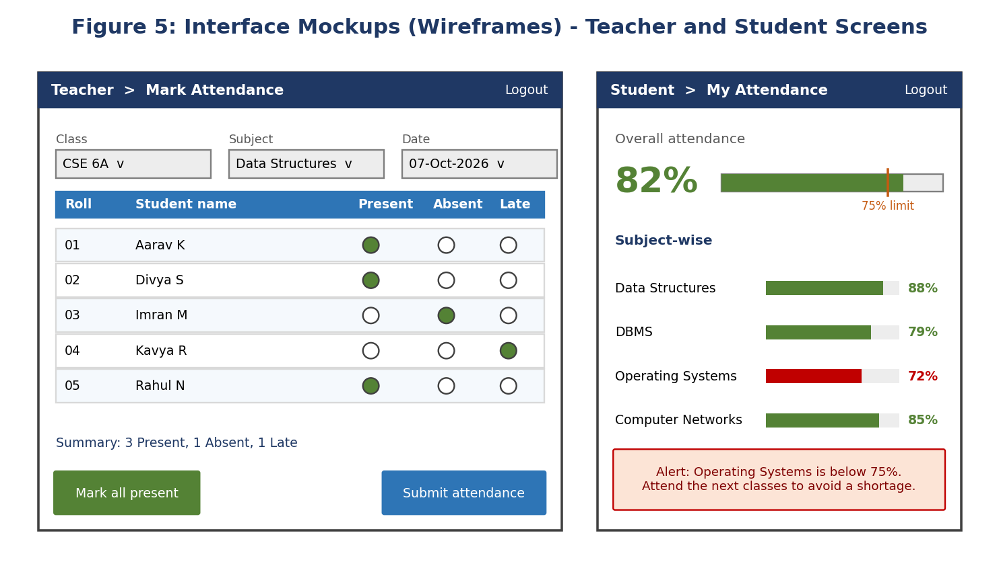

5. Data Flow and Integration

5.1 Data Flow: Marking Attendance
Figure 6 follows a single attendance submission from the teacher's browser to the point where an alert email is sent. The steps are numbered in the diagram and explained below.
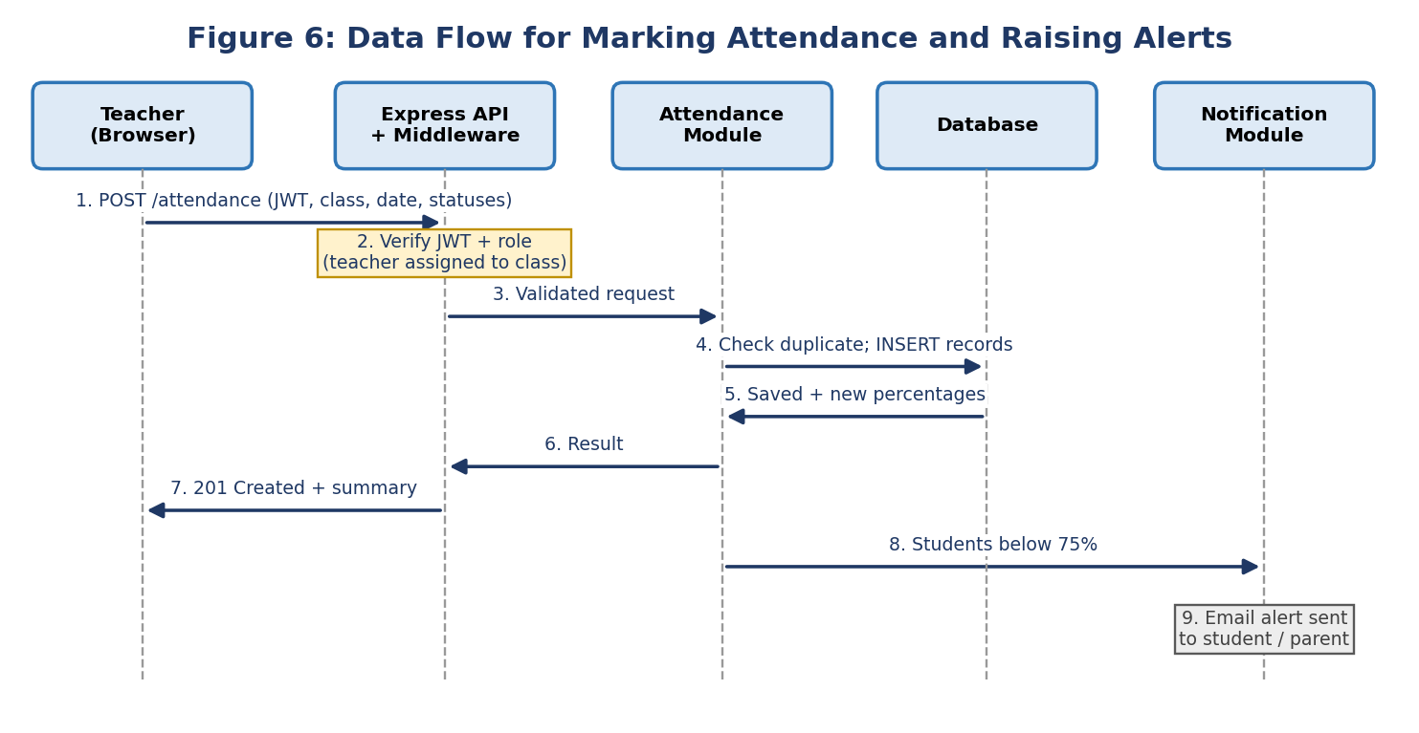

- The teacher submits the class sheet. The browser sends one POST request containing the JWT, class, subject, date and each student's status.
- The middleware verifies the token and checks the role. The Attendance module then confirms that this teacher is assigned to the selected class and subject.
- The validated request is handed to the Attendance module, which checks that every student belongs to the class and that the date is valid.
- Inside one database transaction the module checks for an existing session and inserts or updates the records.
- The database confirms the save and the module recalculates each student's subject-wise percentage.
- The result is returned to the API layer.
- The teacher receives a 201 Created response with a short summary (for example, 3 present, 1 absent, 1 late).
- The module passes the list of students now below 75% to the Notification module.
- The Notification module sends an email alert to each affected student and parent through the external SMTP service.

5.2 Communication Between Modules
Inside the monolith, modules communicate through direct function calls to each other's service interfaces, not by reaching into each other's database tables. This keeps the coupling low and the dependencies explicit. Between the browser and the server, all communication is stateless REST over HTTPS with JSON bodies. The token travels in the Authorization header, so the server holds no session state and can be scaled horizontally later.
Module | Depends on | Type | Why
M1 Auth | M2 User | Sync call | Reads the stored password hash and role at login
M2 User | M3 Class | Sync call | Links students to classes and teachers to subjects
M4 Attendance | M3 Class, Audit Logger | Sync call | Validates the teacher and class; logs every edit
M4 Attendance | M6 Notification | Async trigger | Alerts must never delay the teacher's response
M5 Reports | M4, M3 | Read-only | Aggregates attendance by date, class and subject
M6 Notification | Email service | Outbound SMTP | Delivers alerts; failures are retried and logged

5.3 Planned REST API Endpoints
The API is versioned under /api/v1 and every route except login requires a valid token. The table shows the main routes and who may call them.
Method | Endpoint | Purpose | Allowed roles
POST | /auth/login | Authenticate and receive a JWT | Public
GET, POST, PUT | /users, /users/:id | List, create, edit, deactivate users | Admin
GET, POST, PUT | /classes, /subjects | Manage classes and subjects, assign teachers | Admin
POST | /attendance | Submit a class attendance sheet | Teacher
PUT | /attendance/:id | Correct an entry within 24 hours (logged) | Teacher
GET | /attendance/student/:id | Subject-wise percentage and history | Student (own), Teacher, Admin
GET | /reports?type=&from=&to=&format= | Preview or export PDF / Excel report | Teacher, Admin
GET | /dashboard | Institution-wide trend figures | Admin

5.4 External Integrations
- Email (SMTP). The only external service in Version 1. The Notification module uses Nodemailer to connect to an SMTP provider such as the institution's mail server or a free-tier transactional service. Credentials are kept in environment variables, never in the code. If the mail server is unavailable the alert is queued, retried a limited number of times, and logged, so a mail outage never blocks attendance marking.
- Document generation. PDF and Excel files are produced inside the application by libraries, so no external service is needed and student data never leaves the institution's server.
- Future integrations (out of scope for V1). SMS or WhatsApp alerts and a learning management system link could be added later as new adapters behind the Notification and User modules, without changing the core attendance logic.

6. Scalability, Security and Maintainability

6.1 Scalability
- Stateless server. Because JWTs carry the identity, more Node.js instances can be started behind the reverse proxy to handle growth beyond 500 concurrent users.
- Efficient database access. Indexes on the columns used for lookups, pagination for long lists, and connection pooling keep response times within the 3-second target.
- Modular growth. New classes, departments and later campuses are added as data (a campus or department identifier on classes), not as code changes. Heavy modules such as Reports can be moved to a separate service or worker if needed.
- Caching option. Frequently read, rarely changed data such as class lists can be cached in memory (or Redis later) to reduce database load.

6.2 Security
Threat or need | Design response
Stolen or weak passwords | bcrypt hashing with a salt, minimum password rules, and rate limiting on login
Interception of data | HTTPS (TLS) everywhere, terminated at the reverse proxy; secure and HttpOnly handling of any cookies
Unauthorised access | Role-based access control on every route; students can only read their own records; teachers only their assigned classes
SQL injection | Parameterised queries or an ORM; no string-built SQL
Cross-site scripting and request abuse | Input validation and output escaping, Helmet security headers, and a restricted CORS policy
Silent tampering with records | Audit log of every attendance change with user and timestamp; teachers limited to a 24-hour correction window
Data loss | Automated daily database backups, with the restore process tested regularly
Privacy | Collect only needed data, restrict it to authorised users, and follow the principles of India's DPDP Act 2023

6.3 Maintainability
- Clear folder structure. The backend is organised by module (routes, controllers, services and data-access files per module) with shared middleware and configuration folders, so a developer can find any feature quickly.
- Separation of concerns. Controllers only handle HTTP, services hold business rules, and data-access code holds queries. A change to the database does not affect the routes.
- Testing. Unit tests (Jest) for business rules such as percentage calculation, API tests (Supertest and Postman collections) for each endpoint, and user acceptance testing in Weeks 6 and 7.
- Documentation and workflow. Commented code, an API reference, a README, and Git with feature branches and pull requests on GitHub. Configuration is kept in environment files so the same code runs in development and production.

7. Conclusion
This document turned the Week 1 requirements into a concrete architecture for SmartAttend. A three-tier, modular monolith was chosen because it is the simplest design that satisfies the project's constraints (a small team, free tools and an eight-week deadline) while still meeting the performance, security and scalability targets. Six focused modules divide the work cleanly, a relational database with an audit log protects the accuracy and traceability of attendance data, and a stateless REST API with JWT and role-based access keeps the system secure and easy to scale.
The diagrams, module descriptions, data flow and mockups give the team a common reference for the next phase. In Weeks 3 to 5 the backend can be built module by module following Figures 1 and 2 and the endpoint table, and in Weeks 4 to 6 the frontend can follow the wireframes in Figure 5. Any change to this design will go through the change-request process defined in the Week 1 risk plan so that scope stays under control.

8. References
- IEEE Std 1016-2009, IEEE Standard for Information Technology: Systems Design: Software Design Descriptions.
- ISO/IEC/IEEE 42010:2022, Software, systems and enterprise: Architecture description.
- Bass, L., Clements, P., & Kazman, R. (2021). Software Architecture in Practice (4th ed.). Addison-Wesley.
- Fielding, R. T. (2000). Architectural Styles and the Design of Network-based Software Architectures. Doctoral dissertation, University of California, Irvine.
- OWASP Foundation. OWASP Top 10 and Application Security Verification Standard (owasp.org).
- Express.js and Node.js official documentation (expressjs.com, nodejs.org).
- SmartAttend: Project Planning & Requirements Analysis, Version 1.0 (Week 1 deliverable).

