PROJECT PLANNING & REQUIREMENTS ANALYSISs
SmartAttend
A Web-Based Student Attendance Management System
Task | Week 1: Project Planning & Requirements Analysis
Prepared by | Pallavi R
Role | Junior Software Developer Intern
Organization | YuvaIntern
Date | October 2026
Version | 1.0

Table of Contents
1. Project Overview
2. Objectives
3. Requirements Analysis
4. Project Scope
5. Timeline and Milestones
6. Risk Analysis
7. Conclusion
8. References

1. Project Overview

1.1 Introduction and Problem Statement
Many colleges and training institutes still record attendance on paper registers or in scattered spreadsheets. This approach is slow, prone to human error, and makes it hard to see which students are at risk of falling short of the minimum attendance requirement until it is too late. Teachers lose class time on roll calls, and administrators spend hours consolidating data into monthly reports.
SmartAttend is a web-based system that lets teachers mark attendance in seconds, lets students track their own attendance in real time, and gives administrators accurate, ready-to-export reports. It replaces manual registers with a single, secure and easy-to-use digital platform.

1.2 Target Audience
User group | Description
Teachers | Faculty who take attendance for classes and need quick marking, corrections and reports.
Students | Learners who want to check their attendance percentage and receive early warnings.
Administrators | Office staff and heads of department who manage users, classes and institution-wide reporting.
Parents (indirect) | Receive alerts through email when a student’s attendance drops below the limit.

1.3 Business Use Cases
- Daily attendance capture: teachers mark each class session as present, absent or late.
- Eligibility monitoring: the institution checks who meets the minimum 75% attendance rule before examinations.
- Compliance reporting: departments produce monthly and semester-wise reports for audits and management reviews.
- Early intervention: automatic alerts help mentors reach students before shortages become serious.

1.4 Potential Benefits
- Saves teacher time by reducing attendance marking to under one minute per class.
- Improves data accuracy by removing manual entry and duplicate records.
- Gives students transparency and the chance to correct poor attendance early.
- Cuts report preparation time for administrators from hours to a few clicks.
- Provides a secure, auditable history of every attendance change.

1.5 Proposed Technology Stack
Layer | Proposed technology
Frontend | HTML5, CSS3, JavaScript (responsive design)
Backend | Node.js with Express (REST APIs)
Database | MySQL or PostgreSQL
Authentication | JSON Web Tokens (JWT) with bcrypt password hashing
Tools | Git and GitHub for version control, Postman for API testing

2. Objectives
The project aims to achieve the following measurable objectives:
ID | Objective
O1 | Replace paper-based attendance with a secure digital system covering all classes.
O2 | Allow a teacher to mark attendance for a full class in under one minute.
O3 | Give every student real-time, subject-wise access to their attendance percentage.
O4 | Generate daily, monthly and subject-wise reports and export them as PDF or Excel files.
O5 | Send automatic alerts when a student’s attendance falls below 75%.
O6 | Reduce administrative effort in report preparation by at least 80%.

3. Requirements Analysis

3.1 Requirements Elicitation Approach
Requirements are gathered from the three stakeholder groups (teachers, students and administrators) using the following techniques:
- Interviews: short conversations with teachers and office staff about their current workflow.
- Questionnaires: online forms to collect student expectations such as alerts and reports.
- Observation: studying how attendance registers are filled and consolidated today.
- Document analysis: reviewing existing registers, report formats and attendance policies.
Requirements are written following the structure of IEEE 830 / ISO/IEC/IEEE 29148 (Software Requirements Specification), captured as Agile user stories, and prioritized using the MoSCoW method (Must, Should, Could, Won’t).

3.2 Functional Requirements
ID | Feature | Description | Priority
FR1 | Authentication | Role-based login for admins, teachers and students. | Must
FR2 | User management | Admin can add, edit and deactivate student and teacher accounts. | Must
FR3 | Class management | Admin creates classes and subjects and assigns teachers. | Must
FR4 | Mark attendance | Teacher marks each student present, absent or late for a session. | Must
FR5 | Edit attendance | Teacher corrects entries within 24 hours; every change is logged. | Should
FR6 | View attendance | Student views subject-wise percentage and date-wise history. | Must
FR7 | Reports | Generate daily, monthly and subject-wise reports; export to PDF and Excel. | Must
FR8 | Alerts | Email alert when attendance drops below 75%. | Should
FR9 | Leave requests | Student submits a leave request that a teacher approves or rejects. | Could
FR10 | Admin dashboard | Charts showing attendance trends across classes. | Could

3.3 Non-Functional Requirements
Category | Requirement
Performance | Pages load within 3 seconds; the system supports at least 500 concurrent users.
Security | Passwords stored as bcrypt hashes; HTTPS everywhere; access controlled by role.
Usability | Mobile-responsive interface that a new user can learn with minimal training.
Reliability | 99% availability during working hours; automatic daily database backups.
Scalability | Modular design so more classes, departments or campuses can be added later.
Compatibility | Works on current versions of Chrome, Firefox, Edge and mobile browsers.
Maintainability | Clean, commented and documented code with a clear folder structure.
Data privacy | Student data is accessible only to authorized users, following the principles of India’s DPDP Act 2023.

3.4 User Stories
Each story follows the format: As a [user], I want [feature], so that [benefit].
ID | As a | I want to | So that
US1 | Teacher | mark attendance for my whole class in under a minute | I save lecture time.
US2 | Student | see my attendance percentage for every subject | I know whether I am at risk of shortage.
US3 | Admin | add or deactivate user accounts | the records always stay accurate.
US4 | Teacher | download a monthly attendance report | I can submit it to the department head.
US5 | Student | receive an alert when my attendance is below 75% | I can improve before exams.
US6 | Admin | view an institution-wide dashboard | I can monitor attendance trends.
US7 | Student | submit a leave request online | my absence is recorded as approved.

3.5 Use Cases
Figure 1 shows how each user group interacts with the system.
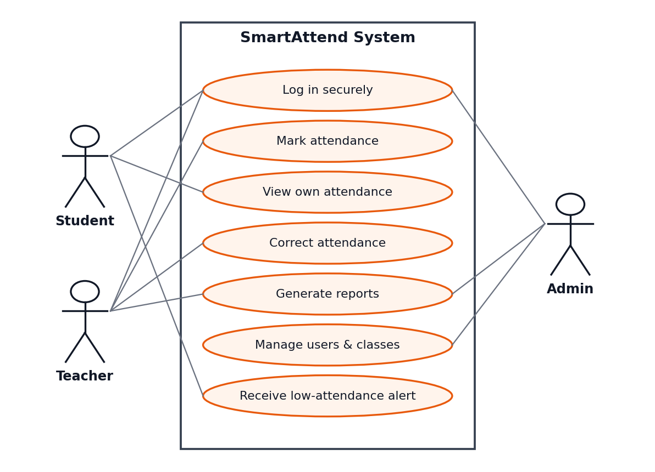
Figure 1: Use case diagram
Use case | UC1: Mark Attendance
Actor | Teacher
Precondition | Teacher is logged in and assigned to the selected class and subject.
Main flow | 1. Teacher selects class, subject and date.  2. System displays the student list.  3. Teacher marks each student present, absent or late.  4. Teacher submits.  5. System saves the record and updates attendance percentages.
Alternative flow | If a record already exists for that session, the system opens it in edit mode.
Postcondition | Attendance is stored; students below 75% are flagged for alerts.

Use case | UC2: View Attendance
Actor | Student
Precondition | Student is logged in.
Main flow | 1. Student opens the My Attendance page.  2. System shows subject-wise percentages.  3. Student selects a subject to see date-wise history.
Postcondition | Student can see their current standing against the 75% requirement.

Use case | UC3: Generate Report
Actor | Teacher or Admin
Precondition | User is logged in and has permission for the selected class.
Main flow | 1. User chooses report type and date range.  2. System compiles the data.  3. User previews the report and exports it as PDF or Excel.
Postcondition | A downloadable report is produced.

3.6 Assumptions and Constraints
Assumptions
- The institution provides initial student, teacher and timetable data.
- All users have an internet-enabled device and a stable connection.
- The institution follows a uniform 75% minimum attendance policy.
- Stakeholders are available for feedback during requirement reviews.
Constraints
- The first version must be delivered within eight weeks.
- The project is built by a small team using free and open-source tools.
- No special hardware (such as biometric devices) is available.

4. Project Scope
Defining scope clearly prevents confusion and uncontrolled growth later. The first release (Version 1.0) includes and excludes the following:
In scope | Out of scope
Role-based login for admin, teacher and student | Biometric or face-recognition attendance
User, class and subject management | Native Android or iOS mobile apps
Marking and correcting attendance with an audit trail | Fee, payroll, examination or grading modules
Student attendance view with subject-wise percentages | Integration with a learning management system
Daily, monthly and subject-wise reports (PDF and Excel) | SMS or WhatsApp notifications (email only in V1)
Email alerts for low attendance | Multi-campus or multi-institution support
Admin dashboard and responsive web interface | Offline attendance marking

5. Timeline and Milestones
The project is planned as an eight-week schedule. Figure 2 gives a visual overview and the table lists the activities and deliverables for each phase.
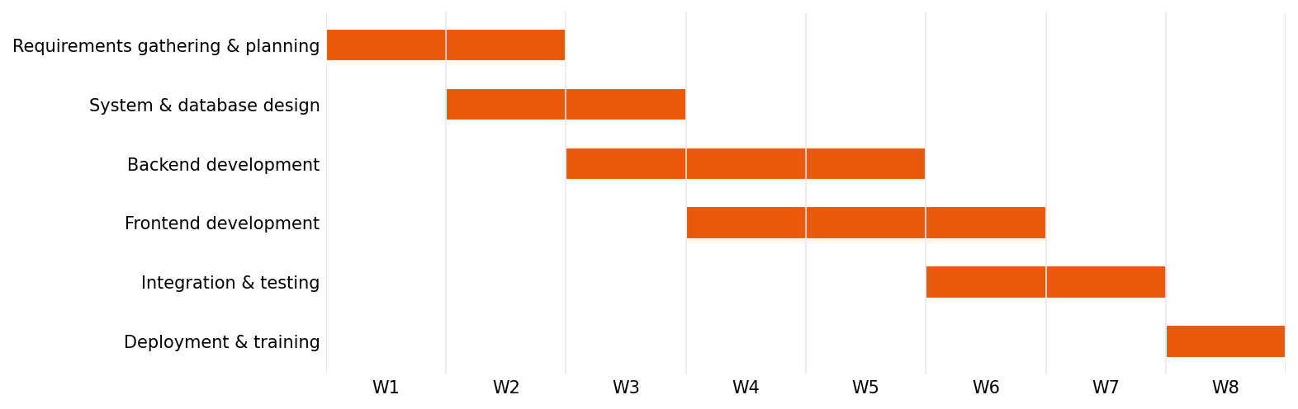
Figure 2: Eight-week project schedule
Phase | Weeks | Key activities | Deliverable
Requirements and planning | 1 to 2 | Stakeholder interviews, requirement documentation, scope sign-off | Approved requirements document
System and database design | 2 to 3 | ER diagram, database schema, wireframes, API design | Design document and wireframes
Backend development | 3 to 5 | Authentication, user and class APIs, attendance logic, reports | Working REST APIs
Frontend development | 4 to 6 | Login, teacher, student and admin screens | Responsive user interface
Integration and testing | 6 to 7 | Connect frontend and backend, unit, integration and user acceptance tests | Test report and bug fixes
Deployment and training | 8 | Deploy to server, prepare user guide, train users | Live system and user manual

Key Milestones
No. | Milestone | Target | Status
M1 | Requirements and scope approved | End of Week 2 | Planned
M2 | Design and wireframes approved | End of Week 3 | Planned
M3 | Backend APIs completed | End of Week 5 | Planned
M4 | Frontend completed and integrated | End of Week 6 | Planned
M5 | Testing completed, bugs resolved | End of Week 7 | Planned
M6 | Go-live and handover | End of Week 8 | Planned

6. Risk Analysis
The table below lists the main risks, their expected impact and likelihood, and the planned mitigation.
No. | Risk | Impact | Likelihood | Mitigation strategy
R1 | Scope creep | High | Medium | Freeze scope after Milestone 1 and handle new ideas through a change-request process.
R2 | Unclear or changing requirements | High | Medium | Hold regular stakeholder reviews and share early prototypes for feedback.
R3 | Schedule delays | High | Medium | Prioritize with MoSCoW, keep buffer time, and track progress weekly.
R4 | Data security or privacy breach | High | Low | Use encryption, role-based access, input validation and security testing.
R5 | Low user adoption | Medium | Medium | Keep the interface simple, run short training sessions and provide a user guide.
R6 | Data loss | High | Low | Schedule automatic daily backups and test the restore process.
R7 | Technical skill gaps | Medium | Medium | Use a familiar technology stack, build small prototypes and use documentation and mentors.

7. Conclusion
This document set out the planning and requirements analysis for SmartAttend. It defined the problem, target users, objectives, functional and non-functional requirements, user stories, use cases, scope, timeline and risks. Completing this analysis before any coding begins ensures that the development team and stakeholders share the same understanding of what will be built, reduces costly rework, and provides a clear foundation for the design and development phases that follow.

8. References
- IEEE Std 830-1998, IEEE Recommended Practice for Software Requirements Specifications.
- ISO/IEC/IEEE 29148:2018, Systems and software engineering: Life cycle processes: Requirements engineering.
- Cohn, M. (2004). User Stories Applied: For Agile Software Development. Addison-Wesley.
- Agile Alliance, User Stories and MoSCoW prioritization guidance (agilealliance.org).

