Fig : Client Management System

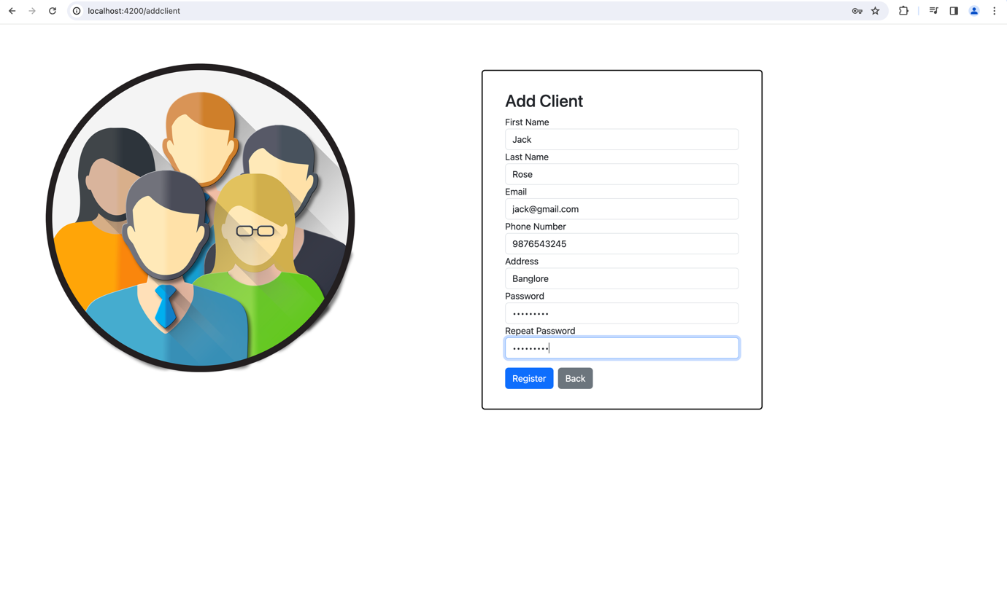

Fig :Add Client Form

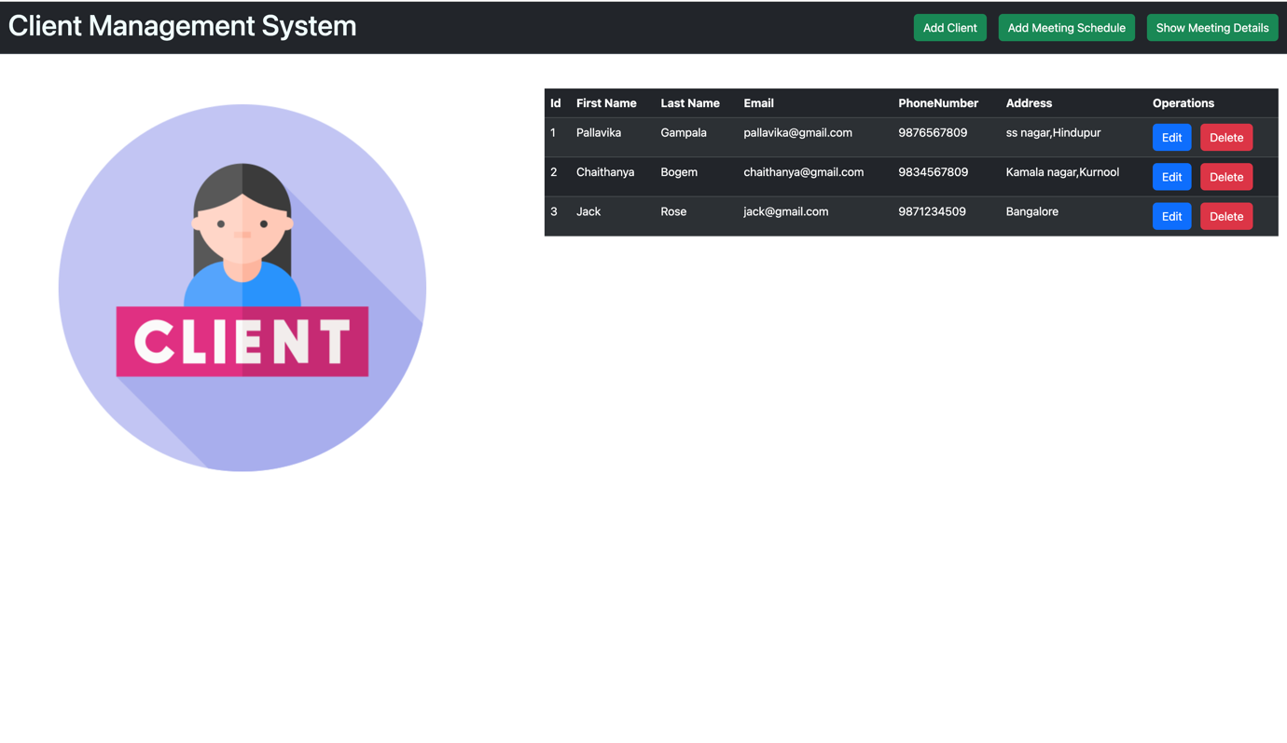

Fig: Client Details table

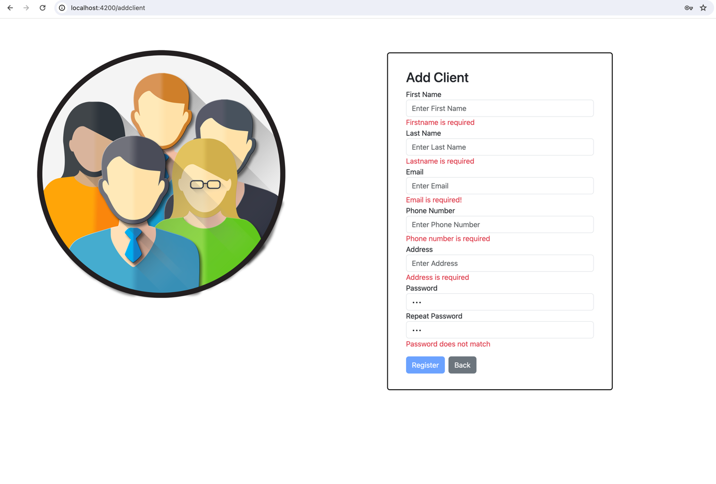

Fig : If the client submits the Empty form then it shows the required fields

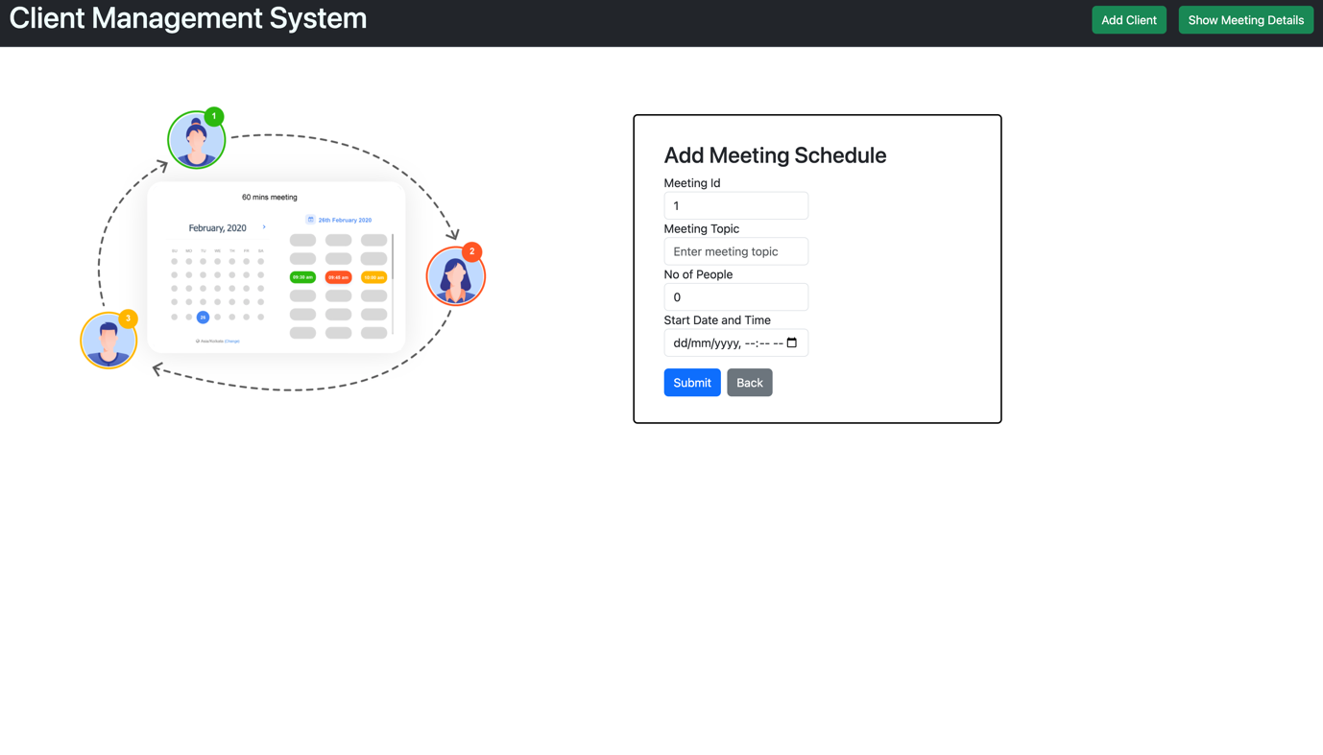

Fig: Add Meeting Schedule form

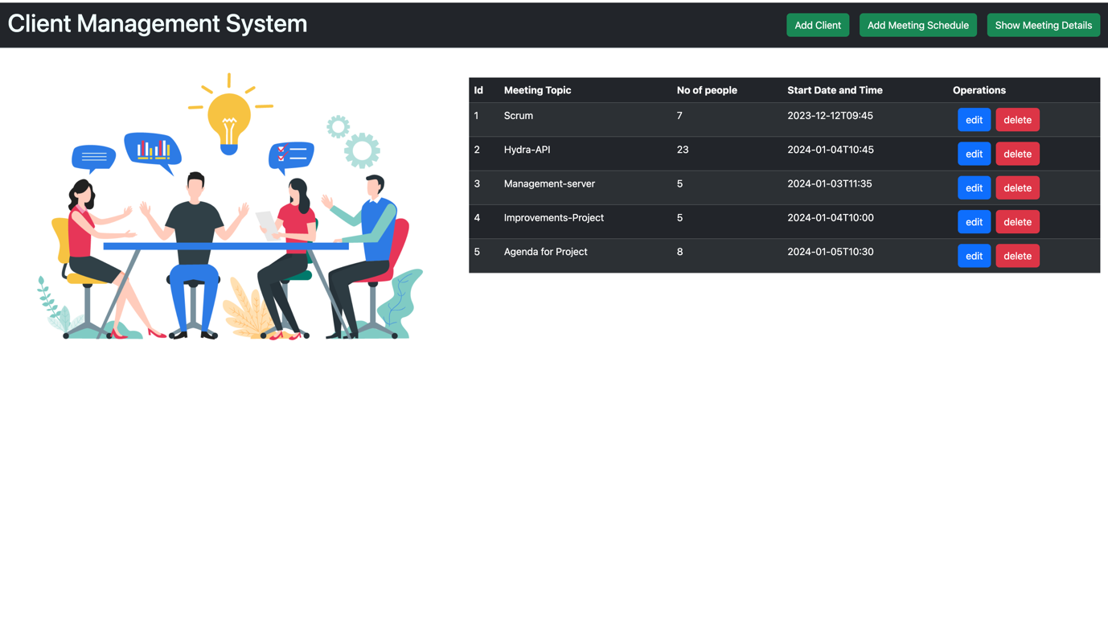

Fig : Meeting Scheduler Details table

Fig : Json format for the client-meeting

Fig : Editing the meeting schedule form

Fig : After Editing the Details it shows the success message as “Meeting details updated”

Fig : After deleting the details it shows the success message as “Meeting details deleted”

**CREATING THE PROJECT IN JIRA**

1. **Creating the epics for client and client meetings**

Fig : Epic for Client Creation

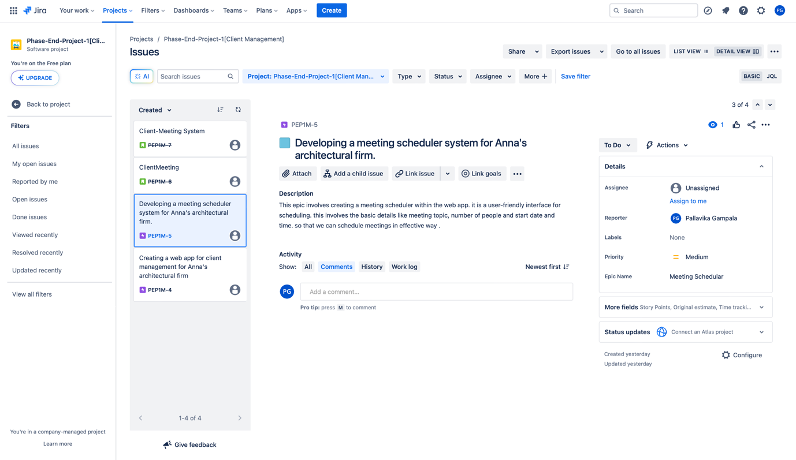

Fig : Epic for Client Meeting scheduler

**2.creating the user stories for the epics**

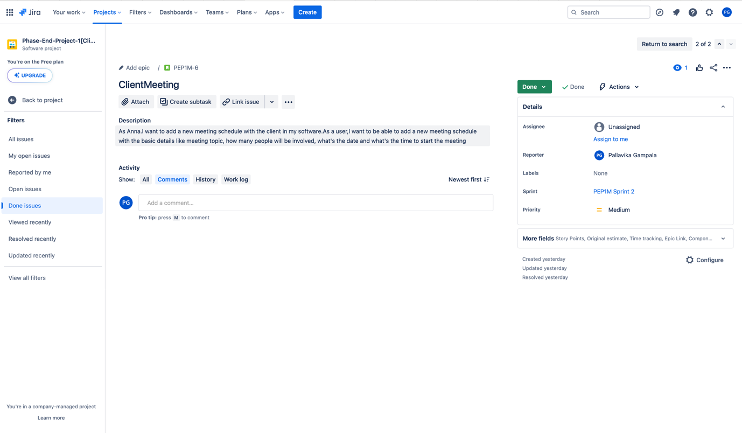

**3.starting and completing the sprint**

Fig: PEPM-7 IS DONE [sprint]

**ER-Diagram for Client ,Meeting and Project.**

Fig :ER Diagram

**SQL- Query for client ,meeting and Project**

CREATE TABLE Client

(

Client_Id INT NOT NULL,

Name VARCHAR(200) NOT NULL,

Phone_No INT NOT NULL,

Email_Id VARCHAR(200) NOT NULL,

Password VARCHAR(200) NOT NULL,

Address_ VARCHAR(200) NOT NULL,

PRIMARY KEY (Client_Id)

);

CREATE TABLE Meeting

(

Client_Id INT NOT NULL,

Topic VARCHAR(200) NOT NULL,

No_of_poeple INT NOT NULL,

Start_time DATE NOT NULL,

Meeting_id INT NOT NULL,

PRIMARY KEY (Client_Id),

FOREIGN KEY (Client_Id) REFERENCES Client(Client_Id),

UNIQUE (Meeting_id)

);

CREATE TABLE Project

(

Client_Id INT NOT NULL,

Project_details VARCHAR(200) NOT NULL,

FOREIGN KEY (Client_Id) REFERENCES Client(Client_Id)

);

**Gherkin for client and meeting system**

Feature : Client Registration

Scenario: Register a Client

Given the user is on the registration page ,

When the user fill in the registration form with valid details :

First Name | Pallavika

Last Name | Gampala

Email-id | pallavika@gmail.com

Address | Hindupur,ss nagar

Password | password123 [min length:8]

Repeat-password | password123

And the user clicks the "Register" button

Then a new client account should be created

And the user should see a success message.

-------------------------------------------------------------------------

Scenario :Edit Client Information

Given the user is on the client details page

And there exists a client with the following details:

First Name | Pallavika

Last Name | Gampala

Email-id | pallavika@gmail.com

Address | Hindupur,ss nagar

When they click on the 'edit' button

Then the form is displayed and they can change their details

And the user clicks "submit" button

Then the changes are made

And it will display a successful message

-------------------------------------------------------------------------

Scenario:Delete client information

Given the user in on the client details page

And there exists a client with the following details:

First Name | Pallavika

Last Name | Gampala

Email-id | pallavika@gmail.com

Address | Hindupur,ss nagar

When the user click on the "delete" button

Then the user details are deleted

And it will display a successful message

-------------------------------------------------------------------------

Feature : Creating Meeting-scheduler

Scenario: submit the meeting details

Given the user is on the meeting scheduler page ,

When the user fill in the meeting-scheduler form with valid details :

Meeting ID. | 1

Meeting Topic. | Agile

NoOfPeople. | 5

Start time. | 2023-12-22T08:30

And the user clicks the "Submit" button

Then a new meeting-scheduler should be created

And the user should see a success message.

--------------------------------------------------------------------------

Scenario: Edit the meeting details

Given the user is on the meeting scheduler details page ,

And there exists a meeting details with the following details:

Meeting ID. | 1

Meeting Topic. | Agile

NoOfPeople. | 5

Start time. | 2023-12-22T08:30

And the user clicks the "Edit" button

Then a new meeting-scheduler should be created

And the user should see a success message as "meeting details updated"

------------------------------------------------------------------------

Scenario: Delete meeting details

Given the user is on the meeting scheduler page ,

And there exists a meeting details with the following details:

Meeting ID. | 1

Meeting Topic. | Agile

NoOfPeople. | 5

Start time. | 2023-12-22T08:30

And the user clicks the "Delete" button

Then a new meeting-scheduler details are deleted

And the user should see a success message as "meeting details deleted"