The UI of the application where the values of trainingname,startdate,end date are entered and updated.

Also the difference between the dates is also being displayed.

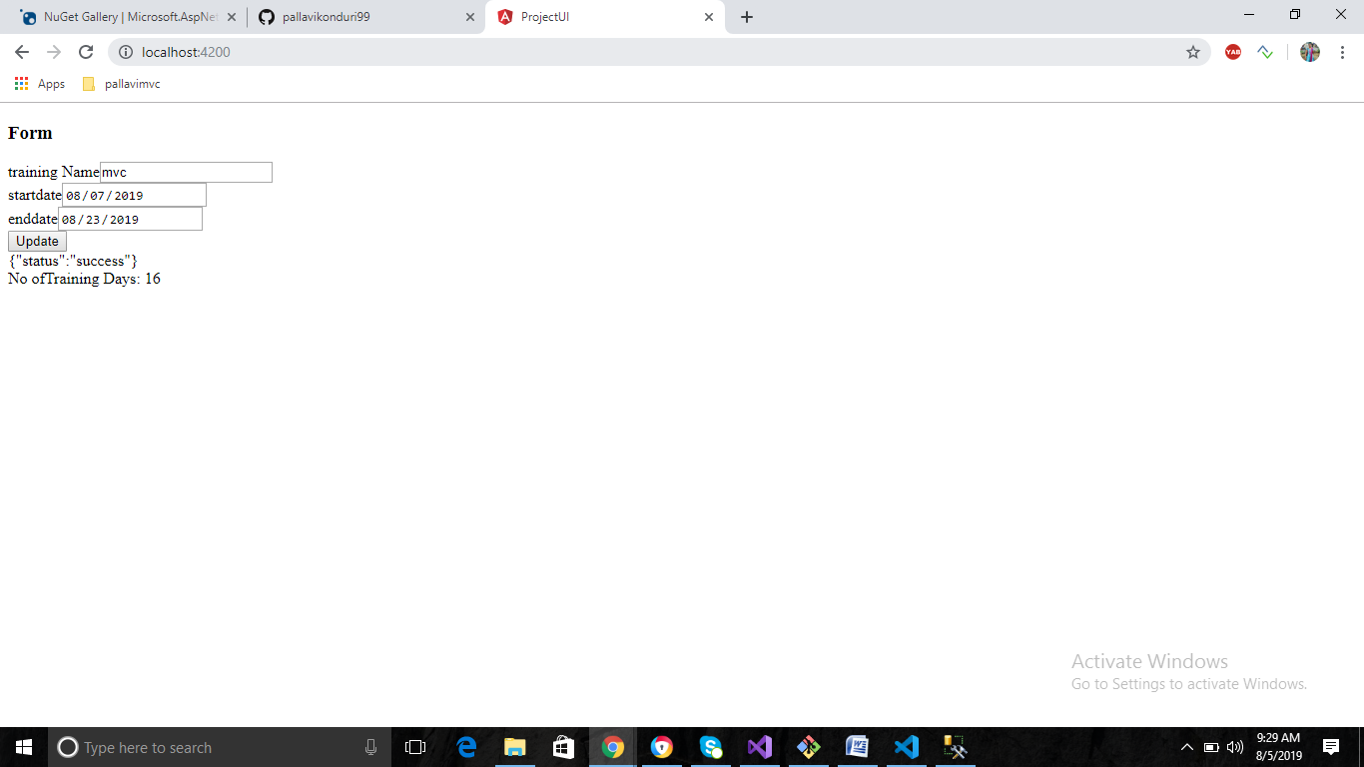

The values of training name,start date,end date are successfully saved to database

Please find the screenshot below

