Mathematics worksheet - Polynomials.
Class :X Date :5/5/2020

- The graphs of y=p(x) are given to us, for some polynomials p(x). Find the number of zeroes of p(x), in each case.

Eg: (i)
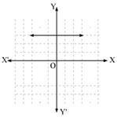

Ans. The given graph does not intersects x-axis at all. Hence, it does not have any zero.

(ii) (iii)
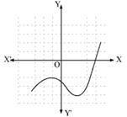
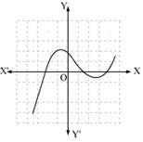

(iv) (v)
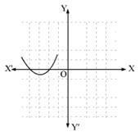
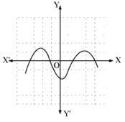

- Find the zeroes of the following quadratic polynomials and verify the relationship between the zeros and the coefficients.

Eg: (I)

Ans. Comparing given polynomial with general form of quadratic

polynomial ,

We get a = 1, b = -2 and c = -8

We have, Equating this equal to 0 will find values of 2 zeroes of this polynomial.

X²-2x-8 =0

X²-4x+2x-8=0

x(x−4)+2(x−4) =0

(x−4)(x+2) = 0

- x = 4, −2 are two zeroes. Sum of zeroes = 4 + (– 2) = 2

- 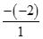= 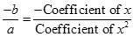 Product of zeroes = 4 × (−2) = −8

= 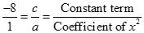

(ii) (iii)

- Find a quadratic polynomial each with the given numbers as the sum and product of its zeroes respectively.

(i) , −1

Let quadratic polynomial be

Let α and β are two zeroes of above quadratic polynomial.

α+β = =

- × β = -1 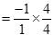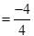 = On comparing, we get


Putting the values of a, b and c in quadratic polynomial , we get

(ii) , 13 (iii) 1, 1

- Divide the polynomial p(x) by the polynomial g(x) and find the quotient and remainder in each of the following.

(i),

(ii),

5. Check whether the first polynomial is a factor of the second polynomial by dividing the second polynomial by the first polynomial: t² -3, 2t⁴+3t³-2t²-9t-12
- Find the zeroes of the polynomial x²-3x-m(m+3).

- A teacher asked 10 of his studentsto write a polynomial in one variable on a paper and thento handover the paper.The following were the answers given by the students:

2x+3, 3x²+7x+2, 4x³+3x²+2, x³+ 3x+7, 7x+ 7 , 5x³-7x+2, 2x²+3- ⁵ , x

Answer the following questions:

- How many of the above ten , are not polynomials?
- How many of the above ten , are quadratic polynomials?

8. If a polynomial 3x⁴-4x³-16x²+15x+14 is divided by another polynomial x²-4, the remainder comes out to be px+q.Find the value of p and q.
9. Find all the zeroes of the polynomial 8x⁴+8x³-18x²-20x-5,if it is
given that two of its zeroes are |  |  |  | and | − |  |  |  | .
 |  | 5 |  |  |  |  | 5
 |  | 2 |  |  |  |  | 2


- On dividing 3x³+4x²+5x-13 by a polynomial g(x) the quotient and remainder were 3x+10 and 16x-43 respectively.Find the polynomial g(x).

