Professional Penetration Testing & Vulnerability Assessment Report
CONFIDENTIAL — AUTHORISED PERSONNEL ONLY
Field | Value
Client Name | Mediroza General Hospital (training/lab target)
Target Domain | medirozahospital.com
Engagement Type | Full Black-box Penetration Test & Vulnerability Assessment
Project Batch | Batch B083 / Week 4
Status | Full & Final Report
Overall Risk Rating | CRITICAL

1. Executive Summary
A comprehensive black-box penetration test was executed against the web infrastructure of Mediroza General Hospital. The objective was to evaluate the external defensive posture of the perimeter, identify system vulnerabilities, and safely assess real-world business risk in an authorized, controlled environment.
The assessment uncovered critical structural and configuration flaws across the application layer and asset infrastructure:
- Critical Authentication Bypass (SQLi): An input validation flaw on the Patient Portal enabled an attacker to bypass authentication and acquire administrative access.
- Sensitive Database Exposure (Information Disclosure): An unindexed legacy deployment backup directory (/old/) left a full production database schema publicly accessible.
- Weak Encryption Configurations: Patient document backups used outdated encryption settings, fully compromised via offline dictionary attack.
Immediate implementation of the remediations in Section 6 is strongly advised to protect corporate assets and Patient Health Information (PHI).

2. Scope and Methodology
Engagement Scope
- Target Host: medirozahospital.com
- Operational Restrictions: Testing was strictly limited to the target domain. Denial-of-Service simulations and social engineering (phishing) were explicitly prohibited.
- Authorization: Written authorization for this engagement was granted by Networkwalks Academy as part of a supervised training program.
Toolset Deployed
- Perimeter Reconnaissance: whois, whatweb, nslookup, curl -I, wafw00f, dnsrecon
- Network Infrastructure Scanning: nmap / Zenmap
- Directory Enumeration: gobuster (v3.8.2)
- Cryptographic Signature Parsing: Networkwalks Academy Hash Calculator
- Offline Dictionary Attack: Networkwalks Academy Password Cracker
- Data Transformation & Structural Parsing: qpdf, exiftool (v13.55)

3. Findings & Proof of Exploitation
Phase 1 — Perimeter Reconnaissance and Network Mapping
- Domain Tracking (whois): Registrant verified, creation date 2026-08-14. 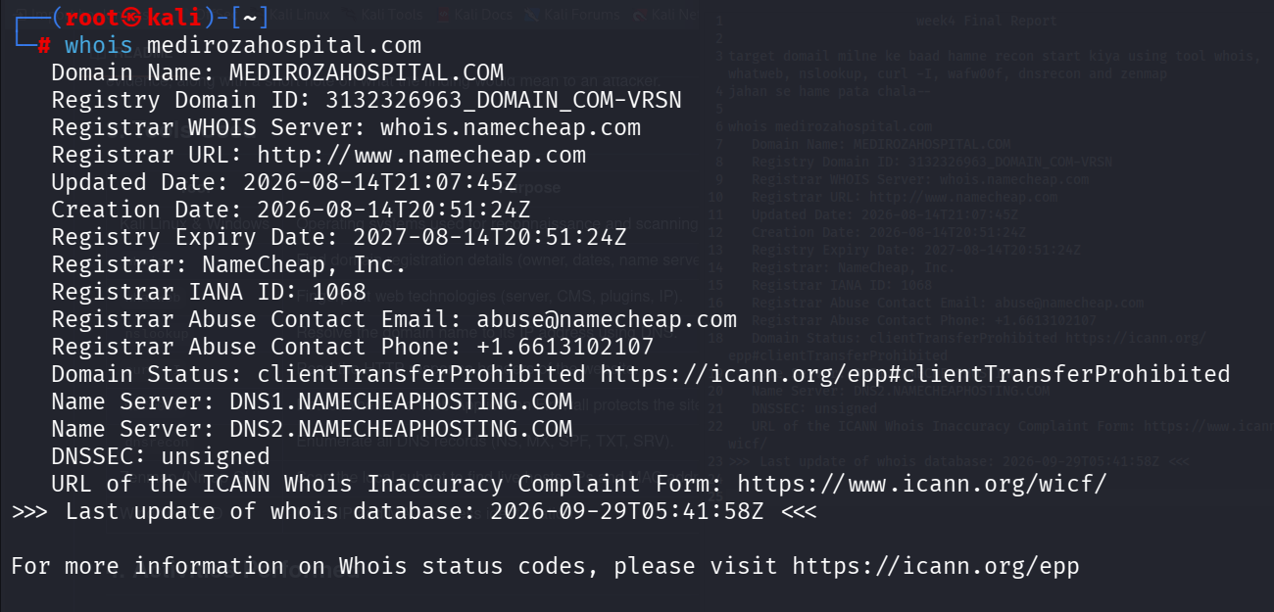
- DNS Mapping (nslookup): Host resolved to 199.188.xxx.xx.
- WAF Fingerprinting (wafw00f): Identified an active LiteSpeed-based WAF. 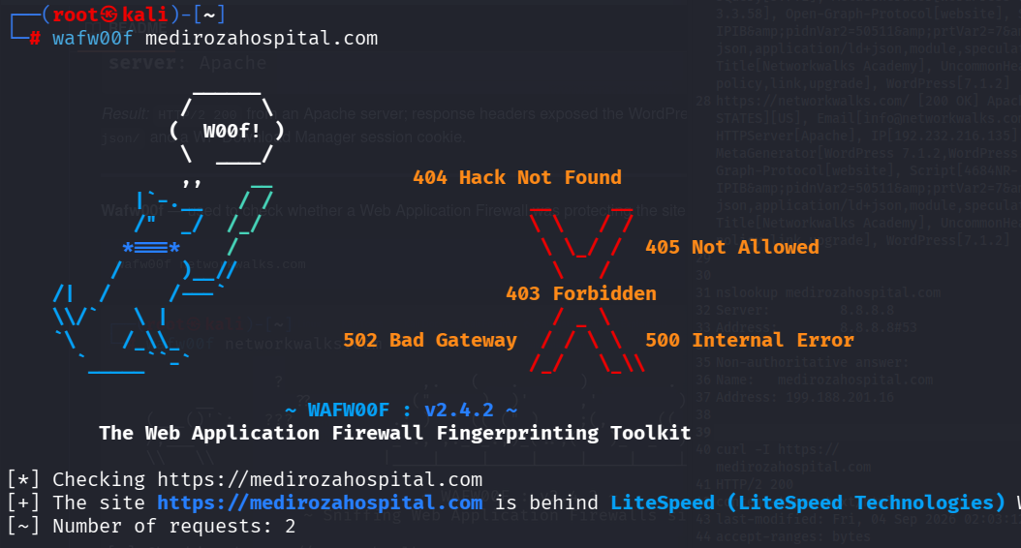
- HTTP Header Inspection (curl -I): Confirmed LiteSpeed application engines at the edge.
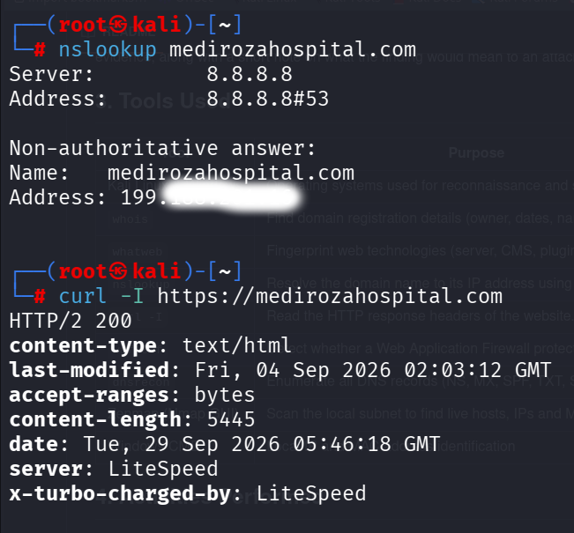
Nmap service enumeration results:
Port(s) | Service
21/tcp | Pure-FTPd
26/587/465/tcp | Exim smtpd 4.100.1
80/tcp, 443/tcp | HAProxy HTTP proxy
110/143/993/995/tcp | Dovecot pop3d/imapd
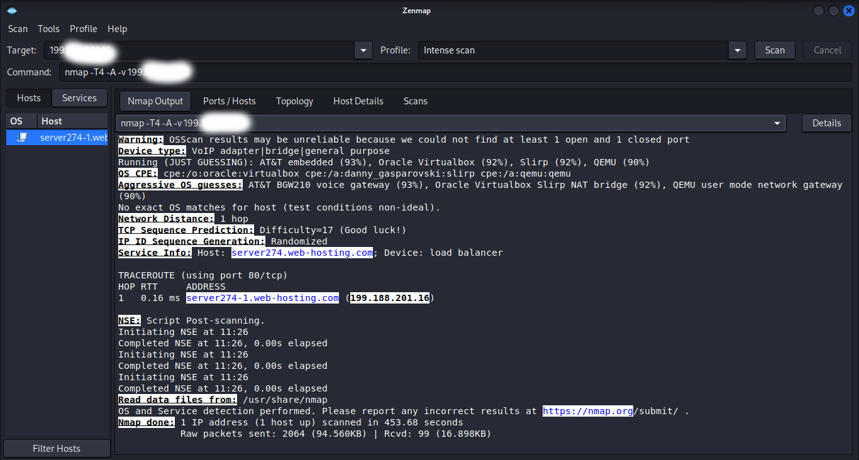
Phase 2 — Web Directory Bruteforcing
gobuster dir -u https://medirozahospital.com \
-w /usr/share/wordlists/seclists/Discovery/Web-Content/DirBuster-2007_directory-list-2.3-big.txt \
-s "301,302,307,401,403" -b ""
Discovered paths:
/cgi-bin (301)
/staff (301)
/mailman (301)
/pipermail (301)
/old (301) <-- Highly Vulnerable Endpoint
/webmail (403)
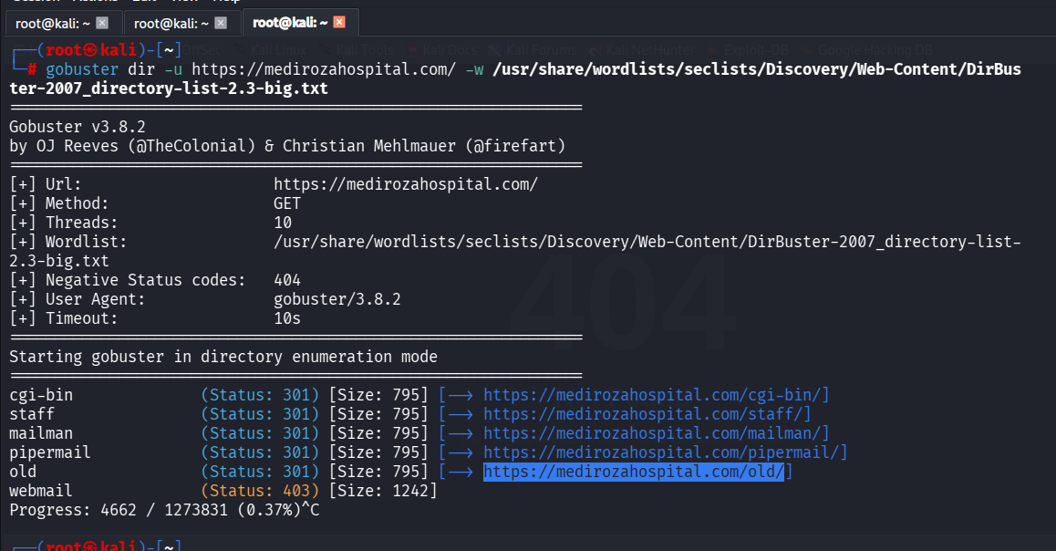
Inspection of the unindexed /old/ directory revealed a publicly exposed plaintext database archive, mediroza_db_backup_2019.sql, containing staff payroll tables and corporate shareholder data.
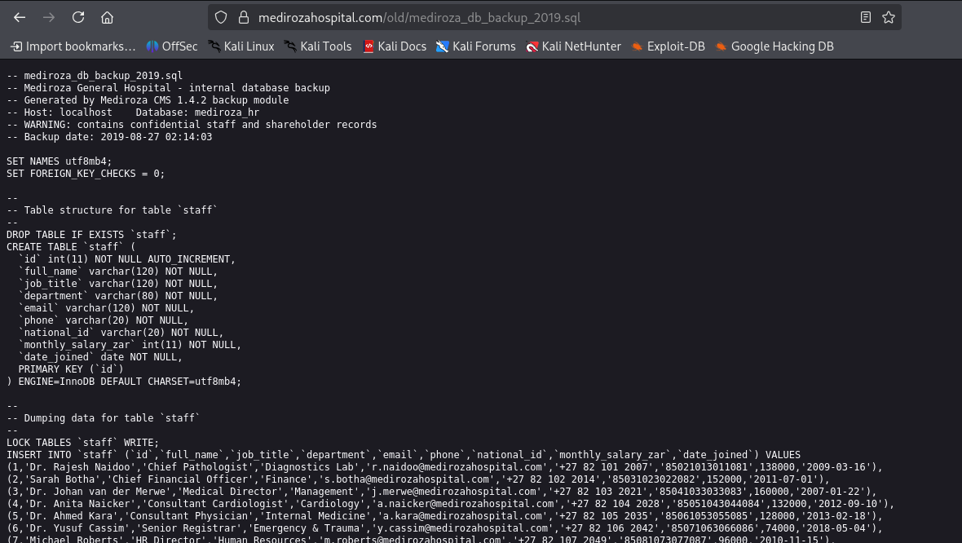
Phase 3 — Application Logic Subversion (Patient Portal SQL Injection)
- /staff/login.php: Returned uniform "Invalid username or password" errors — properly mitigated against enumeration and SQLi.
- /patient/login.php: Vulnerable to username enumeration — an unknown username returned Username not found, while a valid username (admin) returned Incorrect password.
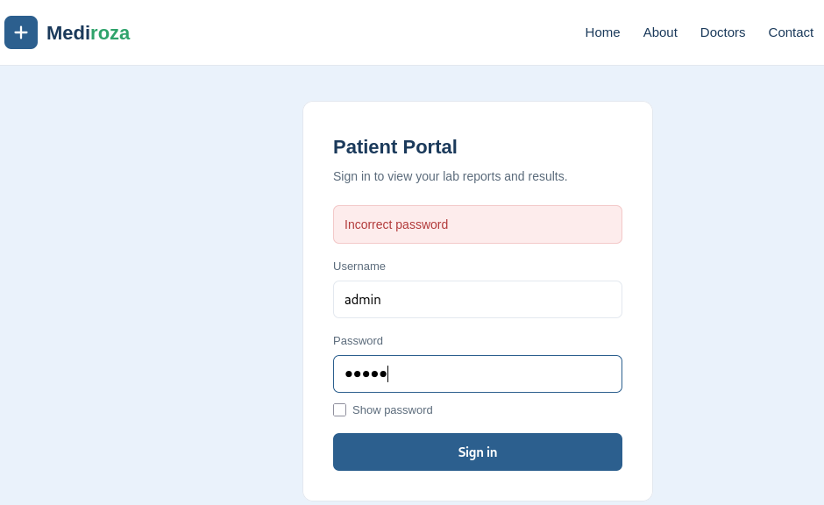
A test payload (admin' OR '1'='1) triggered a verbose SQL error, confirming the query was unsanitized:
Warning: mysqli_query(): You have an error in your SQL syntax; check the
manual that corresponds to your MySQL server version for the right syntax
to use near '' OR '1'='1' at line 1
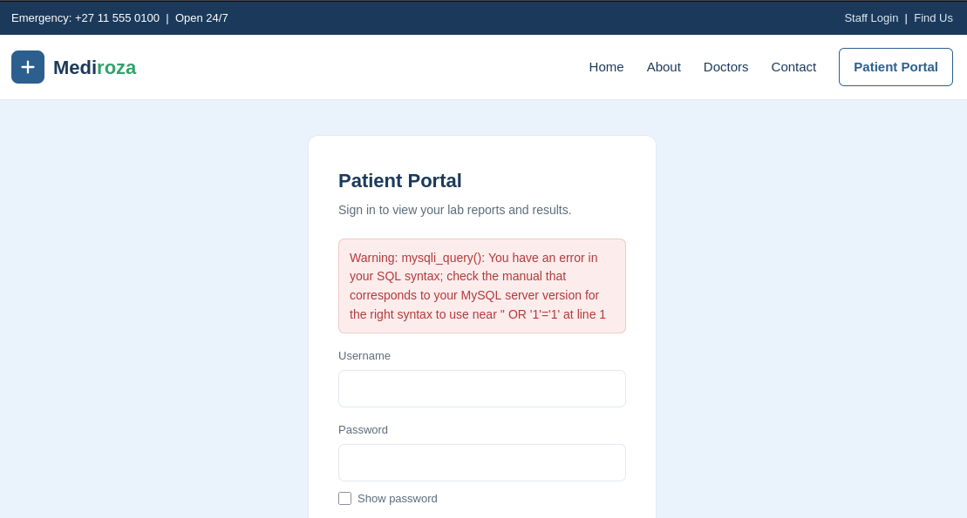
Exploitation — inline SQL comment authentication bypass:
- Username: admin' -- -
- Password: (blank)
Resulting backend query:
SELECT * FROM patients WHERE username = 'admin' -- -' AND password = '';
The -- - sequence commented out the password check entirely, authorizing an admin session with no password. This granted access to a restricted patient workspace and allowed exfiltration of 3 password-protected patient PDF lab reports. 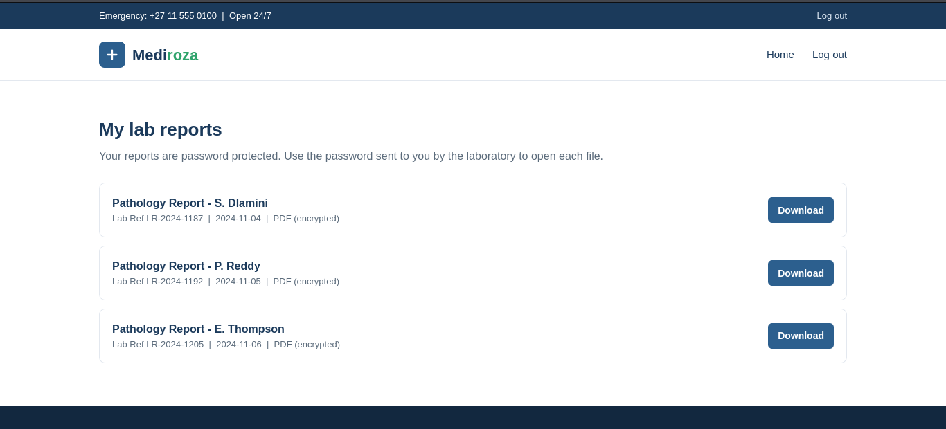
Phase 4 — Cryptographic Key Recovery & Password Cracking
- Hash extraction: The PDFs' encryption metadata confirmed a weak PDF 1.4 Standard V2.3 (128-bit key) configuration.
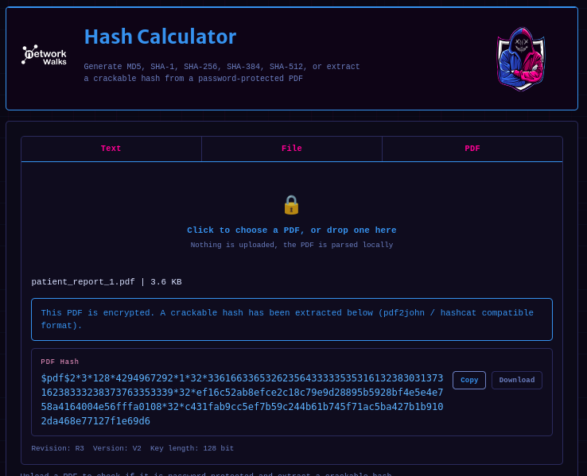
- Dictionary attack:
  - Reports 1 & 2: Cracked almost instantly against a built-in wordlist — weak, default credentials.
  - Report 3: Resisted the default wordlist; required the rockyou.txt dictionary and ~1.5 hours of processing before the password was recovered.
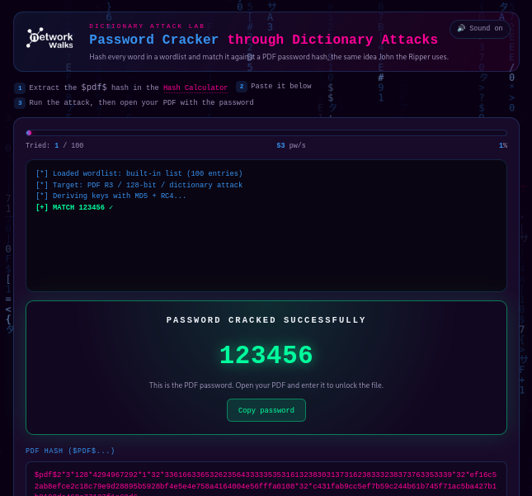
Phase 5 — Document Metadata Mapping & Verification
Recovered passwords were used to decrypt the PDFs, followed by metadata inspection:
qpdf --password=<recovered_password> --decrypt unlocked_report.pdf unlocked_report_decrypted.pdf
exiftool unlocked_report_decrypted.pdf
One decrypted report contained an administrative comment left by an internal IT staff member:
"DB backup moved to /old before site migration, do not delete"
This definitively linked the exposed /old/ database backup to the same infrastructure being actively used by the application — confirming the leaked SQL file was a live representation of the hospital's internal database, not a stale artifact. 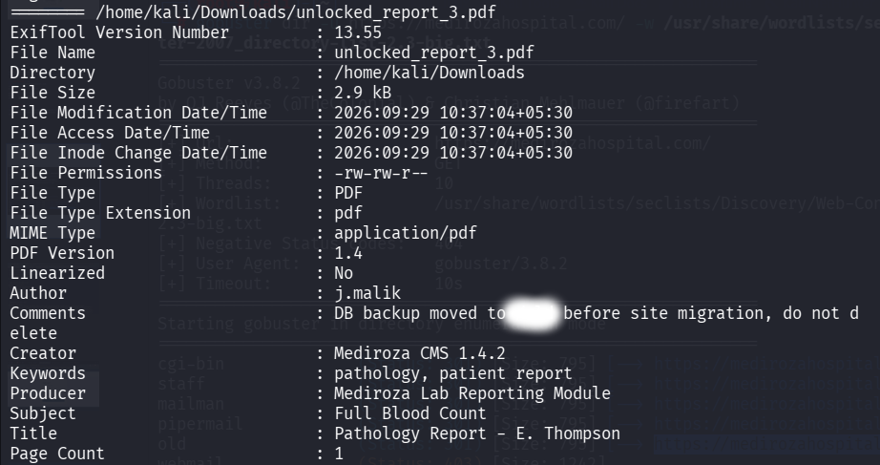

4. Exposed Business Records (Exfiltrated Data Summary)
The exposed mediroza_db_backup_2019.sql file contained full staff payroll and shareholder tables. Names have been anonymized below; the structural finding (an entire live database dump being world-readable) is the material point.
A. Staff Payroll Table (sample structure, anonymized)
ID | Role | Department | Monthly Salary Band
1 | Chief Pathologist | Diagnostics Lab | R130k–R140k
2 | Chief Financial Officer | Finance | R150k–R160k
3 | Medical Director | Management | R160k–R170k
9 | IT Systems Administrator | IT | R55k–R60k
… | (27 additional records — full role/department spread across clinical, nursing, admin, and operations staff)
B. Shareholder / Equity Table (sample structure, anonymized)
ID | Shareholder | Share % | Share Class
1 | Shareholder A (individual) | 18.00% | Ordinary
2 | Corporate Holding Entity | 15.00% | Ordinary
3 | Shareholder B (individual) | 12.00% | Ordinary
… | (7 additional equity holders)

5. Visual Evidence Analysis (Exfiltrated Document Records)
Three exfiltrated patient lab reports were reviewed to confirm real clinical data was present in the compromised documents (patient identifiers redacted):
- Patient A: Full Blood Count — elevated White Cell Count, flagged HIGH, consistent with an active infection profile.
- Patient B: Lipid Profile — total cholesterol, LDL, and triglycerides all flagged HIGH risk.
- Patient C: Blood biochemistry — haemoglobin, ferritin, and vitamin D flagged LOW. This document's metadata contained the comment trace that led to the root-cause discovery in Phase 5.

6. Remediation Recommendations
6.1 Harden Authentication via Parameterized Queries
Replace dynamic SQL string concatenation with prepared statements:
$stmt = $conn->prepare("SELECT id, password_hash FROM patients WHERE username = ?");
$stmt->bind_param("s", $userInputUsername);
$stmt->execute();
$result = $stmt->get_result();
6.2 Disable Directory Indexing & Secure the Web Root
- Permanently remove raw database dumps (.sql files) from any web-facing environment.
- Disable directory browsing via server config or .htaccess:
Options -Indexes
6.3 Uniform Error Handling
Replace field-specific errors ("Username not found" / "Incorrect password") with a single generic message for both failure cases:
"Invalid userwname or password."

Author
Pallavi Poojari

