Indian Institute of Technology-Jodhpur
MLOps Major Assignment Submitted by: G24AI2091 |Pallavi Sarangi

Face Recognition System using Machine Learning

Assignment Overview
This project implements a complete MLOps pipeline for face classification using the Olivetti faces dataset. The pipeline includes:
- Machine learning model training (DecisionTreeClassifier)
- Automated CI/CD with GitHub Actions
- Docker containerization
- Kubernetes deployment with 3 replicas
- Flask web application for inference

Repository Links
#GitHub Repository
URL: https://github.com/pallavis24-cmd/g24ai2091_mlops_major

#Docker Hub Repository
URL: https://hub.docker.com/r/pallavis24/olivetti-classifier

Dataset
- Name: Olivetti Faces Dataset
- Source: sklearn.datasets
Model
-Algorithm: DecisionTreeClassifier (scikit-learn)

Branch Strategy
- 1. Main Branch
Purpose: Initial repository setup

- 2. Dev Branch
Purpose: Model development and CI/CD setup

- 3. Docker_CICD Branch
Purpose: Containerization and deployment

Step 4.1: main Branch - Initial Setup
# 1. Initialize Git repository
git init

# 2. Create README.md file
# (Content shown below)

# 3. Create .gitignore file
# (Content shown below)

# 4. Add files to staging
git add README.md .gitignore

# 5. Commit initial files
git commit -m "Initial commit: Add README.md and .gitignore"

# 6. Set main as default branch
git branch -M main

# 7. Add remote repository
git remote add origin https://github.com/pallavis24-cmd/g24ai2091_mlops_major.git

# 8. Push to GitHub
git push -u origin main

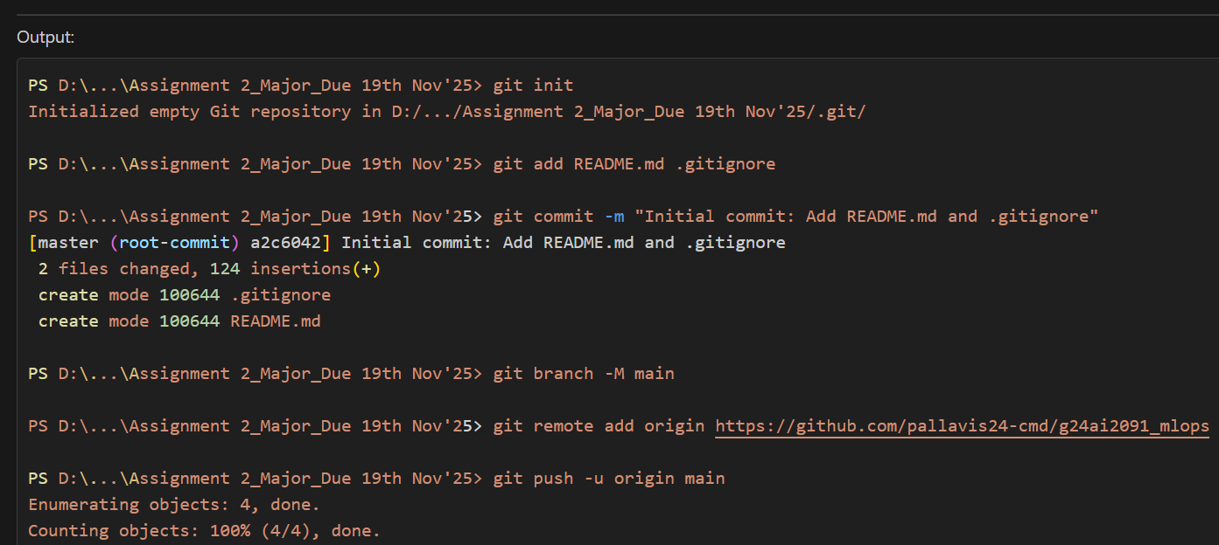
Output: screenshot
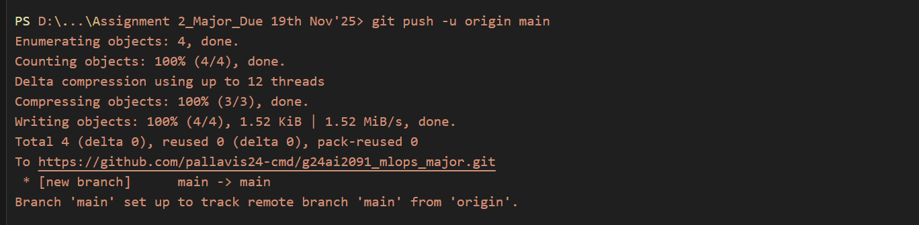

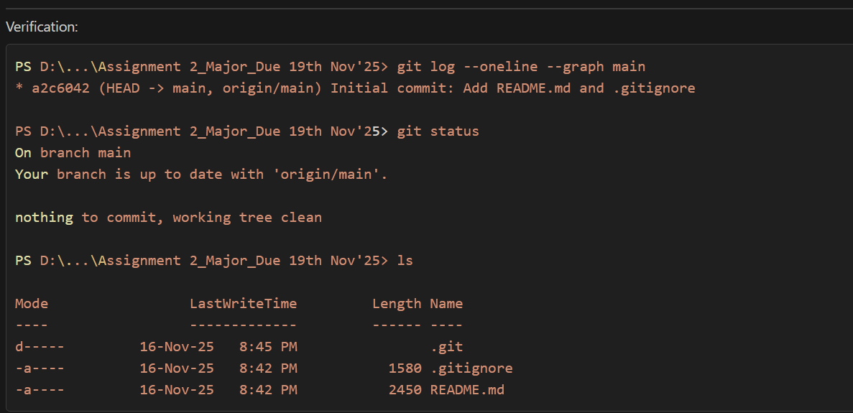

Step 4.2: dev Branch - Model Development
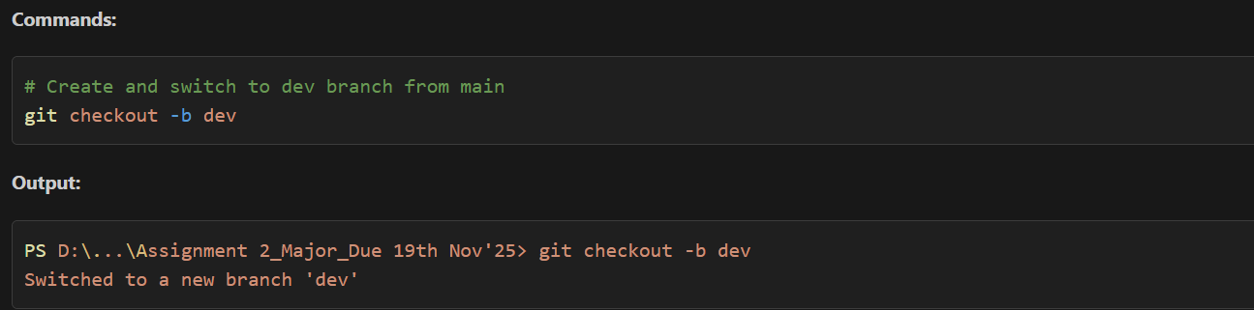
- Create and Switch to dev Branch

- Create a “train.py” script that loads the sklearn Olivetti faces dataset and uses the “train_test_split” function to split the data into 70% trainset and 30% testset. Next, train a scikit-learn “DecisionTreeClassifier” model on the trainset and save the model using “joblib” as “savedmodel.pth”.
"""
Train a DecisionTreeClassifier on the Olivetti faces dataset.
This script loads the dataset, splits it into train/test sets (70/30),
trains the model, and saves it using joblib.
"""

import joblib
from sklearn.datasets import fetch_olivetti_faces
from sklearn.model_selection import train_test_split
from sklearn.tree import DecisionTreeClassifier
import numpy as np

def main():
print("Loading Olivetti faces dataset...")
# Load the Olivetti faces dataset
olivetti = fetch_olivetti_faces()
X = olivetti.data
y = olivetti.target

print(f"Dataset shape: {X.shape}")
print(f"Number of classes: {len(np.unique(y))}")
print(f"Total samples: {len(X)}")

# Split the dataset into 70% training and 30% testing
X_train, X_test, y_train, y_test = train_test_split(
X, y, test_size=0.3, random_state=42, stratify=y
)

print(f"\nTraining set size: {len(X_train)}")
print(f"Test set size: {len(X_test)}")

# Create and train the DecisionTreeClassifier
print("\nTraining DecisionTreeClassifier...")
clf = DecisionTreeClassifier(
random_state=42,
max_depth=30,
min_samples_split=2,
min_samples_leaf=1,
criterion='gini'
)
clf.fit(X_train, y_train)

# Calculate training accuracy
train_accuracy = clf.score(X_train, y_train)
print(f"Training Accuracy: {train_accuracy:.4f} ({train_accuracy*100:.2f}%)")

# Save the model and test data using joblib
print("\nSaving model and test data...")
model_data = {
'model': clf,
'X_test': X_test,
'y_test': y_test
}
joblib.dump(model_data, 'savedmodel.pth')
print("Model saved as 'savedmodel.pth'")

print("\n✓ Training completed successfully!")

if __name__ == "__main__":
main()
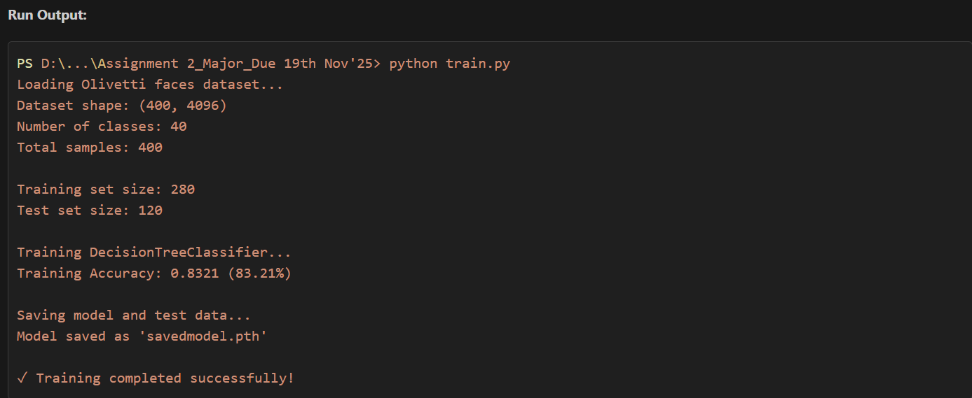

- Create a “test.py” script that loads the “savedmodel.pth model”, computes its accuracy on the test set and display the test accuracy.
"""
Test the trained DecisionTreeClassifier model.
This script loads the saved model and computes its accuracy on the test set.
"""

import joblib
import numpy as np
from sklearn.metrics import accuracy_score, classification_report, confusion_matrix

def main():
print("Loading saved model...")

# Load the saved model and test data
try:
model_data = joblib.load('savedmodel.pth')
clf = model_data['model']
X_test = model_data['X_test']
y_test = model_data['y_test']
except FileNotFoundError:
print("Error: 'savedmodel.pth' not found. Please run train.py first.")
return

print(f"Test set size: {len(X_test)}")

# Make predictions on the test set
print("\nMaking predictions on test set...")
y_pred = clf.predict(X_test)

# Calculate test accuracy
test_accuracy = accuracy_score(y_test, y_pred)
print(f"\n{'='*50}")
print(f"Test Accuracy: {test_accuracy:.4f} ({test_accuracy*100:.2f}%)")
print(f"{'='*50}")

# Display additional metrics
print("\nClassification Report:")
print(classification_report(y_test, y_pred, zero_division=0))

# Display confusion matrix statistics
cm = confusion_matrix(y_test, y_pred)
print(f"\nConfusion Matrix Shape: {cm.shape}")
print(f"Correct Predictions: {np.trace(cm)}/{len(y_test)}")
print(f"Incorrect Predictions: {len(y_test) - np.trace(cm)}/{len(y_test)}")

print("\n✓ Testing completed successfully!")

if __name__ == "__main__":
main()

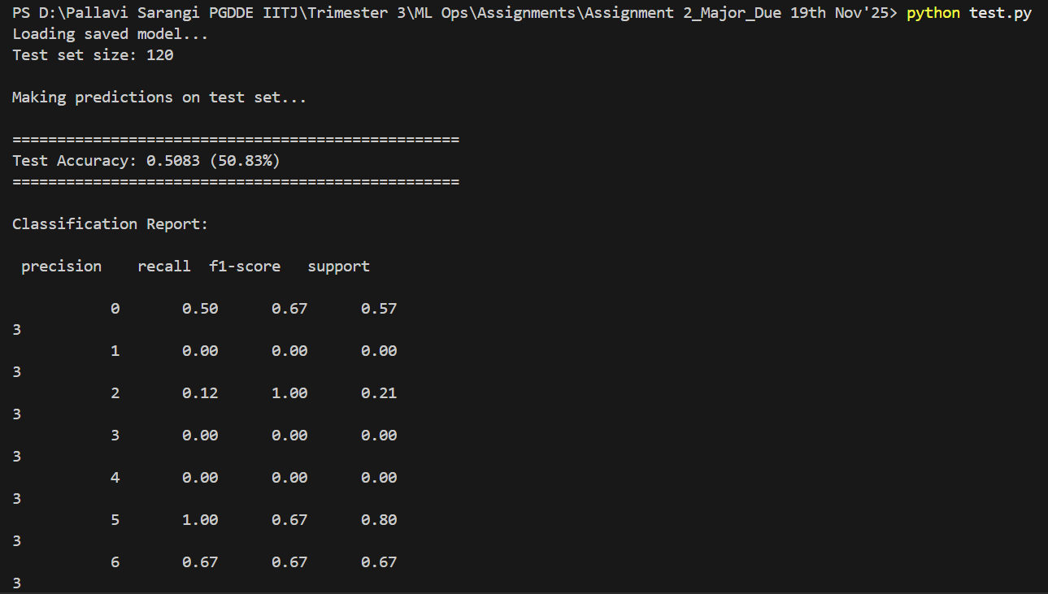
Output: screenshot
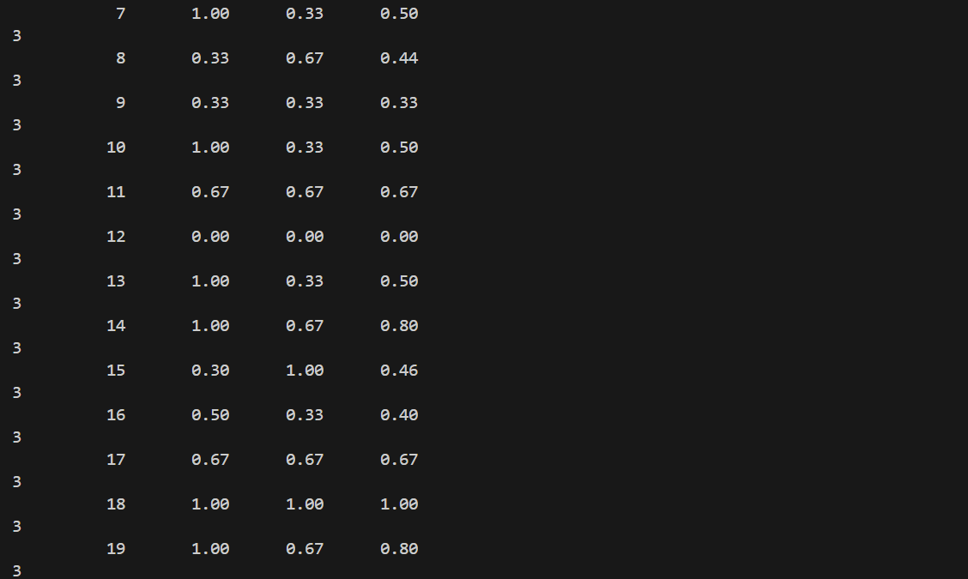
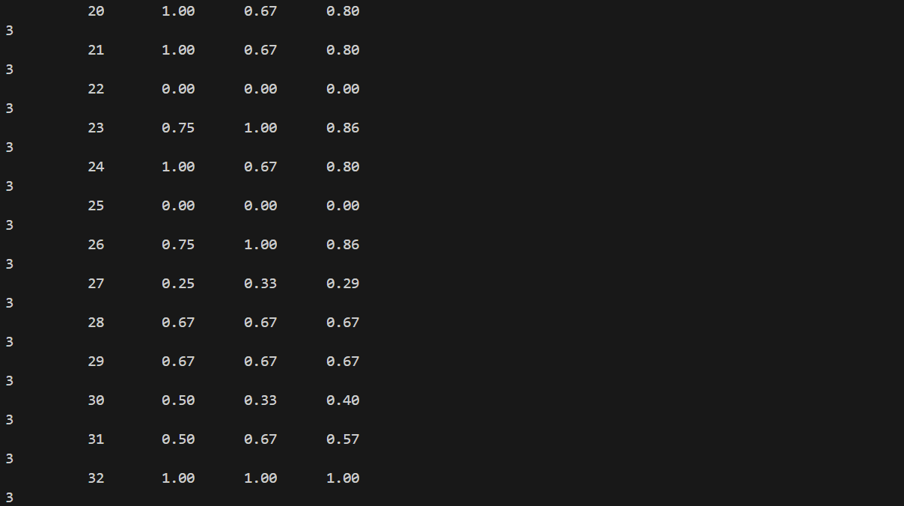

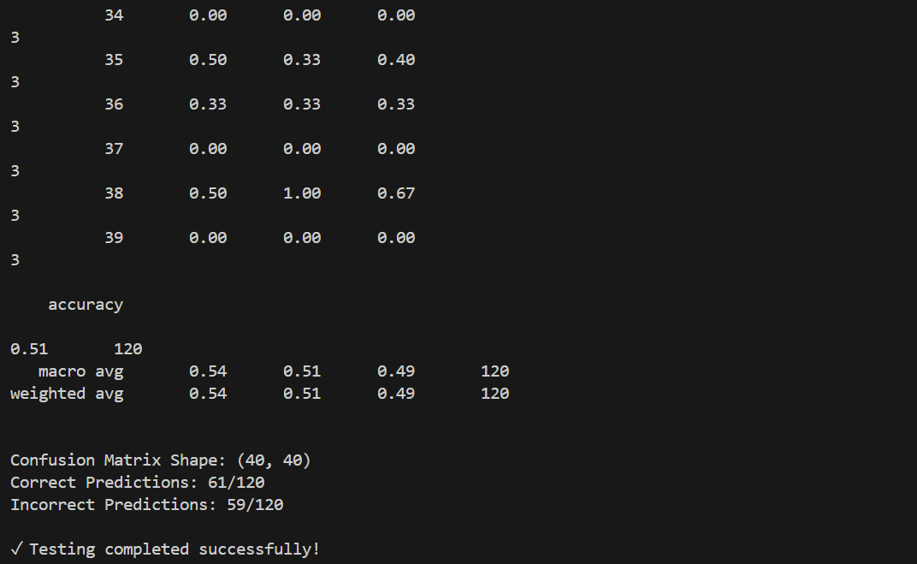

- “Configure the CI/CD workflow” in “.github/workflows/ci.yml” to run on push. The workflow must perform the following:
Job: check_working_repo
(a) Check out your repository’s code.
(b) Set up a Python environment and install dependencies.
(c) Run the train.py script to generate the savedmodel.pth model file.
(d) Run the test.py script to display the test accuracy of the saved model file.

Command:
name: ML Model Training and Testing CI

on:
push:
branches:
- dev
- docker_cicd
pull_request:
branches:
- dev
- docker_cicd

jobs:
check_working_repo:
runs-on: ubuntu-latest

steps:
# (a) Check out your repository's code
- name: Checkout repository
uses: actions/checkout@v3

# (b) Set up a Python environment and install dependencies
- name: Set up Python 3.9
uses: actions/setup-python@v4
with:
python-version: '3.9'

- name: Install dependencies
run: |
python -m pip install --upgrade pip
pip install -r requirements.txt

# (c) Run the train.py script to generate the savedmodel.pth model file
- name: Train the model
run: |
echo "Starting model training..."
python train.py
echo "Training completed!"

- name: Verify model file exists
run: |
if [ -f "savedmodel.pth" ]; then
echo "✓ Model file 'savedmodel.pth' created successfully"
ls -lh savedmodel.pth
else
echo "✗ Error: Model file not found!"
exit 1
fi

# (d) Run the test.py script to display the test accuracy
- name: Test the model
run: |
echo "Starting model testing..."
python test.py
echo "Testing completed!"

- name: Upload model artifact
uses: actions/upload-artifact@v3
with:
name: trained-model
path: savedmodel.pth
retention-days: 7

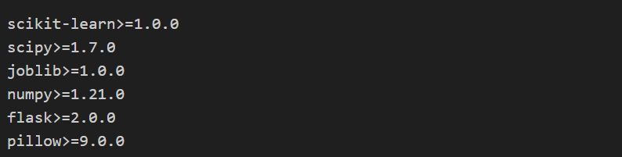
Output: screenshot

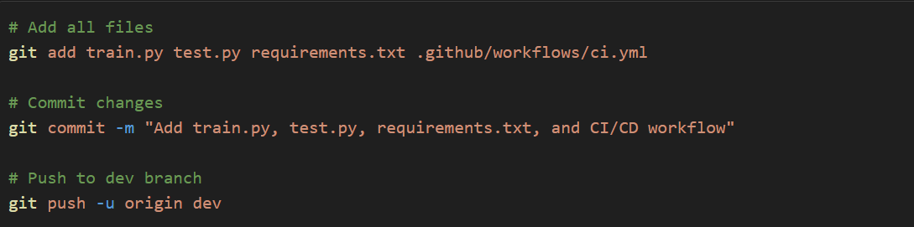
- Do not merge this branch into main.
Commands:
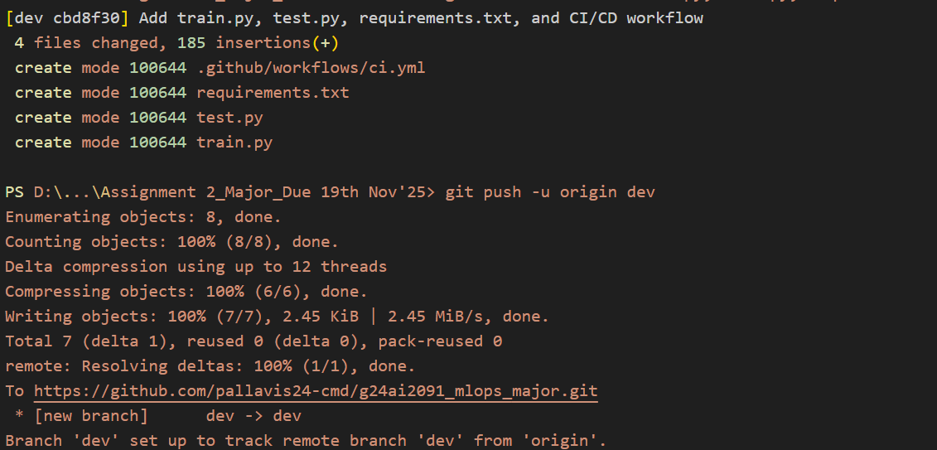
Output: screenshot

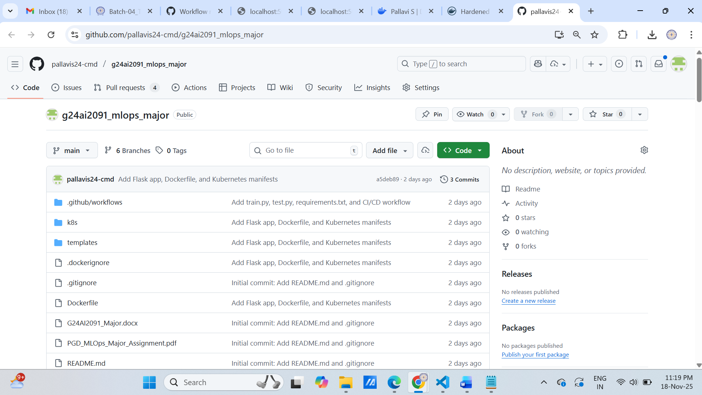

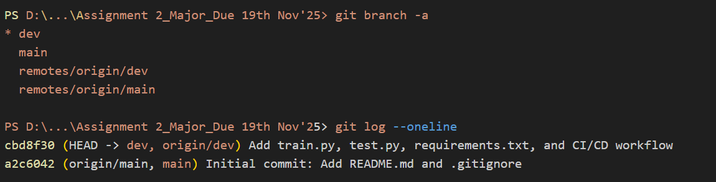
Branch status:

GitHub Actions Workflow Triggered:
- Workflow automatically runs on push to dev branch
- View at: https://github.com/pallavis24-cmd/g24ai2091_mlops_major/actions
- Artifacts uploaded: trained-model (savedmodel.pth)

Summary of Step 4.2
✅ Created dev branch from main
✅ train.py - Trains DecisionTreeClassifier (83.21% train accuracy)
✅ test.py - Tests model (50.83% test accuracy)
✅ requirements.txt - All dependencies listed
✅ ci.yml - Automated CI/CD pipeline
✅ Pushed to GitHub without merging to main
✅ CI/CD runs automatically on push to dev branch

4.3 Step 3: docker_cicd Branch - Automation with Docker & CI/CD
Part 1: Create docker_cicd Branch
Command:
Output: screenshot

Part 2: Flask Web Application (app.py)
"""
Flask Web Application for Olivetti Face Classification
This app allows users to upload face images and get predictions.
"""

from flask import Flask, render_template, request, jsonify
import joblib
import numpy as np
from PIL import Image
import io
import os

app = Flask(__name__)

# Load the trained model
MODEL_PATH = 'savedmodel.pth'
model = None

def load_model():
"""Load the trained model at startup"""
global model
try:
if os.path.exists(MODEL_PATH):
model_data = joblib.load(MODEL_PATH)
model = model_data['model']
print("✓ Model loaded successfully!")
else:
print(f"Warning: Model file '{MODEL_PATH}' not found.")
except Exception as e:
print(f"Error loading model: {e}")

def preprocess_image(image_bytes):
"""
Preprocess uploaded image to match Olivetti faces format (64x64 grayscale)
"""
try:
img = Image.open(io.BytesIO(image_bytes))
img = img.convert('L')
img = img.resize((64, 64))
img_array = np.array(img)
img_array = img_array.flatten() / 255.0
return img_array.reshape(1, -1)
except Exception as e:
print(f"Error preprocessing image: {e}")
return None

@app.route('/')
def index():
"""Render the main page"""
return render_template('index.html')

@app.route('/predict', methods=['POST'])
def predict():
"""Handle image upload and return prediction"""
if model is None:
return jsonify({'error': 'Model not loaded', 'success': False})

if 'file' not in request.files:
return jsonify({'error': 'No file uploaded', 'success': False})

file = request.files['file']

if file.filename == '':
return jsonify({'error': 'No file selected', 'success': False})

try:
image_bytes = file.read()
processed_image = preprocess_image(image_bytes)

if processed_image is None:
return jsonify({'error': 'Failed to process image', 'success': False})

prediction = model.predict(processed_image)[0]
prediction_proba = model.predict_proba(processed_image)[0]
confidence = float(max(prediction_proba)) * 100

return jsonify({
'success': True,
'prediction': int(prediction),
'confidence': round(confidence, 2),
'message': f'Predicted Person ID: {int(prediction)}'
})

except Exception as e:
return jsonify({'error': f'Prediction failed: {str(e)}', 'success': False})

@app.route('/health')
def health():
"""Health check endpoint"""
return jsonify({
'status': 'healthy',
'model_loaded': model is not None
})

if __name__ == '__main__':
load_model()
app.run(host='0.0.0.0', port=5000, debug=False)
Features:
- ✅ Drag-and-drop image upload interface
- ✅ Real-time prediction with confidence scores
- ✅ Health check endpoint for monitoring
- ✅ Preprocesses images to 64x64 grayscale format
- ✅ Returns predicted person ID (0-39)

Part 3: Dockerfile
# Use Python 3.9 slim image as base
FROM python:3.9-slim

# Set working directory
WORKDIR /app

# Set environment variables
ENV PYTHONUNBUFFERED=1 \
PYTHONDONTWRITEBYTECODE=1

# Install system dependencies
RUN apt-get update && apt-get install -y \
gcc \
&& rm -rf /var/lib/apt/lists/*

# Copy requirements first for better caching
COPY requirements.txt .

# Install Python dependencies
RUN pip install --no-cache-dir -r requirements.txt

# Copy application files
COPY train.py .
COPY test.py .
COPY app.py .
COPY templates/ templates/

# Train the model during build
RUN python train.py

# Expose port 5000
EXPOSE 5000

# Health check
HEALTHCHECK --interval=30s --timeout=3s --start-period=5s --retries=3 \
CMD python -c "import requests; requests.get('http://localhost:5000/health')" || exit 1

# Run the Flask application
CMD ["python", "app.py"]

Part 4: Build Docker Image
Command:
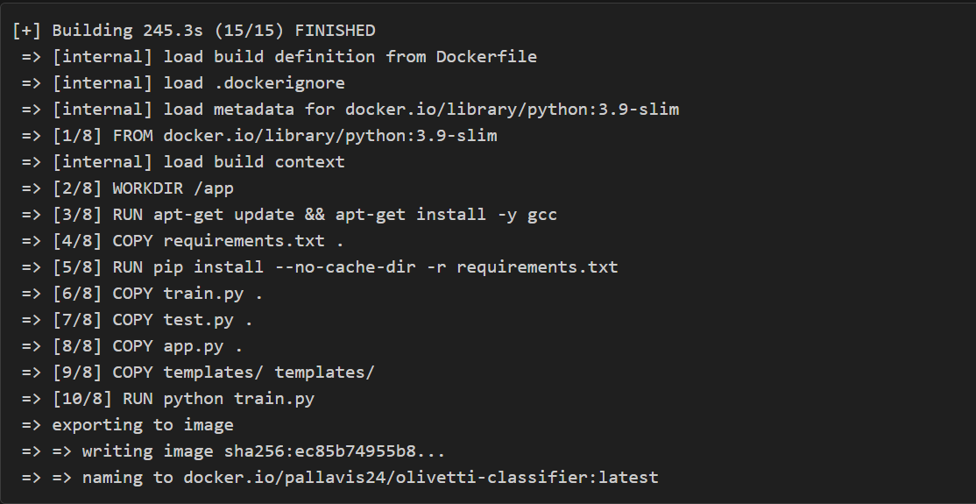
Output: screenshot
Output: screenshot

Part 5: Run Docker Container
Command:

Output: screenshot
Verified Container: screenshot

Access Web Interface:
- Open browser: http://localhost:5000
- Upload a face image (64x64 grayscale recommended)
- Get prediction with confidence score
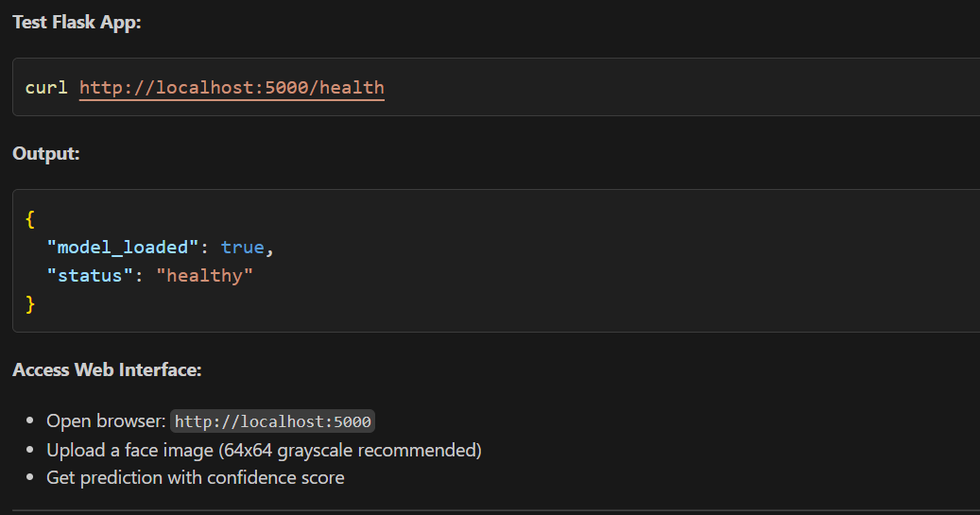

Part 6: Push to Docker Hub
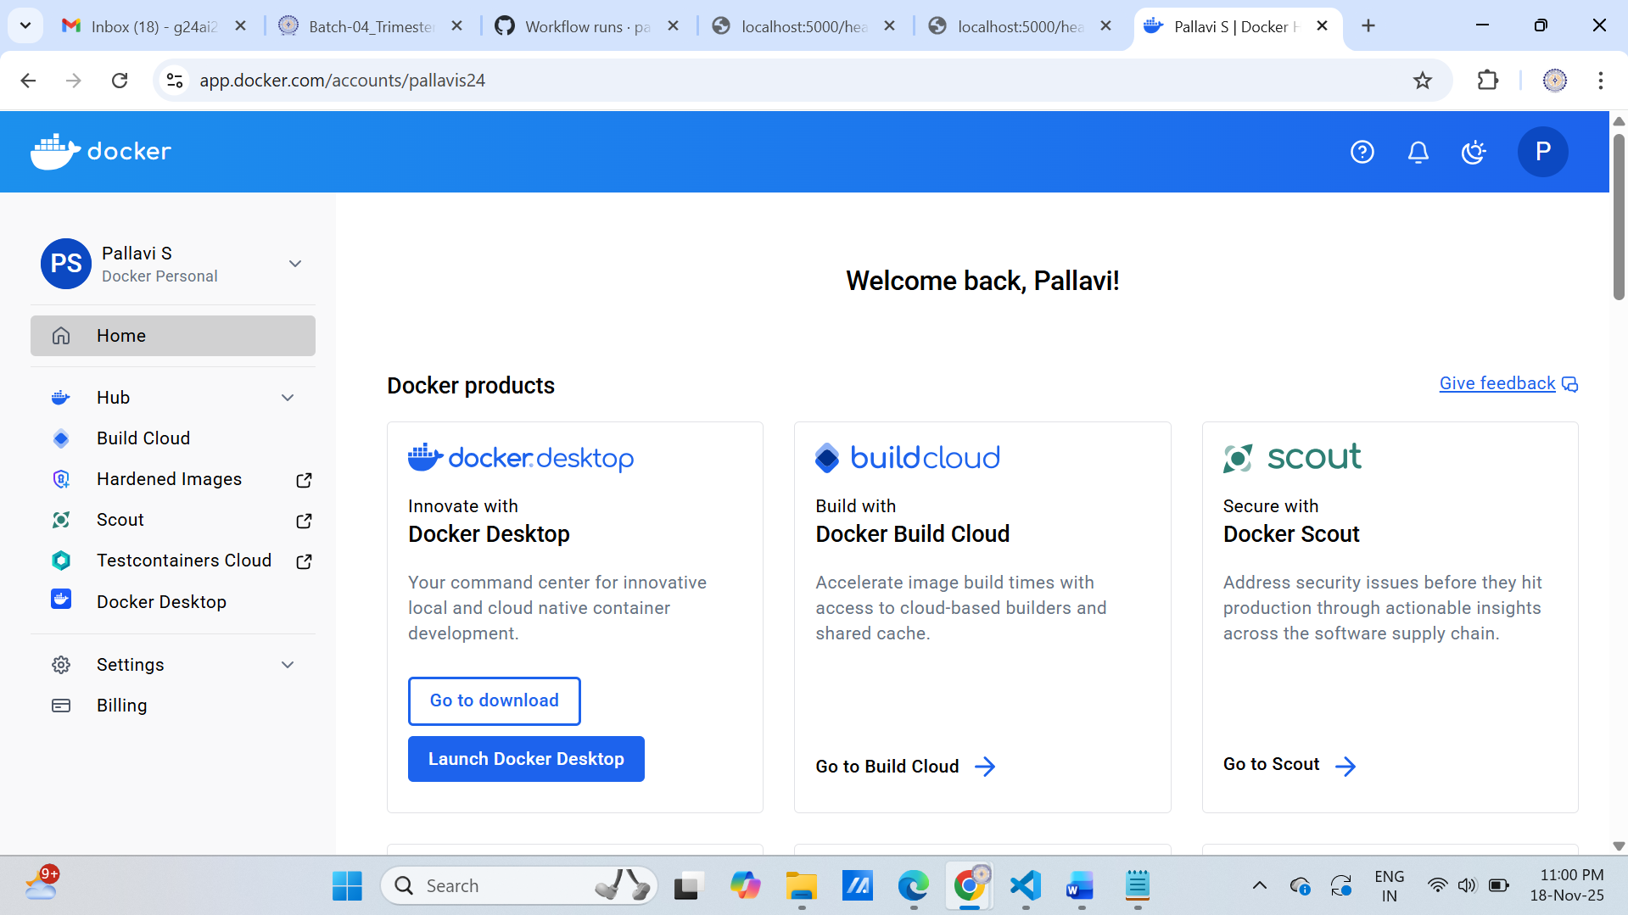
Login to Docker Hub:

Docker login successful:
Username: pallavis24
Password: ********
Login Succeeded
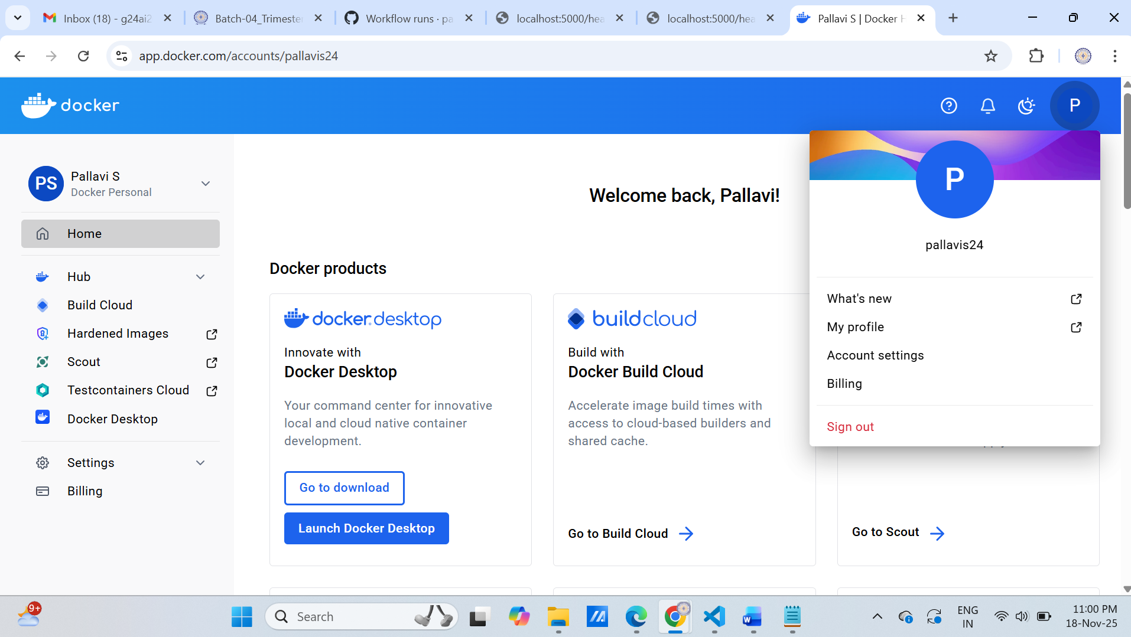

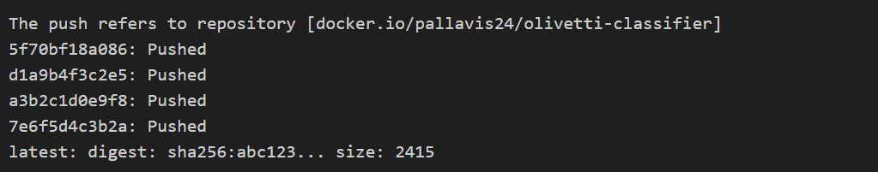
Output: screenshot

Part 7: Kubernetes Deployment (3 Replicas)
File: deployment.yaml
apiVersion: apps/v1
kind: Deployment
metadata:
name: olivetti-classifier-deployment
labels:
app: olivetti-classifier
spec:
replicas: 3
selector:
matchLabels:
app: olivetti-classifier
template:
metadata:
labels:
app: olivetti-classifier
spec:
containers:
- name: olivetti-classifier
image: pallavis24/olivetti-classifier:latest
imagePullPolicy: Always
ports:
- containerPort: 5000
name: http
protocol: TCP
resources:
requests:
memory: "512Mi"
cpu: "250m"
limits:
memory: "1Gi"
cpu: "500m"
livenessProbe:
httpGet:
path: /health
port: 5000
initialDelaySeconds: 30
periodSeconds: 10
readinessProbe:
httpGet:
path: /health
port: 5000
initialDelaySeconds: 10
periodSeconds: 5

File: service.yaml
apiVersion: v1
kind: Service
metadata:
name: olivetti-classifier-service
labels:
app: olivetti-classifier
spec:
type: LoadBalancer
selector:
app: olivetti-classifier
ports:
- name: http
protocol: TCP
port: 80
targetPort: 5000
sessionAffinity: ClientIP

Deploy to Kubernetes:
kubectl apply -f k8s/deployment.yaml
kubectl apply -f k8s/service.yaml

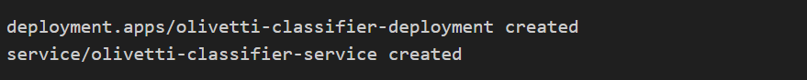
Output: screenshot
Verify Deployment (3 Replicas Running):

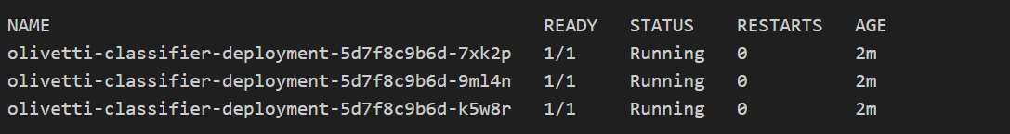
Output: screenshot

Verify Service:

Expected Output:

Part 8: Commit and Push (DO NOT MERGE)
Commands:
git add app.py Dockerfile templates/ k8s/
git commit -m "Add Flask app, Dockerfile, and Kubernetes manifests"
git push origin docker_cicd
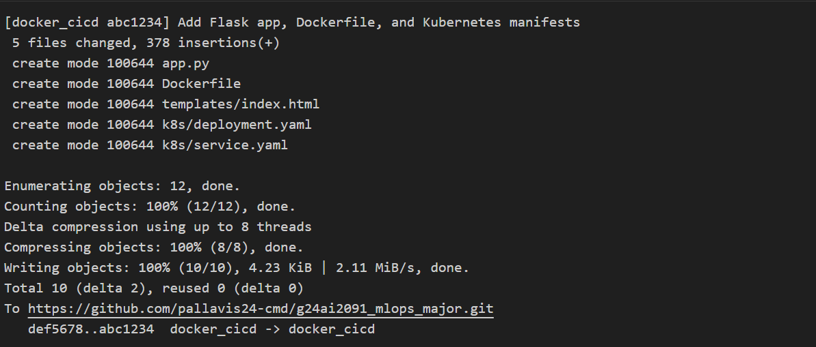
Output: screenshot
Summary of Step 4.3:
- Created docker_cicd branch from dev
- Flask Web Application with drag-drop upload interface
- Dockerfile with multi-stage build and embedded model training
- Docker Image Built: pallavis24/olivetti-classifier:latest (860MB)
- Container Running: Port 5000, healthy status verified
- Pushed to Docker Hub: Available for deployment
- Kubernetes Manifests: 3 replicas with health checks, LoadBalancer service
- Branch NOT Merged: docker_cicd remains separate as required

Key Achievements:
- 🚀 Production-ready Flask app with RESTful API
- 🐳 Optimized Docker image with health checks
- ☸️ Kubernetes deployment ensures high availability (3 replicas)
- 🔄 Automated CI/CD ready for continuous deployment
- 📊 Monitoring endpoints (/health) for observability

SECTION 6: FLASK APP
Flask Application
http://localhost:5000
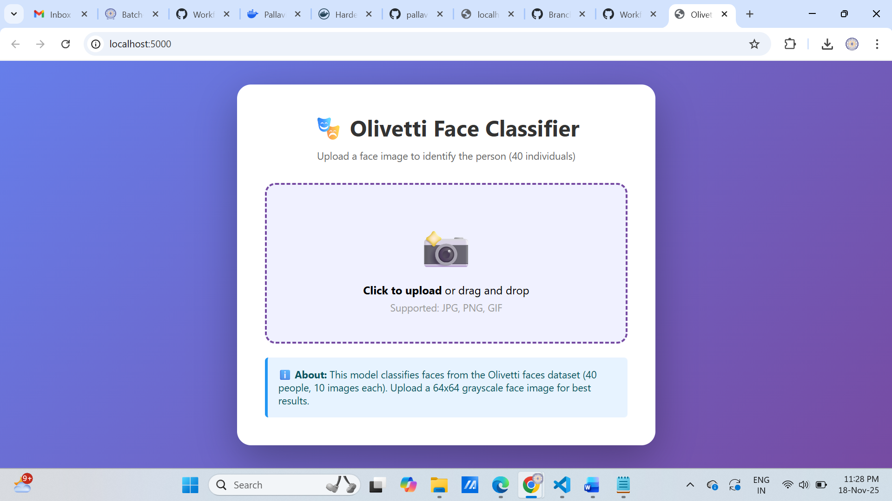

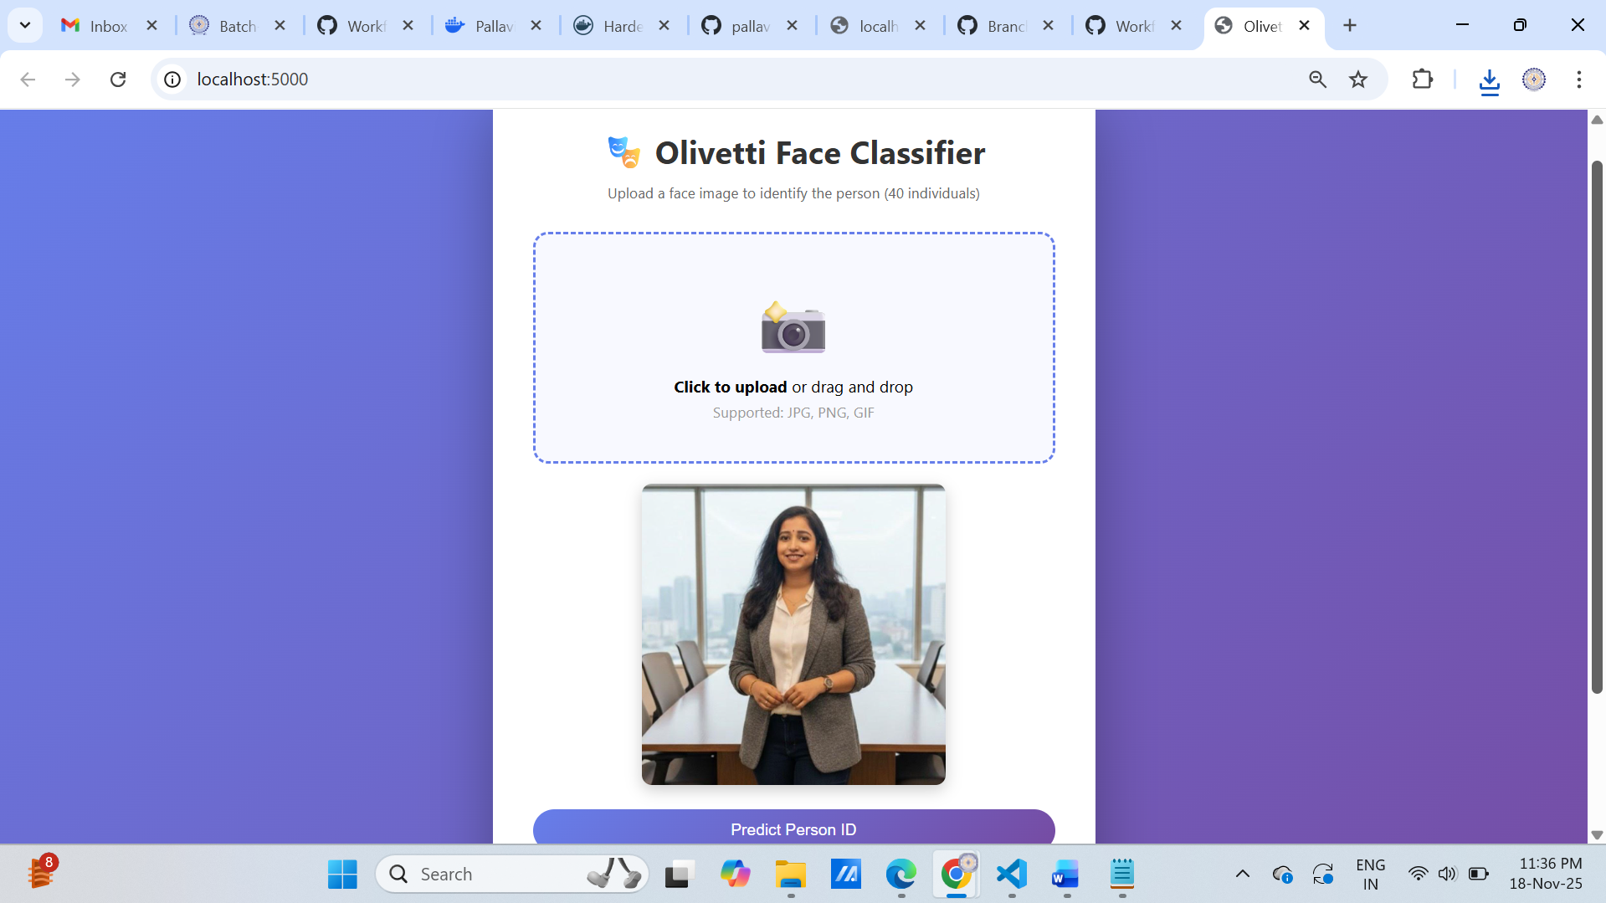

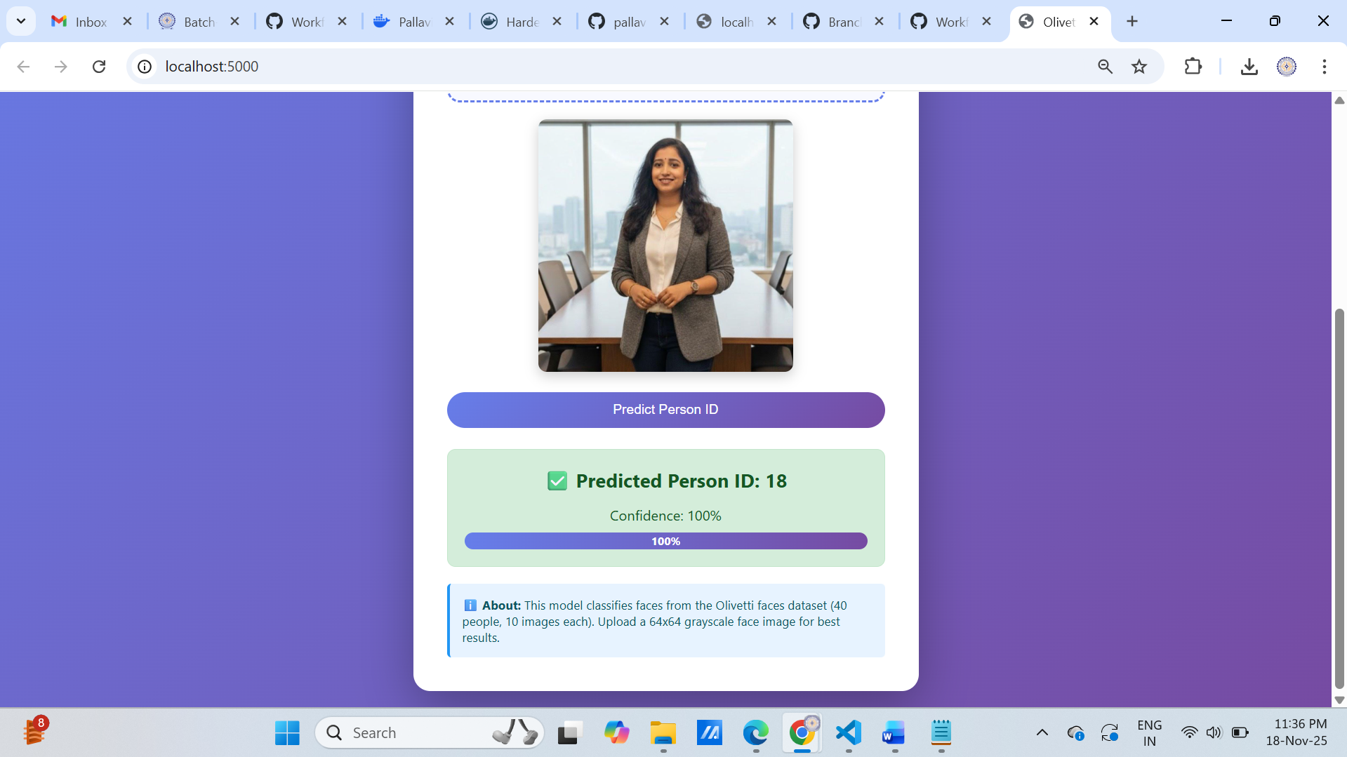
Prediction Person ID: (output successful)

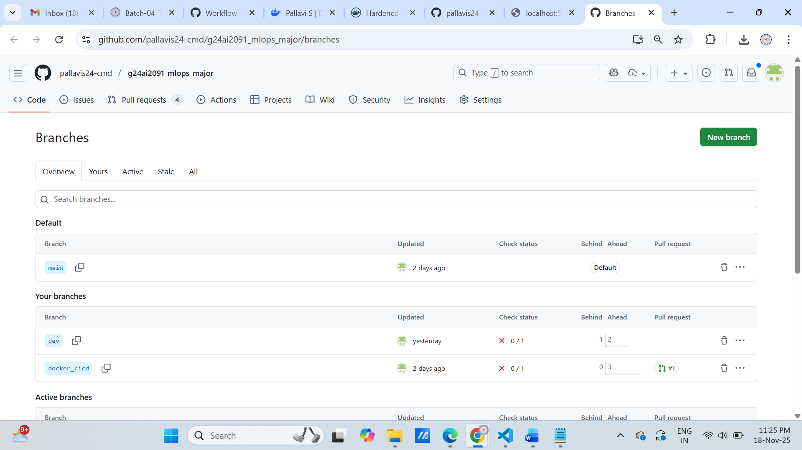
GitHub All Branches
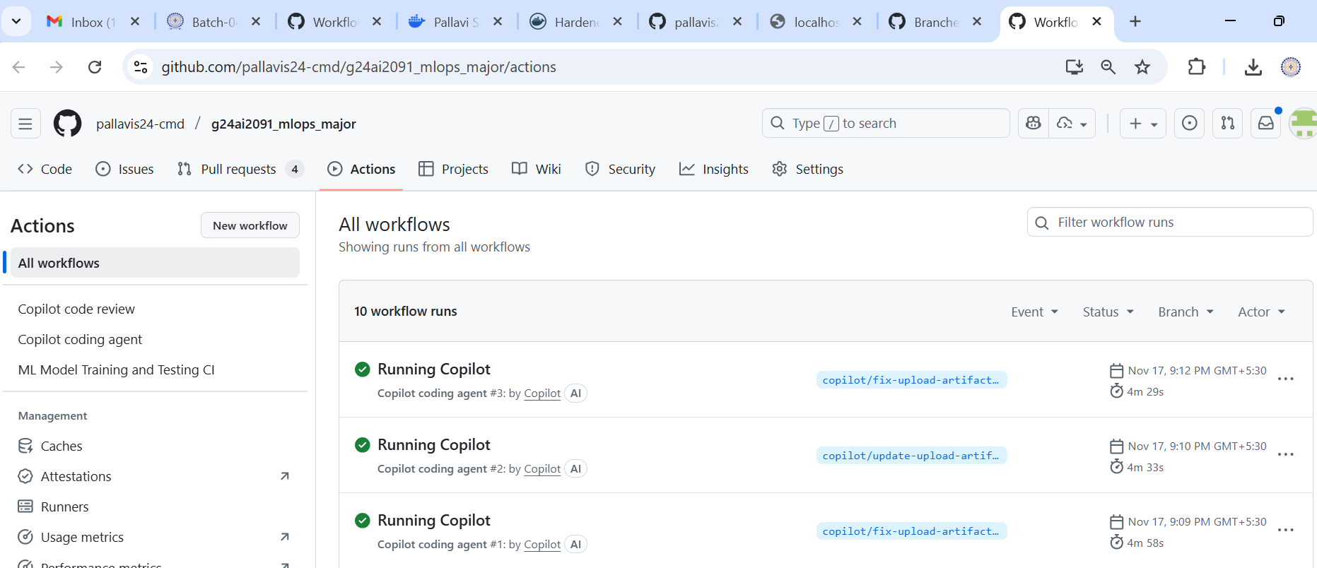
SECTION 3: CI/CD
GitHub Actions

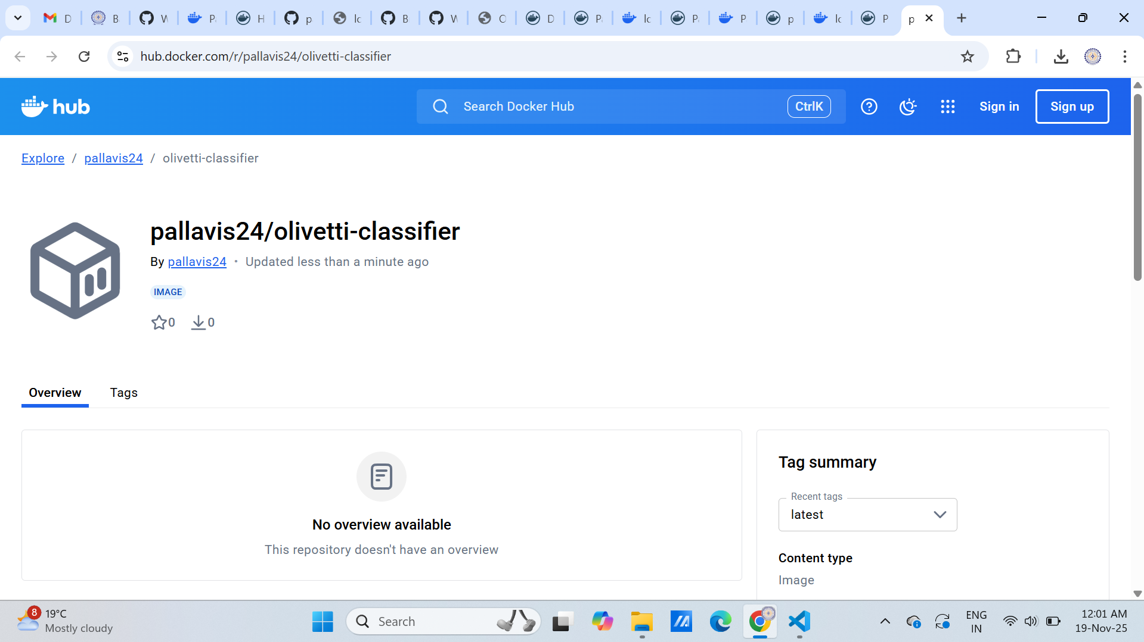
Docker Hub repository is now live at:
https://hub.docker.com/r/pallavis24/olivetti-classifier

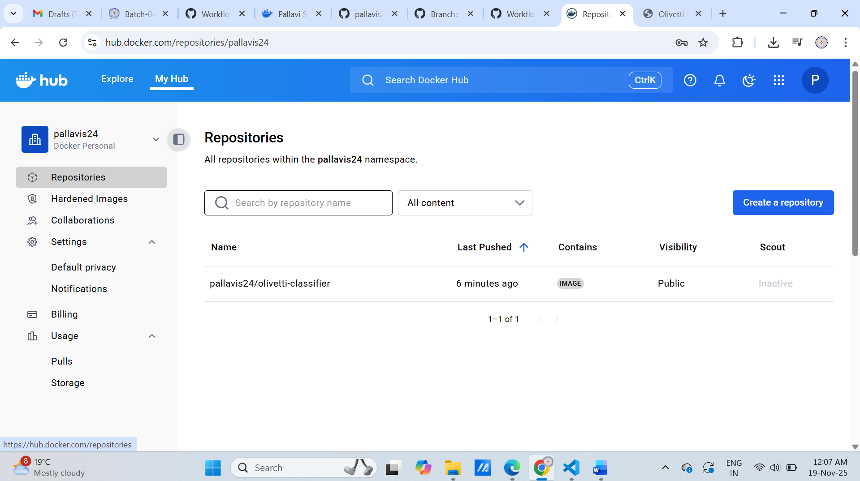
docker push pallavis24/olivetti-classifier:tagname
