SQL-Based Customer Retention & Revenue Analysis
Project Overview
This project focuses on analyzing telecom customer data using MySQL to understand customer churn behavior, revenue trends, customer retention, and business performance.
The main objective of this project was to extract meaningful business insights from customer data using SQL queries and analytical techniques.
Objectives
- Analyze customer churn patterns
- Identify high-value customers
- Understand revenue contribution
- Perform customer segmentation
- Extract business insights for better decision-making
Tools Used
- MySQL
- MySQL Workbench

Dataset Used
- Telco Customer Churn Dataset from Kaggle
Query Analysis & Business Insights
- Total Customers Analysis
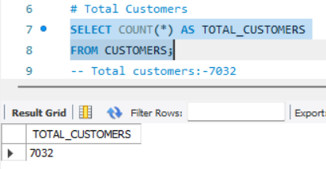
- This query calculated the total number of customers available in the dataset to understand the customer base size.
- Total Revenue Analysis
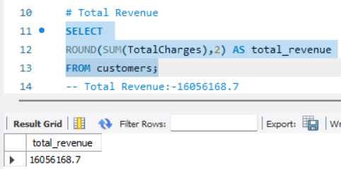
- This query calculated the total revenue generated by customers, helping measure overall business performance.
- Churn Rate Analysis
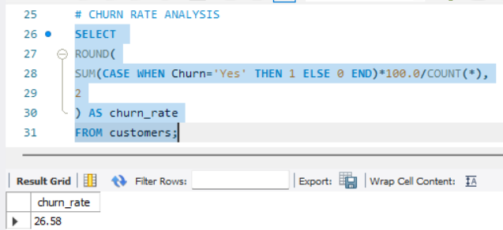
- This analysis identified the percentage of customers who left the company, helping evaluate customer retention performance.
- Contract Type vs Churn Analysis
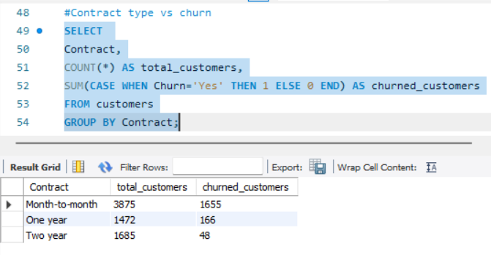
- Month-to-month contract customers showed the highest churn, indicating lower customer retention among short-term plans.
- Revenue by Internet Service
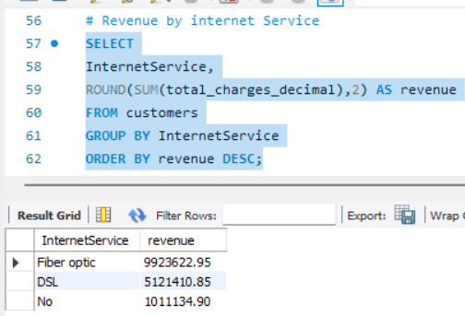
- This analysis identified which internet service i.e Fiber Optic generated the highest revenue contribution.
- JOIN Analysis
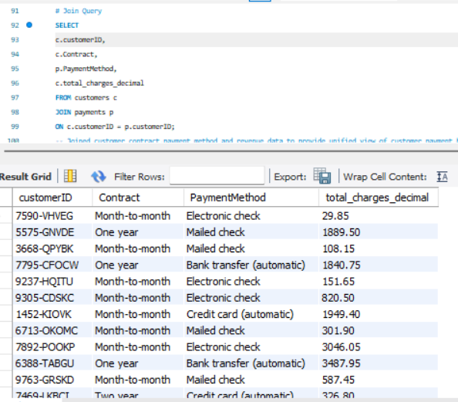
- The JOIN query combined customer contract, payment method, and revenue data to provide a unified view of customer payment behavior and revenue contribution.
- Churn by Payment Method
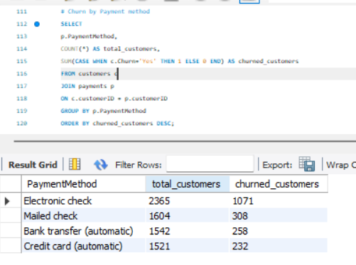
- Electronic check users showed higher churn rates, indicating a potential area for retention improvement.
- Above Average Revenue Customers
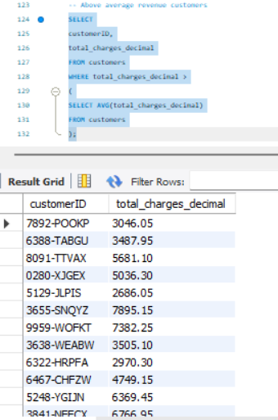
- The subquery identified customers generating above-average revenue, helping recognize high-value customers.
- Long-Term Customer Analysis
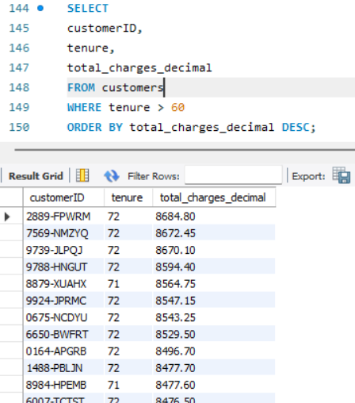
- Long-term customers contributed strong revenue and showed higher customer loyalty.
- Customer Segmentation Analysis
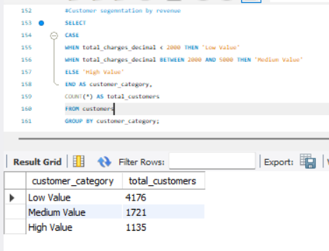
- Customers were segmented into Low, Medium, and High Value groups for better business understanding and targeted strategies.
Conclusion
This project successfully analyzed telecom customer data using MySQL to understand customer churn behavior, revenue trends, customer retention, and customer segmentation.
Using SQL concepts such as aggregations, GROUP BY, CASE statements, joins, and subqueries, meaningful business insights were extracted from the dataset.
The analysis revealed that month-to-month customers and electronic check users showed higher churn rates, while long-term and high-value customers contributed significantly to overall revenue and customer loyalty.
This project demonstrates the practical use of SQL for solving real-world business problems and supporting data-driven decision-making.

