Scalariform

1)Settings in project/plugins.sbt

resolvers += "Sonatype OSS Releases" at "https://oss.sonatype.org/service/local/staging/deploy/maven2"

addSbtPlugin("org.scalariform" % "sbt-scalariform" % "1.5.1")

2) Default settings (in build.sbt)

scalariformSettings

3) Advanced settings(in build.sbt) to customize format

import scalariform.formatter.preferences._

……………………………………………………..

………………………………………………………….

scalariformSettings

SbtScalariform.ScalariformKeys.preferences := SbtScalariform.ScalariformKeys.preferences.value

.setPreference(AlignSingleLineCaseStatements,true)

.setPreference(DoubleIndentClassDeclaration, true)

.setPreference(AlignParameters, true)

.setPreference(PreserveDanglingCloseParenthesis, true)

.setPreference(SpaceInsideBrackets, true)

4)Scalariform formats the source code i.e only the files in "app"

5) EXECUTION of command "scalariformPreferences" DISPLAYS the default formatter settings of scalariform.

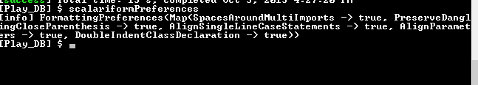

6)Difference in format before and after enabling scalariform

Before

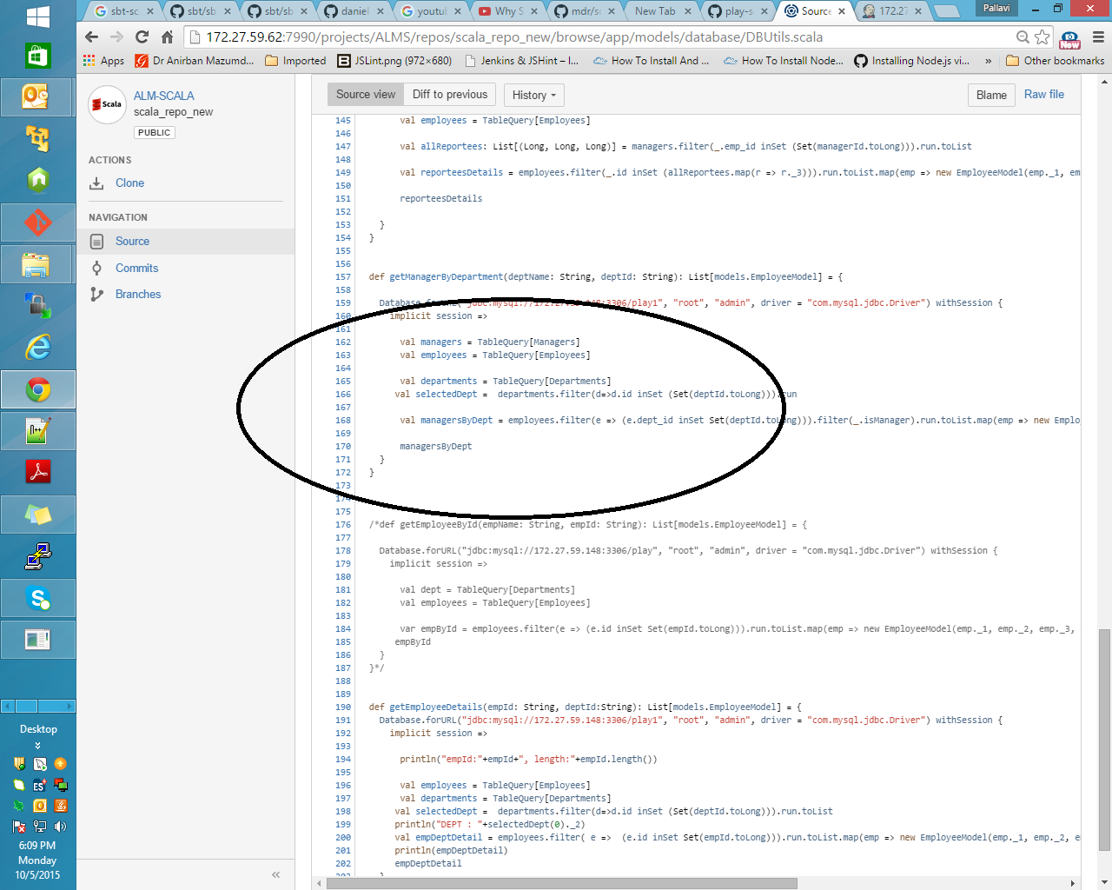

After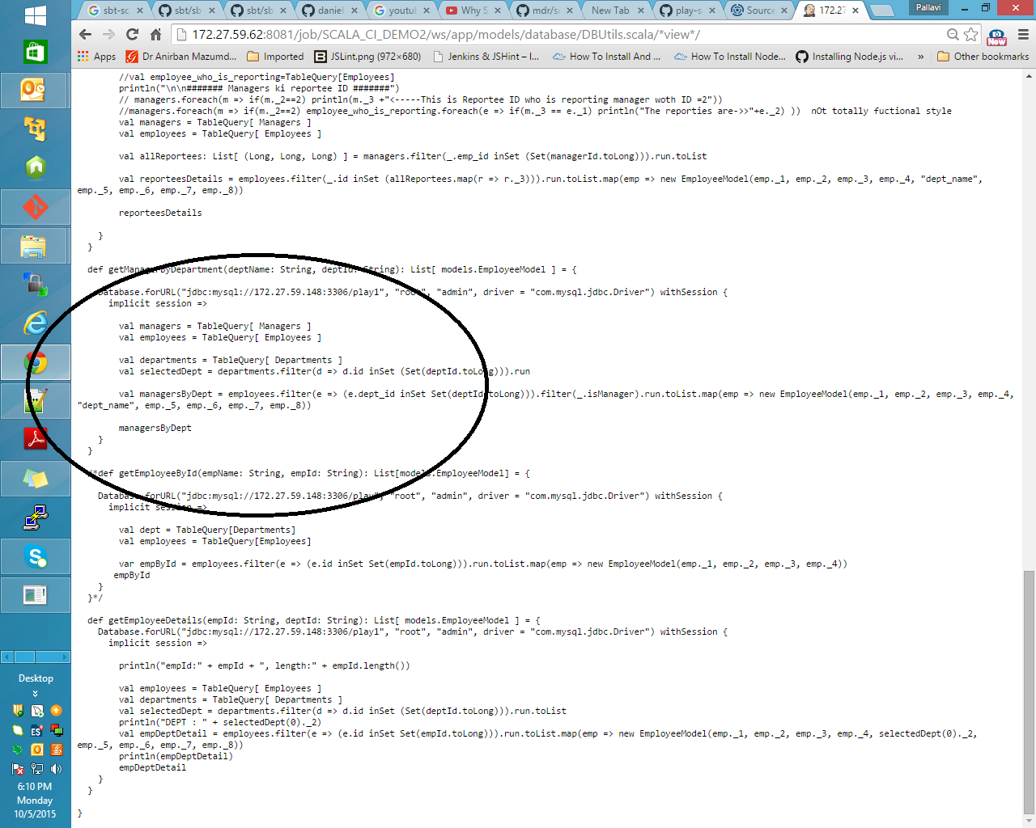

Note:-

* Site referred for inclusion of correct resolvers is

<https://github.com/daniel-trinh/sbt-scalariform>

* Site referred to customize formats

<https://github.com/mdr/scalariform>