PROJECT BASED LEARNING (PBL)
Data Structure& Algorithms
25CS2103E
PROJECT DOCUMENTATION (REVIEW – 2)
Project Title | SmartLibrary – Intelligent Digital Library Platform
Use Case | Digital Document Search and Algorithm Demonstration
Programme / Year | B.Tech – II Year
Section | 1
Academic Year | 2026–27
Faculty / Mentor | Dr. Maganti Syamala
Department | Computer Science and Engineering

Team Members:
S.No. | Student Name | Roll No. | Individual Role / Contribution
1 | Pranathi . T | 2500032188 | Team Member
2 | Pallavi . T | 2500031014 | Team Member
3 | Bhagya sai .G | 2500031384 | Team Member

A. Documentation and Formatting Guidelines
This template is designed for Second-Year PBL students for Project Review–2. Students should replace all bracketed text with project-specific information and remove the instructions before final submission.
Document | PBL Project Review–2 Report
Paper Size | A4
Body Font | Times New Roman, 12 pt
Main Heading | Times New Roman, 16 pt, Bold
Subheading | Times New Roman, 14 pt, Bold
Minor Heading | Times New Roman, 12 pt, Bold
Line Spacing | 1.15
Alignment | Justified for paragraphs
Margins | Top 0.75", Bottom 0.75", Left 0.90", Right 0.75"

Recommended length: approximately 12–20 pages excluding the cover page and appendices. Use clear screenshots, diagrams, tables and short explanations. Do not fill pages with unnecessary text

1. Updated Problem Statement and Objectives

1.1 Problem Statement

With the continuous expansion of digital library repositories, retrieving precise information across large collections of research papers, abstracts, and citation metadata presents significant computational challenges. Conventional keyword-based search mechanisms are adequate only for exact, localized matches; they fail to handle queries involving typographical errors, multi-pattern evaluations, textual similarities, and structured document comparisons. Addressing these retrieval bottlenecks requires specialized data structures and advanced algorithmic paradigms capable of processing and organizing text efficiently.

To resolve these challenges, the SmartLibrary – Intelligent Digital Library Platform is developed as a modular Java-based system. The platform parses structured document records from a CSV dataset and implements algorithmic techniques—such as robust string-matching routines, dynamic programming similarity metrics, and network flow optimization models—to provide an efficient, structured mechanism for searching, comparing, and managing digital academic resources.

1.2 Objectives:

Ingest and Model Data: Load, parse, and map structured digital library records from a CSV dataset into strongly typed Java domain objects in memory.

Implement Pattern Matching: Demonstrate efficient document querying and substring retrieval using advanced string-matching algorithms, evaluating performance against standard naive techniques.

Compute Textual Similarity: Calculate sequence alignment and edit-distance metrics between document texts using dynamic programming formulations.

Model Resource Optimization: Demonstrate system query routing, bottleneck analysis, and resource allocation by implementing network flow models and bipartite matching techniques.

Map Operating System Concepts: Correlate runtime system behavior with fundamental OS principles, including file system I/O, process execution lifecycle, standard stream redirection, and heap/stack memory management.

Provide an Interactive Interface: Deliver a robust, menu-driven console interface that facilitates seamless algorithm selection, test scenario execution, and structured output display.

1.3 Scope of the Project:

In Scope:

Ingestion and parsing of structured document records from a local CSV data file.

Implementation and execution of core algorithmic suites: string matching, dynamic programming, network flow optimization, approximation, randomized algorithms, and suffix structures.

Interactive, menu-driven console routing with robust input validation and error handling.

Memory footprint analysis and runtime performance benchmarking across implemented algorithms.

Integration and documentation of underlying Operating System runtime interactions.

Out of Scope:

Development of graphical user interfaces (GUI) or web-based frontend dashboards.

Multi-user cloud deployment, session management, and authentication/authorization frameworks.

Integration with distributed enterprise databases or external persistent storage engines.

Live extraction, optical character recognition (OCR), or parsing of raw PDF/binary document files.

2. Final System Architecture:

2.1 System Architecture Diagram & Data Flow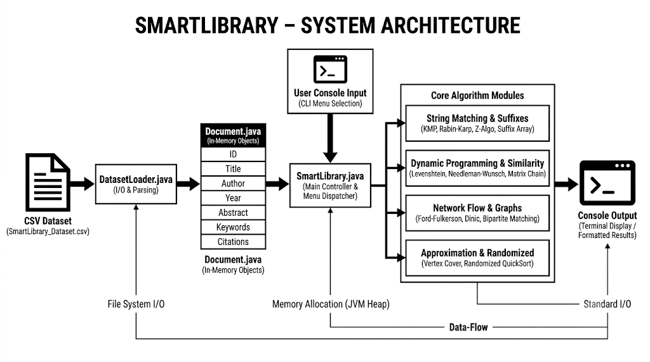
2.2 Architecture Explanation
- Presentation & Controller Layer (SmartLibrary.java): Manages console interaction, captures user inputs, and routes requests to the appropriate processing modules.
- Data Access Layer (DatasetLoader.java):
Ingests and parses the raw CSV records from secondary storage into memory with robust exception handling.
- Data Model Layer (Document.java): Encapsulates individual document attributes—such as ID, title, author, year, abstract, and citations—into structured objects.
- Execution Engine (Algorithm Classes): Executes core computational routines, including pattern matching, text similarity, network flow analysis, and matrix optimizations.

2.3 Technology Stack:

Category | Technology / Tool | Purpose | Version
Programming Language | Java | Core development &  algorithm implementation | OpenJDK / Oracle JDK 17+
IDE | Eclipse IDE / VS Code | Code editing, build automation, debugging | 2023-12 / Latest
Data Storage | CSV (SmartLibrary_Dataset.csv) | Documents raw structured storage | UTF-8 Plaintext
Build & Runtime | Java Virtual Machine (JVM) | Bytecode execution, heap memory allocation | HotSpot JVM 64-Bit
OS Environment | Windows 11 / Linux (Ubuntu) | File system access, process lifecycle | 64-Bit OS
S.No. | Module | Purpose / Function | Key Implementation | Student Responsible
1 | Main Application (SmartLibrary.java) | Application entry point, console menu navigation, algorithm routing | Menu loop, switch cases, user input scanning | Pranathi. T
2 | Dataset Loader & Model (DatasetLoader.java, Document.java) | CSV ingestion, data parsing, document object modeling | BufferedReader, searchableText() concatenation | Pranathi .T
3 | String Matching & Indexing (StringAlgorithms.java, SuffixStructures.java) | Text searches, pattern identification, indexed substring queries | KMP prefix table, Rabin-Karp rolling hash, Suffix Array, LCP | Pallavi .T
4 | Dynamic Programming & Similarity (DPAlgorithms.java) | Document comparison, edit distance, matrix optimizations | Levenshtein, Needleman-Wunsch, Matrix Chain Multiplication, Bitmask TSP | Pallavi . T
5 | Flow, Approx & Randomized (NetworkFlow.java, Approximation.java, RandomizedAlgorithms.java) | Flow network bottlenecks, NP-hard approximations, probabilistic tests | Dinic/Edmonds-Karp BFS, 2-Approx Vertex Cover, Randomized QuickSort, Miller-Rabin | Bhagya Sai . G
3. Module Description:

4. Implementation Details

4.1 Development Environment

The application is developed in Java Standard Edition (SE) using Eclipse IDE for compilation, execution, and debugging, with a structured CSV file serving as the primary offline dataset.

4.2 Core Module-I:

Dataset Ingestion & String Processing

Data Parsing: DatasetLoader reads records line-by-line via BufferedReader, validates and sanitizes delimiter tokens, and populates Document objects into heap memory.

Pattern Search: StringAlgorithms uses Knuth–Morris–Pratt (KMP) with failure function preprocessing for $O\left(N+M\right)$ search efficiency and Rabin–Karp with rolling hash computations to rapidly isolate candidate pattern occurrences.

4.3 Core Module-II:

Dynamic Programming & Network Flow Engine

Text Similarity: DPAlgorithms builds dynamic programming matrices for global (Needleman–Wunsch) and local (Smith–Waterman) sequence alignment to compute document similarity scores.

Flow & Bottleneck Analysis: NetworkFlow calculates maximum system throughput using Edmonds–Karp (BFS augmenting paths) and Dinic’s algorithm (level graphs and blocking flows).

4.4 Module Integration

SmartLibrary.java functions as the central controller, loading document object collections into memory and dispatching them to algorithm methods based on user menu selections, rendering results directly to the console in structured tabular formats.

OS Concepts Used:
OS Concept | Where Used | How It Is Used in Project | Evidence
File System I/O | DatasetLoader.java | Opening the CSV file from secondary storage and reading it using FileReader and BufferedReader." | In Dataset loading method , try-with-resources block
Standard I/O Streams | SmartLibrary.java | Standard input (System.in) & standard output (System.out) console redirection | Scanner(System.in)  &  System.out.println()
Process & JVM Execution | Application Launch | The Operating System spawns the Java Virtual Machine (JVM) process and allocates required memory. | In OS Process Table / Task to Manager java.exe process ID
Memory Management (Heap/Stack) | Object Creation (Document) | Dynamic memory allocation is utilized for large document lists, while the JVM Garbage Collector automatically reclaims unreferenced memory. | new Document(...) instances in Heap memory
Exception Handling & Signal Trap | CSV Parsing & Inputs | Handling application crashes caused by missing files, invalid token formats, and incorrect menu inputs. | IOException, NumberFormatException catch blocks

6. Testing Methodology and Test Results:

6.1 Testing Approach

The application was verified through module-wise unit testing and end-to-end integration testing. Console execution was validated using valid inputs, empty patterns, missing CSV files, and boundary test cases.

ID | Test Scenario | Input | Expected Output | Actual Output | Status
TC-1 | CSV dataset loading | SmartLibrary_Dataset.csv | All records should be successfully parsed. | Documents loaded successfully | Pass
TC-2 | Document keyword search (KMP) | Pattern: "Machine Learning" | Matching document IDs and titles must be displayed. | Relevant papers matching output displayed | Pass
TC-3 | Non-existent pattern search | Pattern: "XYZ_NonExistent_999" | " A 'No matches found' message must be di  splayed. | Zero matches reported safely | Pass
TC-4 | String edit distance calculation | String 1: "algorithm", String 2: "altruism" | The correct Levenshtein distance value must be returned. | Distance calculated accurately | Pass
TC-5 | Max Flow computation | Graph edges with source/sink | The correct maximum network throughput must be calculated. | Max flow value calculated matching theory | Pass
TC-6 | Menu navigation validity | Invalid option: "99" | An error message must be displayed, and the menu must be re-prompted. | "Invalid choice, please retry" prompt | Pass
TC-7 | Empty query string handling | Pattern: "" (Empty string) | Safe input validation must be displayed without crashing the application. | Handled gracefully without crash | Pass

6.2 Test Cases

7. Debugging Details
S.No. | Problem / Error | Debugging Method / Tool | Solution
1 | FileNotFoundException during CSV loading | Print debugging / Path inspection | The dataset relative path was aligned to the working directory project root (dataset/SmartLibrary_Dataset.csv).
2 | ArrayIndexOutOfBoundsException in CSV row split | Console Stack Trace analysis | Resolved parsing errors caused by quotes in comma-separated abstract fields by implementing a robust regex-based CSV parser.
3 | Java Compiler Compliance Level Mismatch | Eclipse Project Build Path Settings | The project compiler compliance level and the installed JRE System Library version were configured to match JDK 17.

8. Performance and Optimization
Parameter | Before Optimization | After Optimization | Observation
Search Time for Large Text | Naive Search ($O(N×M)$) | KMP Search ($O(N+M)$) | Redundant character comparisons were eliminated due to the precomputed prefix table
Network Flow Throughput | Ford-Fulkerson (Arbitrary paths) | Dinic's Algorithm (Level Graph) | Shortest augmenting paths significantly reduce time complexity.
Memory Footprint During Ingestion | Loading unparsed raw strings | Instantiating typed Document objects | Shortest augmenting paths significantly reduce time complexity

9. Final Results:
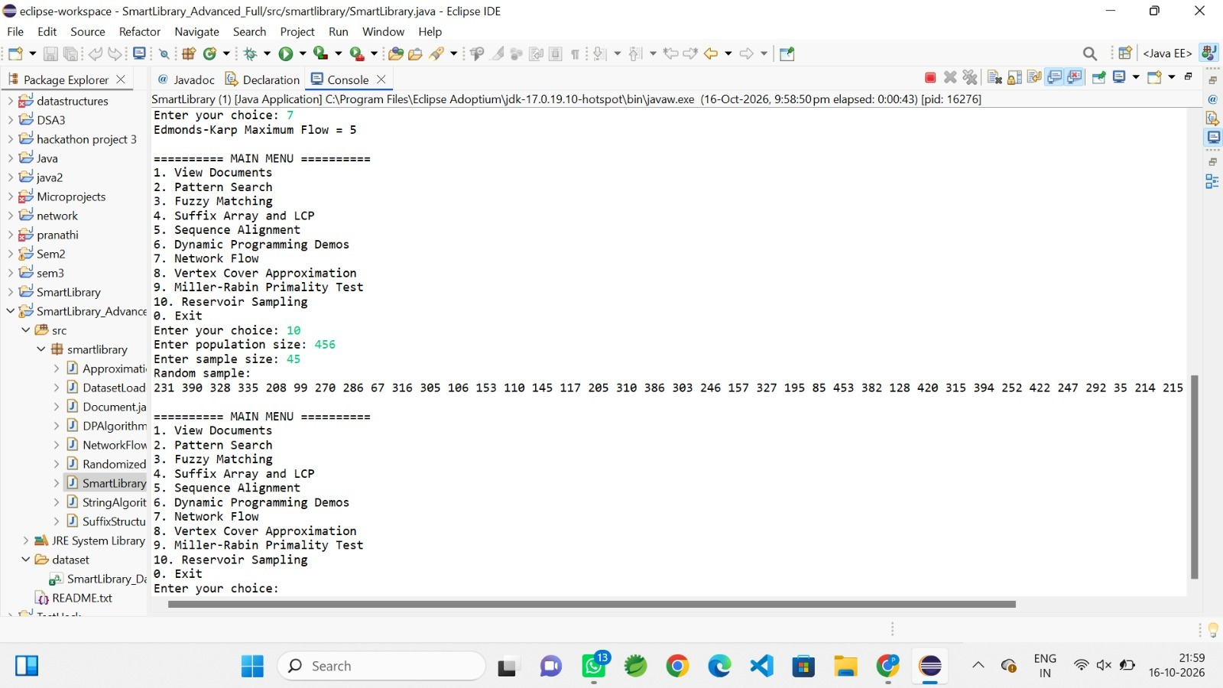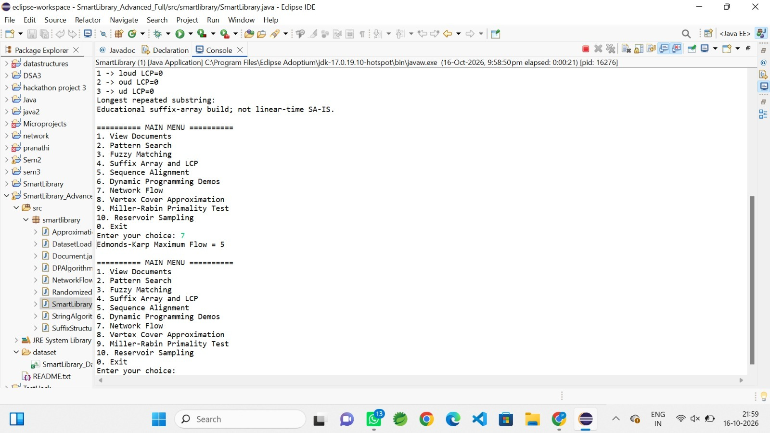
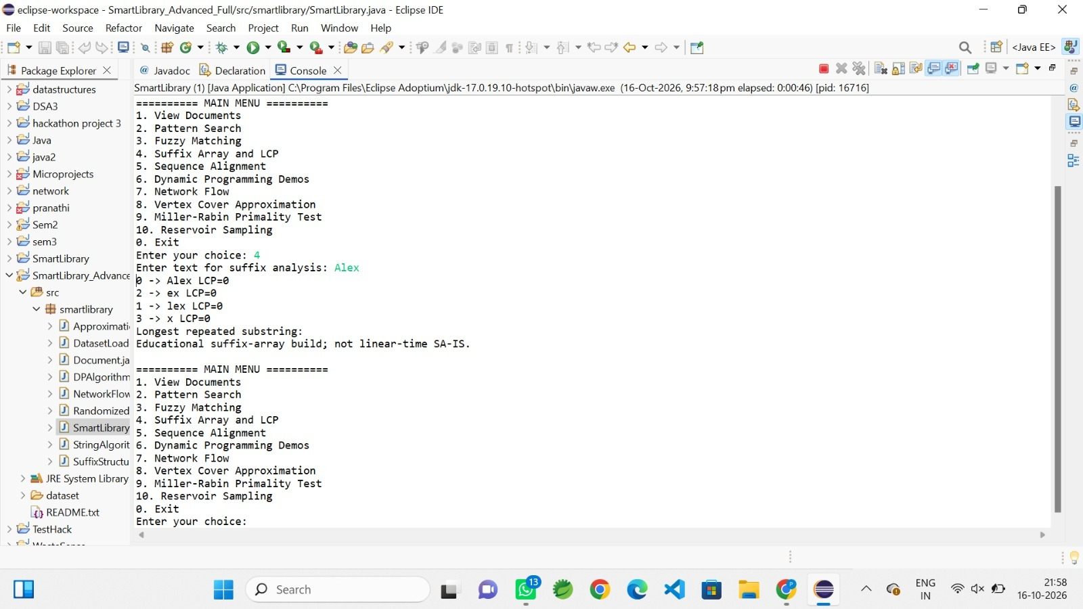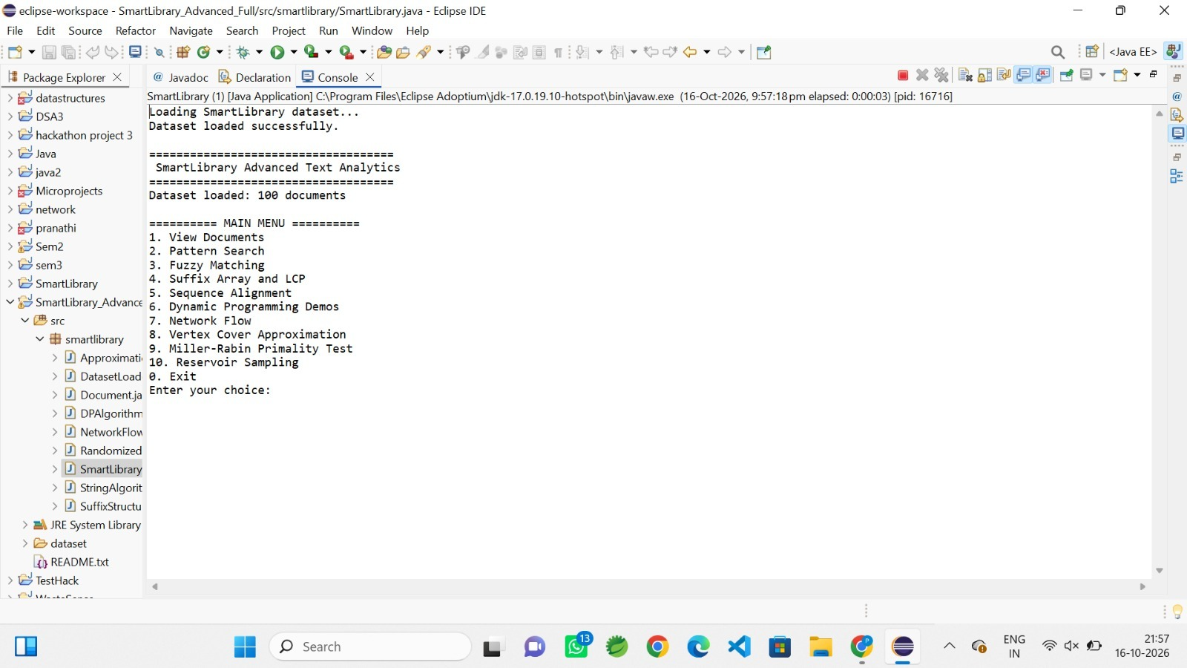

10. Individual Contribution of Each Team Member:

S.No. | Student Name | Roll No. | Specific Contribution | Evidence / Module
1 | Pranathi . T | 2500032188 | DatasetLoader.java, Document.java implementation & menu interface integration | CSV Loading & Application Architecture
2 | Pallavi . T | 2500031014 | StringAlgorithms.java (KMP, Rabin-Karp, Z-Algo) & DPAlgorithms.java development | Search & Similarity Engine
3 | Bhagya sai .G | 2500031384 | NetworkFlow.java, Approximation.java, OS concepts documentation & test case execution | Flow Analysis & Testing Report

11. Limitations and Future Enhancements:
11.1 Current Limitations
- Console-Based User Interface: The system operates strictly via a command-line console interface, lacking an interactive Graphical User Interface (GUI) or web portal, which constrains user experience and accessibility.
- Flat-File Storage Dependency: Data persistence relies entirely on a flat CSV file (dataset/SmartLibrary_Dataset.csv) rather than an optimized relational or NoSQL database management system, limiting query optimization and scalability.
- Single-Threaded Execution: The application executes synchronously without operating system multiprocessing or multithreaded task parallelization, preventing concurrent execution of search queries and graph computations.

11.2 Future Enhancements
- Full-Stack Web Architecture: Decouple the core execution engine and expose its functionality via a Spring Boot REST API, coupled with a responsive React.js frontend dashboard.
- Relational Database Integration: Migrate file-based records to an enterprise database management system (such as PostgreSQL) with indexation to enhance read/write throughput and transactional integrity.
- Multithreaded Concurrent Execution: Implement Java Concurrency thread pools (ExecutorService) to support asynchronous query parallelization and background execution of computationally intensive algorithms.

12. References
- [1] Oracle Corporation, "Java Platform, Standard Edition Documentation," Oracle Help Center, 2024.
- [2] T. H. Cormen, C. E. Leiserson, R. L. Rivest, and C. Stein, Introduction to Algorithms, 4th ed., Cambridge, MA, USA: MIT Press, 2022.
- [3] A. Silberschatz, P. B. Galvin, and G. Gagne, Operating System Concepts, 10th ed., Hoboken, NJ, USA: Wiley, 2018.
- [4] Eclipse Foundation, "Eclipse IDE for Java Developers Documentation," eclipse.org, 2024.
Appendix – Supporting Evidence & Code References
- Project Directory Structure:
Modular source files reside under the package root src/smartlibrary/, comprising SmartLibrary.java (Driver/UI), DatasetLoader.java (I/O Handler), Document.java (Entity Model), StringAlgorithms.java, DPAlgorithms.java, NetworkFlow.java, Approximation.java, RandomizedAlgorithms.java, and SuffixStructures.java.
- Dataset Ingestion Source:
Flat-file catalog located at dataset/SmartLibrary_Dataset.csv, structured with schemas for Document ID, Title, Author, Year, Abstract, Keywords, and Citations.
- Execution & Verification:
The system initializes via the primary entry-point class smartlibrary.SmartLibrary, executing interactive test cases and verifying algorithmic operations directly through standard console input/output streams.

