Project Documentation
Title: Plugging into the Future: An Exploration of Electricity Consumption Patterns

1. Problem Statement
Analyze electricity consumption patterns across Indian states (2019–2020), including COVID-19 lockdown impact, using MySQL, Tableau and Flask.

2. Objectives
• Analyze monthly, quarterly and yearly consumption.
• Compare regions and states.
• Study lockdown impact.
• Build interactive dashboards and stories.

3. Dataset Collection
Collected electricity consumption dataset in Excel/CSV format. Verified columns, date fields, missing values and duplicates.
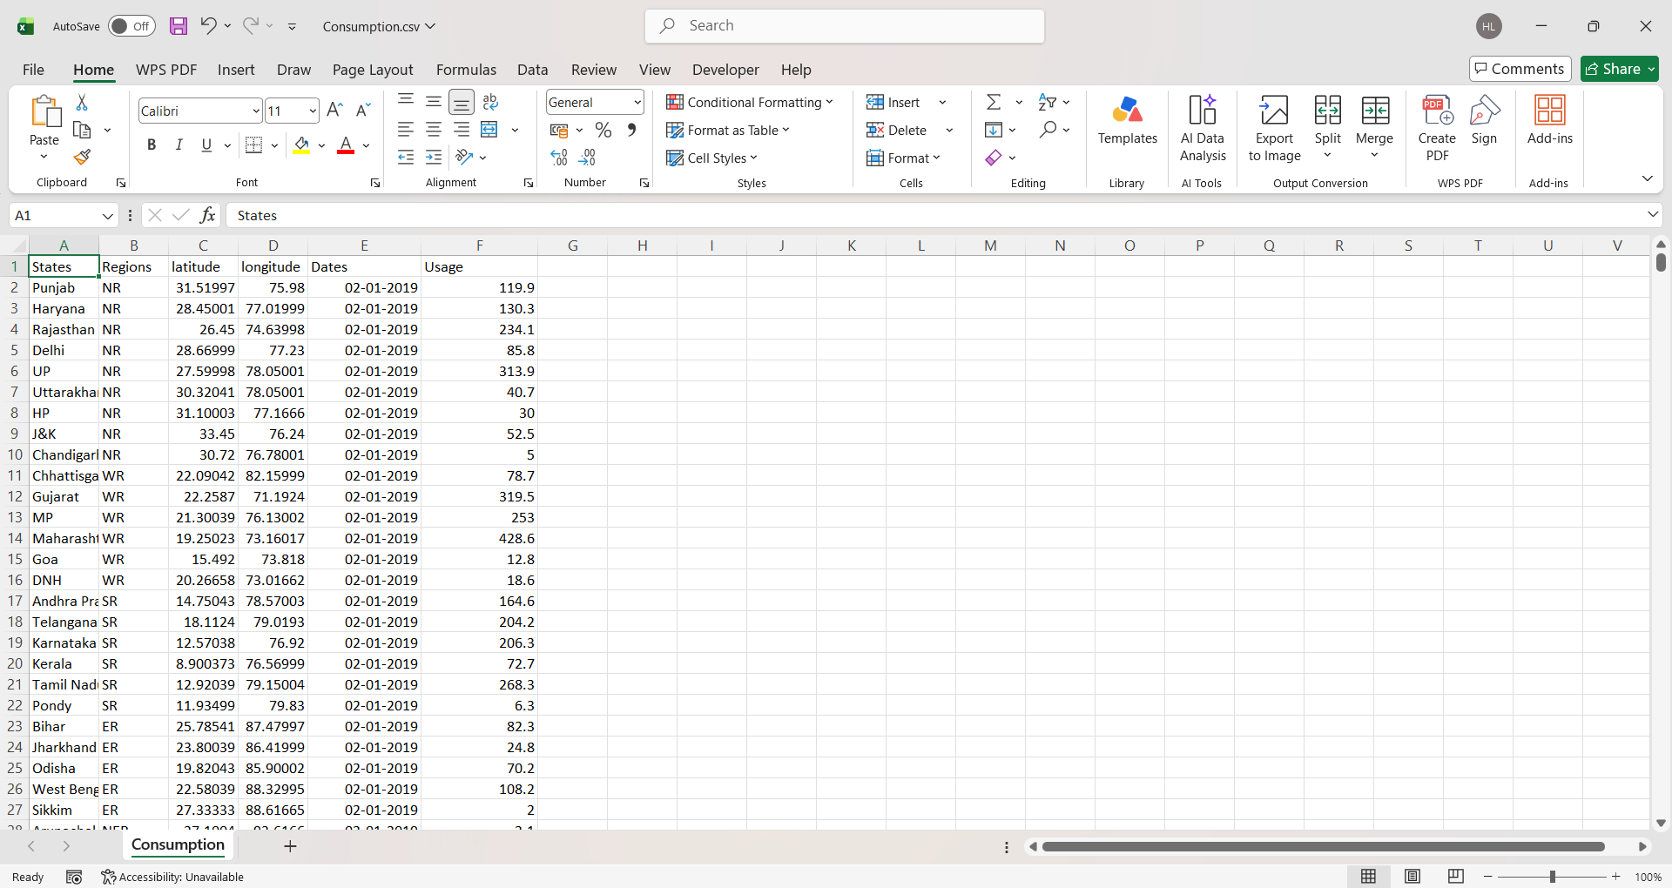

4. Database Creation
Created MySQL database and table. Imported dataset into MySQL using Import Wizard. Verified records with SELECT queries.

5. SQL Operations
Executed SELECT, WHERE, ORDER BY, GROUP BY, COUNT, SUM, AVG and filtering queries to validate and analyze data.

6. Connect MySQL with Tableau
Connected Tableau Desktop to MySQL, selected database and table, loaded data for analysis.

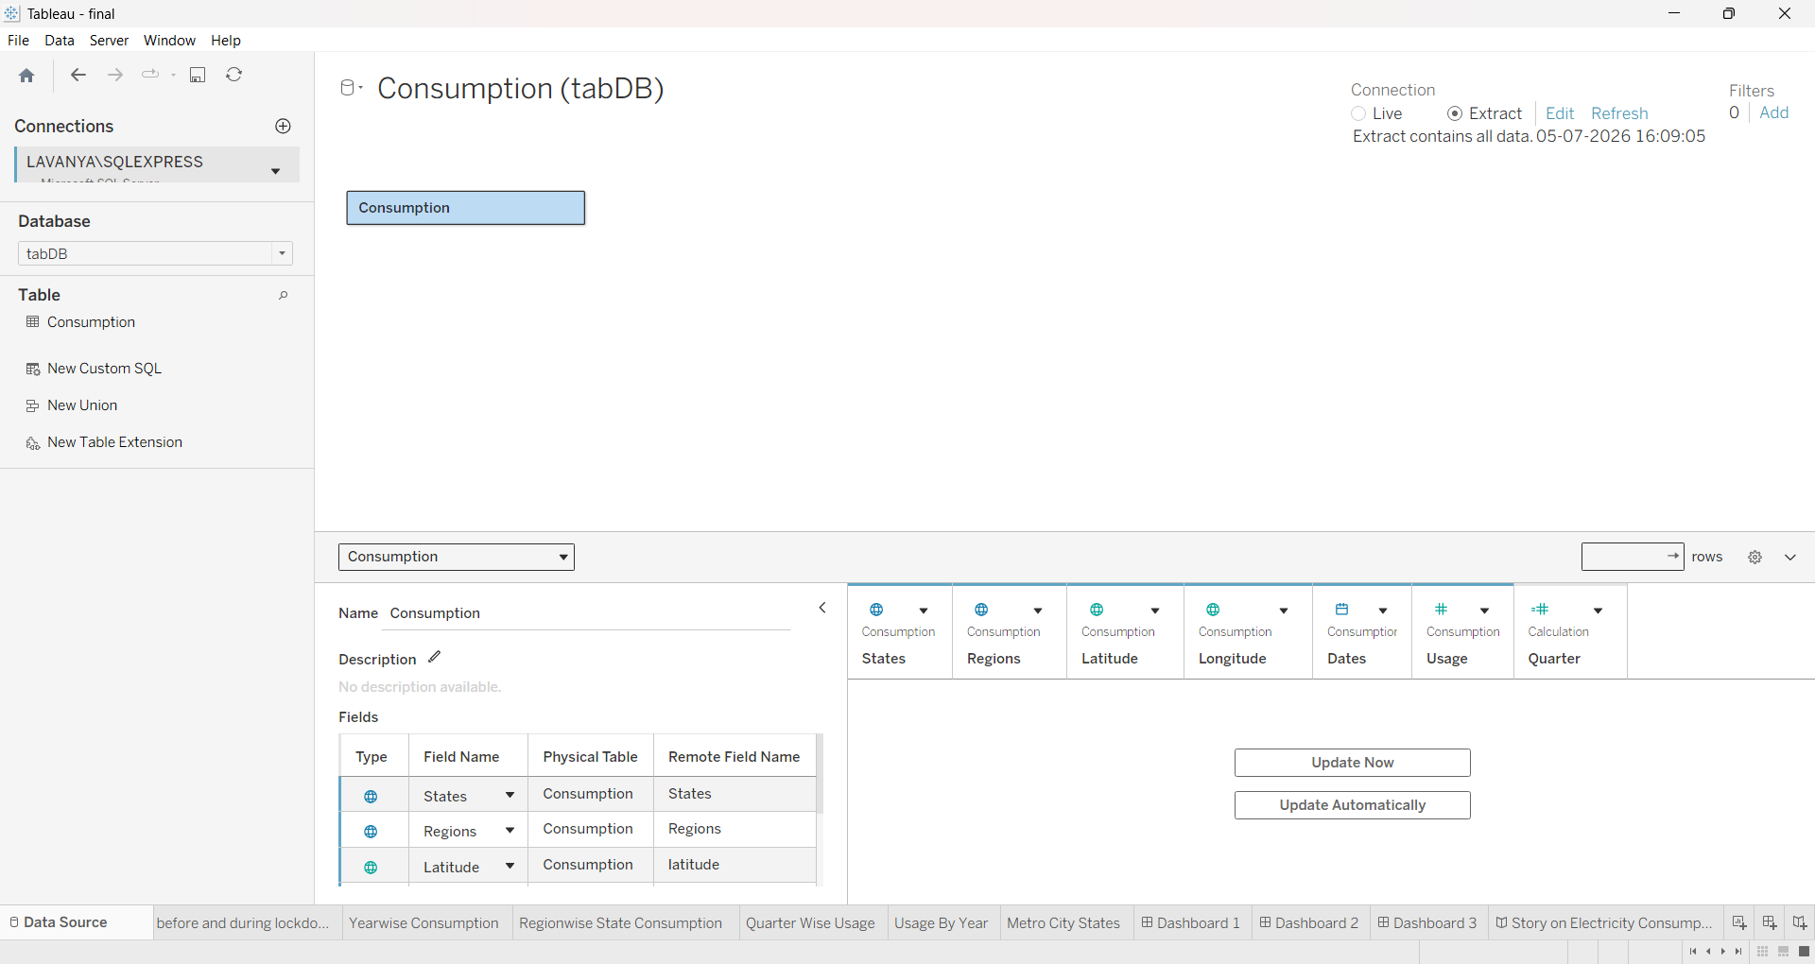

7. Data Preparation
Verified data types, renamed fields, checked date formats, created calculated fields (Year, Quarter), validated data.

8. Data Visualizations
Created Region-wise Consumption, Year-wise Consumption, Usage by Year, Quarter-wise Usage, Metro City Analysis, Monthly Trend, Top/Bottom States and Lockdown Analysis.

9. Dashboard
Combined visualizations into an interactive dashboard with filters for Year, Region and State.
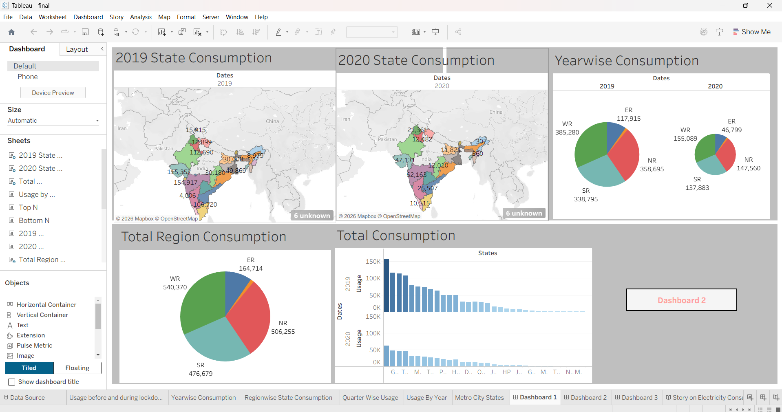

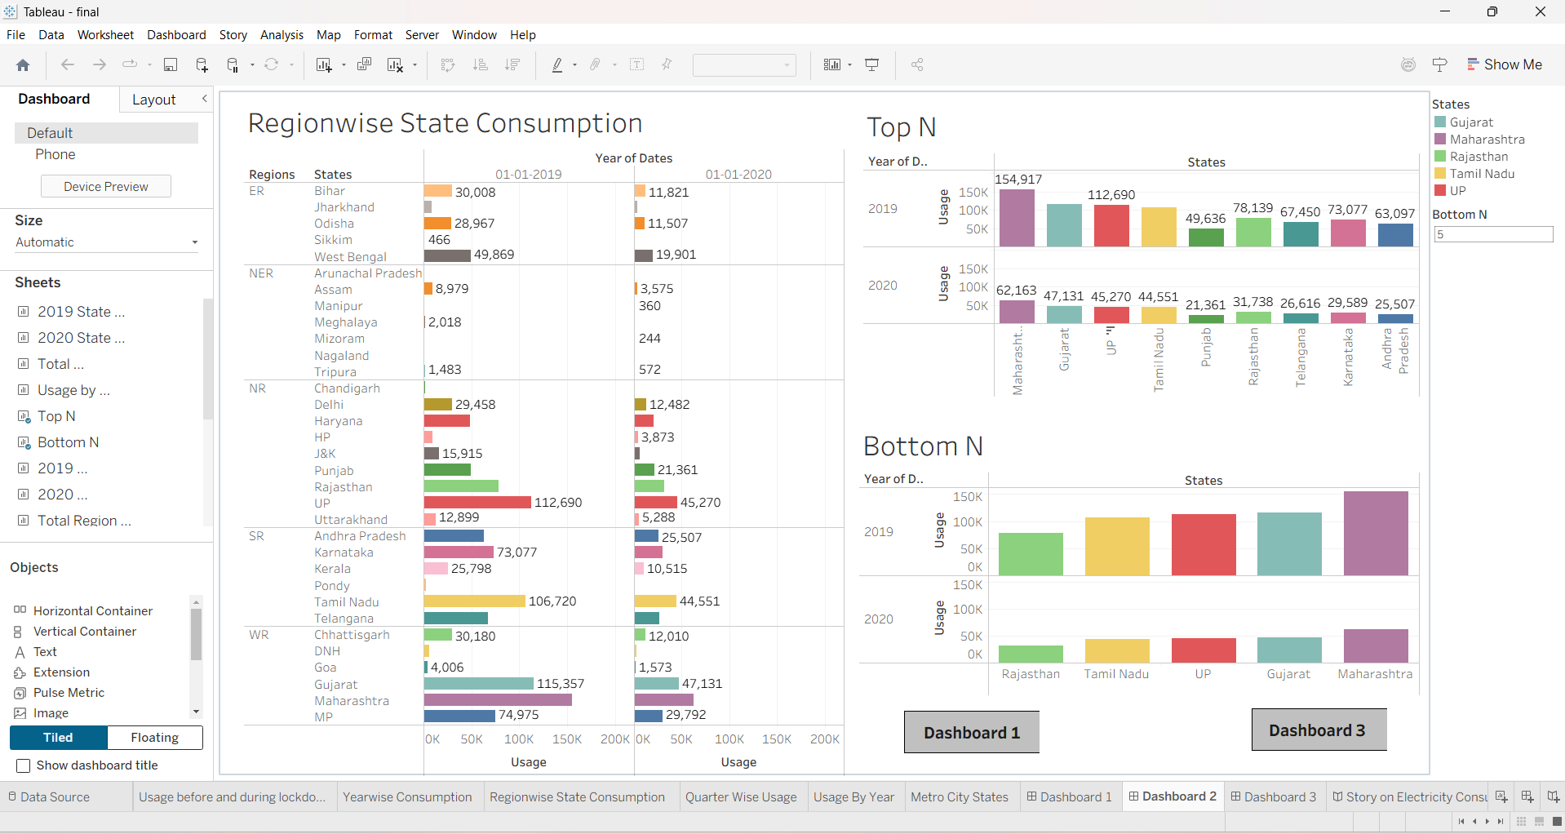

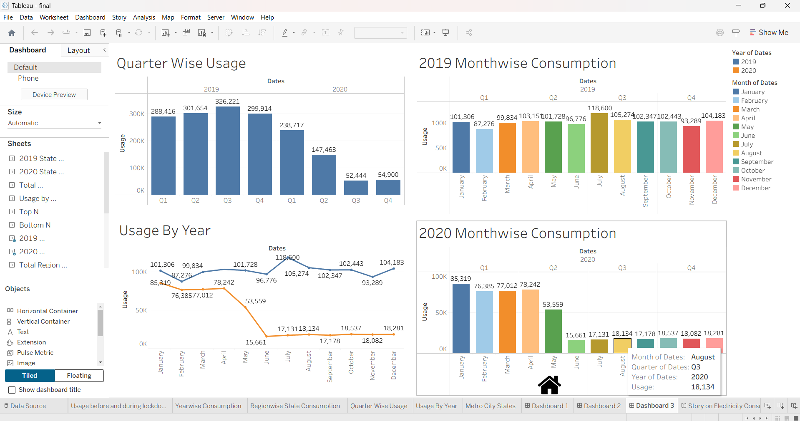

10. Story
Created Tableau Story explaining insights through multiple scenes.

11. Performance Testing
Verified data rendering, optimized filters and calculations, ensured dashboard responsiveness.

12. Web Integration
Published dashboards to Tableau Public and embedded dashboard into Flask application.

13. Results
Identified regional demand differences, quarterly trends, recovery after lockdown and state-wise consumption patterns.

14. Conclusion
The project successfully analyzed electricity consumption using MySQL, Tableau and Flask, providing interactive insights for decision making.

15. Future Scope
Add real-time data, predictive analytics, cloud deployment and advanced dashboards.

Team Members
• Balam Hema Lavanya (Team Lead)
• Golla Samatha
• Malin Shaik
• Asiya Moin
• Sumiya Syed

