Audio-Visual Event Localisation
in Untrimmed Videos
Team Onboarding Guide — Project Overview, Architecture & Setup
Dataset: AVE (Audio-Visual Events), Tian et al., ECCV 2018
Architecture aligned with the paper's reference implementation (models.py)

1. Project Overview
This project builds a model that detects whether what we hear and what we see in a video are actually connected — at every second of the video.

Concrete example: a 10-second video clip contains a dog barking. The model must figure out:
- WHEN the barking happens (which seconds)
- WHETHER the dog is actually visible on screen at that moment, or just heard off-camera

This is harder than it sounds — a video can have sound with no matching visual (e.g. a dog barking off-camera), or visuals with no matching sound (e.g. a silent dog on screen). The model needs to tell these cases apart.

1.1 The Core Concept: Audio-Visual Correspondence
Scenario A — Aligned  Sound + Visible on screen = Correspondence | Scenario B — Not Aligned  Sound + Not visible = No Correspondence

1.2 Dataset — AVE
- 4,143 video clips, 28 real event categories (dog barking, church bell, violin, car horn...) PLUS 1 Background class = 29 total classes for the model to predict
- Each clip is 10 seconds long. The dataset is a subset of AudioSet, and the clips are sourced from YouTube (confirmed via the original paper and independent citing literature)
- Labeled per second: which seconds the event audio-visually occurs
- Train / validation / test splits are already provided by the dataset authors (3,339 / 402 / 402)
- GitHub: github.com/YapengTian/AVE-ECCV18

The Background class
Not every second of every clip contains an audio-visual event. The raw annotation file only gives a category, a start second, and an end second for the real event — it never writes the word 'Background' anywhere. Background is something we derive ourselves: any second NOT covered by the given start-end range counts as Background. There are also 178 entire videos in the dataset with no event annotation at all — every second of those videos is Background by default. Only about 17.8% of all 1-second segments across the dataset lack a real audio-visual event, so Background is the minority class, not the majority — relevant for the class imbalance handling in Section 5.
Practical effect on the model: the final classification layer must output 29 values (28 real classes + Background), not 28.

Annotation format (decoded)
Example: "Church bell&RUhOCu3LNXM&good&0&10"

- Field 1 — Event category
- Field 2 — YouTube video ID
- Field 3 — Annotation quality
- Field 4 — Event start second
- Field 5 — Event end second

2. The Complete Pipeline
This is the heart of the project. Every teammate should understand this flow before touching code.
Updated to align with the reference implementation in the original AVE paper's models.py (att_Net class — the 'AV_att' model), so our results stay directly comparable to their published baseline.
Step 1 — Segmentation: Split audio + video into 10 one-second chunks
Step 2 — Audio Encoding: chunk -> VGGish -> 128-dim Audio Vector
Step 3 — Video Encoding: chunk -> R(2+1)D -> 512-dim Video Feature Map
(kept as a spatial grid, not flattened to one vector)
Step 4 — Audio-Guided Attention:
Audio vector guides WHICH spatial region of the
video frame the model should focus on
Step 5 — Temporal Modeling:
Bi-directional LSTM (one for audio, one for
attended video) models how the event evolves
across the 10 one-second segments
Step 6 — Fusion: Concatenate audio-LSTM and video-LSTM outputs
Step 7 — Classification: Two Linear layers + softmax -> event prediction
Step 8 — Training: Compare with ground truth -> backpropagation -> learn

Note on LSTM here: our system-thinking session argued against RNNs for raw audio due to vanishing gradients over very long sequences (16,000+ samples per second). That risk does not apply here — by this stage the audio is already compressed into one 128-dim VGGish vector per second, so the LSTM only processes a short sequence of 10 steps, well within what LSTMs handle reliably.

The diagram below shows the same pipeline as a data-flow chart — useful for visualising how tensors move between stages.
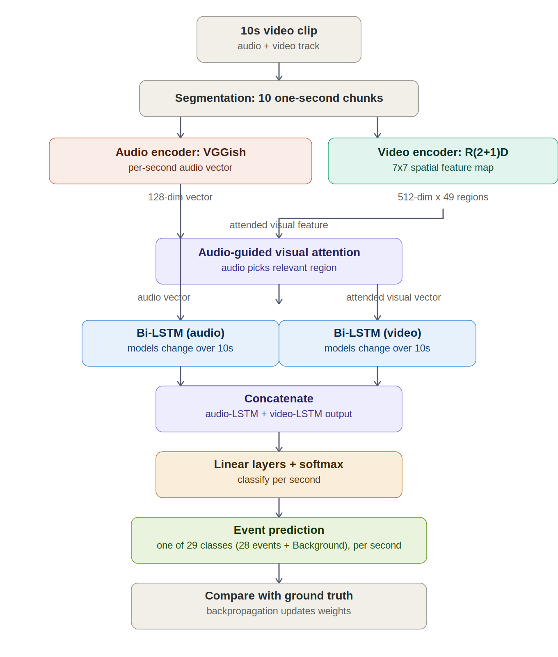

3. Why We Chose These Models
Not just WHAT we are using, but WHY — so everyone can defend these choices in the colloquium and debug intelligently.

3.1 Why not a simple RNN for audio?
Audio is a sequence (16,000 samples per second at 16kHz). RNNs process sequences step-by-step, which causes the Vanishing Gradient Problem — information from early time steps gets lost by the time the model reaches later time steps. This makes RNNs weak at understanding long audio clips.

3.2 Why Transformers instead?
Transformers (introduced in the 2017 paper "Attention is All You Need") let every time step directly look at every other time step at once, instead of processing one at a time. Position information is preserved using positional encoding. This avoids the vanishing gradient problem entirely.

3.3 Audio Encoder — VGGish
- Converts a 1-second audio chunk into a fixed 128-dimensional vector
- Pre-trained on AudioSet — a massive dataset of labeled real-world sound events (the same kind of sounds in AVE: barks, bells, engines...)
- Used directly by the ORIGINAL AVE paper — gives us a clean, comparable baseline
- Lightweight — no fine-tuning needed if used as a frozen feature extractor, which saves significant training time
- PyTorch-native — fits cleanly with the rest of our stack (no mixing frameworks)

Important: sample rate mismatch
Our actual dataset audio is natively 44,100 Hz (confirmed by directly inspecting a sample video file with librosa — see Section 7 environment checks). VGGish, however, was pre-trained expecting 16,000 Hz input. This 16kHz figure is a fixed requirement of the pre-trained model, not a property of our dataset. Every audio chunk must be downsampled from 44,100 Hz to 16,000 Hz before being fed into VGGish.

The math behind downsampling
The simplest possible idea for downsampling is to just keep every Nth sample. The skip distance N is found by dividing the original rate by the target rate:
downsampling factor = original rate / target rate
44,100 / 16,000 = 2.75625
This is the first complication: a clean dataset like 10 samples down to 5 gives a whole-number factor of 2 (keep every 2nd sample), but our real factor, 2.75625, is not a whole number. You cannot literally skip every 2.75625th sample, so naive skip-counting breaks down for real audio.

Why naive skipping is dangerous: aliasing
An intuitive picture first: imagine filming a spinning bicycle wheel with a camera that only takes one photo per second. If the wheel spins slowly, the photos show it rotating normally. But if the wheel spins very fast — almost a full turn between each photo — the photos can trick the eye into seeing a completely different, slower spin, even appearing to rotate backwards. This is the well-known fast-spinning-wheel illusion seen on camera. Sound works the same way: a fast vibration is like a fast spin, and a low sample rate is like a slow camera.
Audio is a smooth, continuously oscillating wave. If a wave oscillates very fast (a high pitch) and is sampled too sparsely, the few remaining points can connect into a completely different, slower wave that was never actually played — the audio equivalent of the wheel's fake backward spin. This is called aliasing — fast information disguising itself as fake, slower information. It is not the same as noise: a fake slow note looks like a completely legitimate, real sound, which is what makes it dangerous. A model has no way to know it is wrong.
There is a precise threshold for which frequencies are safe at a given sample rate, called the Nyquist rule:
highest safe frequency = target sample rate / 2
At 16,000 Hz, the highest safe frequency = 8,000 Hz
Any sound vibrating faster than 8,000 Hz cannot be safely represented at 16,000 Hz and is at risk of aliasing into a fake lower frequency if not handled correctly. Sounds vibrating slower than 8,000 Hz are already safe and need no correction at all.

The fix: low-pass filtering before downsampling
The solution is to apply a low-pass filter to the audio before reducing the sample count. Using the wheel analogy: this is like turning down a fan's speed dial before filming it — the fan genuinely, physically slows down, so the slow camera can capture it accurately with no illusion. A low-pass filter does the same thing to sound: it genuinely weakens (not disguises, not relocates) any vibration faster than the 8,000 Hz safe threshold, so that by the time samples are discarded, there is nothing fast and strong enough left to be misread as a fake slower note.
- This must happen BEFORE downsampling, not after — once samples are discarded, a fake slow wiggle is indistinguishable from a real one. There is no way to undo aliasing after the fact, the same way a photo of the fake-spinning wheel cannot be corrected after it is taken.
- The filter is selective, not blanket: only vibrations faster than 8,000 Hz are weakened. A slow, low-pitched sound that was already safely under 8,000 Hz passes through completely untouched — there is nothing to fix
- The filter does not delete the fast detail outright; it weakens it until it is too quiet to survive into the reduced sample set
- This does mean some genuine fine detail (e.g. the highest shimmer of a violin note) is sacrificed — but a small, honest loss of detail is far less harmful than a fake note that actively misleads the model
In practice, this filtering is handled automatically by audio libraries such as librosa when resampling (e.g. librosa.load(path, sr=16000)) — the library applies an appropriate anti-aliasing filter internally before reducing the sample rate.

How VGGish turns 1 second of audio into a 128-dim vector
At a high level, VGGish does not feed raw amplitude samples into a neural network directly. A single raw amplitude value at one instant carries almost no information about what sound is occurring — meaning only emerges from how amplitude changes over a window of time. The pipeline is:
- 1. Downsample audio to 16,000 Hz, mono channel (with anti-aliasing filtering applied automatically, as above)
- 2. Convert the 1-second waveform (16,000 samples) into a log-mel spectrogram — a 2D image-like representation of frequency content over time, using a Short-Time Fourier Transform (STFT) followed by mapping onto the mel scale (which approximates human pitch perception) and a log transform (which approximates human loudness perception)
- 3. Feed the resulting spectrogram (a small image, roughly 96 x 64) through a VGG-style convolutional neural network — the same convolutional architecture family used in image classification, since a spectrogram is treated as an image
- 4. Take the output of the final fully-connected layer as the 128-dimensional embedding — a compressed numerical summary of the sound's frequency-over-time pattern
In short: raw waveform -> spectrogram (turns sound into an image of frequency vs time) -> CNN (extracts visual-style patterns from that image) -> 128-dim vector (a compact fingerprint of the sound).

3.4 Video Encoder — R(2+1)D
- A 3D convolutional network that understands motion across frames, not just single images
- Pre-trained on Kinetics (a large action-recognition video dataset)
- Available directly in torchvision — no extra library, one line to load
- Much lighter than large Transformer-based video models (like VideoMAE), which need more GPU memory and longer fine-tuning — a safer choice given our timeline

Important implementation detail: the original paper's attention mechanism needs the video features as a 7x7 spatial grid of 512-dim vectors (49 regions per second), not one flattened vector per second. When extracting features from R(2+1)D, we take the output of the last convolutional layer BEFORE the final pooling step, so spatial layout is preserved for the attention step in Section 4.

3.5 Pre-training vs Fine-tuning
Analogy: a general doctor (pre-trained model) completes a cardiology residency (fine-tuning on AVE data) to become a cardiac specialist (task-specific model). Both VGGish and R(2+1)D start as general-purpose encoders and may be fine-tuned on AVE-specific data.

4. Fusion Strategy — Combining Audio and Video
Earlier in our planning we considered simple fusion operators (sum, difference, multiplication, concatenation) in isolation. The original AVE paper combines two of these ideas — attention AND concatenation — rather than picking just one operator. We follow that approach so our results stay comparable to the published baseline.

4.1 Why not just multiplication (Hadamard product)?
Multiplication is simple and intuitive (acts like an AND gate — high output only when both audio and video are strong). However, the original paper's approach is more expressive: it lets the AUDIO decide which part of the VIDEO FRAME matters, before combining anything. This handles cases where the sound source occupies only a small part of the frame (e.g. a barking dog in the corner of a wide shot).

4.2 Step A — Audio-Guided Visual Attention
- The video frame is kept as a spatial feature grid (7x7 regions), not flattened into a single vector
- The audio vector for that second is used to compute an attention score for each of the 49 regions
- Regions more relevant to the current sound get higher attention weight
- The result is a single 'attended' video vector — a weighted combination of regions, weighted by relevance to the audio

4.3 Step B — Temporal Modeling with Bi-LSTM
- A separate Bi-LSTM processes the audio vectors across all 10 seconds of the clip
- Another Bi-LSTM processes the attended video vectors across the same 10 seconds
- This captures how the event builds up or fades across time, not just within a single second

4.4 Step C — Concatenation and Classification
- The audio-LSTM output and video-LSTM output are concatenated into one combined vector per second
- Passed through two Linear layers, then softmax, to produce a probability across 29 classes (28 real events + 1 Background) — the final layer's output size must be 29, not 28

4.5 Fusion Methods Considered (for context)
Method | Operation | Assessment
Sum Fusion | A + V | Combines signals but doesn't require both to be present
Difference Fusion | A - V | Near zero = aligned; captures disagreement
Hadamard Product | A x V | Simple AND-gate behaviour; easy to implement, but less expressive than attention
Attention + Concatenation | [LSTM(A); LSTM(attend(A,V))] | CHOSEN — matches the original AVE paper's att_Net model; audio guides WHERE to look in the frame before combining with temporal context

5. Known Risks and Solutions
Risk | Description | Solution
Class Imbalance | Some event categories (e.g. dog barking) have far more clips than others | Class weighting in the loss function — rare classes get a higher penalty when misclassified
Modality Dominance | Model learns to rely only on audio and ignores video entirely (or vice versa) | Modality dropout — randomly disable one modality during training so the model is forced to use both; verify with an ablation study (audio-only vs video-only vs fused)

6. Evaluation — How We Measure Success

6.1 Confusion Matrix
Predicted EVENT Predicted NO EVENT
Actual EVENT | True Positive | False Negative |
Actual NO EVENT | False Positive | True Negative |

- False Positive (false alarm) — model says EVENT but there wasn't one
- False Negative (missed event) — model says NO EVENT but there was one

6.2 Precision vs Recall — and why Recall matters more here
Precision = TP / (TP + FP) -> Of predicted events, how many were real?
Recall = TP / (TP + FN) -> Of real events, how many did we catch?

Missing a real event (False Negative) is worse than a false alarm for this task — a missed event means our system fails at its core job of indexing events. So Recall is prioritised over Precision.

6.3 Temporal IoU (Intersection over Union)
Measures HOW PRECISE the predicted timing is, not just whether an event was found.
Example:
Real event: second 3 to 8 (5 seconds)
Predicted event: second 5 to 11 (6 seconds)
Intersection: second 5 to 8 = 3 seconds
Union: second 3 to 11 = 8 seconds
Temporal IoU = 3 / 8 = 0.375

- IoU > 0.5 is generally treated as a correct prediction
- Calculated during evaluation, not during training

6.4 Baseline Comparison Ladder
A score means nothing without something to compare against. We climb this ladder to know where our model actually stands:
Level | Baseline | If we fail to beat this...
Level 1 | Always predict NO EVENT | There is a fundamental bug somewhere
Level 2 | Random prediction | The model is no better than chance
Level 3 | Simple ML (e.g. logistic regression on audio features) | The architecture needs rethinking
Level 4 | Yapeng Tian et al. 2018 (original AVE paper) | We are below the published state of the art for this dataset
Level 5 | Our model | Goal: match or beat Level 4

7. Environment Setup — Same Steps for Every Teammate
Follow these exact steps so all three of us have an identical, working environment. This avoids 'works on my machine' problems later.

7.1 Create a fresh conda environment
Use a modern Python version (3.10) — not 3.6 — so all required libraries (torch, torchvision, transformers) have ready-made install packages and we avoid build-from-source errors.
conda create -n ave_project python=3.10
conda activate ave_project

7.2 Install dependencies
Create a file named requirements.txt with the following pinned versions. Pinning avoids the situation where one teammate's machine silently installs a newer version that behaves differently — everyone gets the exact same, tested combination.
torch==2.9.1
torchvision==0.24.1
torchaudio==2.9.1
opencv-python==4.10.0.84
librosa==0.10.2
pandas==2.2.3
numpy==1.26.4
scikit-learn==1.5.2
mlflow==2.18.0

Why these versions: torch, torchvision, and torchaudio must share matching release numbers (per the official PyTorch compatibility matrix) — installing them separately without pinning risks a mismatch that causes cryptic runtime errors. All versions above have prebuilt wheels for Python 3.10 on Windows, macOS, and Linux, so pip install never needs to compile anything from source.

Then install everything in one command:
pip install -r requirements.txt

7.3 Install ffmpeg (required to read audio from video files)
conda install -c conda-forge ffmpeg

7.4 Verify the setup
python -c "import torch; print(torch.__version__)"
python -c "import torchvision; print(torchvision.__version__)"
python -c "import cv2; print(cv2.__version__)"
ffmpeg -version

Every command should print a version number with no errors before moving on.

7.4b GPU check — different hardware per teammate
Our team has mixed hardware: Windows laptops with NVIDIA GPUs (RTX 4050 and another NVIDIA card) use CUDA, while the MacBook Air (Apple Silicon) uses Apple's MPS backend instead — Apple Silicon GPUs do not support CUDA at all. The same torch package works on both, but the device name in code is different, so the code must detect which device is available rather than hard-coding "cuda" anywhere.
Each teammate should run the check that matches their machine:
# Windows / Linux with NVIDIA GPU:
python -c "import torch; print(torch.cuda.is_available(), torch.cuda.get_device_name(0))"

# MacBook (Apple Silicon):
python -c "import torch; print(torch.backends.mps.is_available())"

Both should print True (plus the GPU name on Windows/Linux). If either prints False, training will silently fall back to CPU, which is far slower but will not throw an error — so this check matters even if everything else seems to work.
Use this device-detection snippet in all training code, instead of hard-coding a device name, so the same code runs correctly on every teammate's machine:
import torch
if torch.cuda.is_available():
device = torch.device("cuda")
elif torch.backends.mps.is_available():
device = torch.device("mps")
else:
device = torch.device("cpu")
print(f"Using device: {device}")

Note on VRAM: the RTX 4050 has roughly 6 GB of VRAM, which is modest for training. If training crashes with an out-of-memory error, reduce the batch size first before assuming there is a code bug.

7.5 Dataset placement
Download the AVE dataset and place it in the same relative folder structure for everyone, e.g.:
project_root/
AVE_Dataset/
AVE/ <- video files
Annotations.txt
trainSet.txt
valSet.txt
testSet.txt

7.6 MLflow — experiment tracking (local, no server needed)
import mlflow
mlflow.set_tracking_uri("file:./mlruns")
mlflow.set_experiment("AVE_audio_visual_localisation")

with mlflow.start_run(run_name="baseline_random"):
mlflow.log_param("model_type", "random_baseline")
mlflow.log_metric("recall", 0.0)

View results anytime with:
mlflow ui
This opens a local dashboard at http://localhost:5000 — no cloud setup needed.

8. Individual Task Breakdown (3-Person Team)
Phases 1 and 2 (Data Exploration and Architecture Design) should be done TOGETHER first — they create shared assumptions every later task depends on. After that, work safely splits as below.
Phase | Who / What
Days 1-2 | ALL THREE together — Data Exploration: confirm video resolution/fps, audio sample rate, class distribution
Day 3 | ALL THREE together — Architecture Design: lock encoder configs, fusion layer, classification head
Day 4+ | Person A: Data pipeline (loading, chunking, preprocessing)  Person B: Model implementation (encoders, fusion, classification head)  Person C: Evaluation + MLflow logging + baseline reproduction

9. Estimated Timeline
Phase | Duration | Notes
Data Exploration | 2-3 days | Lock resolution, fps, sample rate, class balance
Architecture Design | 1 day | Encoder configs + fusion + classification head
Environment Setup | 1 day | Conda env, requirements, MLflow
Data Pipeline (code) | 2-3 days | Loading, chunking, preprocessing
Model Implementation | 2-3 days | Encoders, fusion, classification head
Training & Debugging | 2-3 days | GPU dependent — biggest variable
Evaluation & Writeup | 1-2 days | Recall, F1, Temporal IoU, baseline comparison

Questions or blockers — raise them as a team before going deep solo. Shared understanding now saves debugging time later.

