Project: BP User profile review

Wbcom Designs is building a plugin namely: **BP User profile review** Plugin which will add an extended feature to the big name: **“BuddyPress”** that will allow BuddyPress member to add reviews to members. This plugin allows only site members to add reviews to the BuddyPress members on the site. But the member cannot review itself. And if the visitor is not logged in, he can only see the listing of the reviews but cannot review. The review form allows the members to even rate the member's profile out of 5 points with multiple review criteria. You can add multiple criteria for review. Review form shows on the member's profile but you can show review form on another page just by Shortcode. BP member profile review plugin adds a widget for display top reviewed member listing.

ADMINISTRATION

Review

The admin user will get a menu page (Reviews) that will show pages all reviews and BP member review setting.

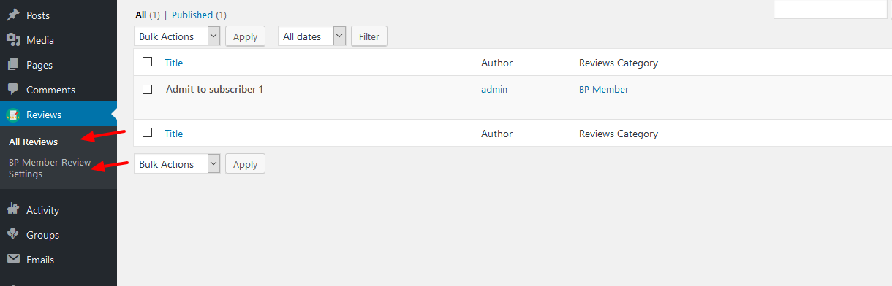

All Reviews

In the All reviews page member can see what member have been reviewed.

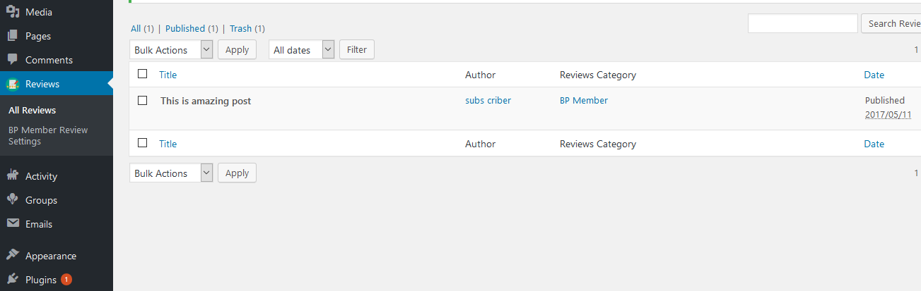

BP Member Review

In the BP Member Review setting page. You can set the functionality of review page and add more review criteria.

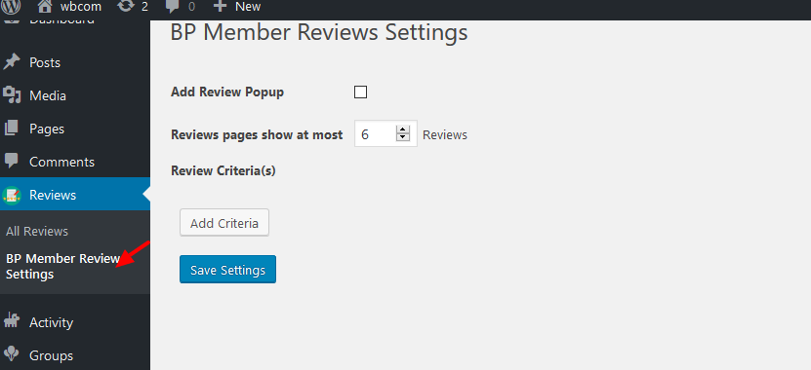

1: Add Review Popup check box if you checked this box then add review form will be open in popup box.

2: Set how many review you have to show.

3: Click Add Criteria button to add more fields for multi reviews.

4: You can remove unnecessary fields just click on Remove button.

5: Click Save Settings button to update Review settings

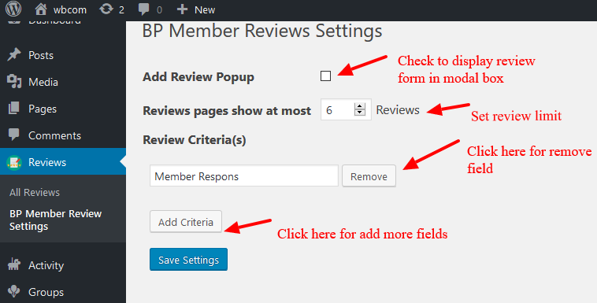

Display review form on another page just copy member review Shortcode.

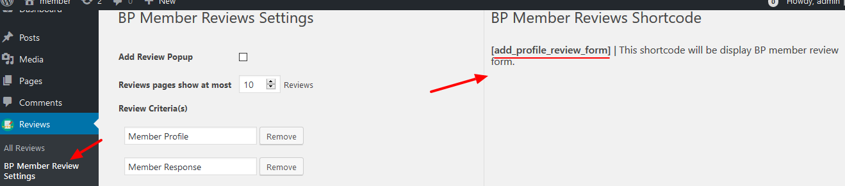

And paste it on another page.

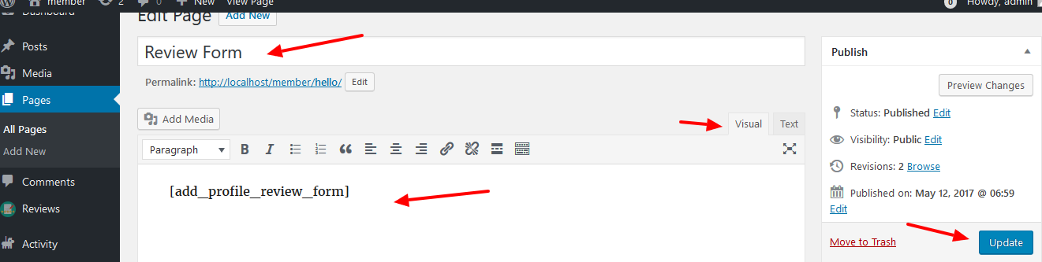

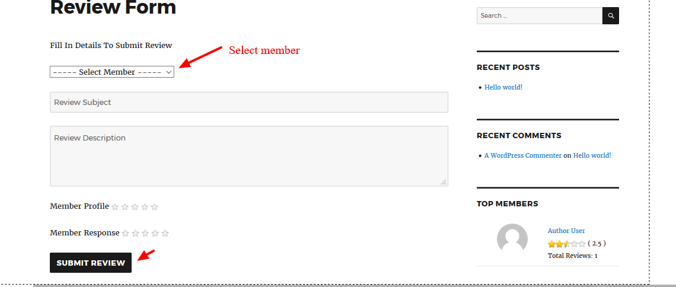

Widgets

**BP User profile review** Plugin adds a widget ( Members Reviews ) when plugin successfully activated. You can display members list on your site .

1: (Text Field) Enter widget title

2: (Number field) set number of members you want to show.

3: (Radio buttons ) Display member’s according to review.

4: ( Select box ) You can show/hide member’s profile picture.

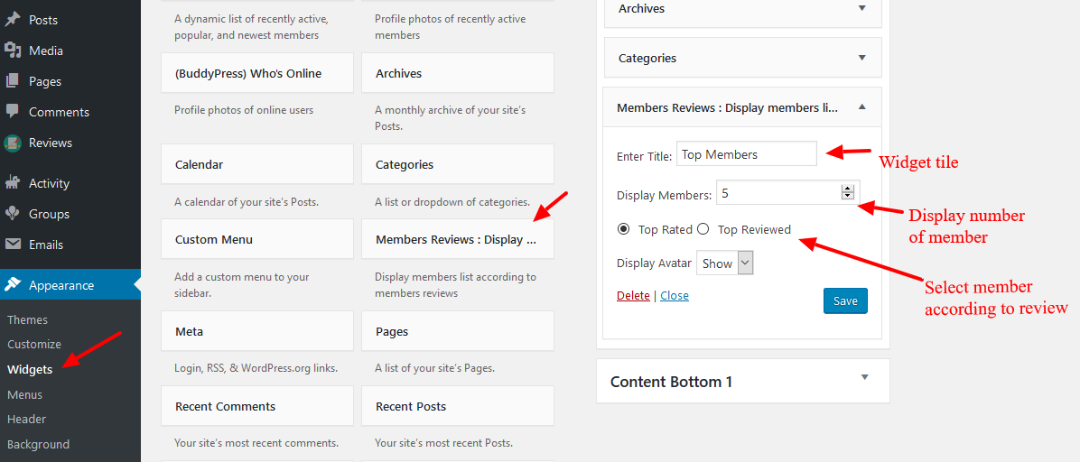

In side bar members listing will look something like this.



SITE FRONT-END

Review Tab

When visiting the "/members" section in the site. You can see list of reviewed

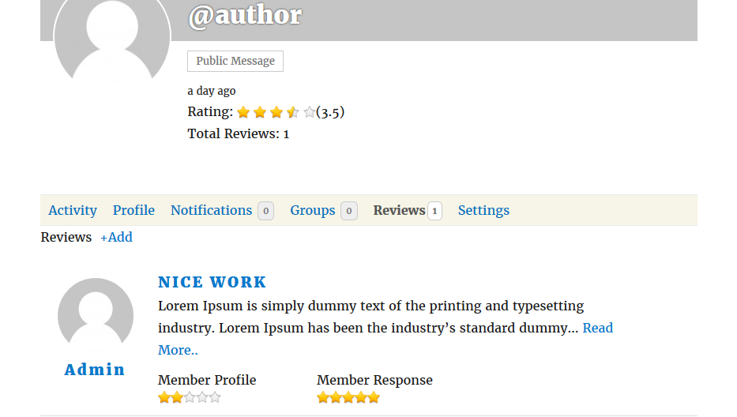

Please click on the (Review +add ) to review the member. You will see the review form open.

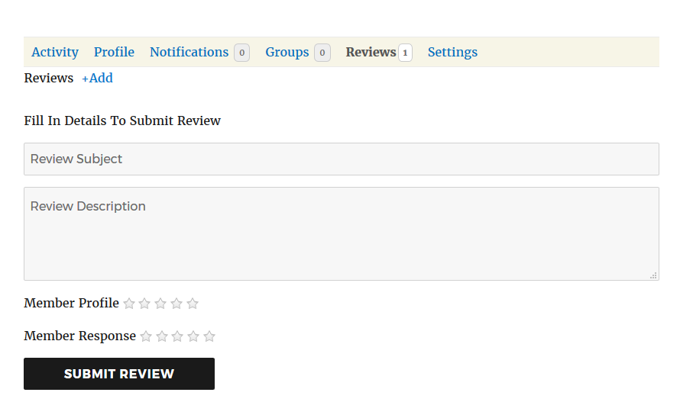

SUPPORT

For any technical support, wbcomdesigns welcomes your queries at:

[support@wbcomdesigns.com](mailto:support@wbcomdesigns.com)