**ELIGIBILITY CONDITIONS AND RESTRICTIONS**:

**For Base Plan:**

* Minimum Age at entry for Life Assured : [8] years (completed)
* Maximum Age at entry for Life Assured : [59] years (nbd) for Policy Term 16 years  
  [54] years (nbd) for Policy Term 21 years & [50] years (nbd) for Policy Term 25 years
* Maximum Age at Maturity for Life Assured: [75] years (nbd)
* Policy Term/Premium Paying Term : [16/10,21/15 and 25/16] years
* Minimum Basic Sum Assured : Rs. 2,00,000/-
* Maximum Basic Sum Assured : No Limit
* The Basic Sum Assured shall be in multiples of Rs. 10,000/- only.
* Age at entry for the Policyholder is to be taken as age nearest birthday (nbd) except for the minimum age at entry i.e. 8 years.
* Date of Commencement of Risk**:** Under this plan the risk will commence immediately on acceptance of risk.

**Date of Vesting under the plan (Applicable only if the Life Assured is below 18 years on the date of commencement of policy):** If the policy is inforce and the Life Assured is alive on the vesting date and if a request in writing for surrendering the policy has not been received by Corporation before such vesting date from the person entitled to the policy moneys, this policy shall automatically vest in the Life Assured on such vesting date i.e. on the policy anniversary coinciding with or immediately following the completion of 18 years of age and shall on such vesting be deemed to be a contract between the Corporation and the Life Assured.

Eligibility Conditions For LIC Jeevan Labh Base Plan

|  |  |
| --- | --- |
| Entry age | * Minimum age – 8 years(completed) * Maximum age –   + 59 years(Nearest Birthday) for Policy Term 16 years.   + 54 years (Nearest Birthday) for Policy Term 21 years.   + 50 years (Nearest Birthday) for Policy Term 25 years. |
| Maximum Age of Maturity | * 75 years(Nearest Birthday). |
| Policy Term | * 16 years. * 21 years. * 25 years. |
| Premium Paying Term | * 10 years for the policy term 16 years. * 15 years for the policy term 21 years. * 16 years for the policy term 25 years. |
| Sum Assured | * Minimum – Rs.2,00,000/- * Maximum – No limit. |
| Premium paying modes | * Monthly (ECS only or through salary deductions), Quarterly, Half yearly, Yearly. |
| Grace Period | * If the Premium is not paid to LIC Jeevan Labh Plan within the time then a delay of 30 days for Yearly, Half-Yearly and Quarterly modes and **15 days** for monthly mode is extended to pay the premium amount that is the grace period. |

**BENEFITS:**The benefits payable under an inforce policy are as under:

* **Benefits payable on death:**On death of the Life Assured during the term of the policy, the Death Benefit, defined as sum of “Sum Assured on Death” and vested Simple Reversionary Bonuses and Final Additional bonus, if any, shall be payable. Where “Sum Assured on Death” is defined as the higher of 10 times of annualised premium or Absolute amount assured to be paid on death i.e. Basic Sum Assured.  
  This death benefit shall not be less than 105% of the total premiums paid as on date of death.  
  Premiums mentioned above shall not include any taxes, extra amount chargeable under the policy due to underwriting decision and rider premium(s), if any.
* **Benefits payable on maturity:**On survival to the end of the policy term, “Sum Assured on Maturity” along with vested simple reversionary bonuses and Final Additional bonus, if any, shall be payable. Where Sum Assured on Maturity is equal to Basic Sum Assured.
* **Participation in Profits:**The policies shall participate in the profits of the Corporation and shall be entitled to receive Simple Reversionary Bonus declared as per the experience of the Corporation, provided the policy is in full force.  
  Final Additional Bonus may also be declared under the policy which will be payable on the expiry of the policy term or on earlier death.  
  Final Additional Bonus shall not be payable under paid – up policies.

**OPTIONAL BENEFIT:**This plan provides the following optional rider by payment of additional premium:

* **LIC’s Accidental Death and Disability Benefit Rider**:
  + LIC’s Accidental Death and Disability Benefit Rider (AD&DB) is available as an optional rider by payment of additional premium. This rider can be opted for on any policy anniversary within the premium paying term of the Base Plan provided the outstanding premium paying term is atleast 5 years. The benefit cover under this rider shall be available during the policy term or upto the policy anniversary on which the age nearer birthday of the Life Assured is 70 years, whichever is earlier.
  + If this benefit is opted for, an additional amount equal to the Accident Benefit Sum Assured is payable on death due to accident, provided the rider is in force at the time of accident. In case of accidental permanent disability (within 180 days from the date of accident), an amount equal to the Accident Benefit Sum Assured will be paid in equal monthly installments spread over 10 years and future premiums for Accident Benefit Sum Assured as well as premiums for the portion of Basic Sum Assured which is equal to Accident Benefit Sum Assured under the policy, shall be waived. If the policy becomes a claim by way of death or maturity before the expiry of the said period of 10 years, the disability benefit instalments which have not fallen due will be paid along with the claim amount.
  + The premium for this rider shall not be required to be paid after all premiums under the Base Plan have been paid or on after the policy anniversary on which the age nearer birthday of the life Assured is 70 years, whichever is earlier.
  + If there be more policies than one and if the total Accident Benefit exceeds Rs.100 lakhs, the benefits shall apply to the first Rs. 100 lakhs Sum Assured in order of date of policies issued.  
    Accidental Death and Disability Benefit Rider shall not acquire any paid-up value and the rider benefit will cease to apply, if policy is in lapsed condition.
* **LIC’s New Term Assurance Rider** :
  + LIC’s New Term Assurance Rider is available at the inception of the policy on payment of additional premium. The additional premium for this Rider will need to be paid along with the premium of the Base Plan and any other rider, if opted for, during the premium paying term of the policy. If this rider is opted for, an additional amount equal to Term Assurance Rider Sum Assured shall be payable on death of the
  + Life Assured during the policy term, provided the rider cover is If there be more policies than one and if the total Term Assurance Rider Sum Assured exceeds Rs. 25 lakhs, the benefits shall apply to the first Rs. 25 lakhs Term Assurance Rider Sum Assured in order of date of policies issued.

**For LIC’s Accidental Death and Disability Benefit Rider:**

* Minimum Entry Age: 18 years (completed)
* Maximum Entry Age: The cover can be opted for at inception or at any policy anniversary thereafter, provided the outstanding premium paying term under the base plan is at least 5 years i.e. the cover can be opted for, on or before 5thpolicy anniversary in case of PPT= 10 years, on or before 10th policy anniversary in case of PPT= 15 years and on or before 11thpolicy anniversary in case of PPT= 16 years under the base plan. However, in any case the maximum age at entry shall not exceed 65 years (nearest birthday).
* Maximum cover ceasing Age: 70 years (nearest birthday)
* Minimum Accident Benefit Sum Assured : Rs. 10,000/-
* Maximum Accident Benefit Sum Assured: An amount equal to the Basic Sum Assured subject to the maximum of Rs.100 lakh overall limit taking all existing policies of the Life Assured under individual as well as group policies including policies with inbuilt accident benefit taken with Life Insurance Corporation of India and the Accident Benefit Sum Assured under the new proposal into consideration.
* The Accident Benefit Sum Assured shall be in multiples of Rs. 10,000/-only.

**For LIC’s New Term Assurance Rider;**

* Minimum Entry Age: 18 years (completed)
* Maximum Entry Age: [59] years (nbd) for Policy Term 16 years  
  [54] years (nbd) for Policy Term 21 years & [50] years (nbd) for Policy Term 25 years
* Policy Term; Same as Base Plan
* Premium Paying Term: Same as Base Plan
* Minimum Term Assurance Rider Sum Assured : Rs. 100,000/-

**Maximum Term Assurance Rider Sum Assured**: The maximum Term Rider Sum Assured shall be less than or equal to the Basic Sum Assured under the base plan, but not exceeding the overall limit of Rs. 25 lakhs taking all Term Assurance Riders Sum Asured under all existing policies of the life assured including the new proposal under consideration.

The Term Assurance Rider Sum Assured can be taken in multiples of Rs. 10,000/-only.

**MODE OF PREMIUM PAYMENT:**The modes of premium payment allowable are Yearly, Half Yearly, Quarterly, and Monthly (ECS only or through salary deductions).

**GRACE PERIOD FOR PAYMENT OF PREMIUM:**

* A grace period of one calendar month but not less than 30 days will be allowed for payment of yearly or half-yearly or quarterly premiums and 15 days for monthly mode of premium payment.
* If the death of the Life Assured occurs within the grace period but before the payment of premium then due, the policy will be treated as inforce and the benefits will be paid after deduction of the said unpaid premium and also the unpaid premium/s falling due before the next policy anniversary.
* If premium is not paid before the expiry of the days of grace, the Policy lapses.
* If the Policy has not lapsed and the claim is admitted in case of death under the policy where the mode of payment of premium is other than yearly, unpaid premium(s), if any, falling due before the next policy anniversary shall be deducted from the claim amount.
* The above grace period will also apply to riders’ premiums as the riders premiums are to be paid along with the premium of the base plan.

**REBATES:**The rebates for base plan are as under;

**Mode Rebate:**

|  |  |
| --- | --- |
| **Mode** | **Percentage** |
| Yearly | Table Premium 2% |
| Half yearly | Table Premium 1% |
| Quarterly & monthly | NIL |

**High Basic Sum Assured Rebate:**

|  |  |
| --- | --- |
| **Basic Sum Assured (B.S.A)** | **Rebate per Rs.1000 B.S.A** |
| Rs. 2,00,000 to Rs. 4,90,000 | NIL |
| Rs. 5,00,000 to Rs. 9,90,000 | 1.25 % of(B.S.A) |
| Rs. 5,00,000 to Rs. 9,95,000 | 1.50 % of (B.S.A) |
| Rs. 15,00,000 and above. | 1.75 % of (B.S.A) |

**PAID-UP VALUE:**

* If, after atleast three full years’ premium have been paid and any subsequent premiums be not duly paid, this policy shall not be wholly void, but shall subsist as a paid-up policy.
* The Sum Assured on Death under a paid-up policy shall be reduced to such a sum, called ‘Death Paid-up Sum Assured’ and shall be equal to [Sum Assured on Death * (no. of premiums paid / no. of premiums payable during the premium paying term)].
* The Sum Assured on Maturity under a paid-up policy shall be reduced to such a sum called ‘Maturity Paid-up Sum Assured’ and shall be equal to [Sum Assured on Maturity * (no. of premiums paid / no. of premiums payable during the premium paying term)].
* If a policy continues as a paid – up policy the same shall not be entitled to participate in future profits. However, the vested simple reversionary bonuses, if any, shall remain attached to the reduced paid up policy.
* Notwithstanding what is stated above, if atleast 3 full years’ premiums have been paid in respect of this policy, and any subseguent premium be not duly paid, in the event of the death of the Life Assured within six months from the due date of first unpaid premium, “Sum Assured on Death” along with vested simple reversionary bonuses and final additional bonus, if any, will be paid after deduction of (a) the premium(s) for the base policy unpaid with interest thereon upto the date of death on the same terms as for revival of the Policy during such period, and (b) the balance premium(s) for the base policy falling due from the date of death and before the next Policy anniversary.
* Notwithstanding what is stated above, if at least 5 full years’ premiums have been paid in respect of this policy, and any subseguent premium be not duly paid, in the event of death of the Life Assured within 12 months from the due date of first unpaid premium, “Sum Assured on Death” along with vested simple reversionary bonuses and final additional bonus, if any, will be paid after deduction of (a) the premium(s) for the base policy unpaid with interest thereon upto the date of death on the same terms as for revival of the Policy during such period, and (b) the balance premium(s) for the base policy falling due from the date of death and before the next Policy anniversary.
* These provisions do not apply to optional riders as riders do not acquire any paid up value and the rider benefits cease to apply, if policy is in lapsed condition

**SURRENDER VALUE:**The policy can be surrendered at any time during the policy term provided atleast three full years’ premiums have been paid.

* **Guaranteed Surrender Value:**The Guaranteed Surrender Value shall be a percentage of total premiums paid (net of taxes) excluding any extra premiums and premiums for riders, if opted for. This percentage will depend on the policy term and policy year in which the policy is surrendered.  
  In addition, the surrender value of vested Simple Reversionary bonuses, if any, shall also be payable, which is equal to vested bonuses multiplied by the surrender value factor applicable to vested bonuses. These surrender value factors will depend on the policy term & policy year in which policy is surrendered.
* **Special Surrender Value:**Corporation may however, pay Special Surrender Value as applicable as on the date of surrender, provided the same is higher than Guaranteed Surrender Value. The Special Surrender Value will be the discounted value of the sum of Maturity Paid-up Sum Assured (as defined in Para 11) and the vested Simple Reversionary bonuses, if any. The discount factors shall be the special surrender value factors as provided in Table-1A of Special Surrender Values booklet used for Endowment Assurance plan, and will depend on the policy term and the duration elapsed since the commencement of the policy.  
  Further, if the policy is surrendered during the last policy year the same shall be treated as discounting of Maturity Claim. Where, in case of inforce policy the maturity claim is Sum Assured on Maturity and in case of paid-up policy the maturity claim is Maturity Paid-Up Sum Assured.

LIC’s Accidental Death and Disability Benefit Rider and LIC’s New Term Assurance Rider will not acquire any surrender value. However, refund of additional rider premiums charged in respect of cover after premium paying term shall be refunded in respect of these riders.

**i) For LIC’s Accidental Death and Disability Benefit Rider**:

**In case of Surrender during Premium Paying Term:** 80% * (annualised rider premium per Rs. 1000 Accident Benefit Sum Assured – 1) * (Accident Benefit Sum Assured/1000) * (Number of years for which premiums in respect of this rider have been paid)

**In case of Surrender after Premium Paying Term**: 80% * (annualised rider premium per Rs. 1000 Accident Benefit Sum Assured – 1) * (Accident Benefit Sum Assured/1000) * (premium paying term of the rider) * (outstanding term for the rider in completed years / (Policy term in respect of this rider – Premium paying term of the rider))

Where annualised rider premium mentioned above excludes tax.

**ii) For LIC’s New Term Assurance Rider:**

**In case of Surrender during Premium Paying Term:**75% * d* (Pppf-Pn)*(Term Assurance Rider Sum Assured/1000)

**In case of Surrender after Premium Paying Term:**75% * Pppr*(Term Assurance Rider Sum Assured/1000)*(ppt/n)*(n-t)

Where; Pppf =Tabular annual premium for the limited premium paying term per Rs. 1000/-Term Assurance Rider Sum Assured at inception

Pn = Equivalent tabular annual regular premium per Rs. 1000/- Term Assurance Rider Sum Assured applicable to the Life Assured’s age at inception and term of the rider being n years.

(Above Premiums excludes service tax and extra premium, if any.)

d = Policy duration elapsed in completed years as on date of surrender

n=Term of the Rider

ppt=Premium paying term of the Rider

t= Policy duration elapsed in nearest completed years as on the date of surrender

**REVIVALS:**If the policy has lapsed, it may be revived during the lifetime of the Life Assured, but within a period of 2 consecutive years from the date of first unpaid premium on submission of proof of continued insurability to the satisfaction of the Corporation and the payment of all the arrears of premium together with interest (compounding half-yearly) at such rate as may be decided by the Corporation from time to time.

The Corporation reserves the right to accept at original terms, accept with modified terms or decline the revival of a discontinued policy. The revival of a discontinued policy shall take effect only after the same is approved by the Corporation and is specifically communicated in writing to the Life Assured.

Revival of Rider(s), if any, will only be considered along with the revival of the Base policy and not in isolation.

**LOAN:** Loan facility is available under this plan, after payment of premiums for at least 3 full years subject to following conditions:

* a) The maximum loan that can be granted as a percentage of surrender value are as under:  
  For inforce policies – 90%  
  For paid-up policies – 80%  
  However, the above percentages may vary from time to time.
* b) The rate of interest to be charged for the loan amount would be determined from time to time by the Corporation.
* c) No foreclosure action under fully paid-up and inforce policies shall be taken under this plan even if there is a default in payment of loan interest. However, any loan outstanding alongwith interest shall be recovered from the claim proceeds at the time of exit.

**UNDERWRITING, AGE PROOF AND MEDICAL REQUIREMENTS :**

U & R department will issue instructions in this regard.

**SUICIDE CLAUSE:**This policy shall be void

* a) If the Life Assured (whether sane or insane) commits suicide at any time within 12 months from the date of commencement of risk, the Corporation will not entertain any claim under this policy except for 80% of the premiums paid excluding any extra amount if charged under the policy due to underwriting decisions and rider premiums other than term assurance rider, if any, provided the policy is inforce.
* b) If the Life Assured (whether sane or insane) commits suicide within 12 months from date of revival, an amount which is higher of 80% of the premiums paid till the date of death excluding extra amount if charged under the policy due to underwriting decisions and rider premiums other than ;erm assurance rider, if any, or the surrender value, shall be payable. The Corporation will not entertain any other claim under this policy. This clause shall not be applicable for a policy lapsed without acquiring paid up value and hence nothing shall be payable under such policies.

**FORFEITURE IN CERTAIN EVENTS:**In case it is found that any untrue or incorrect statement is contained in the proposal, personal statement, declaration and connected documents or any material information is withheld, then and in every such case the policy shall be void and all claims to any benefit by virtue thereof shall be subject to the provisions of Section 45 of the Insurance Act, 1938 as amended from time to time.

**TAXES:** Statutory Taxes, if any, imposed on such insurance plans by the Govt, of India or any other constitutional tax Authority of India shall be as per the Tax laws and the rate of tax as applicable from time to time.

The amount of Service Tax payable as per the prevailing rates shall be payable by the policyholder on premiums (for base plan & rider(s) if any) including extra premiums, which shall be collected separately over and above in addition to the premiums payable by the policyholder. The amount of Tax paid shall not be considered for the calculation of benefits payable under the plan.

The instructions regarding issues related to taxes will be issued by Finance & Accounts Department, Central office, separately, as applicable from time to time.

**NORMAL REQUIREMENTS FOR CLAIM:** The normal documents which the claimant shall submit while lodging the claim in case of death of the Life Assured shall be claim forms, as prescribed by the Corporation, accompanied with original policy document, NEFT mandate from the claimant for direct credit of the claim amount to the bank account, proof of title, proof of death, proof of accident/disability (as mentioned in the rider circular), medical treatment prior to the death, School/College/employer’s certificate, whichever is applicable, to the satisfaction of the Corporation. If the age is not admitted under the policy, the proof of age of the Life assured shall also be submitted.

Where the policy results into a maturity claim or in case of surrender of a policy, the Life Assured shall submit the discharge form along with the original policy document, NEFT mandate from the claimant for direct credit of the claim amount to the bank account besides proof of age, if the age is not admitted earlier.

**FREE LOOK (COOLING – OFF) PERIOD:** If a Policyholder is not satisfied with the “Terms and Conditions” of the policy, he/she may return the policy to the Corporation stating the reasons of objections, within 15 days from the date of receipt of the policy.

The refund of premium to the Policyholder shall be subject to following deductions:

1. Stamp duty on policy;
2. Actual cost of medical examination and special reports, if any;
3. Proportionate risk premium (in respect of Base Plan and Riders, if opted for) for the period on cover as per CO.

**BACK-DATING INTEREST:**The policies can be dated back within the same financial year. Back-dating interest as applicable at the time of completion of the policy (at the rate as fixed by the Corporation from time to time) will be charged for the period in excess of one month. However, if the policy is back dated to lean months, viz. April, May, July & August, interest is to be charged for period in excess of three months. The period upto 14 days is to be ignored and 15 days or more is to be rounded to a month.

**REINSURANCE:** Normal procedure for Reinsurance shall apply as per applicable Reinsurance Treaty.

**PROPOSAL FORM** : Revised Proposal Form No. 300, 340 and 360 shall be used under this plan.

**Jeevan Labh Premium details:**

[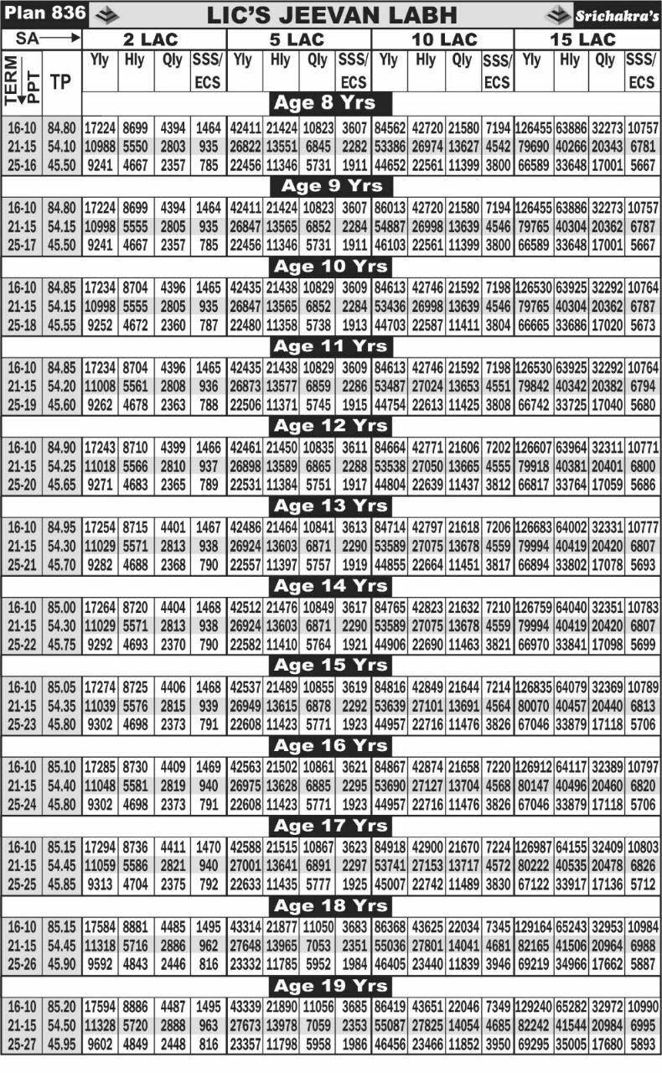](http://licinformation.com/wp-content/uploads/2016/01/IMG-20160104-WA0004.jpg)

Jeevan Labh Premium Calculator for Age 8 to 19 Years

[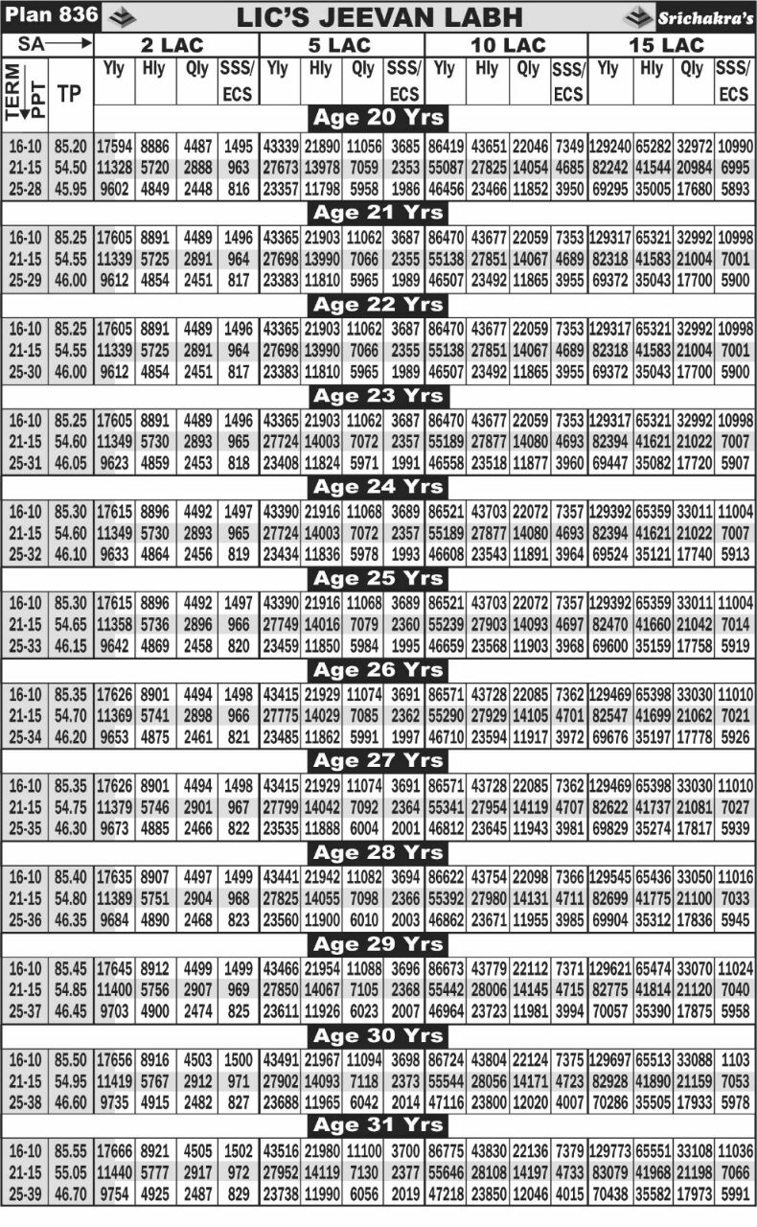](http://licinformation.com/wp-content/uploads/2016/01/IMG-20160104-WA0006.jpg)

Jeevan Labh Premium Calculator for Age 20 to 31 Years

[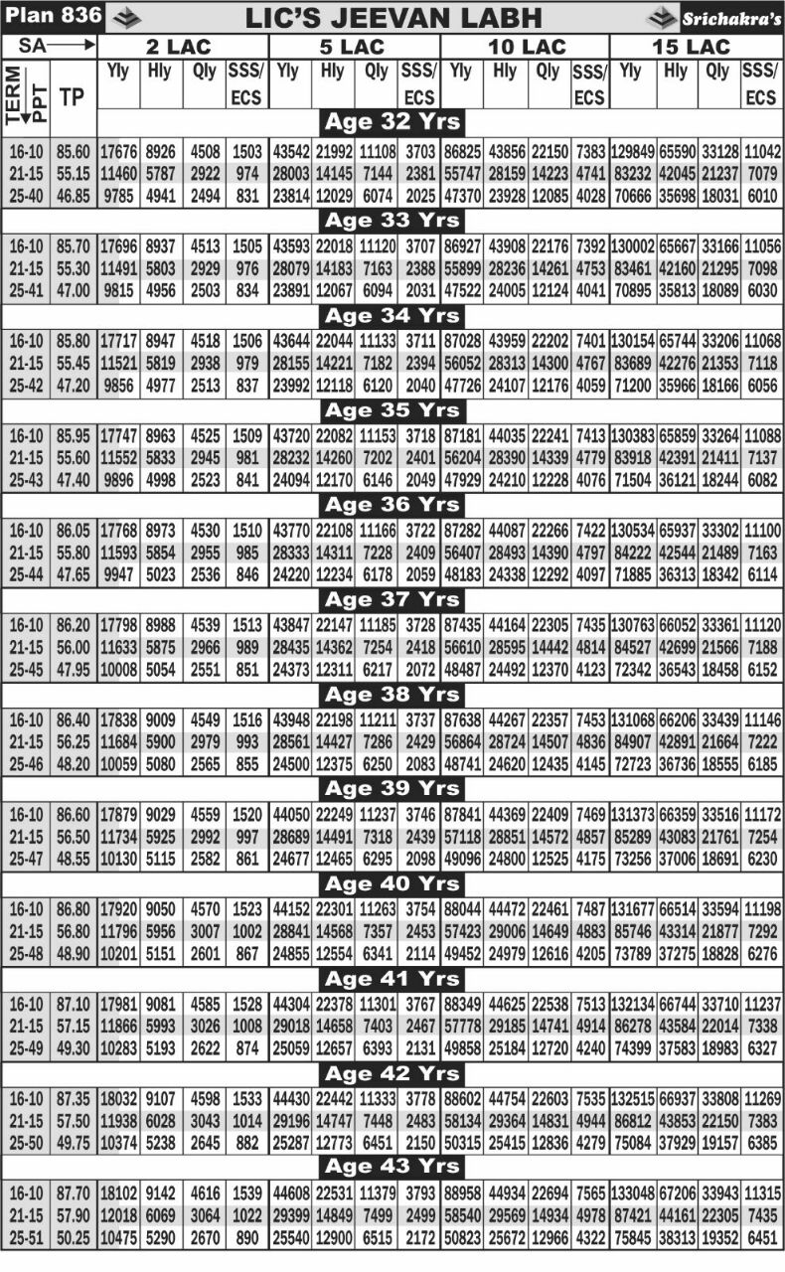](http://licinformation.com/wp-content/uploads/2016/01/IMG-20160104-WA0007.jpg)

Jeevan Labh Premium Calculator for Age 32 to 43 Years

[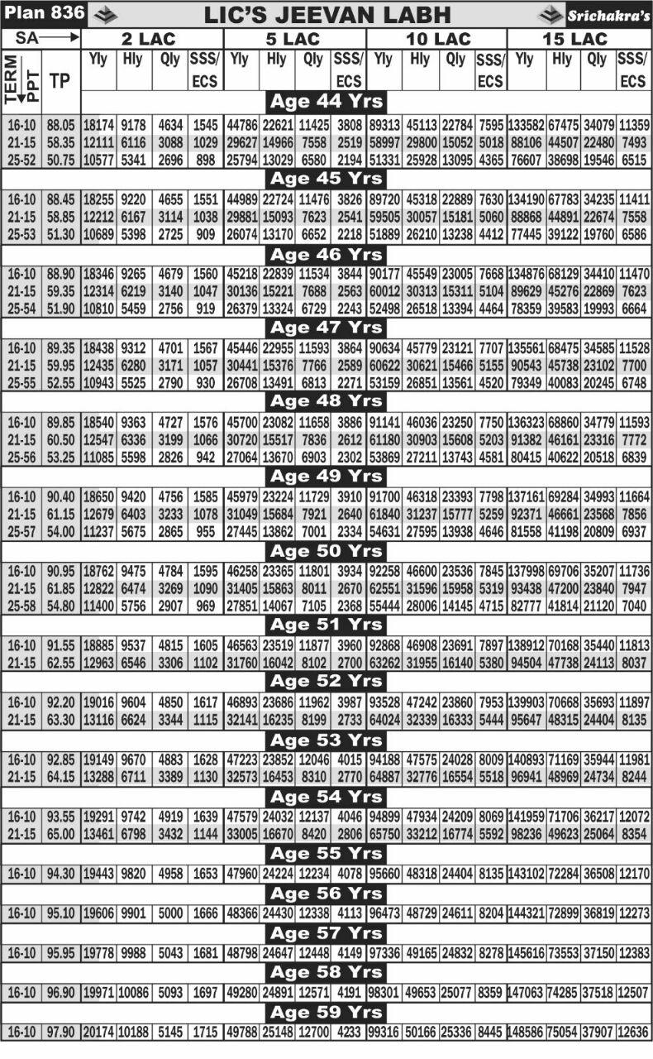](http://licinformation.com/wp-content/uploads/2016/01/IMG-20160104-WA0005.jpg)

Jeevan Labh Premium Calculator For Age 44 to 59 years