**Alt + F11** -> Macro window          View-> Immediate window

F8 -> go line by line



Select Relative References when using some **not** **definite columns /rows**

Then switch it back off again and paste/copy ***in abv eg****.*

*In Immediate Window,  paste these for cells* (for checking just in case)

* ?activecell.Address
* ?selection.address

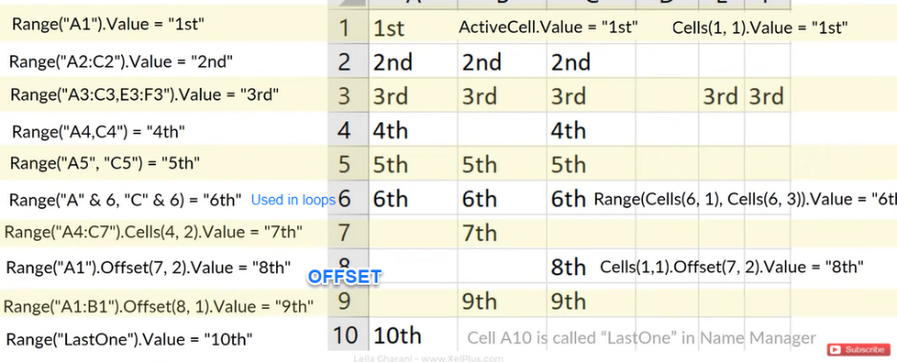

***' Select cell***

Range("A10").Select

Range("C4").Activate

Sheet2.Range("A3:B10") = "Pall"

Sheets("Sheet1").activate

Rows("2:1200").Select

*Range("A5").Offset(0, 7).Range("A1:A16").Select*

    ' Different way to select

***' Change the font***

Range("A1:F1").Font.Name = "Times New Roman"

Range("A1:F1").Font.Size = 12

***' Clearing***

Range("J1:K4").Clear

***' Delete cells***

Range("J1:R6").Delete

Range("J:R").EntireColumn.Delete

Range("A3").EntireRow.Delete

*Sheets("123").Select*

*Cells.Select*

*Selection.Delete Shift:=xlUp*

***' Insert cells***

Range("B:B").Insert

Range("C3").Insert

***' Hide/Unhide***

Range("C:C").columns.Hidden=true

Range("C:C").columns.Hidden=false

***' Cut***

Range("B:B").Cut Range("E:E")

*Range("B:B").Cut*

*Range("A:A").Insert*

***' Paste special***

Range("A1:C20").Copy

Range("O1").PasteSpecial xlPasteValuesAndNumberFormats

Range("O1").pastespecial xlPasteAll

*xlPasteValues*

***' Variable***

xy = "pallv"

Range("P1:P10") = XY

***'Replacement:***

Range("B486").Replace What:="0", Replacement:="099"

***' Functions***

Range("J1")="=SUM(F:F)"

Range("J3")="=AVERAGE(H:H)"

**Autofill**

Selection.AutoFill Destination:=Range("G3:G" & Range("I" & Rows.Count).End(xlUp).Row)

*G3 is first cell ; Refference column is I*

***' Last cells***

*Dim cnt As Integer  'counting last row number*

*cnt = Range("A" & Rows.Count).End(xlUp).Row*

Range("A" & rows.count).End(xlUp).End(xlToRight).Select

    Selection.End(xlDown).Select

***Selection.End(xlDown).Offset(1, 0).Select*** **[with offset]**

***' EntireColumn***

Range(Range("B1"),Range("B1").End(xlDown)).Select

 Range( Range("A1").end(xlToRight), Range("A1").end(xlToRight).End(xlDown) ).Select

***' InputBox***

a = inputbox("Hello","Hey")

*Dim rng1 As* ***String***

*rng1 = InputBox("String:")*

*Range(rng1).select*

    Dim rng As Range

   Set rng = Application.InputBox("Range:", Type:=8)

    Range("P10").Value = rng

***' Add Sheet/Workbook***

Sheets.Add

Sheets.Add.name ="Pallll"

ActiveSheet.Name = "Sheet1"

Sheets.Delete

Workbooks.Add

Workbooks.Add.SaveAs Filename:="C:\Users\Desktop\abcde.xlsx"

Kill ("C:\Users\Desktop\abcde.xlsx")

Sheet1.name="Abc"

*Application.DisplayAlerts = False*

*Sheets("ALLLL").Delete*

*Sheets.Add.Name = "ALLLL"*

*Application.DisplayAlerts = True*

**' Save/Close**

Workbooks("Book2").Save

Workbooks("Book2").Close

**' Protect/Unprotect sheet**

Sheets("Sheet1").protect password:=1000

Sheets("Sheet1").unprotect password:=1000

**' New folder**

Mkdir ("C:\Users\Desktop\abcde")

**MsgBOX**

**MsgBox "Action Completed" & vbCrLf & Application.UserName, vbExclamation, "THANK YOU"**

*vbCrLf -> Nexr Link*

**Filters** (Select Range)

Selection.AutoFilter       **(add filter)**

ActiveSheet.ShowAllData    **(Remove all filter)**

ActiveSheet.Range("$A$1:$AA$3000").**AutoFilter Field:=4,** Criteria1:="<>"

*ActiveSheet.Range("****$A$1:$BU$262")****.****AutoFilter Field:=3,*** ***Criteria1:=Array(*** *"ABC", "GHI"),* ***Operator:=*** ***xlFilterValues***

-----AutoFilter Field:=4, or *AutoFilter Field:=3, ( the column number)*

Criteria1:="<>" ( everything except blank)

**ActiveSheet.Range("$A$1:$D$471").AutoFilter Field:=2, Criteria1:="=OK*",** **Operator:=xlAnd**

**Open workbook**

**Workbooks.OpenText Filename:= _**

**"**[**https://ABCDEFGH-my.sharepoint.com/Folder/File1.xlsm**](https://ABCDEFGH-my.sharepoint.com/Folder/File1.xlsm)**"**

**ERROR**

***On Error Resume Next***

**Not prompt while msg box**

Application.DisplayAlerts = False

Application.DisplayAlerts = True

***If Else***

If Range("F2").Value > 100 And Range("F2").Value < 200 Then

    Range("M2") = "%%%"

ElseIf  ...... Then

        ............

 Else

    Range("M2") = "AAAAA"

End If

'Selecting Cell F2 and checking the single value

***For loop***

Dim x As Integer

For x = 1 To 20

    Range("A" & x).Value = x

Next

***While loop***

Dim x As Integer

x = 1

Do While Range("P" & x).Select

Range("P" & x).Value = x

x = x + 1

Loop

***Do until loop***

Dim x As Integer

x = 1

Do Until x > 5

Cells(x, 17).Value = x

x = x + 1

Loop