Assignment-1
04-07-2026: Normalization

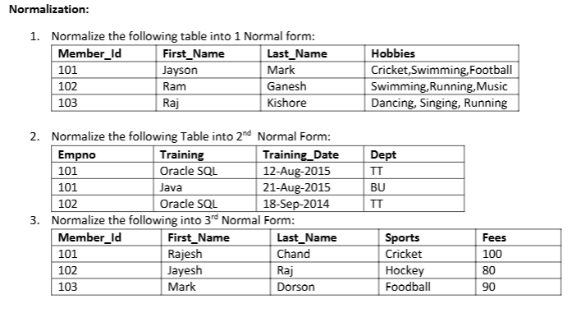
1NF:

Member_Id | First_Name | Last_Name | Hobby
101 | Jayson | Mark | Cricket
101 | Jayson | Mark | Swimming
101 | Jayson | Mark | Football
102 | Ram | Ganesh | Swimming
102 | Ram | Ganesh | Running
102 | Ram | Ganesh | Music
103 | Raj | Kishore | Dancing
103 | Raj | Kishore | Singing
103 | Raj | Kishore | Running

2NF:

Composite key=(Empno, Training)

Employee_Training Table:
Empno | Training | Training_Date
101 | Oracle SQL | 12-Aug-2015
101 | Java | 12-Aug-2015
102 | Oracle SQL | 18-Sep-2014

Empno | Dept
101 | IT
102 | IT

3NF:
Functional Dependencies:
Member_id --> First_Name,Last_Name,Sports
Sports --> Fees

Member Table:

Member_Id | First_Name | Last_Name | Sports
101 | Rajesh | Chand | Cricket
102 | Jayesh | Raj | Hockey
103 | Mark | Dorson | Football

Sports_Fee Table:
Sports | Fees
Cricket | 100
Hockey | 80
Football | 90

Assignment-2

07-07-2026: Retriving data using the sql select statement

- Determine the structure of DEPT table and its content.

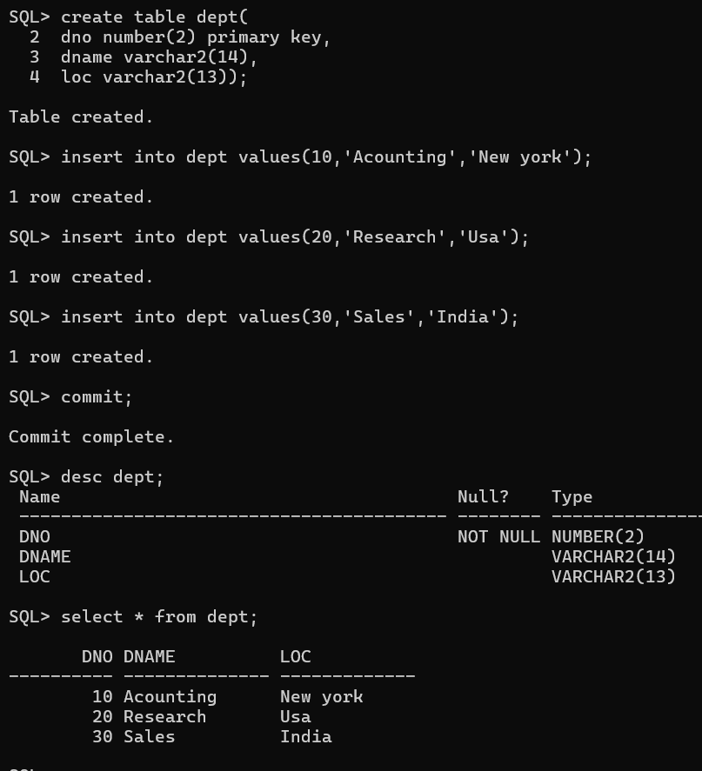

- Determine the structure of Emp table and its content.
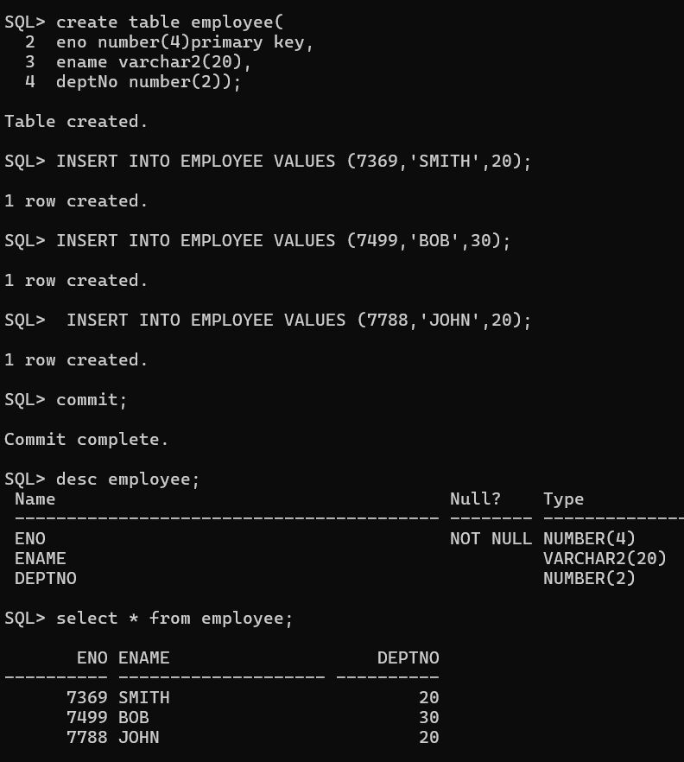

- Display the Ename and DeptNo from Emp table whose EmpNo is 7788.

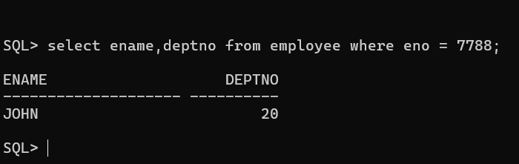

Assignment-3

08-07-2026: Restricting and sorting Data
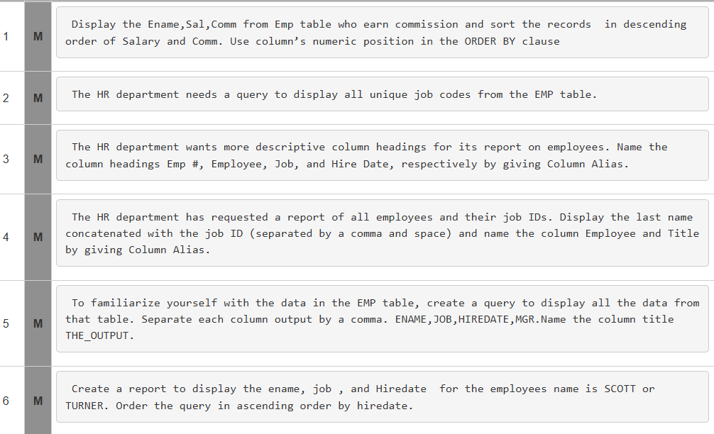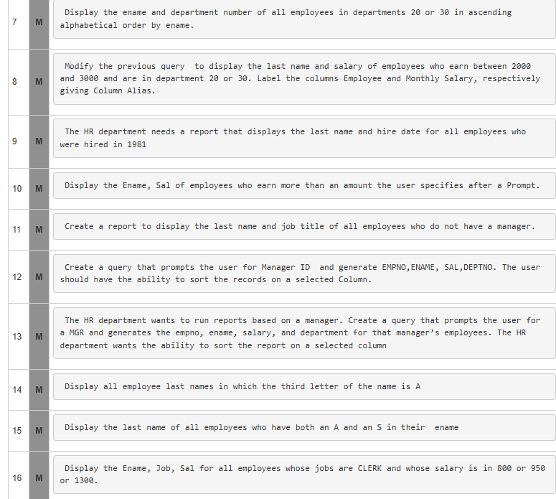
Solutions:

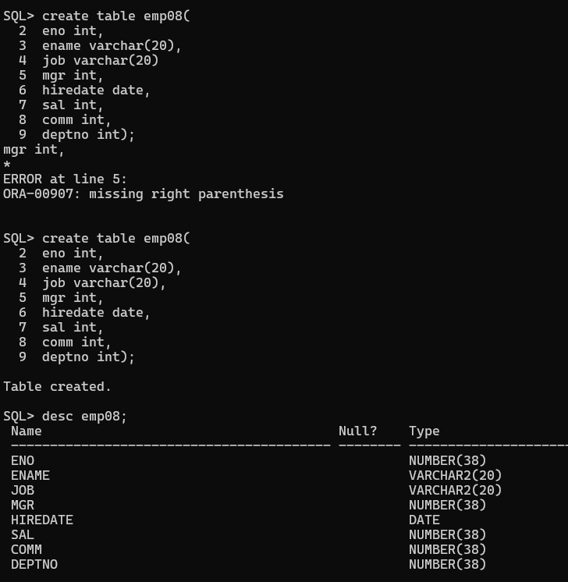
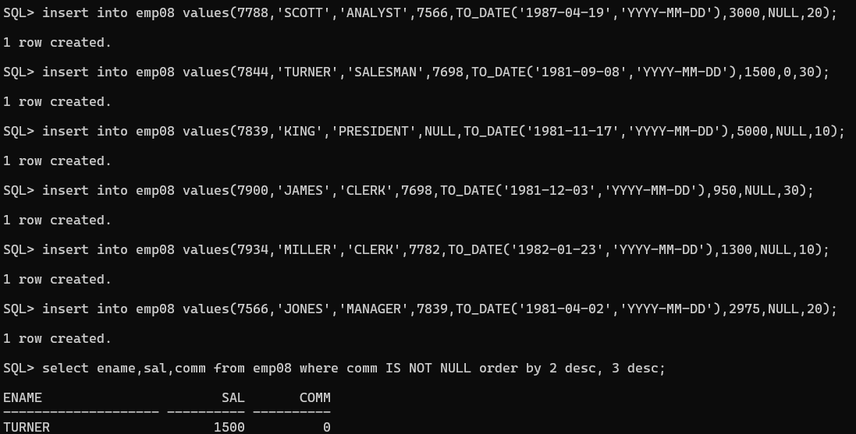
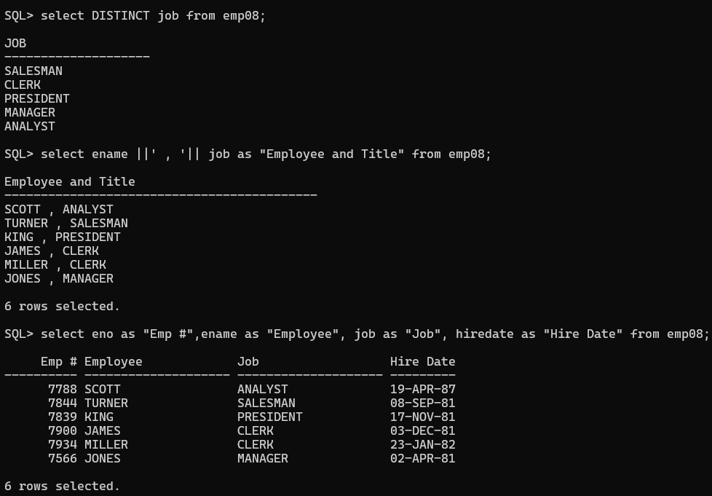
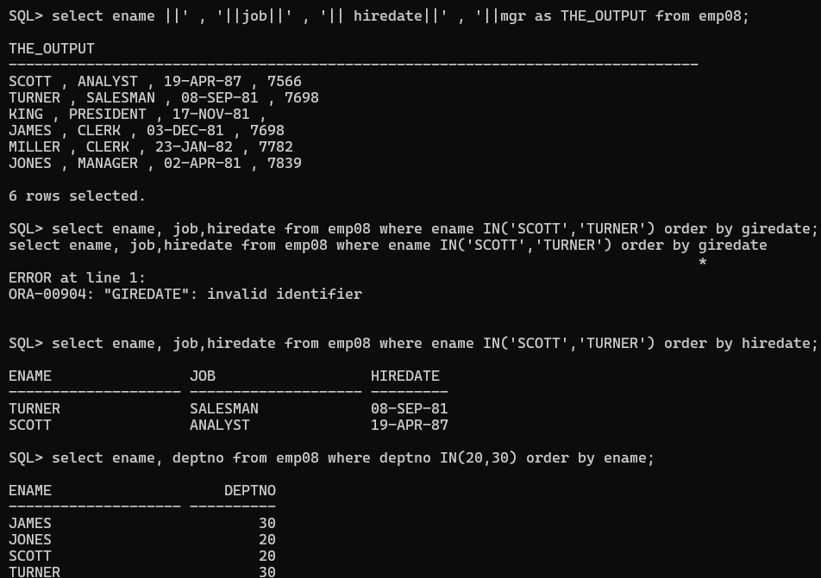
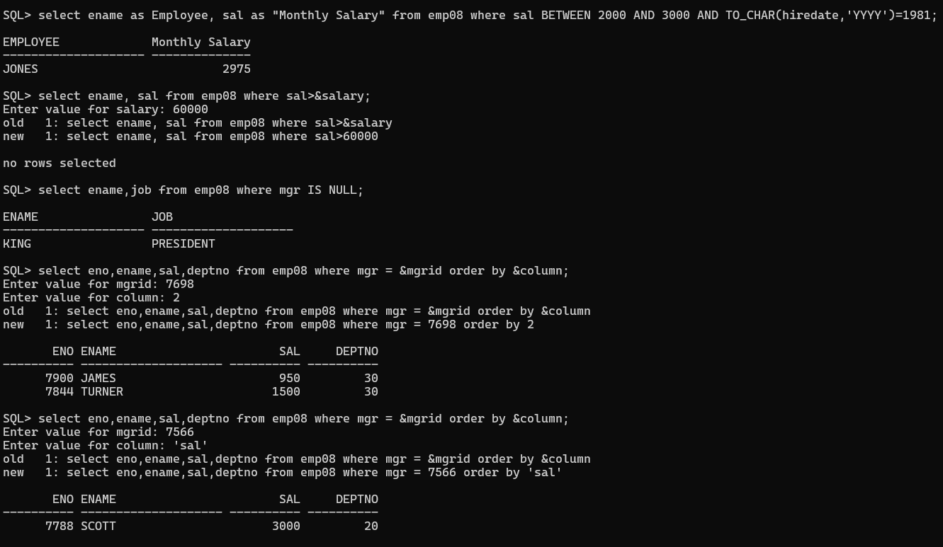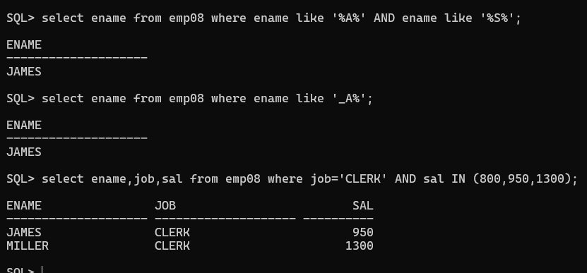

Assignment-4

09-07-2026: Using single row functions to customize the output.
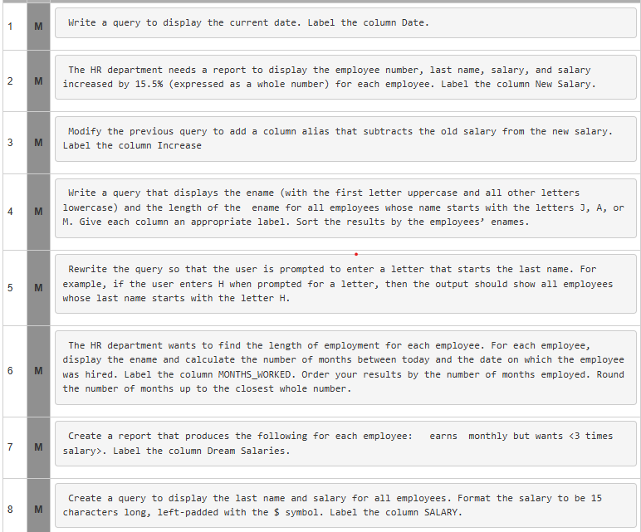
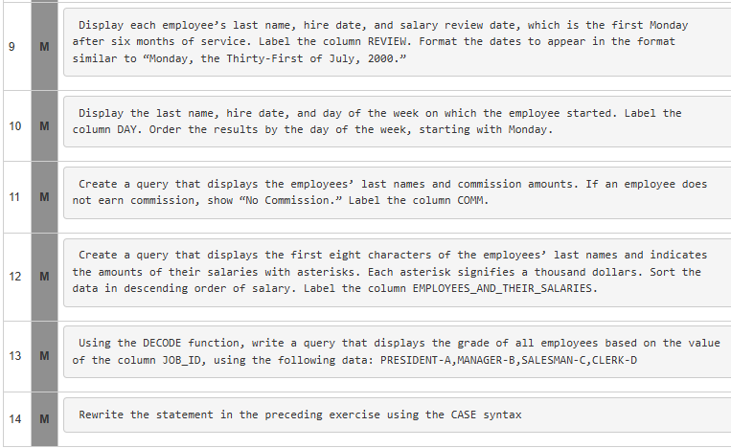
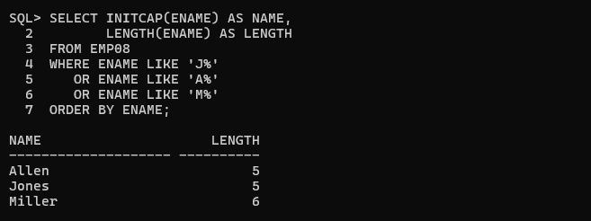
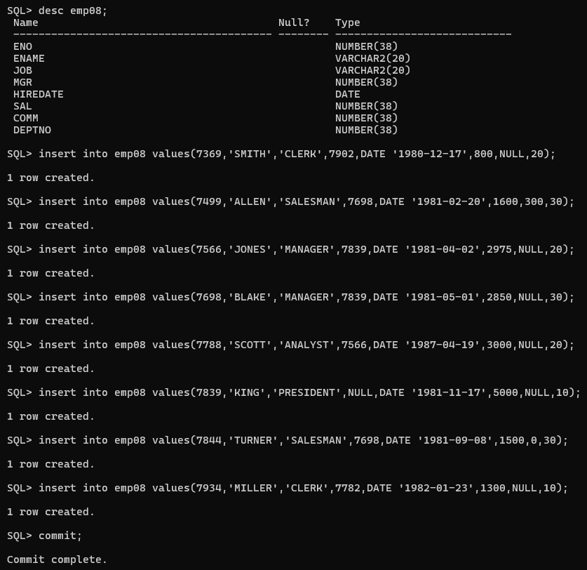
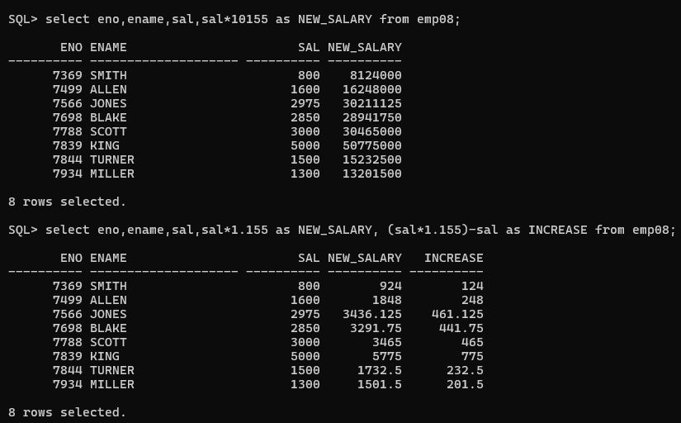

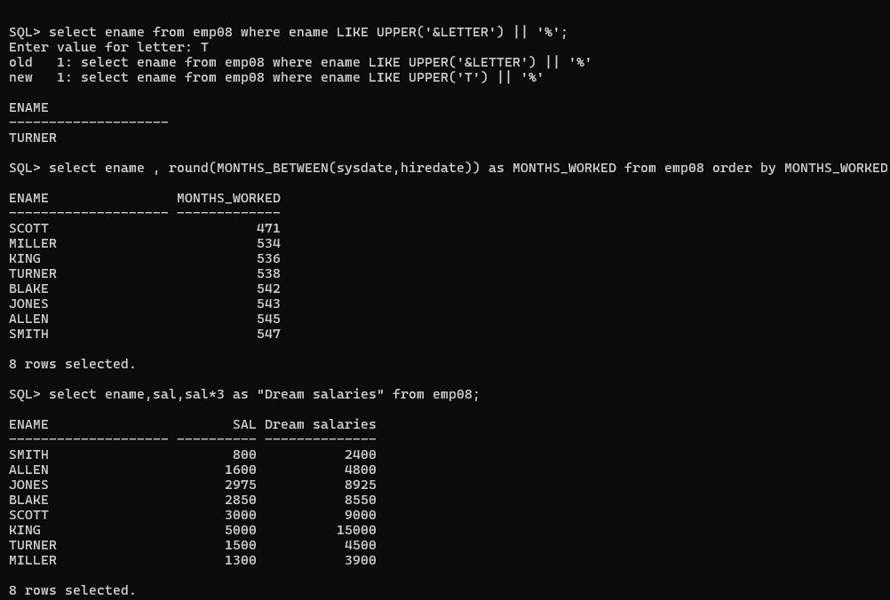
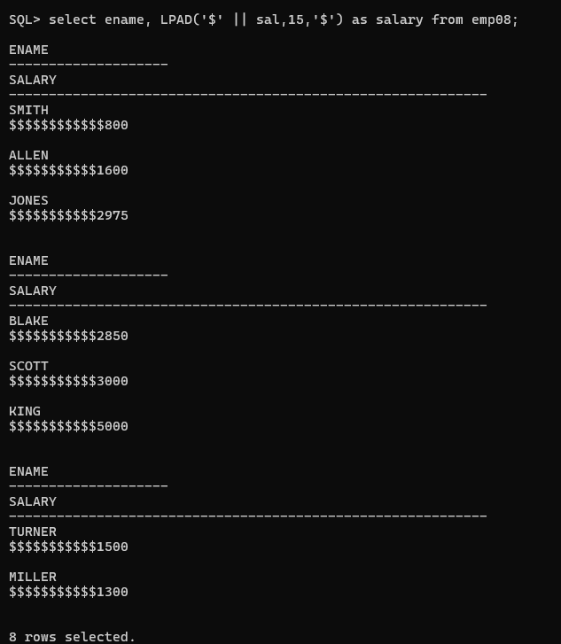
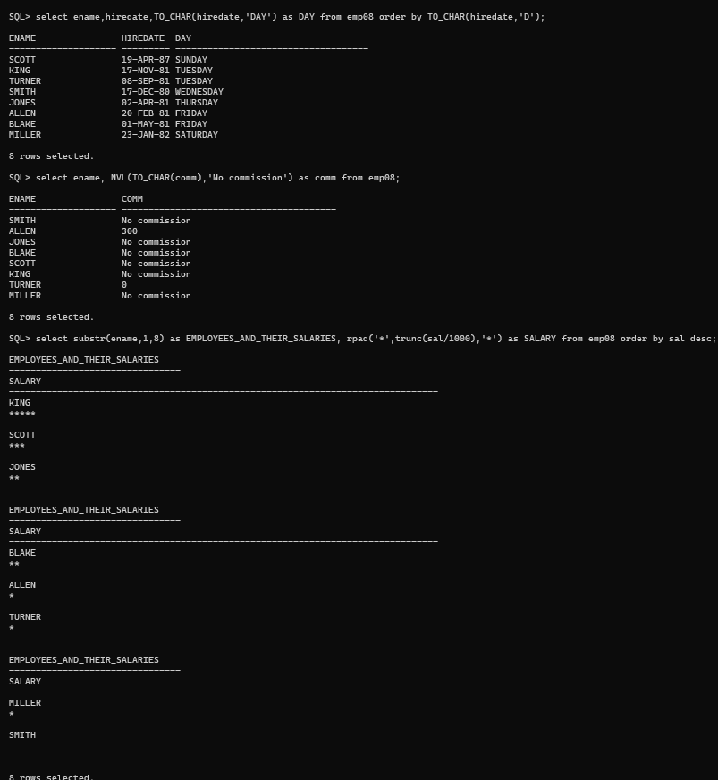

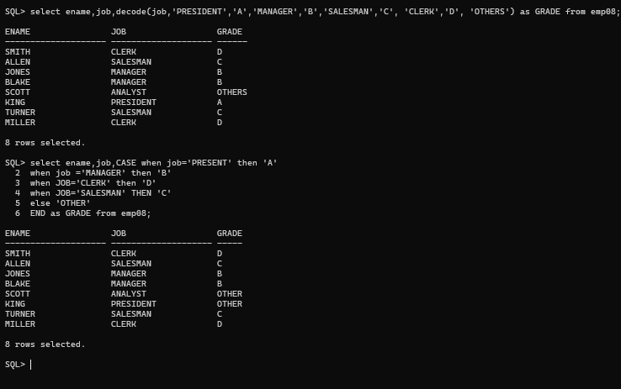

Assignment-5
10-07-2026 : Reporting Aggregated Data using the Group functions

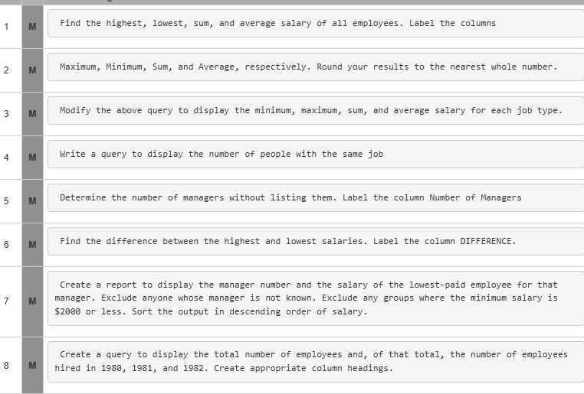
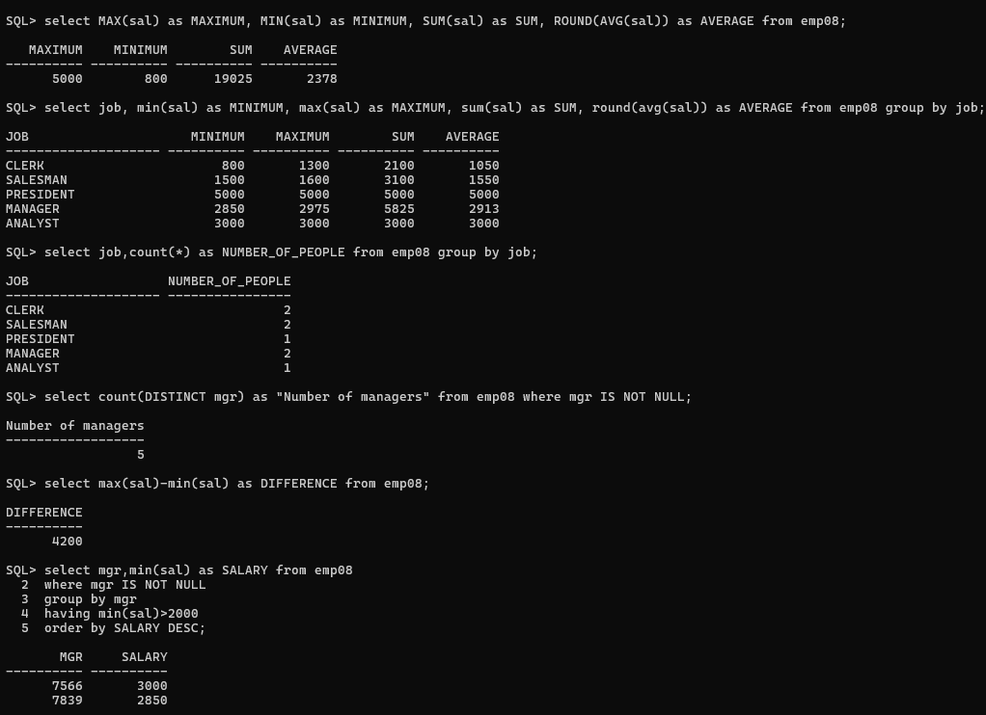
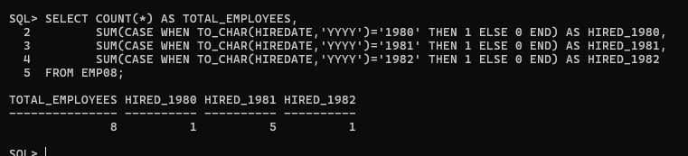

Assignment-6
11-07-2026: Using the set Operators
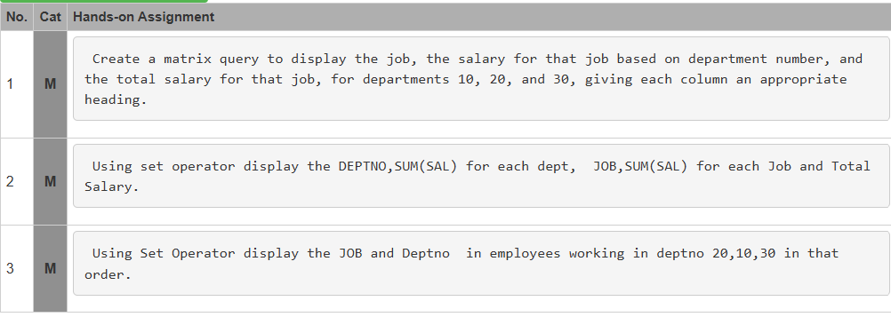

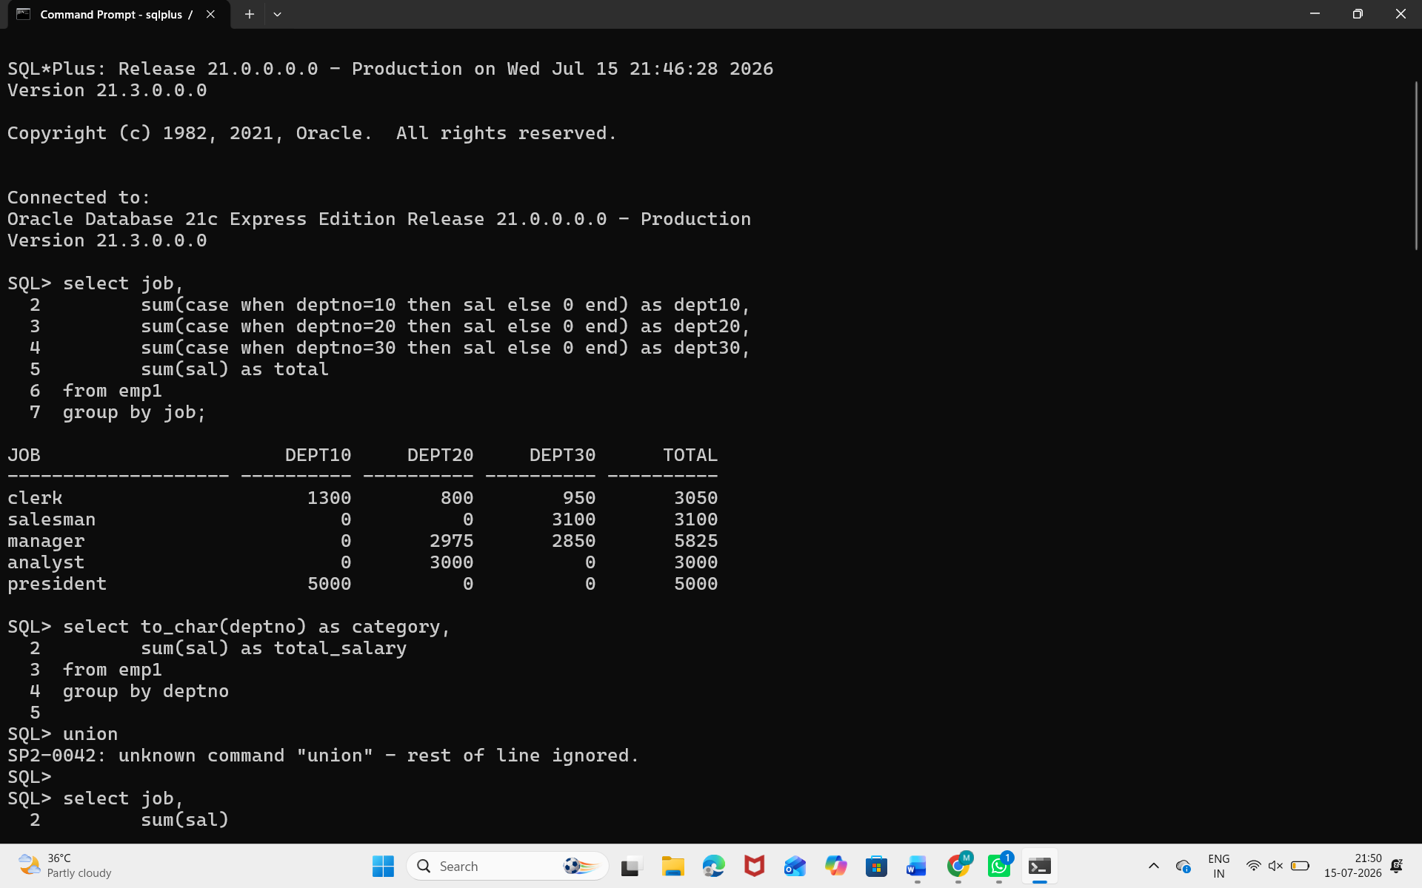
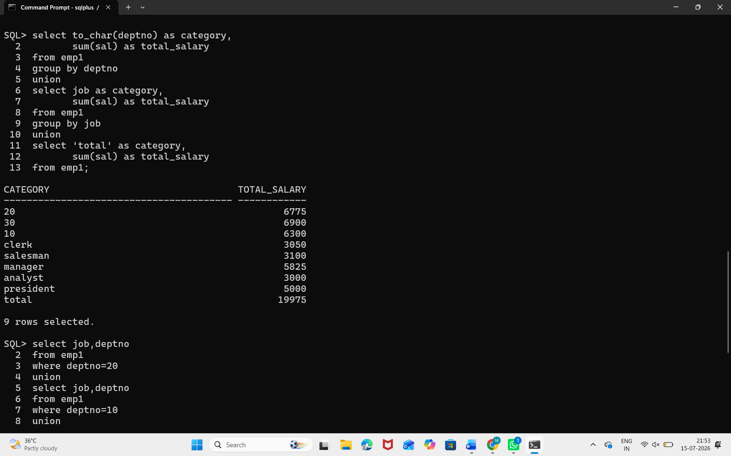
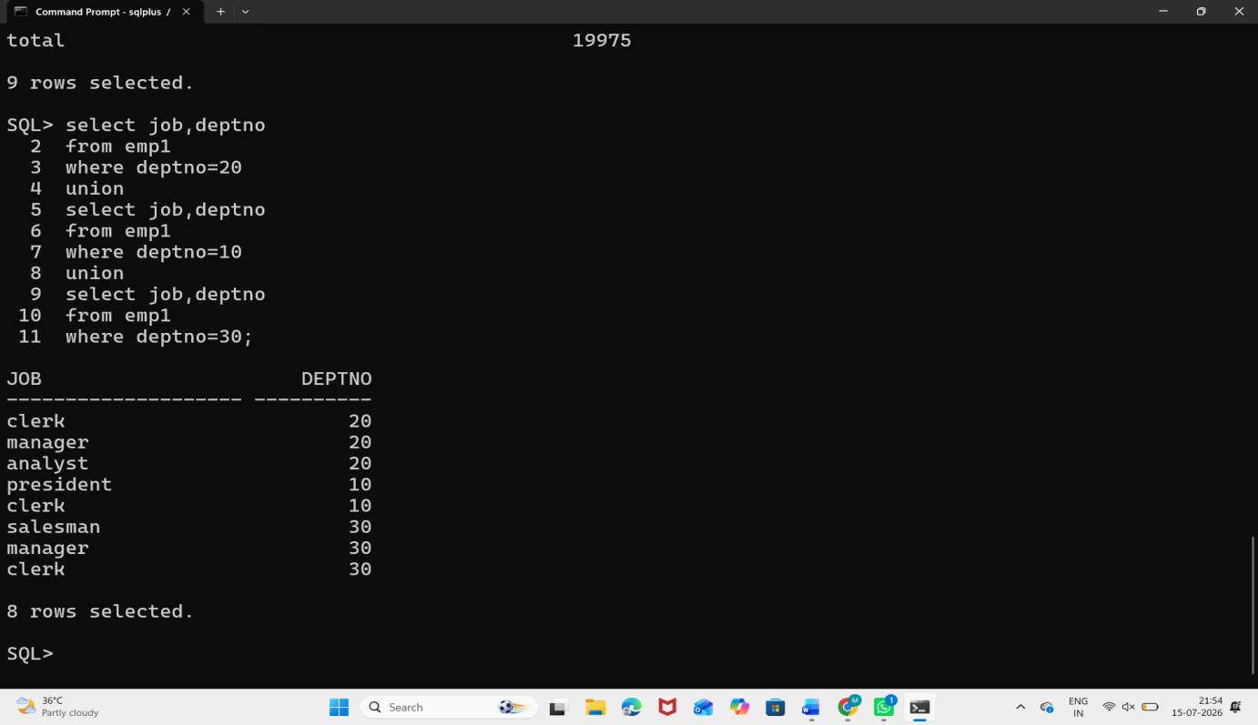

Assignment-7
13-07-2026: Displaying data from multiple tables using joins:
