Department of Computer Science and Engineering
(AI & ML)
B. Tech. CSE - 5th Semester
Aug – Dec 2025

UE23CS351A
DATABASE MANAGEMENT SYSTEMS (DBMS)

PROJECT REPORT on

SmartIntern – AI-Powered Internship Recommendation Platform

Submitted by:
SRN 1 : PES1UG24AM183 | Name 1 : | 5_D
  Palleneni Sloka
SRN 2 : PES1UG24AM182 | Name 2 : | 5_D
  Pabbisetty Harshitha Sai

Class of Prof. Raghu B A
Lab Faculty: Devna Sumesh

Abstract

SmartIntern is an AI-powered internship recommendation platform designed to simplify and improve the internship search process for students. The platform helps students create profiles, upload resumes, identify relevant skills, explore internship opportunities, receive personalized job recommendations, and track their applications.

The project uses Next.js, React, and TypeScript for the frontend and backend development, with PostgreSQL as the primary relational database and MongoDB for storing recommendation activity logs. PostgreSQL manages structured data such as user details, student profiles, resumes, skills, companies, jobs, applications, and messages. MongoDB supports the storage of recommendation-related activity data.

The database design incorporates entities, relationships, primary keys, foreign keys, constraints, indexes, and SQL queries to maintain data consistency and retrieve meaningful information. The platform also integrates authentication, resume processing, job matching, application tracking, and messaging functionalities.
SmartIntern demonstrates the practical application of database management concepts in a real-world web application by combining relational and NoSQL databases to support structured information management and recommendation activity tracking.

Table of Contents
Sl. No | Topic | Page No.
 | Introduction  - Problem Statement | 4
 | User Requirements Specification- Tech Stack | 5
 | E-R Model  - List of Entities [labeling Weak ones]  - List non-simple Attributes  - ER Diagram Snapshot  - ERD from tool like draw.io | 6
 | Relational Model  - List of Relations that are not Entities in ER Model  - Schema Diagram [ensure light background image] | 8
 | SQL DDL Statements | 10
 | SQL DML Statements | 13
 | NoSQL/ Vector Database Commands | 15
8. | Results  - Resulting Tables’ Screenshots | 16
9. | Next.js-Project Tree Structure | 21
10. | Few sample Screenshots of application code and demo | 22
11. | Evaluation Rubrics- Completion Status | 30

Introduction

Problem Statement
Finding suitable internships is an important challenge for students seeking practical experience and career development. Students often need to search across multiple platforms, manually compare internship requirements with their skills, and manage application details independently. This process can be time-consuming and may result in students missing relevant opportunities.
SmartIntern – AI-Powered Internship Recommendation Platform is developed to address these challenges by providing a centralized platform for internship discovery, personalized recommendations, and application management. The system allows students to register, maintain their profiles, upload resumes, identify relevant skills, explore internship opportunities, and receive job recommendations based on their skill sets.
The platform also provides application tracking, messaging, and dashboard insights to improve the overall internship search experience. From a database management perspective, the project focuses on efficiently storing, organizing, retrieving, and managing student, internship, company, and application-related information.
The system uses PostgreSQL to manage structured and relational data and MongoDB to store recommendation activity logs. By integrating these databases with a web application, SmartIntern aims to make internship searching more organized, efficient, and personalized.

User Requirements Specification
2.1 Functional Requirements
The SmartIntern platform provides the following functionalities:
- User Registration and Authentication: Students can register and log in securely to access the platform.
- Student Profile Management: Students can create and maintain profiles containing their academic and skill-related information.
- Resume Upload: Students can upload resumes in PDF format for processing and skill extraction.
- Skill Management: The system identifies and maintains student skills for internship matching.
- Internship Recommendations: Students receive internship recommendations based on their skills and job requirements.
- Internship Browsing: Students can explore internship opportunities posted by companies.
- Application Tracking: Students can apply for internships and track their application status.
- Messaging: The platform supports communication through an inbox and messaging functionality.
- Dashboard and Insights: Students can view relevant application and recommendation information through a dashboard.
- Recommendation Activity Logging: Recommendation-related activities are stored for analysis and tracking

2.2 Technology Stack
Technology | Purpose
Next.js | Web application framework and API routes
React | User interface development
TypeScript | Type-safe application development
Tailwind CSS | Responsive UI styling
PostgreSQL | Structured relational data storage
MongoDB | Recommendation activity log storage
JWT | Authentication and session-related token handling
PDF Parsing | Resume text extraction

2.3 Justification for Technology Stack
Next.js and React are used to develop a responsive and interactive web application. Next.js also provides API routes that support communication between the frontend and databases. TypeScript improves code reliability through static type checking, while Tailwind CSS enables efficient and consistent UI styling.

PostgreSQL is selected as the primary database because SmartIntern contains structured data with multiple relationships, including users, student profiles, resumes, skills, companies, jobs, and applications. PostgreSQL supports primary keys, foreign keys, constraints, joins, transactions, and complex SQL queries, making it suitable for maintaining data consistency and integrity.
MongoDB is used as a NoSQL database to store recommendation activity logs. Its document-oriented structure is suitable for storing activity records that may contain flexible metadata and recommendation-related information.

The combination of PostgreSQL and MongoDB provides a hybrid database architecture that supports both structured relational information and flexible activity-log storage.

E-R Model

List of Entities (Highlight Weak Ones)

The SmartIntern database consists of the following 11 entities:
- User: Stores user identification, full name, email, password hash, role, and account creation date.
- Student_Profiles: Stores student profile information such as degree, branch, university, graduation year, CGPA, and experience years.
- Resumes: Stores uploaded resume details including file name, file path, extracted text, and upload date.
- Student_Skills: Stores skills possessed by students along with proficiency information.
- Skills: Stores skill identification details such as skill ID and skill name.
- Companies: Stores company information including company name, industry, website, and description.
- Jobs: Stores internship/job details such as title, description, opportunity type, location, minimum CGPA, stipend or salary, application deadline, and active status.
- Job_Skills: Stores skills required for jobs along with their importance.
- Applications: Stores student application details including application ID, user ID, job ID, application status, and applied date.
- Recommendation_Runs: Stores recommendation details including match percentage, matching skills, missing skills, explanation, and generated date.
- Inbox_Messages: Stores messaging information including sender, recipient, subject, body, creation date, and read date.
Weak Entities: No weak entities are explicitly represented in the given ER diagram. All entities are represented using their own primary key attributes.

ER Diagram
The ER diagram of SmartIntern represents the entities, attributes, and relationships involved in the internship recommendation platform. It illustrates how users interact with student profiles, resumes, skills, companies, jobs, applications, recommendation runs, and inbox messages.
The diagram also represents associative entities such as Student_Skills and Job_Skills to manage student skills and job-required skills.

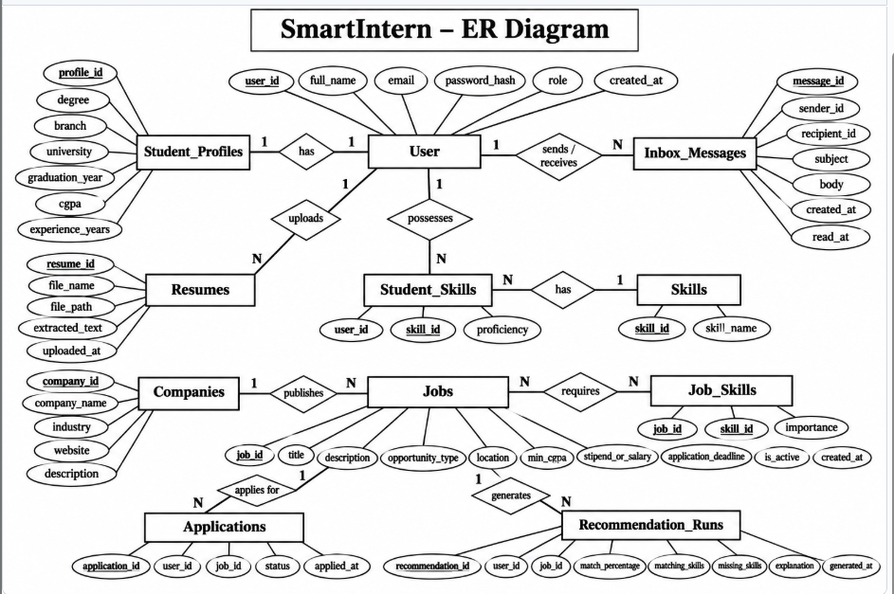

Relational Model
List of Relations (Label Those That Are Not Entities in ER Model)

The SmartIntern relational database consists of the following 11 relations:
- users (user_id, full_name, email, password_hash, role, created_at)
- student_profiles (profile_id, user_id, degree, branch, university, graduation_year, cgpa, experience_years)
- resumes (resume_id, user_id, file_name, file_path, extracted_text, uploaded_at)
- skills (skill_id, skill_name)
- student_skills (user_id, skill_id, proficiency)
- companies (company_id, company_name, industry, website, description)
- jobs (job_id, company_id, title, description, opportunity_type, location, min_cgpa, stipend_or_salary, application_deadline, is_active, created_at)
- job_skills (job_id, skill_id, importance)
- applications (application_id, user_id, job_id, status, applied_at)
- recommendation_runs (recommendation_id, user_id, job_id, match_percentage, matching_skills, missing_skills, explanation, generated_at)
- inbox_messages (message_id, sender_id, recipient_id, subject, body, created_at, read_at)
The relations student_skills and job_skills are associative relations used to represent many-to-many relationships.

Schema Diagram
The relational schema diagram of SmartIntern represents the tables, attributes, primary keys, foreign keys, and relationships between tables. PostgreSQL is used to maintain relational integrity and consistency among the database tables.

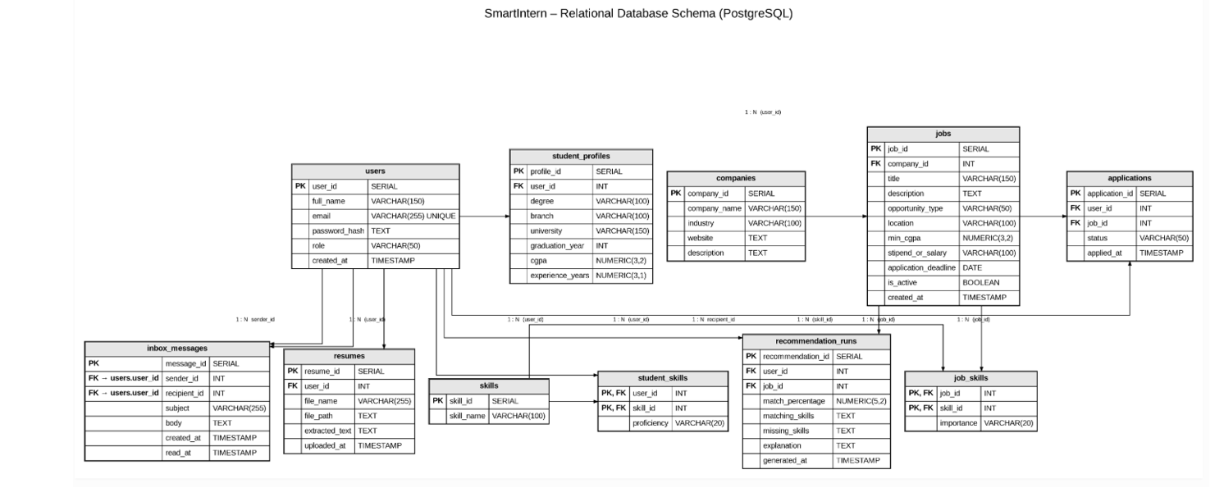

SQL DDL Statements
The following Data Definition Language (DDL) statements are used to define the relational database structure of SmartIntern in PostgreSQL. The database consists of 11 tables with primary keys, foreign keys, and constraints to maintain data integrity.

1. Create Database
CREATE DATABASE smartintern_db;

2. Create Users Table
CREATE TABLE users (
user_id SERIAL PRIMARY KEY,
full_name VARCHAR(150),
email VARCHAR(255) UNIQUE,
password_hash TEXT,
role VARCHAR(50),
created_at TIMESTAMP DEFAULT CURRENT_TIMESTAMP
);

3. Create Student Profiles Table
CREATE TABLE student_profiles (
profile_id SERIAL PRIMARY KEY,
user_id INT UNIQUE REFERENCES users(user_id),
degree VARCHAR(100),
branch VARCHAR(100),
university VARCHAR(150),
graduation_year INT,
cgpa NUMERIC(3,2),
experience_years NUMERIC(3,1)
);

4. Create Resumes Table
CREATE TABLE resumes (
resume_id SERIAL PRIMARY KEY,
user_id INT REFERENCES users(user_id),
file_name VARCHAR(255),
file_path TEXT,
extracted_text TEXT,
uploaded_at TIMESTAMP DEFAULT CURRENT_TIMESTAMP
);

5. Create Skills Table
CREATE TABLE skills (
skill_id SERIAL PRIMARY KEY,
skill_name VARCHAR(100)
);

6. Create Student Skills Table
CREATE TABLE student_skills (
user_id INT REFERENCES users(user_id),
skill_id INT REFERENCES skills(skill_id),
proficiency VARCHAR(20),
PRIMARY KEY (user_id, skill_id)
);

7. Create Companies Table
CREATE TABLE companies (
company_id SERIAL PRIMARY KEY,
company_name VARCHAR(150),
industry VARCHAR(100),
website TEXT,
description TEXT
);

8. Create Jobs Table
CREATE TABLE jobs (
job_id SERIAL PRIMARY KEY,
company_id INT REFERENCES companies(company_id),
title VARCHAR(150),
description TEXT,
opportunity_type VARCHAR(50),
location VARCHAR(100),
min_cgpa NUMERIC(3,2),
stipend_or_salary VARCHAR(100),
application_deadline DATE,
is_active BOOLEAN,
created_at TIMESTAMP DEFAULT CURRENT_TIMESTAMP
);

9. Create Job Skills Table
CREATE TABLE job_skills (
job_id INT REFERENCES jobs(job_id),
skill_id INT REFERENCES skills(skill_id),
importance VARCHAR(20),
PRIMARY KEY (job_id, skill_id)
);
10. Create Applications Table
CREATE TABLE applications (
application_id SERIAL PRIMARY KEY,
user_id INT REFERENCES users(user_id),
job_id INT REFERENCES jobs(job_id),
status VARCHAR(50),
applied_at TIMESTAMP DEFAULT CURRENT_TIMESTAMP
);

11. Create Recommendation Runs Table
CREATE TABLE recommendation_runs (
recommendation_id SERIAL PRIMARY KEY,
user_id INT REFERENCES users(user_id),
job_id INT REFERENCES jobs(job_id),
match_percentage NUMERIC(5,2),
matching_skills TEXT,
missing_skills TEXT,
explanation TEXT,
generated_at TIMESTAMP DEFAULT CURRENT_TIMESTAMP
);

12. Create Inbox Messages Table
CREATE TABLE inbox_messages (
message_id SERIAL PRIMARY KEY,
sender_id INT REFERENCES users(user_id),
recipient_id INT REFERENCES users(user_id),
subject VARCHAR(255),
body TEXT,
created_at TIMESTAMP DEFAULT CURRENT_TIMESTAMP,
read_at TIMESTAMP
);

SQL DML Statements

Data Manipulation Language (DML) commands are used to insert, retrieve, update, and delete records from database tables. SmartIntern uses SQL DML statements to manage student information, skills, companies, internship opportunities, and applications.

1. INSERT Statement
The INSERT statement is used to add new records into database tables.
INSERT INTO users (full_name, email, password_hash, role)
VALUES ('Rahul Sharma', 'rahul@example.com', 'hashed_password', 'student');
INSERT INTO skills (skill_name)
VALUES ('Python');

2. SELECT Statement
The SELECT statement retrieves information from database tables.
SELECT * FROM users;
SELECT title, location, stipend_or_salary
FROM jobs
WHERE is_active = TRUE;

3. UPDATE Statement
The UPDATE statement modifies existing records.
UPDATE applications
SET status = 'Under Review'
WHERE application_id = 1;

4. DELETE Statement
The DELETE statement removes records from database tables.
DELETE FROM applications
WHERE application_id = 1;

5. JOIN Query
JOIN queries retrieve information from multiple related tables.
SELECT u.full_name, j.title, a.status
FROM applications a
JOIN users u ON a.user_id = u.user_id
JOIN jobs j ON a.job_id = j.job_id;

6. GROUP BY and HAVING
These clauses are used to group records and filter aggregated results.
SELECT job_id, COUNT(*) AS total_applications
FROM applications
GROUP BY job_id
HAVING COUNT(*) > 1;

7. Subquery
A subquery is a query nested inside another SQL query.
SELECT title
FROM jobs
WHERE job_id IN (
SELECT job_id
FROM applications
);

8. Common Table Expression (CTE)
A CTE is used to define a temporary result set that can be referenced within a SQL query.
WITH application_counts AS (
SELECT job_id, COUNT(*) AS total_applications
FROM applications
GROUP BY job_id
)
SELECT j.title,
COALESCE(ac.total_applications, 0) AS total_applications
FROM jobs j
LEFT JOIN application_counts ac
ON j.job_id = ac.job_id
ORDER BY total_applications DESC;

NoSQL/ Vector Database Commands

SmartIntern uses MongoDB as a NoSQL database to store recommendation activity logs. MongoDB stores data in document format, providing flexibility for recommendation-related records.
The collection used in SmartIntern is recommendation_activity_logs in the smartintern database.

1. Select Database
use smartintern

2. Create Collection
db.createCollection("recommendation_activity_logs")

3. INSERT Operation
The INSERT operation adds recommendation activity records to MongoDB.
db.recommendation_activity_logs.insertOne({
user_id: 1,
job_id: 101,
match_percentage: 85,
activity: "recommendation_generated",
created_at: new Date()
})

4. READ Operation
The READ operation retrieves recommendation activity records.
db.recommendation_activity_logs.find()
db.recommendation_activity_logs.find({
user_id: 1
})

5. UPDATE Operation
The UPDATE operation modifies existing recommendation activity records.
db.recommendation_activity_logs.updateOne(
{ user_id: 1, job_id: 101 },
{ $set: { match_percentage: 90 } }
)

6. DELETE Operation
The DELETE operation removes a recommendation activity record.
db.recommendation_activity_logs.deleteOne({
user_id: 1,
job_id: 101
})

7. Aggregation Operation
Aggregation is used to process and analyze recommendation activity records.
db.recommendation_activity_logs.aggregate([
{
$group: {
_id: "$user_id",
total_recommendations: { $sum: 1 }
}
}
])
These MongoDB commands demonstrate document insertion, retrieval, modification, deletion, and aggregation operations for recommendation activity data.

Results

The SmartIntern – AI-Powered Internship Recommendation and Management System was successfully developed using PostgreSQL and MongoDB. The database was created to manage student information, resumes, skills, companies, internship opportunities, applications, recommendations, and communication.

The results demonstrate the successful implementation of relational database tables, primary and foreign key constraints, SQL queries, indexes, views, and MongoDB operations. The following screenshots present the database structure and execution results.

Fig. 8.1: SmartIntern Database Overview
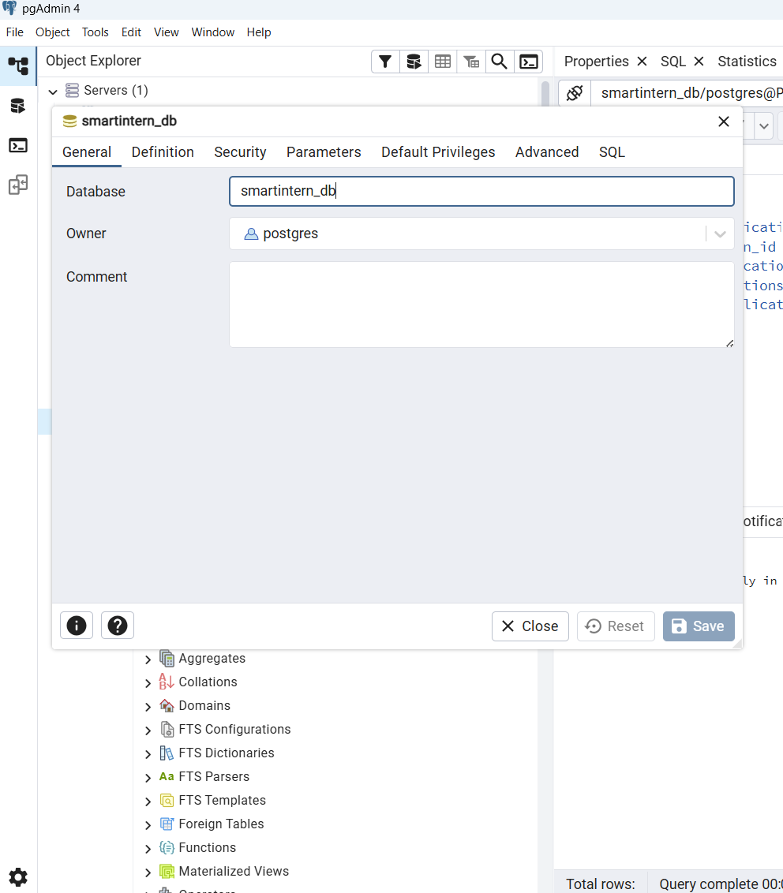

Fig. 8.2: PostgreSQL Tables in SmartIntern

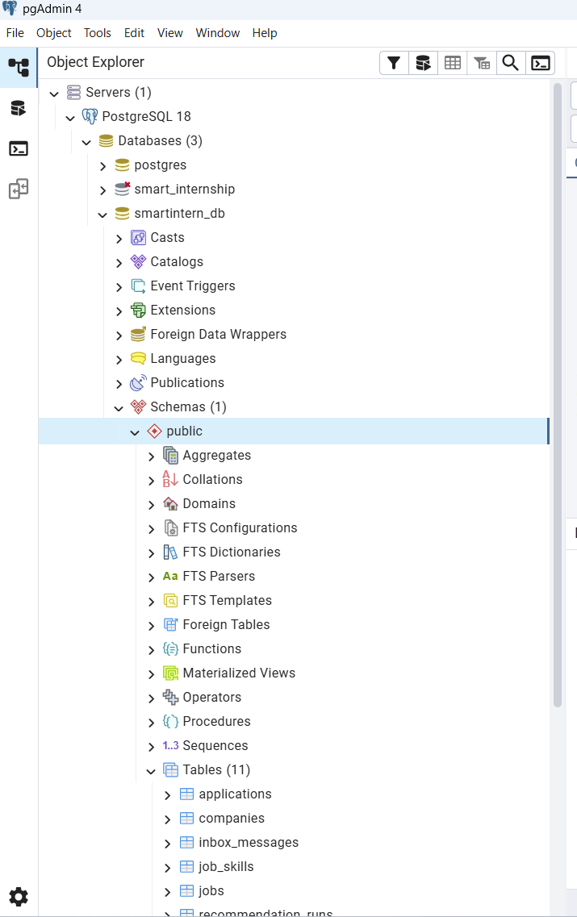
Fig. 8.3: Primary and Foreign Key Constraints

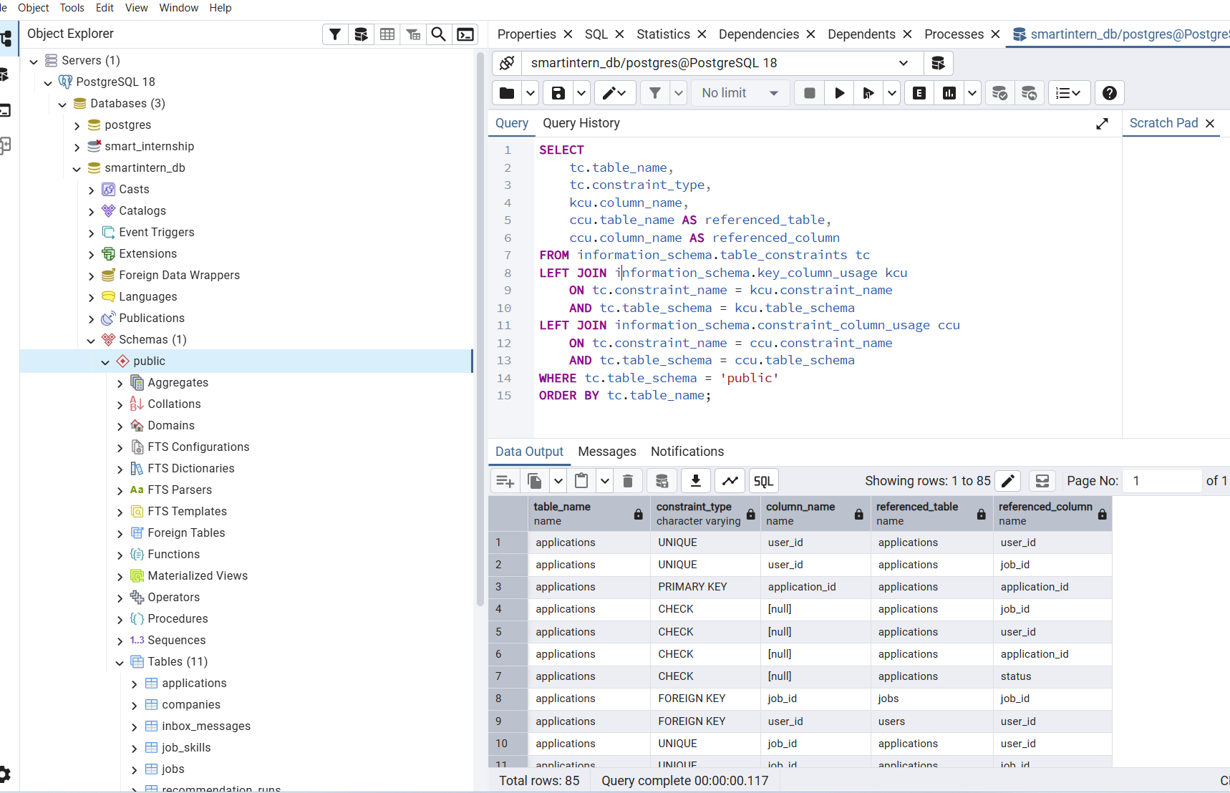

Fig. 8.4: SQL View Creation and Results

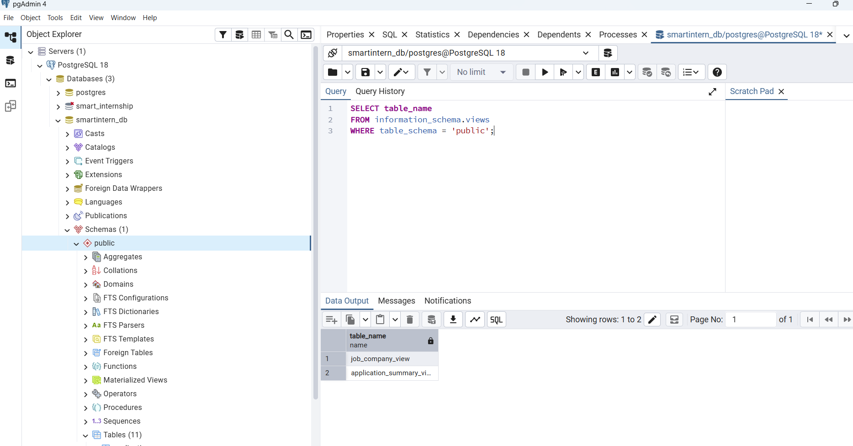

9.Next.js Project Tree Structure

SmartIntern is developed using Next.js with React and TypeScript. The project follows a modular folder structure that separates application pages, API routes, database connectivity, documentation, and testing files.
The following project structure illustrates the organization of the SmartIntern application.

SmartIntern/
├── app/
│ ├── api/
│ │ ├── admin/jobs/
│ │ ├── applications/
│ │ ├── auth/login/
│ │ ├── auth/logout/
│ │ ├── auth/register/
│ │ ├── inbox/
│ │ ├── profile/
│ │ ├── recommendation-history/
│ │ ├── recommendations/
│ │ └── resume/
│ ├── globals.css
│ ├── layout.tsx
│ └── page.tsx
├── database/
│ ├── advanced_queries.sql
│ ├── indexes.sql
│ ├── mongodb_aggregation.js
│ ├── smartintern_complete.sql
│ └── views.sql
├── docs/
│ ├── DATABASE_DOCUMENTATION.md
│ ├── ER_DIAGRAM.png
│ └── RELATIONAL_SCHEMA.md
├── lib/
│ ├── db.ts
│ ├── mongodb.ts
│ └── session.ts
├── tests/
│ └── database_tests.md
├── public/
├── package.json
├── README.md
└── tsconfig.json

10.Few Sample Screenshots of Application Code and Demo

This section presents the implementation and working interface of the SmartIntern application. The screenshots demonstrate user registration, authentication, resume management, internship recommendations, communication, and application tracking.
The application is developed using Next.js, React, TypeScript, PostgreSQL, and MongoDB. The following screenshots illustrate the major features implemented in the system.

10.1 Student Registration
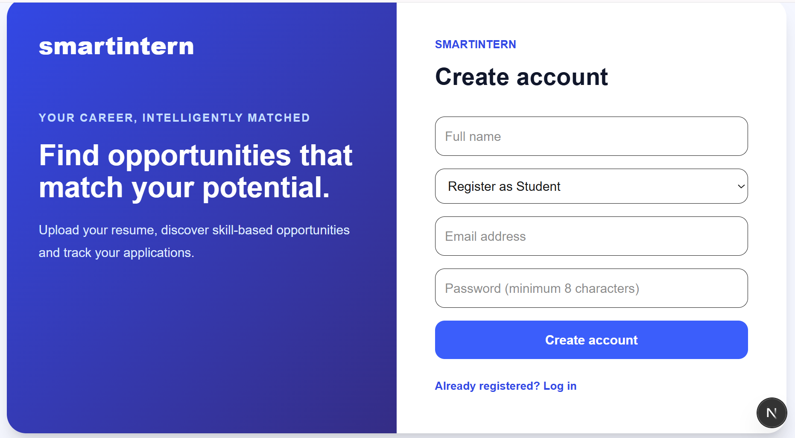

10.2 Student Login

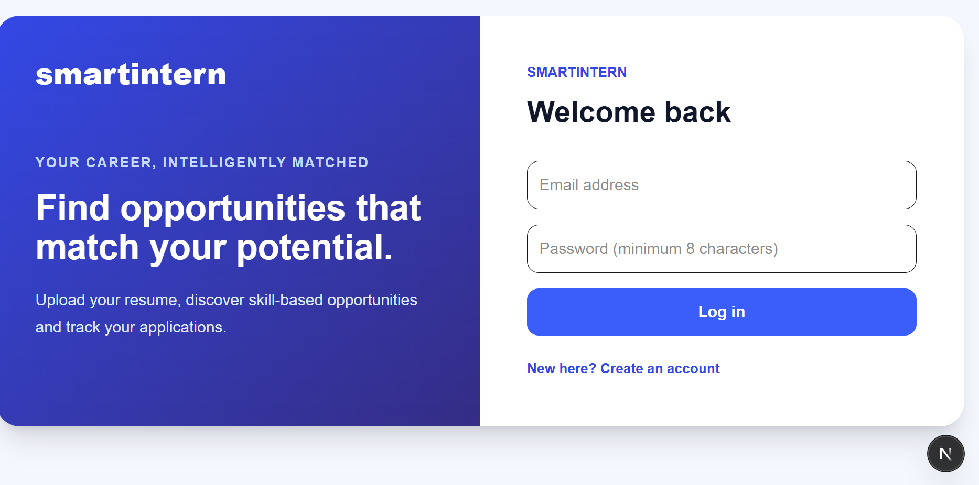

10.3 Resume Management
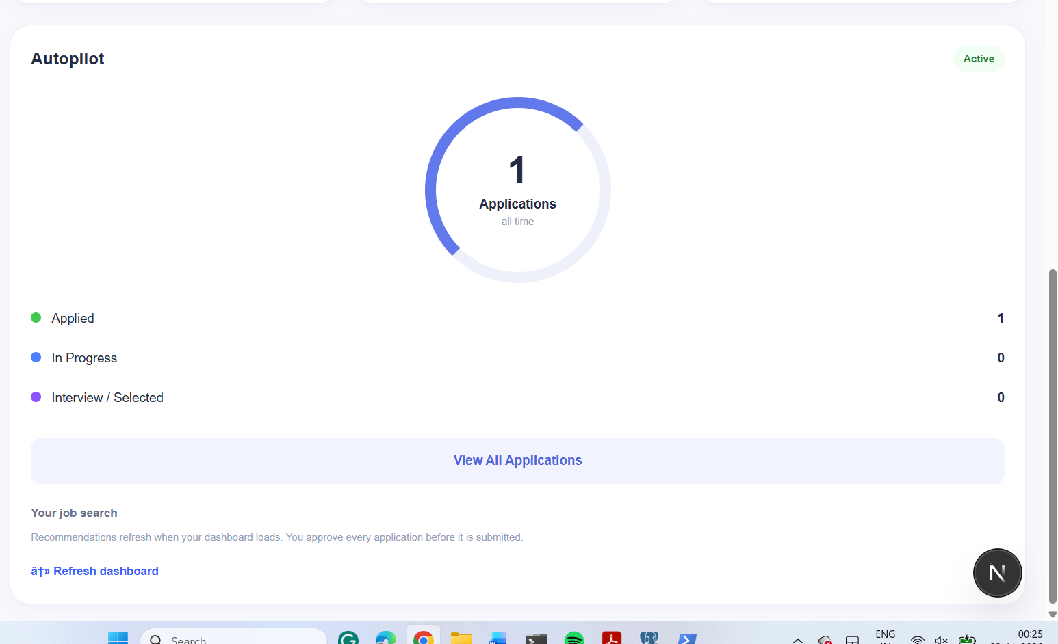

10.4 Internship Recommendations
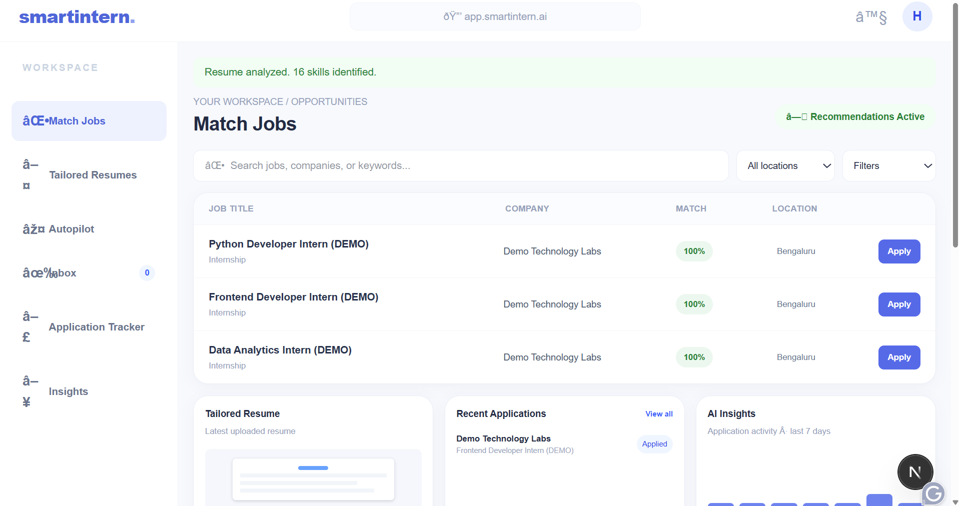

10.5 Inbox

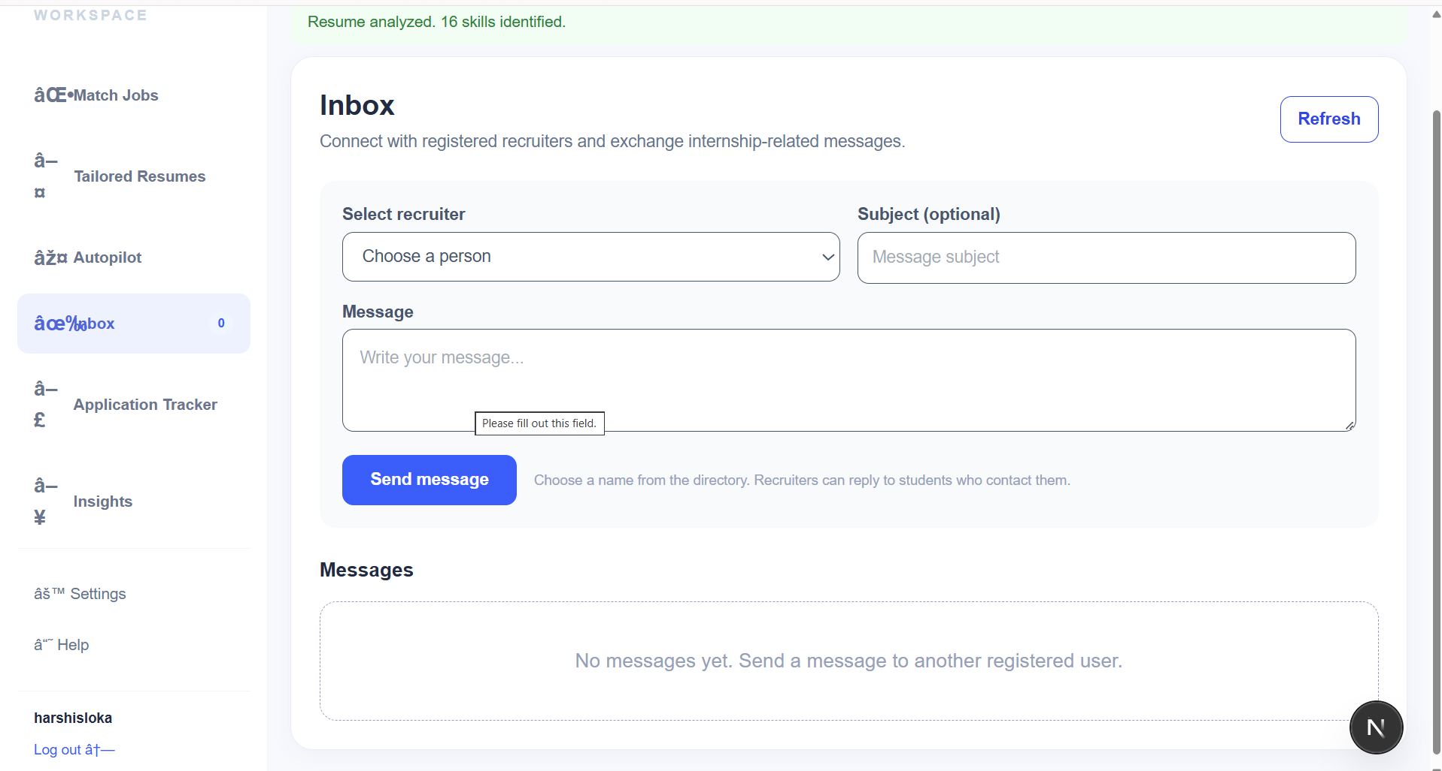

10.6 Application Tracker
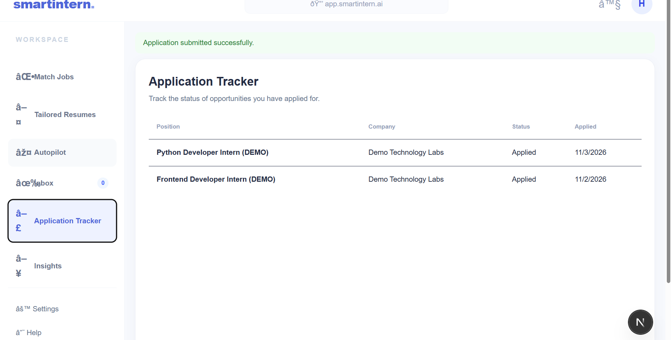

10.7 Settings

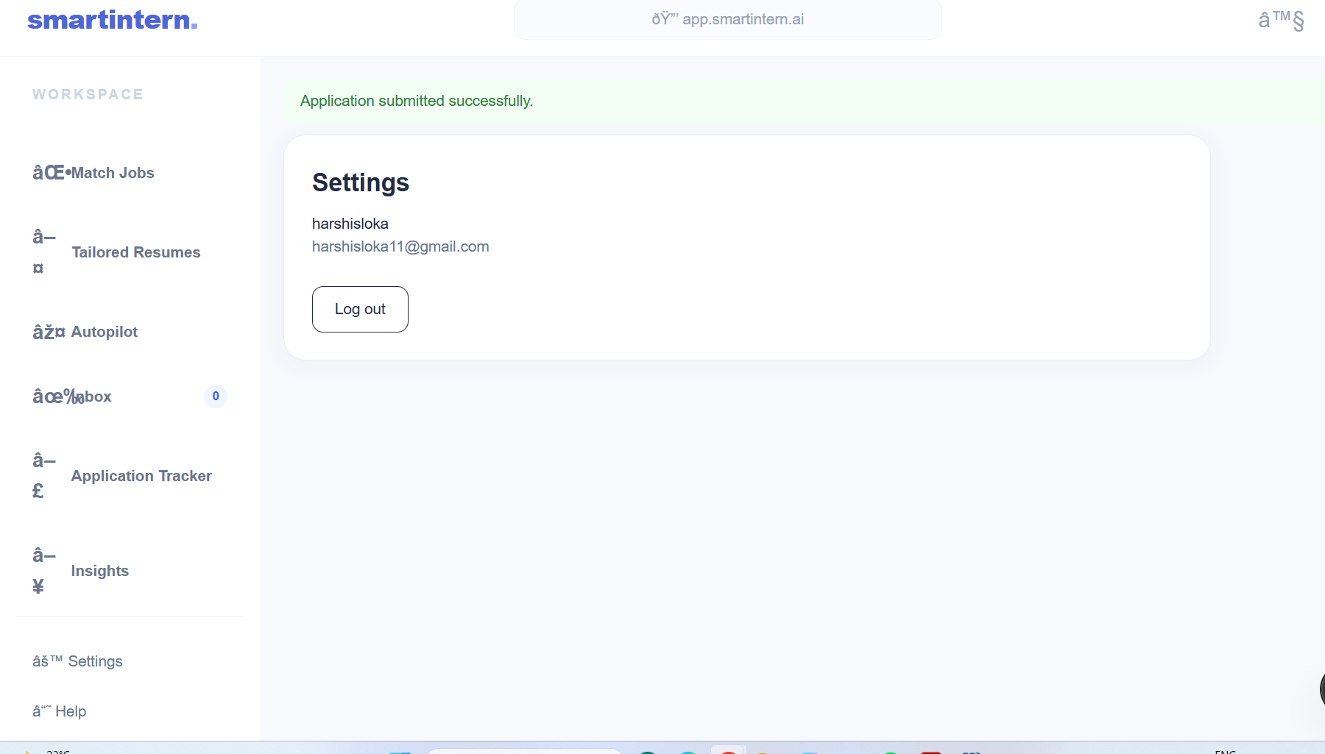

10.8 Help

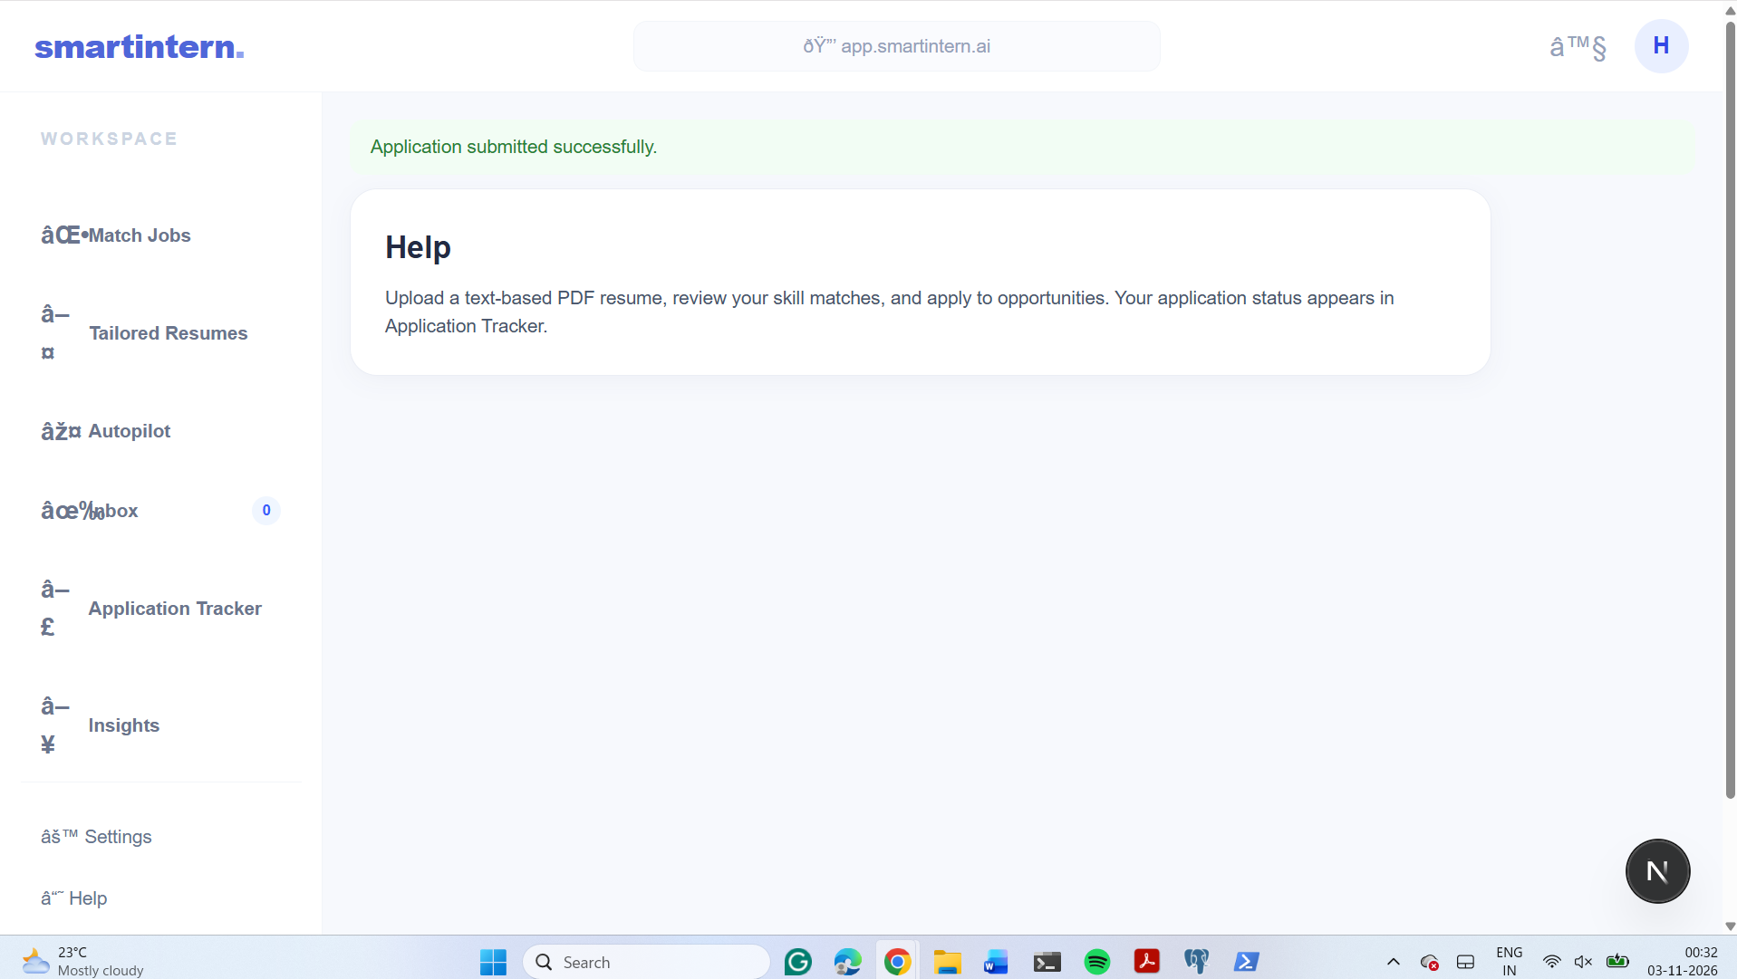

10.1: PostgreSQL Database Connection Implementation

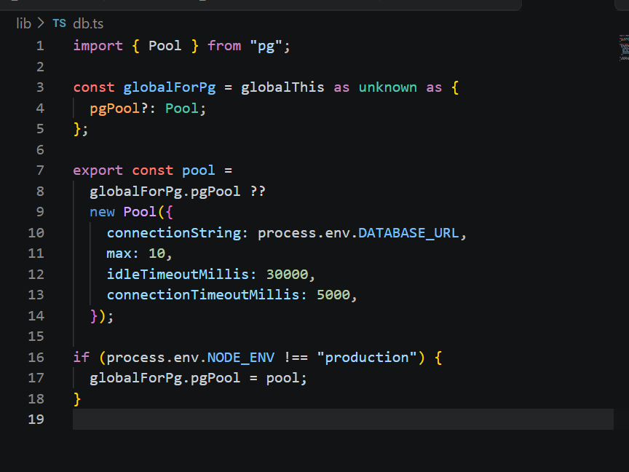

10.2: MongoDB Database Connection Implementation
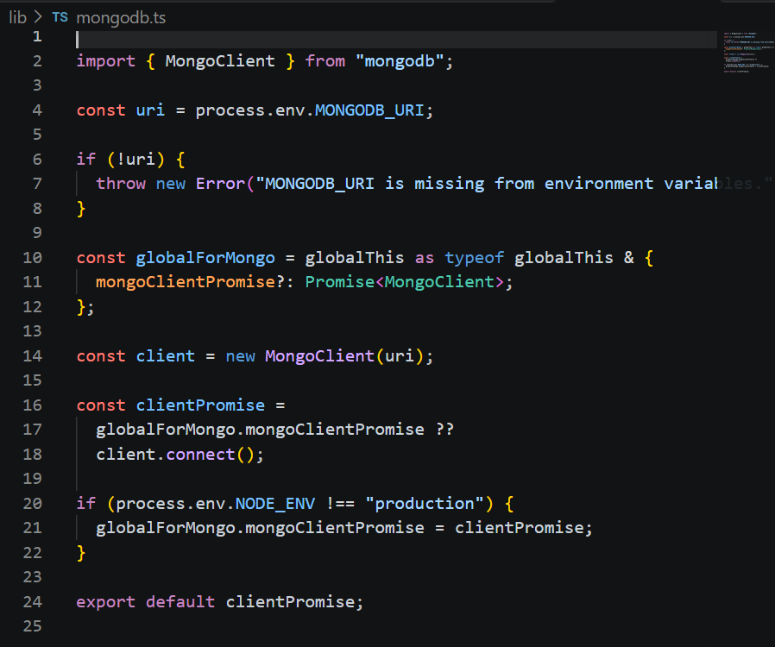

Evaluation Rubrics

# | Criteria | Distribution | Status
1 | Database Design | ER diagram , relational schema with keys, relationships, and constraints | Completed
2 | Database Creation | SQL database implementation - DDL with constraints , NoSQL/Vector database creation , Technology justification | Completed
3 | SQL Operations and Queries | DML operations , Nested/correlated/Recursive SQL queries, Join SQL queries | completed
4 | Advanced Database Concepts | Advanced database concepts (Procedure/function, trigger, CTE) , NoSQL/Vector feature RUD | completed
5 | Web Application and Database Integration | Next.js interface , Backend/API and database integration | completed
6 | Authentication and Authorization | Authentication implementation (front end and backend) and minimum two roles and role-based access control in database | completed
7 | Documentation, Git/GitHub, Demonstration, Testing, and Originality | Documentation, Git/GitHub , Originality and individual contribution | completed

