Task 2: Operating System Security Fundamentals (Linux & Windows)

STEP 1: Set Up Ubuntu Linux in a Virtual Environment

Begin by downloading and installing VirtualBox, a powerful and widely-used virtualization platform that allows you to run multiple operating systems on your current machine without risk. Next, obtain the Ubuntu ISO file; both Ubuntu 20.04 LTS and 22.04 LTS are stable, secure choices with long-term support. Launch
VirtualBox and create a new virtual machine, allocating at least 2 to 4 GB of RAM to ensure smooth operation. When it comes to storage, reserve a minimum of 25 GB to give Ubuntu enough room for system files, applications, and updates.

Go through the standard Ubuntu installation process, selecting your keyboard layout, time zone, and creating your first user account with a strong password. Once installation is complete and you’ve logged in, you’ll see the Ubuntu desktop—this is your isolated, safe playground for learning and experimentation. Capture a screenshot at this stage to document your successful setup.

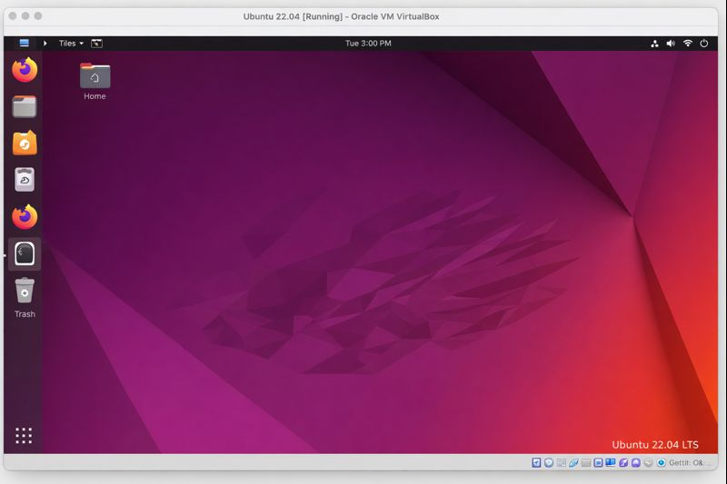

STEP 2: Investigate User Accounts and System Identity

Open the Terminal application, your gateway to powerful Linux command-line tools. Run the commands:

whoami
id
cat /etc/passwd

whoami lets you confirm which user account is currently active—this is useful when managing privileges or troubleshooting. The id command provides additional details, including your user ID (UID), group ID (GID), and any supplementary groups you belong to, which all influence your level of access to system resources.
By running cat /etc/passwd, you can view all user accounts registered on your system. Each line here represents a user, including system and service accounts, with details such as their home directory and default shell. Notice that only a handful of these are meant for people; most are for system processes and background services.
Remember, normal users have limited capabilities to protect the system from accidental or malicious changes, whereas the root user wields unrestricted power. Document your findings by taking a screenshot of your Terminal showing the whoami and id outputs

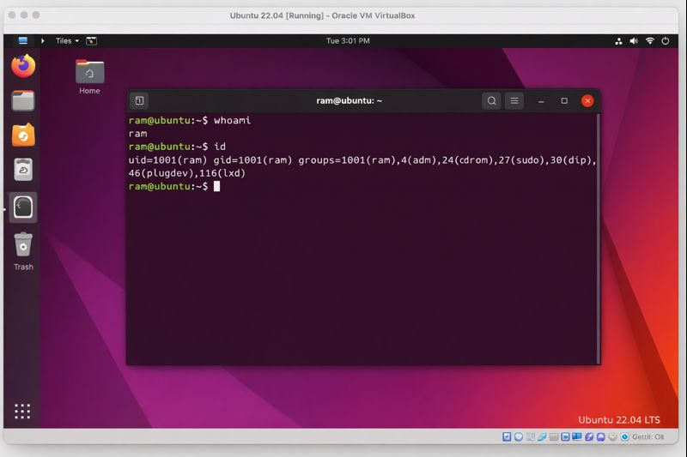

STEP 3: Examine and Modify File Permissions

Explore how Linux controls access to files and directories by entering:

ls -l

This command lists files in the current directory along with their permissions, ownership, and other metadata. For example, you may see a line like -rw-r--r-- which breaks down as follows:

r = read permission
w = write permission
x = execute permission

Permissions are divided into three groups: Owner (the file’s creator), Group (other users in the same group), and Others (everyone else). This model enforces security by restricting who can read, change, or execute files.

To modify these permissions, use the chmod command. For instance,

chmod 700 testfile

will grant all permissions (read, write, execute) to the file owner, but none to group or others. To change who owns the file, use chown:

sudo chown root:root testfile

This assigns both user and group ownership to root, reinforcing the concept of privileged access. Before and after you make these changes, use ls -l and take screenshots to clearly demonstrate the effects of your commands.

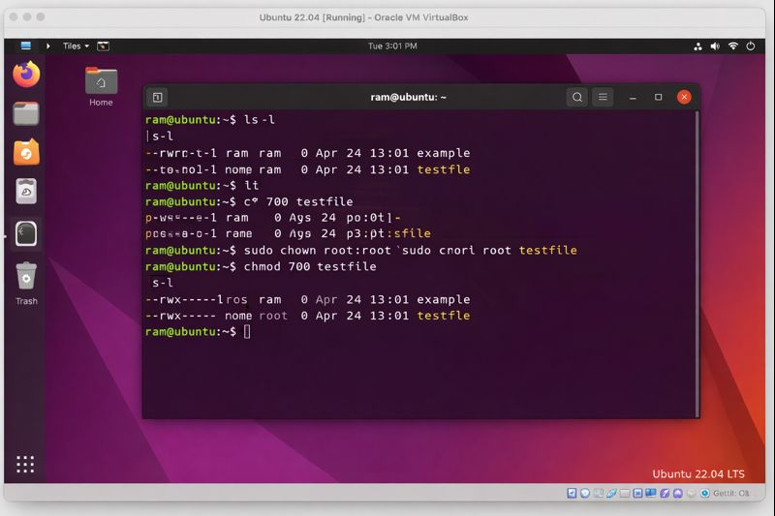

STEP 4: Differentiate Between Root and Normal Users

At times, system maintenance requires elevated privileges. You can temporarily become the root user by typing:

sudo su

While operating as root (notice the # prompt), you can perform any administrative task, but this power comes with risk—mistakes can have system-wide consequences. Always use root access judiciously and only when necessary. To safely return to your normal user, type exit.

Understanding this division of roles is crucial for system security. Regular users are shielded from making accidental changes that could destabilize the system, while root access is tightly controlled. Capture a screenshot showing the root prompt to illustrate your elevated session.

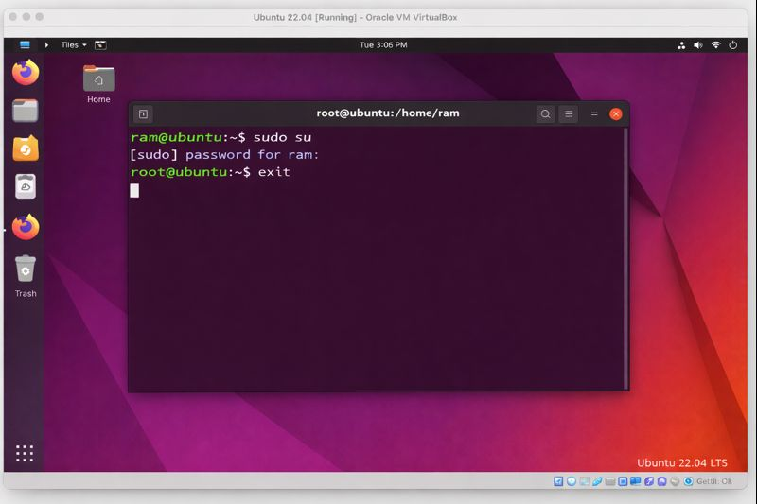

STEP 5: Strengthen Security by Enabling the Firewall (UFW)
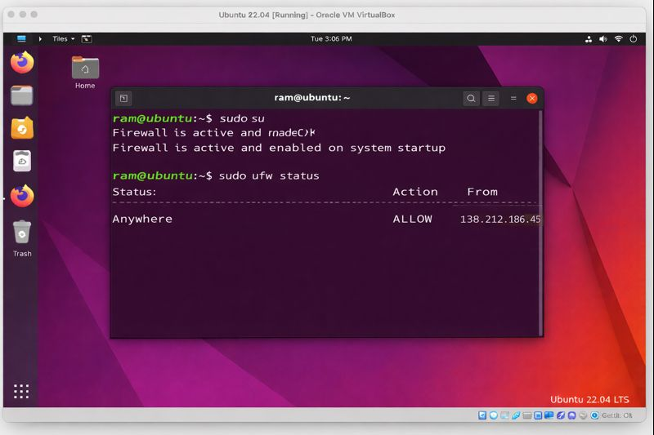
Check the status of your firewall using:

sudo ufw status

If it’s inactive, activate it with:

sudo ufw enable

If you plan to access your system remotely via SSH, ensure that this connection remains possible by explicitly allowing it:

sudo ufw allow ssh

The uncomplicated firewall (UFW) is a user-friendly front-end for managing iptables, offering a straightforward way to block unwanted network traffic and reduce your attack surface. Take a screenshot that confirms the firewall is active, providing visual evidence of this essential security measure

.

STEP 6: Monitor Running Processes and
Services
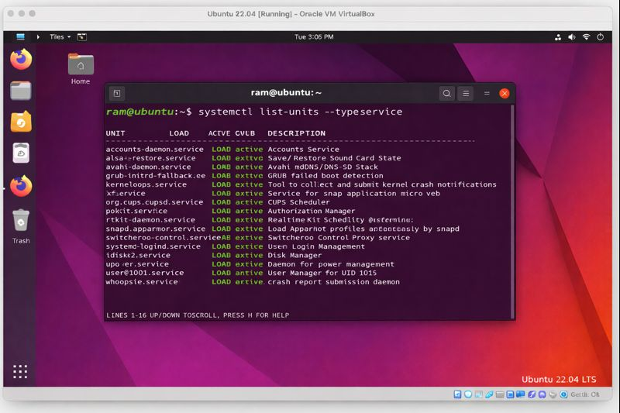

Knowing what’s happening under the hood is essential for maintaining a healthy and secure system. Use:

ps aux

to list all current processes, revealing what programs and background tasks are running. For a real-time, interactive view, enter:

top

You’ll see a dynamic display of system activity, including CPU and memory usage. To focus specifically on services managed by systemd, use:

systemctl list-units --type=service

This command lists all active services, which are background programs that start automatically and often listen for incoming connections. Regularly reviewing this list helps you spot anything unexpected or unnecessary. Document your findings with a screenshot of your active services.

STEP 7: Reduce Risk by Disabling Unneeded Services

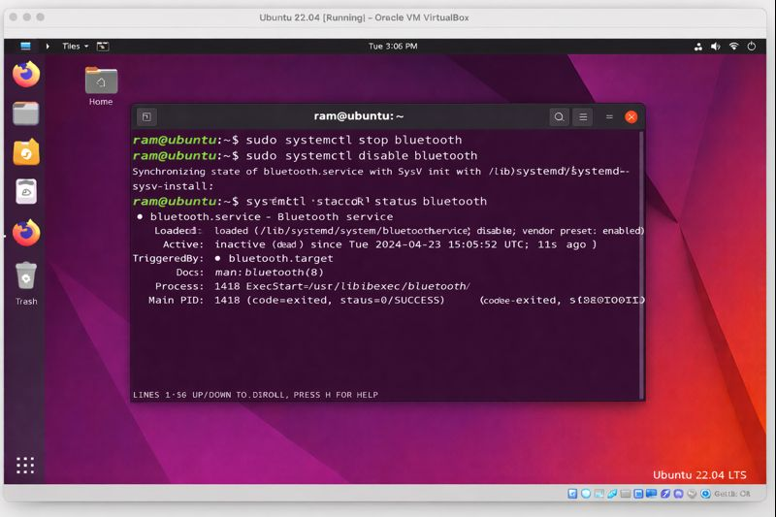

Minimizing the number of running services is a key security practice, as each service represents a potential entry point for attackers. For example, if you don’t use Bluetooth, you can turn it off with:

sudo systemctl stop bluetooth
sudo systemctl disable bluetooth

Stopping a service halts it immediately, while disabling it prevents it from starting on boot. By pruning unnecessary services, you reduce your system’s exposure to vulnerabilities—making it a less attractive target. Capture a screenshot that shows the Bluetooth service is disabled, documenting your proactive hardening.

STEP 8: Adopt Robust Operating System Hardening Practices

To secure your Ubuntu system:

- Always use strong, unique passwords for every account to prevent unauthorized access.
- Disable services and features you don’t need, reducing the number of potential weaknesses.
- Keep the firewall enabled and properly configured to block unwanted traffic.
- Follow the principle of least privilege: perform everyday tasks as a normal user, only switching to root when absolutely necessary.
- Regularly update your system to patch security vulnerabilities, using apt update and apt upgrade.
- Continuously monitor running processes and services, staying alert for unfamiliar or suspicious activity.
- Avoid logging in as root directly; instead, use sudo to execute administrative commands, ensuring there’s always an audit trail.

Thoroughly document each step you take, including configuration changes and screenshots, to create a comprehensive record of your system’s security posture. This process not only protects your system, but also deepens your understanding of Linux security fundamentals and best practices.

