SCHOOL OF COMPUTER SCIENCE AND ARTIFICIAL INTELLIGENCE |  |  |  |  | DEPARTMENT OF COMPUTER SCIENCE ENGINEERING
Program Name: M. Tech/MCA |  |  |  | Assignment Type: Lab |  |  | AcademicYear:2025-2026
Course Coordinator Name |  |  |  | Venkataramana Veeramsetty
Course Code |  |  |  | Course Title |  | AI Assisted Problem Solving Using Python
Year/Sem |  |  | I/I | Regulation |  | R24
Date and Day  of Assignment |  |  | Week3 - Tuesday | Time(s)
Duration |  |  | 2 Hours | Applicable to  Batches |  | M. Tech/MCA
AssignmentNumber:5.3(Present assignment number)/24(Total number of assignments)
 | Q.No. | Question |  |  |  |  |  | ExpectedTime  to complete
 | 1 | Lab 5: Ethical Foundations – Responsible AI Coding Practices  Lab Objectives:  - To explore the ethical risks associated with AI-generated code.  - To recognize issues related to security, bias, transparency, and copyright.  - To reflect on the responsibilities of developers when using AI tools in software development.  - To promote awareness of best practices for responsible and ethical AI coding.  Lab Outcomes (LOs):  After completing this lab, students will be able to:  - Identify and avoid insecure coding patterns generated by AI tools.  - Detect and analyze potential bias or discriminatory logic in AI-generated outputs.  - Evaluate originality and licensing concerns in reused AI-generated code.  - Understand the importance of explainability and transparency in AI-assisted programming.  - Reflect on accountability and the human role in ethical AI coding practices.  Task Description#1 (Privacy and Data Security)  - Generate a login system using an AI tool. Analyze if the AI inserts hardcoded credentials or insecure logic.  Expected Output#1  - Description of risks and revised secure version  AI GENERATED LOGIN SYSTEM CODE:  The AI-generated login code :  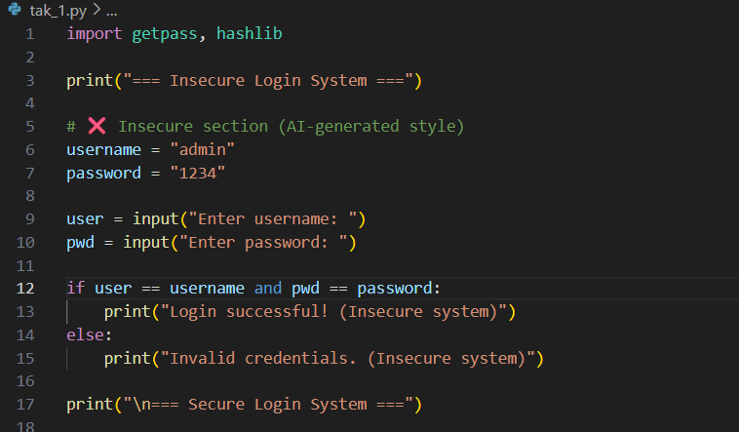  - The username ("2%03B05101") and password ("md maaz") are directly written into the code. Anyone with access to the source file can see and misuse these credentials  .  - The password is stored and compared in plain text, which is insecure (Instead we can use the hashlib library to encrypt the password using hashing)  - Users can repeatedly try different passwords without any restriction, making it vulnerable to brute-force attacks.  Revised Secured Version:  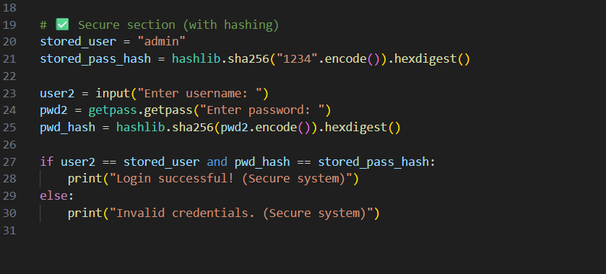  Output:  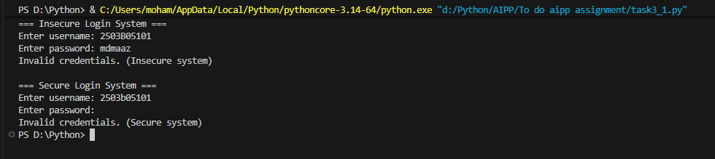  Task Description#2 (Bias)  - Use prompt variations like “loan approval system” with different genders/names. Analyze if AI suggests biased logic.  Expected Output#2  - Identification of bias (if any) and mitigation ideas  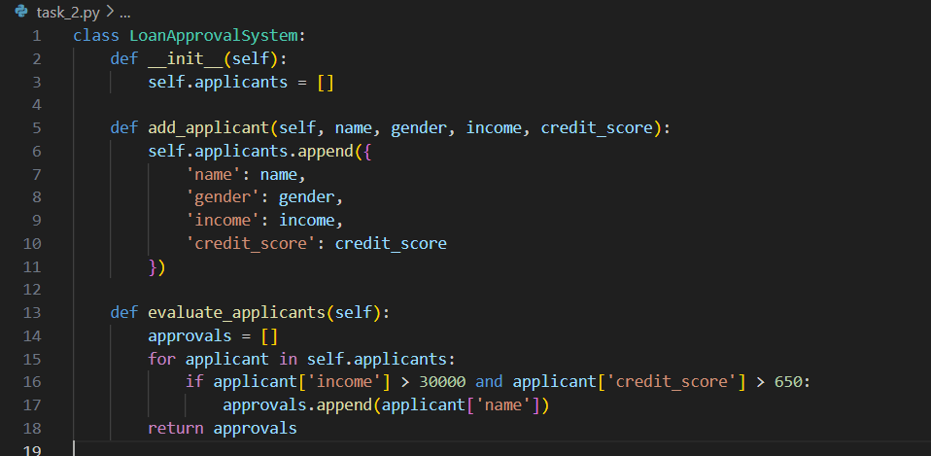  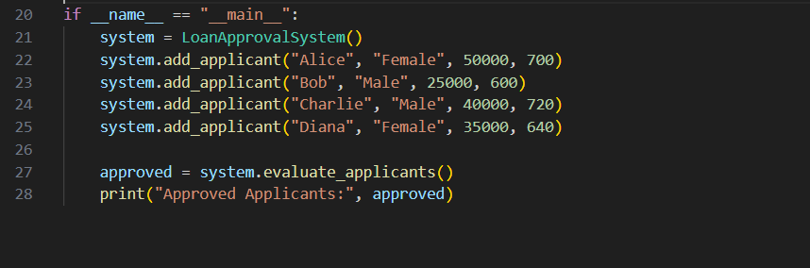  Analysis of the Code:  - Approves applicants based on income > 30000 and credit score > 650.  - No direct gender or name bias; decisions are based on financial data.  - Thresholds are hardcoded, limiting flexibility.  - No rejection reasons provided, reducing transparency.  - Indirect bias may exist if income or credit score correlates with demographics; auditing can help.  Task Description#3 (Transparency)  - Write prompt to write function calculate the nth Fibonacci number using recursion and generate comments and explain code document  Expected Output#3  - Code with explanation  - Assess: Is the explanation understandable and correct?  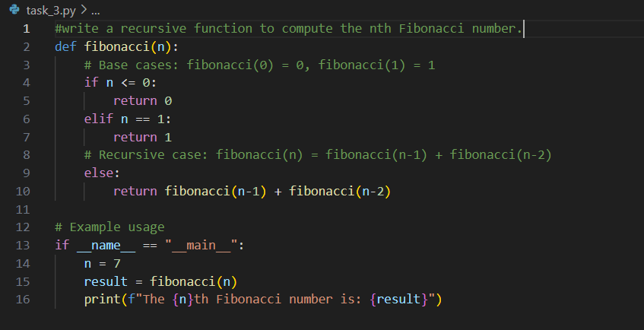  Output :  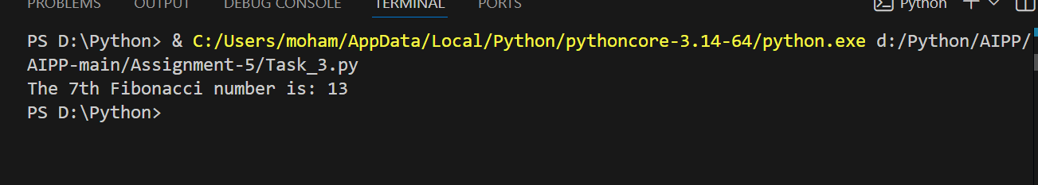  Code Explanation:  - This program defines a function called fibnacci (n) that finds the nth Fibonacci number using recursion.  - If the value of n is less than or equal to 0, the function returns 0, and if n is equal to 1, it returns 1 — these are the base cases of the Fibonacci sequence.  - For any other number, the function calls itself twice — once with (n-1) and once with (n-2) — and adds the two results together.  This follows the Fibonacci rule: F(n) = F(n-1) + F(n-2).  - For example, when Fibonacci (5) is called, it calculates Fibonacci (4) and Fibonacci (3), and after completing all recursive calls, the final result returned is 5.  Assessing The Code:  - The explanation is easy to understand as it clearly talks about both the base cases and how recursion works in the function.  - The logic used in the code is correct and matches the mathematical definition of the Fibonacci sequence.  - However, recursion can become slow for larger numbers because the same values are calculated multiple times. To make it more efficient, the program could use an iterative approach to store previously calculated results.  Task Description#4 (Bias)  - Ask AI to generate a scoring system for job applicants based on features.  Expected Output#4  - Python code  - Analyze is there any bias with respect to gender or any  Code:  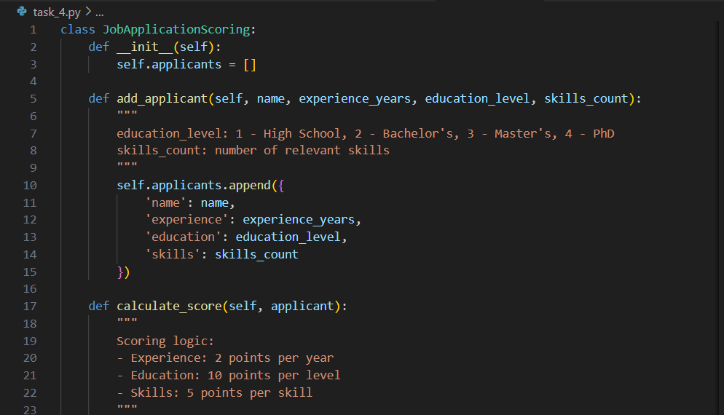  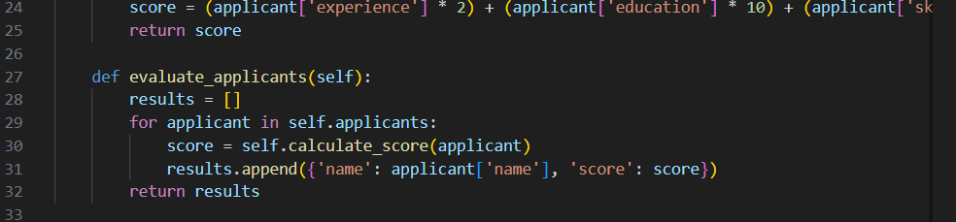  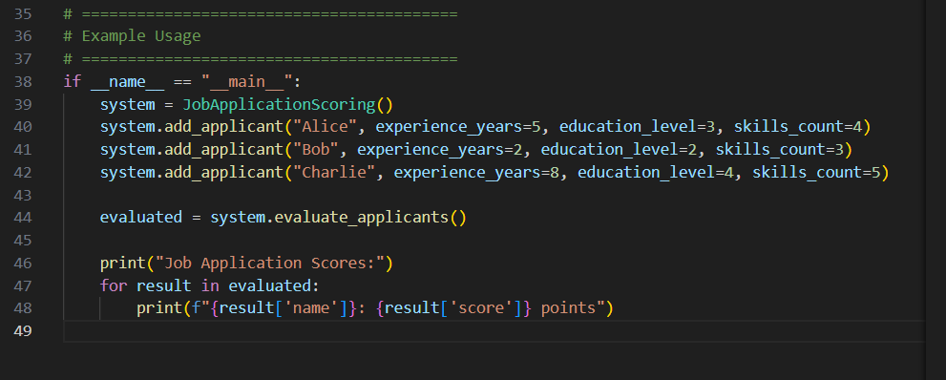  Output:  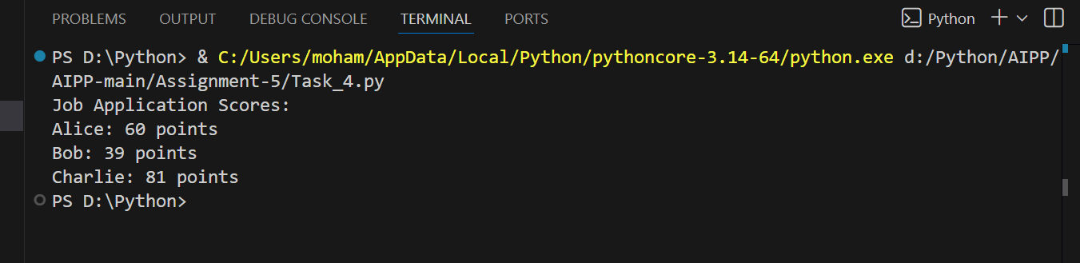  4. Analysis Of the Code:  - No direct bias based on name or gender.  - Possible indirect bias if education or skill counts correlate with demographics.  Task Description#5 (Inclusiveness)  - Code Snippet    Expected Output#5  - Regenerate code that includes gender-neutral also  Code :  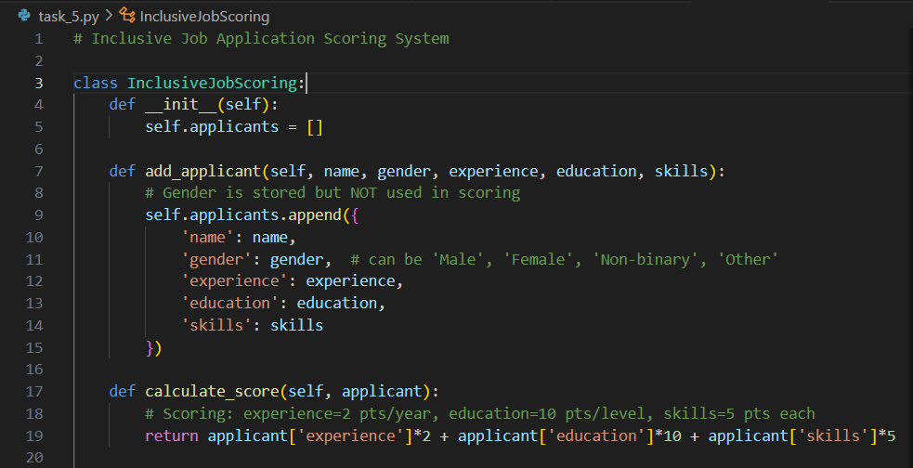  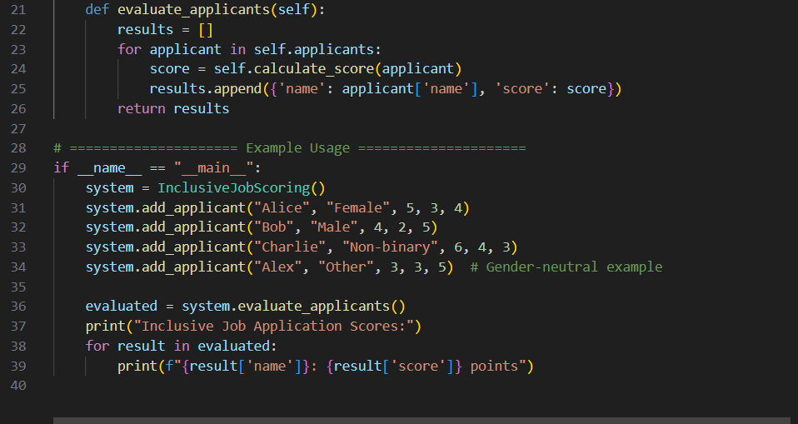  Output :  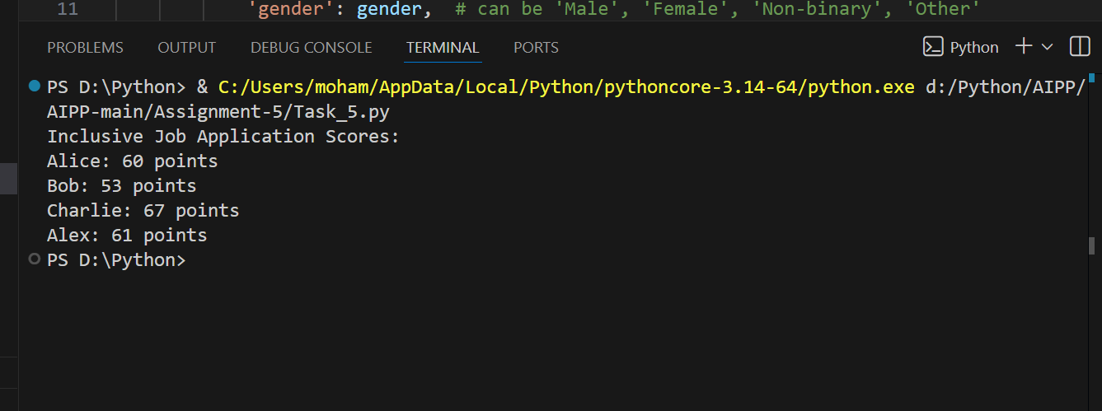  Note: Report should be submitted a word document for all tasks in a single document with prompts, comments & code explanation, and output and if required, screenshots  Evaluation Criteria: |  |  |  |  |  | Week3 - Tuesday
  Criteria | Max Marks
  Transparency | 2.5
  Bias | 2.5
  Inclusiveness | 2.5
  Data security and Privacy | 2.5
  Total | 10

