|  |
| --- |
| Name: Luciana Palucci |
| Course: CEDB 1250 (Big Data Storage) |
| Exercise #4: MOLAP Model |

Conceptual Model Design:

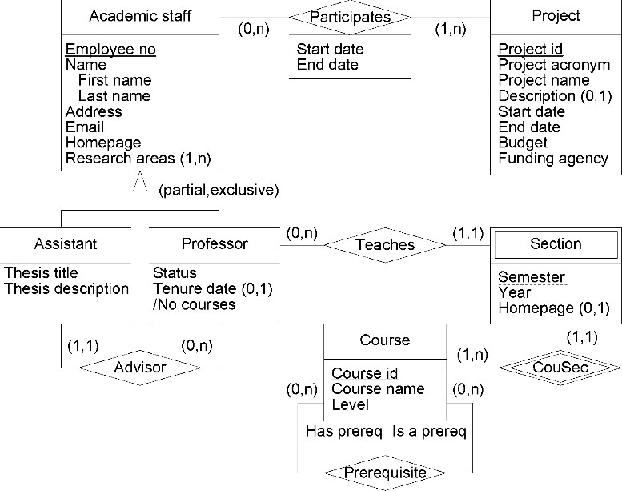

Question: Based on our database model, define a MOLAP model with at least one fact and 4 dimensions

**STAR SCHEMA**

Fact Table:

|  |
| --- |
| **FACT TABLE** |
| Employee_no (FK) |
| Participates_key (FK) |
| Teaches_key (FK) |
| Advises_key (FK) |
| Research_key (FK) |
| Participates_start_date |
| Participates_end_date |
| Semester |
| Year |
| Homepage |
|  |

|  |
| --- |
| **Employee Profile Dimension** |
| Employee_no (PK) |
| First_name |
| Last_name |
| Address |
| Email |
| Homepage |
| Research_key (FK) |
| Advises_key(FK) |
| Participates_key(FK) |
| Teaches_key (FK) |
| Status |

|  |
| --- |
| **Project Dimension** |
| Project_id (PK) |
| Project_name |
| Project_acronym |
| Description |
| Start_date |
| End_date |
| Budget |
| Funding_agency |
| Participates_key(FK) |

|  |
| --- |
| **Course Dimension** |
| Course_id (PK) |
| Course_name |
| Level |
| Has_prereq |
| Is_prereq |
| Teaches_key(FK) |
|  |

|  |
| --- |
| **Reseach Dimension** |
| Research_id (PK) |
| Thesis_title |
| Thesis_description |
| Advises_key (FK) |