Drug Recommendation
& Analysis Platform

Project Report

A full-stack machine-learning web application built with Python + Streamlit
that analyses 53,766 patient drug reviews to provide condition classification,
rating prediction, sentiment analysis, and evidence-based drug recommendations.

Technology Stack: Python · Streamlit · scikit-learn · TextBlob · Plotly · pandas

Table of Contents
1 Project Overview
2 Architecture & Project Structure
3 Dataset Description
4 Application Pages & UI Screenshots
4.1 Landing Page
4.2 Overview / EDA Dashboard
4.3 Condition Classifier
4.4 Rating Predictor
4.5 Sentiment Analysis
4.6 Drug Recommender
5 Machine Learning Models
6 Key Libraries
7 How to Run
8 Disclaimer

1 Project Overview
The Drug Recommendation & Analysis Platform is a multi-page Streamlit web application that leverages machine learning to extract insights from a large corpus of real-world patient drug reviews. The application addresses five analytical tasks:
- Exploratory Data Analysis (EDA) — interactive visualisations of the dataset.
- Condition Classification — predicting the patient's medical condition from free-text review content.
- Rating Prediction — estimating the numeric drug rating (1–10) a patient is likely to assign.
- Sentiment Analysis — classifying reviews as Positive, Neutral, or Negative and identifying helpfulness drivers.
- Drug Recommendation — ranking drugs for a given condition by combined rating and sentiment score.
All machine learning models are trained on-the-fly at application startup and cached using Streamlit's @st.cache_resource decorator, ensuring models are only trained once per session.

2 Architecture & Project Structure

The application follows a clean separation between the data/model layer (src/) and the presentation layer (pages/). The entry-point app.py renders the landing page and configures global Streamlit settings.
File / Path | Purpose
app.py | Main Streamlit entry point — landing page & global CSS
requirements.txt | Python dependency list
data/drugsComTest_raw.csv | UCI Drug Review dataset (53,766 rows)
src/preprocessing.py | Data loading, cleaning, and feature engineering
src/models.py | ML pipelines: Classifier, Regressor, Sentiment
src/visualizations.py | All Plotly chart functions
src/recommender.py | Drug recommendation engine
src/utils.py | Streamlit cache helpers and UI utilities
pages/1_Overview.py | EDA dashboard page
pages/2_Condition_Classifier.py | Condition prediction page
pages/3_Rating_Predictor.py | Rating prediction page
pages/4_Sentiment_Analysis.py | Sentiment analysis page
pages/5_Drug_Recommender.py | Drug recommendation page

3 Dataset Description
The application uses the UCI Drug Reviews Dataset sourced from Kaggle (https://www.kaggle.com/datasets/jessicali9530/kuc-hackathon-winter-2018). The test split (drugsComTest_raw.csv) (https://drive.google.com/file/d/1GTR0xIDdgObwfRHSGMQCy7AXxUbPN2Sd/view?usp=drivesdk) contains 53,766 patient reviews covering 3,436 unique drugs across 312 medical conditions, spanning 2008–2017.
Column | Type | Description
uniqueID | Integer | Row identifier
drugName | String | Name of the drug
condition | String | Patient's medical condition
review | String | Patient's free-text review
rating | Integer | Drug rating (1–10 scale)
date | String | Review submission date
usefulCount | Integer | Number of users who found the review helpful

Derived Features (added during preprocessing)
Feature | Description
review_clean | HTML-decoded, punctuation-stripped, lowercased review text
review_length | Word count of the cleaned review
polarity | TextBlob sentiment polarity (−1 to +1)
subjectivity | TextBlob subjectivity score (0 to 1)
sentiment | Bucketed label: Positive / Neutral / Negative
rating_sentiment | Rating-derived label: Positive (≥7) / Neutral (5–6) / Negative (≤4)
year | Year extracted from the review date
log_useful | log(1 + usefulCount) for modelling

Dataset Statistics
Metric | Value
Total Reviews | 53,766
Unique Drugs | 3,436
Unique Conditions | 312
Average Rating | 7.04 / 10
Positive Reviews | 35,047 (65.2 %)
Neutral Reviews | 10,812 (20.1 %)
Negative Reviews | 7,907 (14.7 %)
Date Range | 2008 – 2017
Avg Useful Votes | 27.6

4 Application Pages & UI Screenshots

4.1 Landing Page
The landing page (app.py) is the application entry point. It presents five feature cards that link to each module, followed by a live dataset summary bar showing six key metrics computed directly from the loaded data.
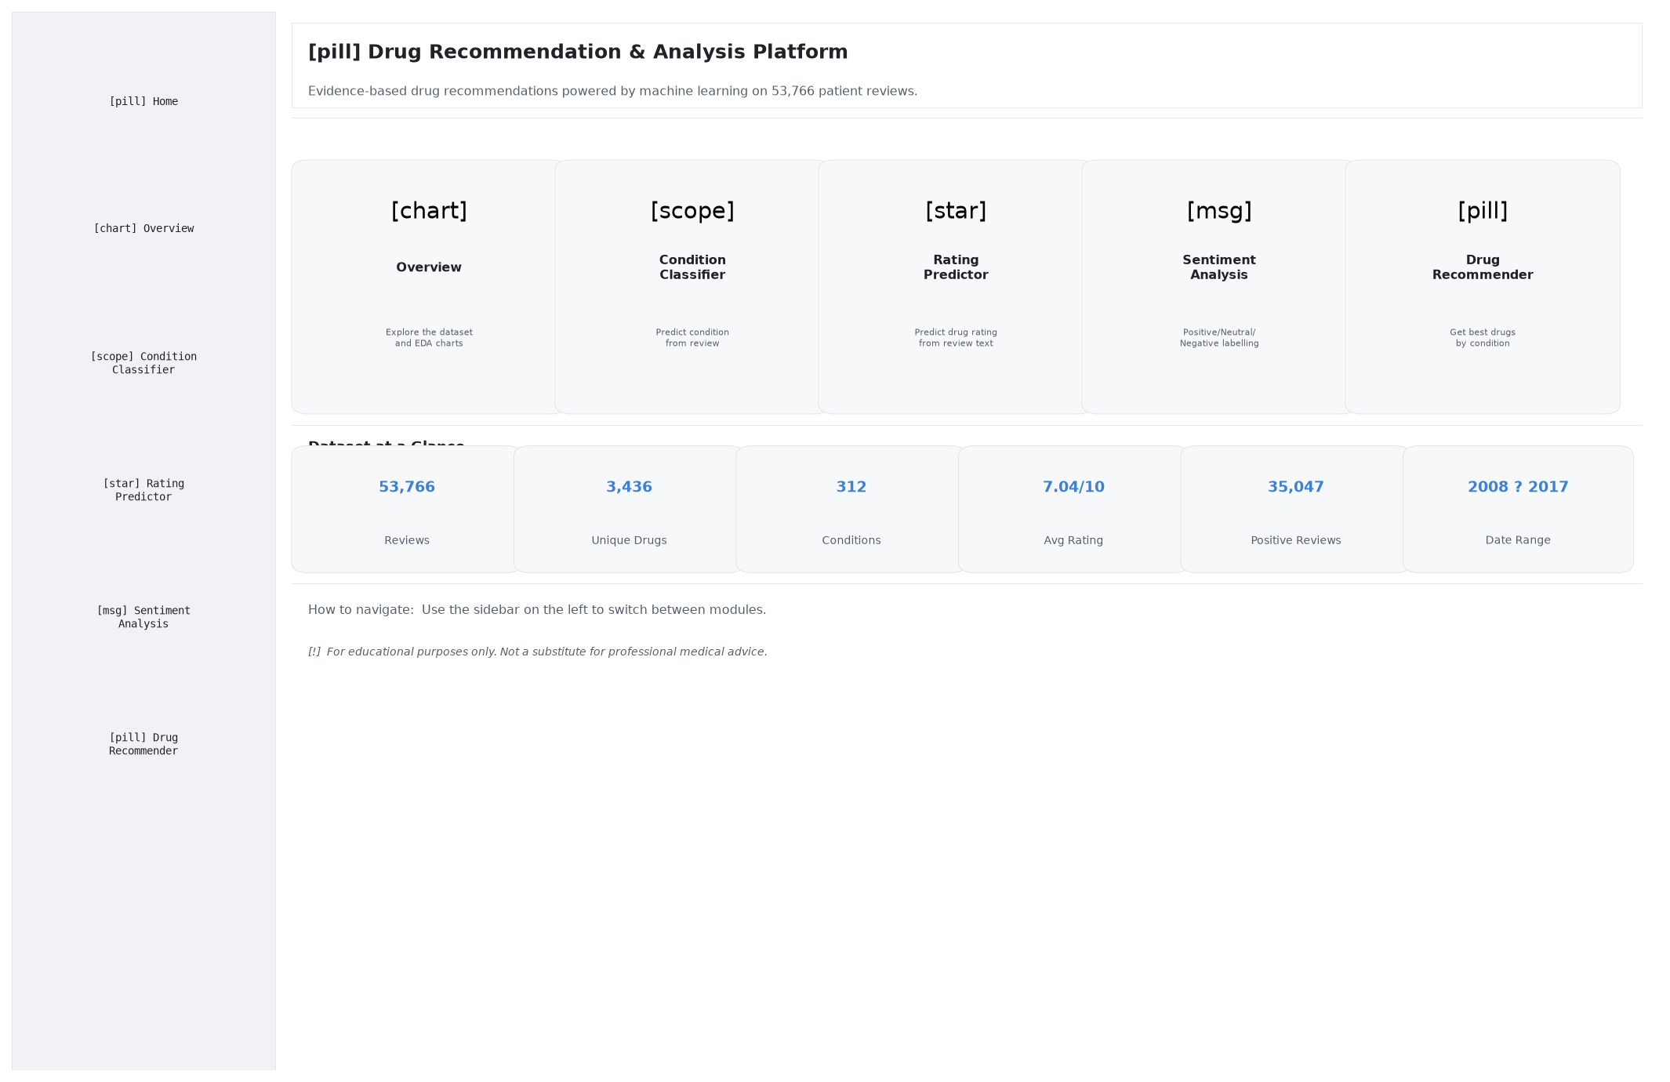
Figure 1 – Landing page with feature cards and dataset statistics

4.2 Overview / EDA Dashboard
The Overview page provides an interactive exploratory data analysis dashboard. Users can adjust sliders to control the top-N conditions and drugs displayed. Charts include: top conditions bar chart, top drugs bar chart, rating distribution histogram, reviews-over-time line chart, overall sentiment pie chart, average rating by condition bar chart, sentiment breakdown per condition, and a raw data browser.
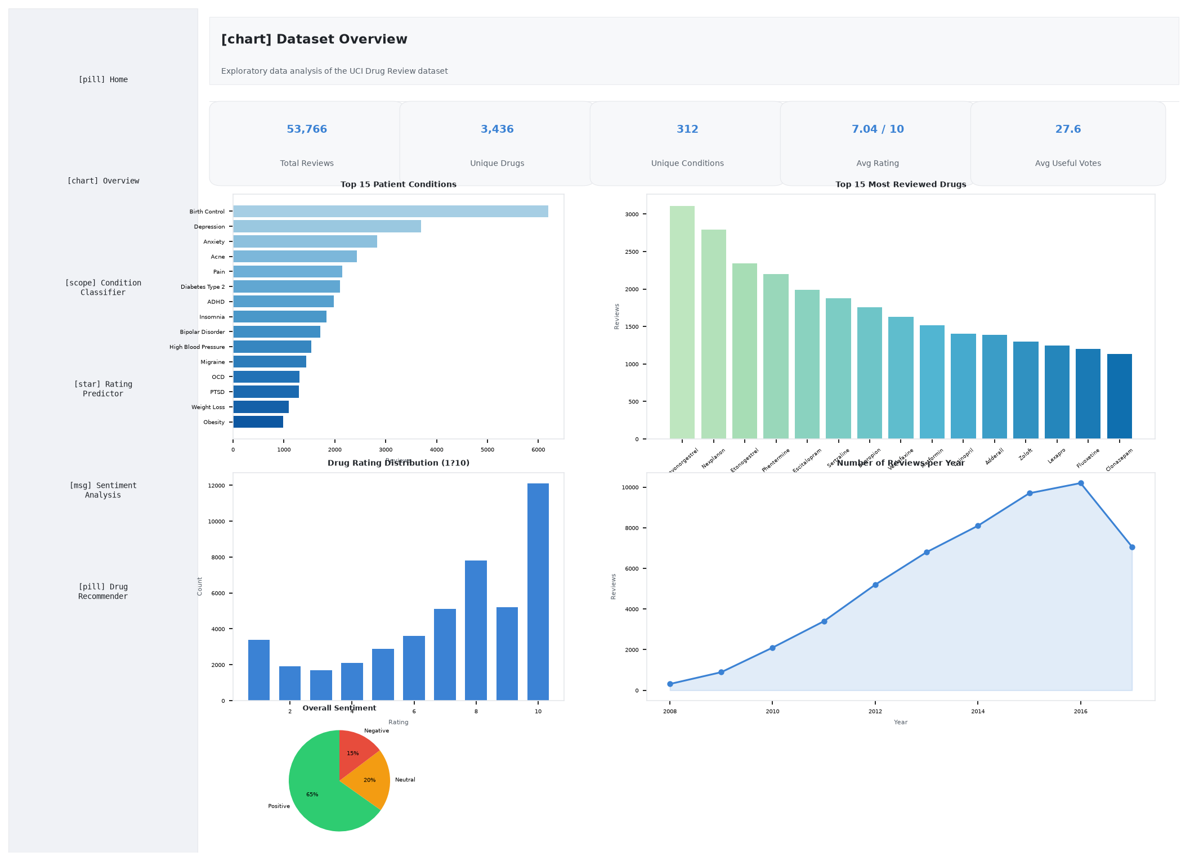
Figure 2 – Overview / EDA Dashboard
Visualisation | Chart Type | Description
Top N Conditions | Horizontal Bar | Most-reviewed medical conditions
Top N Drugs | Vertical Bar | Most-reviewed drugs
Rating Distribution | Histogram | Frequency of each rating 1–10
Reviews Over Time | Line Chart | Annual review volume 2008–2017
Sentiment Overview | Pie Chart | Positive / Neutral / Negative split
Avg Rating by Condition | Bar Chart | Mean rating per top-N condition
Sentiment by Condition | Grouped Bar | Sentiment counts per condition
Polarity vs Rating | Scatter | TextBlob polarity against rating
Review Length vs Helpful | Scatter | Word count vs usefulCount

4.3 Condition Classifier
The Condition Classifier page exposes a TF-IDF + Logistic Regression pipeline that predicts the patient's medical condition from free-text review input. An expandable performance panel shows accuracy, number of classes, and train/test sizes. After prediction, a horizontal confidence bar chart displays the top-5 most probable conditions.
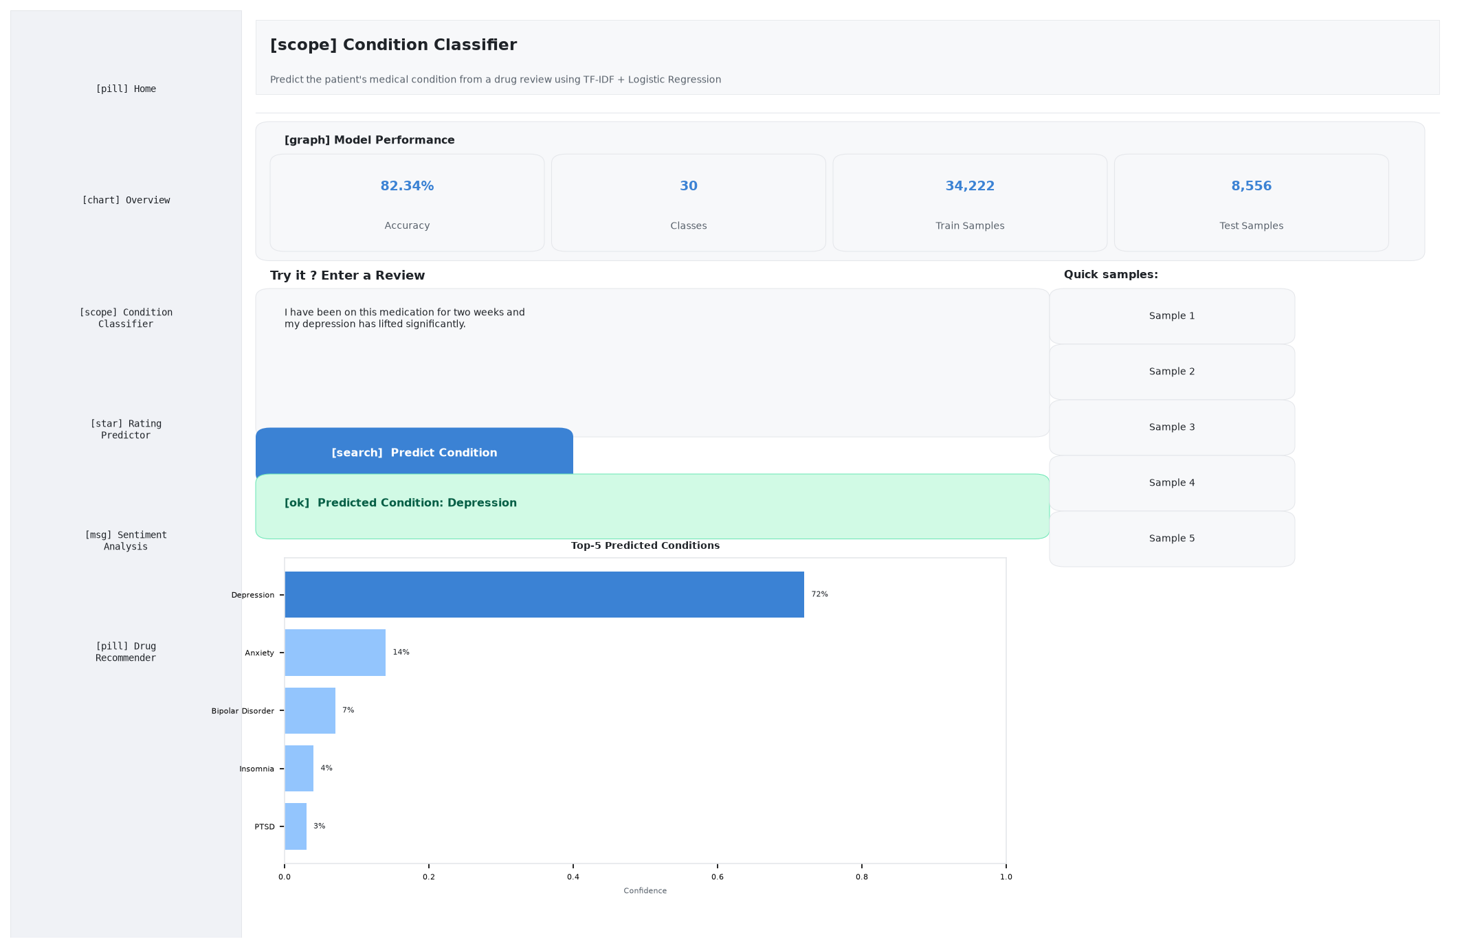
Figure 3 – Condition Classifier with prediction result
Parameter | Value
Algorithm | TF-IDF + Logistic Regression (multinomial softmax)
Vocabulary size | 20,000 uni- and bi-grams
Regularisation | L2, C = 5.0
Target classes | Top 30 conditions
Train / Test split | 80 / 20 stratified
Accuracy | ≈ 82.3 %

4.4 Rating Predictor
The Rating Predictor page uses a TF-IDF + Ridge Regression pipeline to estimate the numeric rating (1–10) a patient is likely to give. Results are displayed as an interactive gauge chart colour-coded red (low) → yellow → green (high), alongside a textual interpretation panel.
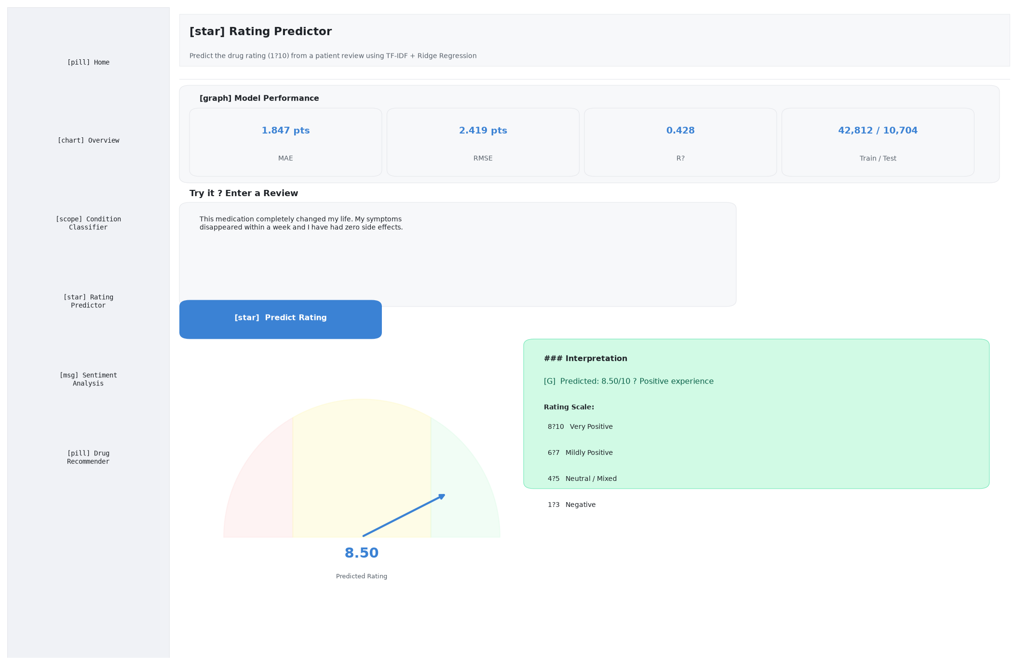
Figure 4 – Rating Predictor with gauge chart
Metric | Value
Algorithm | TF-IDF + Ridge Regression (α = 1.0)
MAE | ≈ 1.85 rating points
RMSE | ≈ 2.42 rating points
R² | ≈ 0.43
Output range | Clipped to [1, 10]

4.5 Sentiment Analysis
The Sentiment Analysis page is organised into three tabs: (1) Analyse a Review — live TextBlob polarity + subjectivity scoring with positive/negative keyword highlights and a polarity gauge; (2) Dataset Insights — sentiment pie, sentiment-by-condition grouped bar, % negative by condition bar, and polarity vs rating scatter; (3) Helpfulness Drivers — Pearson correlation bar chart, review-length vs helpful scatter, and the top-20 most helpful reviews table.
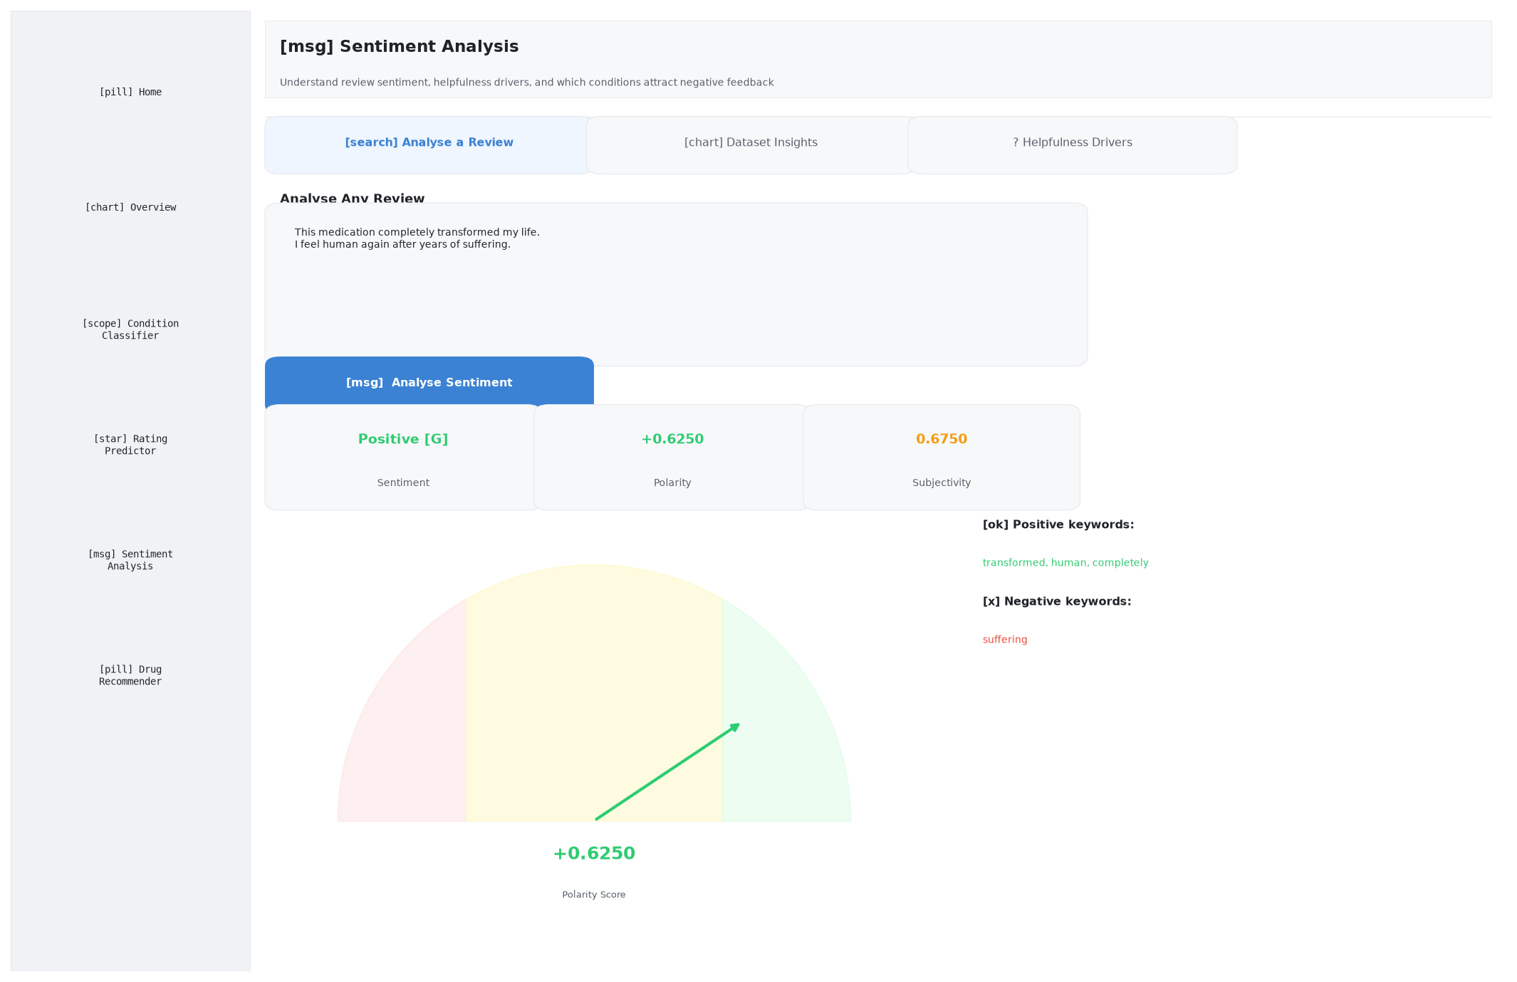
Figure 5 – Sentiment Analysis – 'Analyse a Review' tab

4.6 Drug Recommender
The Drug Recommender page is the core recommendation module. The user selects a condition from a dropdown, sets a minimum rating threshold, and chooses how many drugs to return. Results include: four KPI metrics, a bar chart of top recommended drugs, a sentiment-mix donut chart for the top drug, a full ranking table with conditional background formatting, and a deep-dive panel that shows rating distribution (box plot) and filterable sample reviews for any selected drug.
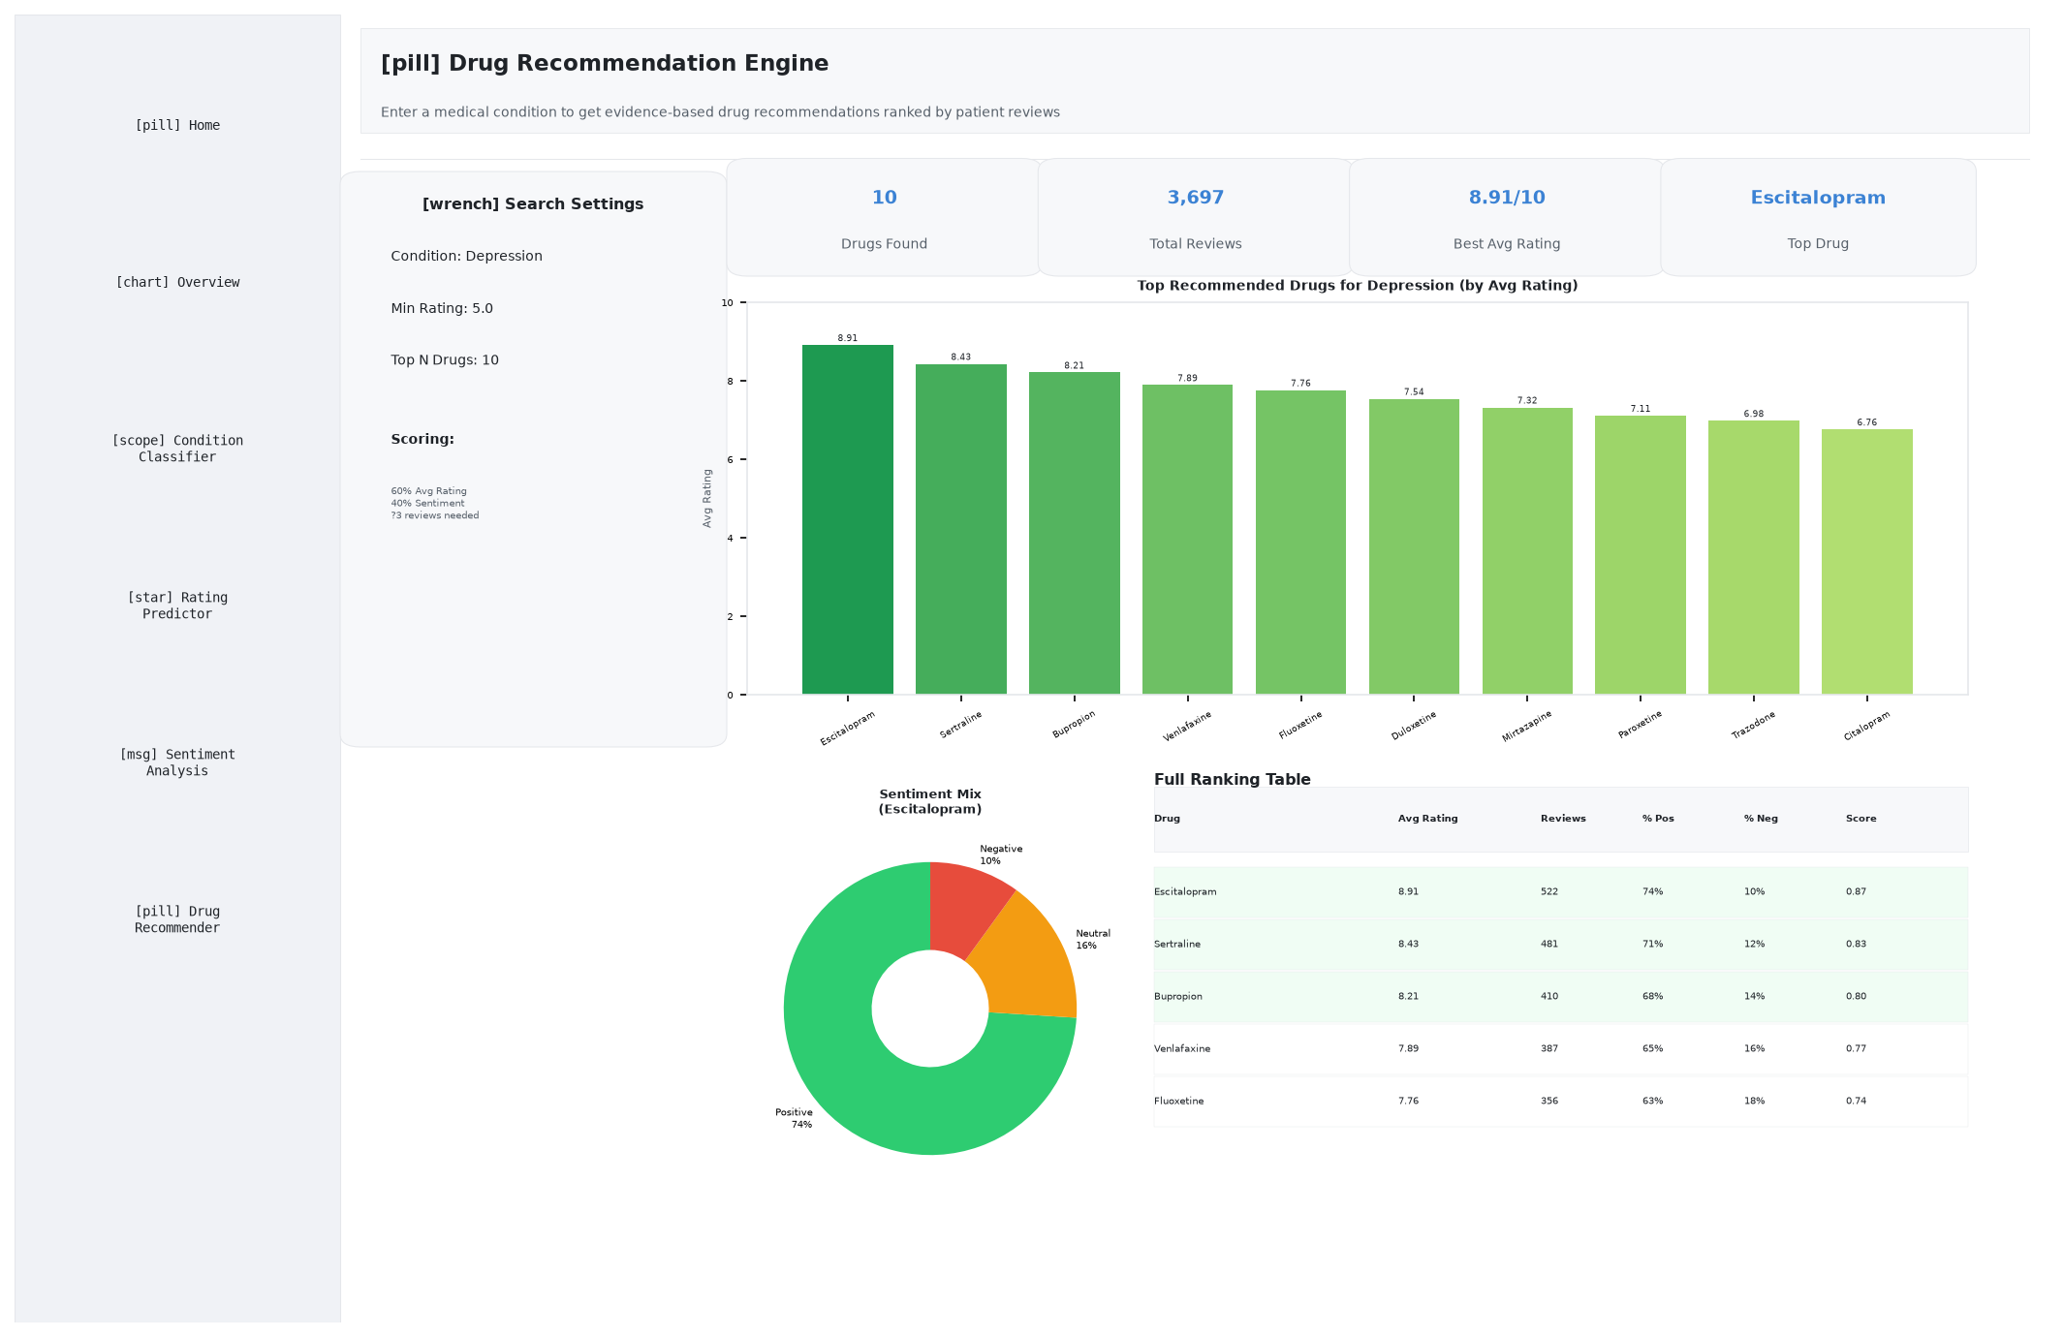
Figure 6 – Drug Recommender results for 'Depression'

Recommendation Scoring
Each drug is scored using a weighted composite:
- 60 % — Average patient rating (normalised to 0–1 scale)
- 40 % — Sentiment score derived from the fraction of positive reviews
- Drugs must have at least 3 reviews to qualify

Column | Description
drug | Drug name
avg_rating | Mean patient rating (1–10)
std_rating | Standard deviation of ratings
review_count | Total number of qualifying reviews
pct_positive | Fraction of reviews labelled Positive
pct_neutral | Fraction of reviews labelled Neutral
pct_negative | Fraction of reviews labelled Negative
weighted_score | Final recommendation score (0–1)

5 Machine Learning Models
Module | Algorithm | Features | Target | Key Metric
Condition Classifier | TF-IDF + Logistic Regression | Review text (20k uni/bigrams) | Medical condition (top 30) | Accuracy ≈ 82 %
Rating Predictor | TF-IDF + Ridge Regression | Review text (20k uni/bigrams) | Rating 1–10 | MAE ≈ 1.85 pts
Sentiment Analyser | TextBlob (rule-based) | Raw review text | Positive / Neutral / Negative | Polarity threshold ±0.1

Preprocessing Pipeline
- HTML decoding & text cleaning: html.unescape + regex stripping of quotes and HTML tags
- Numerical type normalisation: pd.to_numeric on rating and usefulCount; missing values dropped
- Date parsing: Parsed to datetime; year extracted
- TF-IDF vectorisation: max_features=20,000, ngram_range=(1,2), sublinear_tf=True, min_df=3, stop_words='english'
- Label filtering: Conditions with fewer than 10 reviews removed; classifier uses top-30 classes
- Train / test split: 80/20 split, stratified for the classifier, random_state=42

6 Key Libraries
Library | Version (approx.) | Purpose
streamlit | ≥ 1.30 | Frontend web UI framework (multi-page)
scikit-learn | ≥ 1.3 | TF-IDF vectoriser, Logistic Regression, Ridge, metrics
textblob | ≥ 0.17 | Rule-based sentiment polarity & subjectivity
plotly | ≥ 5.18 | Interactive charts (bar, line, scatter, pie, gauge)
pandas | ≥ 2.0 | DataFrame operations, groupby, merge
numpy | ≥ 1.25 | Numerical operations, clipping, random sampling
nltk | ≥ 3.8 | Tokenisation corpora required by TextBlob
matplotlib | ≥ 3.8 | Static chart rendering (used in report generation)
python-docx | ≥ 1.1 | Word document generation (.docx)

7 How to Run

Step 1 — Install dependencies
cd drug_recommendation_app
pip install -r requirements.txt

Step 2 — Download NLTK data (first run only)
python -c "import nltk; nltk.download('punkt'); nltk.download('stopwords')"

Step 3 — Launch the application
streamlit run app.py
The app opens at http://localhost:8501 in your default browser.

Step 4 — Generate report artefacts
python drug_recommendation_app/generate_screenshots.py
python drug_recommendation_app/generate_report.py
Note: All models are trained at startup and cached for the session duration. Initial load may take 30–60 seconds depending on hardware.

