MATLAB OPTIMIZATION PROBLEMS
This paper presents three applications relevant to engineering and agro-processing: minimizing the material required for a cylindrical container, maximizing the profit of a food-processing factory, and minimizing the cost of a protein-rich animal-feed mixture. MATLAB is used to obtain numerical solutions and produce plots.
Problem One: Minimizing Material Used in a Cylindrical Container
Problem statement
A food-processing company wants to manufacture a closed cylindrical container having a capacity of 1,000cm³ for storing a product. The company wants to use the least possible sheet material while maintaining the required capacity. The radius and height that minimize the total surface area are to be determined.
Variables and objective function
Let r be the radius (cm) and h be the height (cm). For a closed cylinder, the material area is the sum of the two circular ends and the curved surface:
Minimize: A(r,h) = 2πr² + 2πrh
The volume requirement is: πr²h = 1,000
Constraints: r > 0, h > 0, and πr²h = 1,000.
MATLAB method and result
This is a nonlinear constrained optimization problem. The MATLAB function fmincon is used with the surface area as the objective function and the fixed-volume equation as a nonlinear equality constraint. The computed optimum is approximately:
Optimal radius = 5.419 cm; optimal height = 10.839 cm; minimum surface area = 553.581 cm².
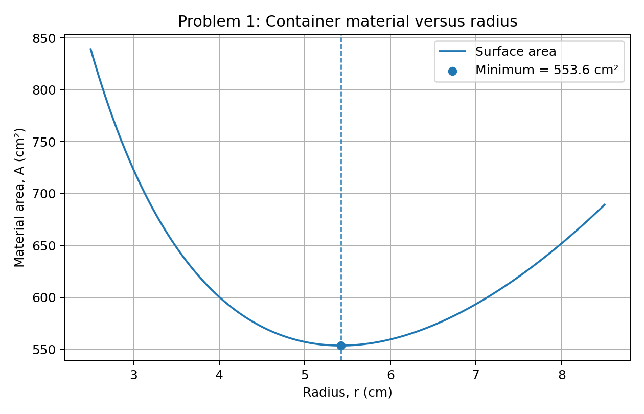
Figure 1: Surface area against cylinder radius when the volume is kept constant. The marked point represents the minimum material area.
Interpretation
The optimum dimensions give the required 1,000 cm³ capacity with the least surface area among feasible cylindrical designs. In practice, reducing surface area can reduce sheet-material use and packaging cost. Manufacturing allowances, wall thickness, seams, and strength requirements would also need to be considered in a detailed design.

Problem Two: Maximizing Profit in a Food-Processing Factory
Problem statement
A food-processing factory produces two products, A and B. Each batch of product A earns 500 currency units, while each batch of product B earns 400 currency units. Production is limited by machine time and labour. Product A requires 2 machine-hour units and 1 labour-hour unit per batch. Product B requires 1 machine-hour unit and 2 labour-hour units per batch. The factory has 100 machine-hour units and 80 labour-hour units available per day. The daily production quantities that maximize profit are to be determined.
Variables and objective function
Let x be the number of batches of product A per day and y be the number of batches of product B per day.
Maximize: P = 500x + 400y
Machine-time constraint
2x + y ≤ 100
Labour constraint
x + 2y ≤ 80
x ≥ 0, y ≥ 0.
MATLAB method and result
This is a linear programming problem. MATLAB linprog is used to maximize profit by minimizing the negative of the profit function. The optimal solution is:
Product A = 40 batches/day; Product B = 20 batches/day; maximum profit = 28,000 currency units/day.
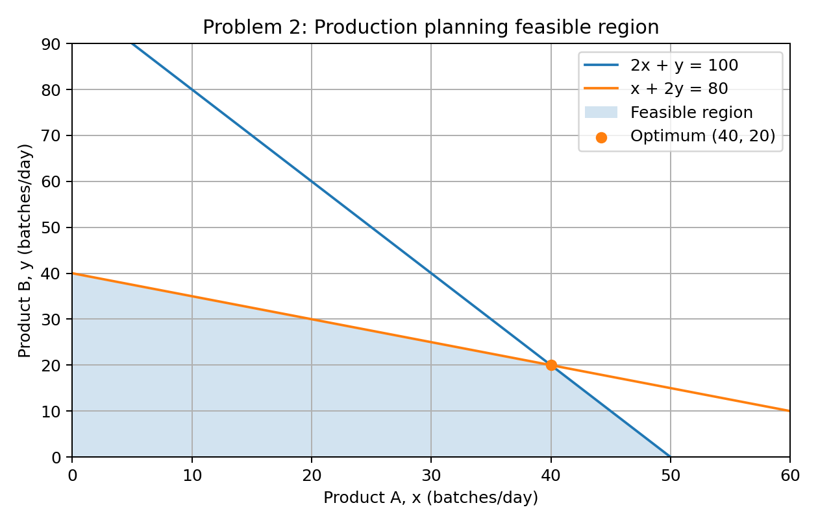
Figure 2: Feasible production region. The optimum occurs at the intersection of the machine-time and labour constraints.

Problem Three: Minimizing the Cost of a Protein-Rich Feed Mixture
Problem statement
An agro-processing enterprise prepares a 100 kg animal-feed mixture using maize and soybean meal. Maize contains 9% protein and costs 1,200 currency units per kilogram. Soybean meal contains 40% protein and costs 3,000 currency units per kilogram. The finished mixture must contain at least 18 kg of protein. Determine the quantities of maize and soybean meal that meet the protein requirement at the minimum ingredient cost.
Variables and objective function
Let x be the mass of maize (kg) and y be the mass of soybean meal (kg).
Minimize: C = 1,200x + 3,000y
Total mixture mass
x + y = 100
Minimum protein requirement
0.09x + 0.40y ≥ 18
x ≥ 0, y ≥ 0.
For linprog, the protein constraint is entered as
−0.09x − 0.40y ≤ −18
MATLAB method and result
MATLAB linprog is used with ingredient cost as the objective function. The minimum-cost mixture is:
Maize = 70.97 kg; soybean meal = 29.03 kg; minimum cost = 172,258.06 currency units. The mixture supplies 18.00 kg of protein.
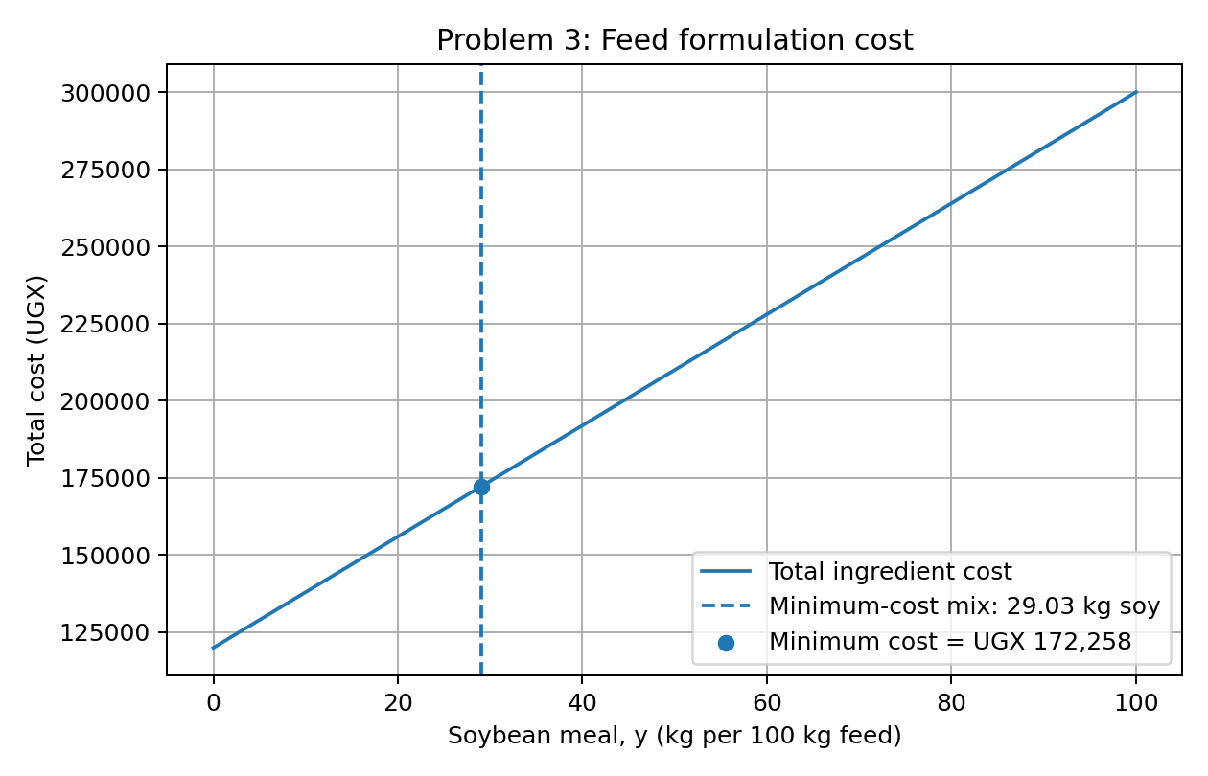
Figure 3: Total ingredient cost as the soybean-meal proportion changes while the total mixture mass remains 100 kg. Only mixtures meeting the protein requirement are feasible; the marked point is the least-cost feasible mixture.
Interpretation
Because soybean meal is more expensive but contains more protein, the least-cost formulation uses the smallest amount of soybean meal that satisfies the protein requirement. The model assumes fixed ingredient prices and protein percentages and does not include other nutritional requirements, processing losses, or ingredient availability limits

References
MathWorks. (n.d.). fmincon: Find minimum of constrained nonlinear multivariable function. MATLAB documentation. https://www.mathworks.com/help/optim/ug/fmincon.html
MathWorks. (n.d.). linprog: Linear programming. MATLAB documentation. https://www.mathworks.com/help/optim/ug/linprog.html

