Pedro Almeida

CFD Project 1

1a)

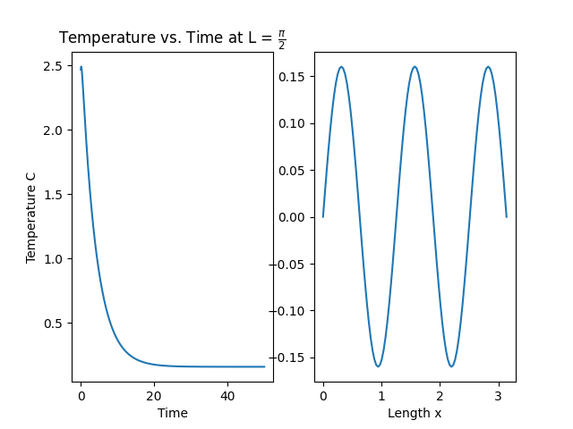

1b) When $Δt={10}^{-2}$, the sampling rate is not fast enough to discretize the data. As such, there are large skips and the system becomes unstable. The phenomenon can be seen by the stability equation:

1c) The order of accuracy of the discretization is roughly quadratic, which is to be expected for a second order discretization of $\frac{δ^{2}T}{δx^{2}}.$

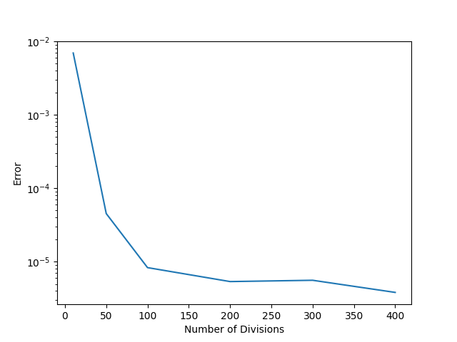

1d) When the number of divisions are increased, $Δx$ decreases as a result. The new value makes the system unstable. To fix it while maintaining the new number of divisions, either the sampling rate must increase ( $Δt$ becomes smaller), or the diffusion rate $α$ must decrease.

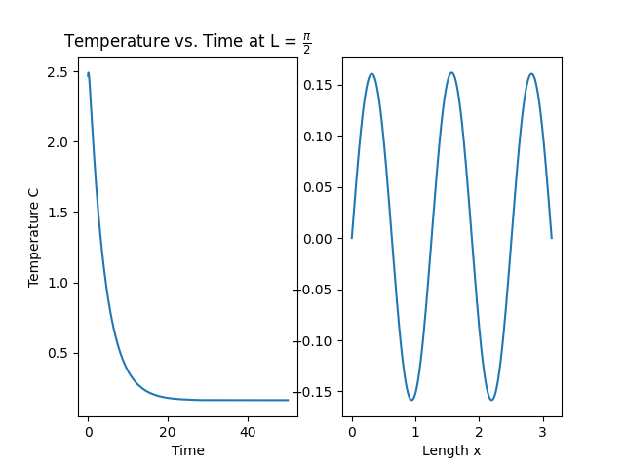

2. Video attached

3. The simulation represents a beam where one end is subject to temperature following a sine function. The animation shows the heat diffusing through the length of the beam with a response that decays as the distance to the heat source increases, though still roughly reflecting the temperature oscillations on a time delay that increases with the distance to the heat source.