**Affordable and Efficient:**

**A Budget PC Build Proposal**

for

BTB Heavy Equipment, Inc.

03-2023a

by

Ethan Palmer, Connor Justason, Ryelee McCoy, Maria Pineda

Citrine Contractors

April 04, 2023

# Summary

## Executive summary

The proposal provides a detailed breakdown of the components selected for the build, highlighting the benefits of each part for the end-user, and demonstrating how well they work together. Our team carefully chose each component with the end user in mind, ensuring that the final product provides the best possible experience for employees at BTB Heavy Equipment. The parts were selected to provide fast performance so that the user will have no trouble getting their work done in a timely manner. This will ensure a frustration-free experience, leading to less stressed, more efficient workers. Other important areas for users taken into account were the keyboard and monitor. Our team selected an ergonomic keyboard to prevent wrist pain and a large HD monitor to make managing applications easy.

In addition to the user quality of life, the availability of the parts and the allocated budget when selecting components for the desktop computer were also considered. Ready availability was a factor considered when selecting components to ensure that ordering components would be an easy, hassle-free experience. Another benefit of selecting highly available parts is that it makes the assembled component list less likely to require modifications. Regarding budget, the build is currently priced at $896 per PC, with a total cost of $224,000 for the 250 PCs requested.

By prioritizing the user experience, the PC ensures that the workers can complete their tasks efficiently and effectively. The team at Citrine Contractors are confident that the build will meet and exceed their expectations.

## Abstract summary

The aim of the assembled build was to make a PC with parts optimized for the office environment, providing a pleasant user experience at an affordable cost. The build is currently priced at $896 per PC, making it a great deal for the features and performance the build provides. The total cost for the 250 PCs requested would be $224,000. The report’s main components include an Intel CPU (the i3-12100) which utilizes integrated graphics allowing the PC to be budget friendly by avoiding the high cost of a video card. The lack of a video card also reduces the power consumption of the PC. Another important component for the office environment that was prioritized was a large, 24-inch, 1080p monitor to provide a workspace with plenty of room for multitasking. Other components such as the 8gb of DDR5 RAM and the high-performance i3-12100 also assist in making handling multiple applications a fast and smooth process. The PC’s components were also selected to provide reliable, long-term performance for users while keeping costs low. The motherboard supporting DDR5, the DDR5 itself and the modern CPU released in 2022 are all examples of the build being future proof.

The only limitations a PC would have using these components are the result of the budget and are not relevant to the company’s use case. The build will perform well using standard workplace applications such as Microsoft Word, Excel, Access, and internet browsers.

# Table of Contents

Summary i

Executive summary i

Abstract summary i

Table of Contents ii

Table of Figures - 1 -

Formal Introduction - 2 -

Background - 3 -

Project Description - 4 -

CPU - 4 -

Motherboard - 5 -

Memory - 6 -

Hard Drive - 8 -

Power Supply - 8 -

Enclosure - 10 -

Keyboard - 10 -

Mouse - 11 -

Optical Drive - 11 -

Card Reader - 12 -

Sound - 12 -

Monitor - 13 -

Conclusion - 14 -

Budget - 15 -

References - 17 -

Glossary - 21 -

Appendices - 22 -

Appendix A: Copy of RFP - 22 -

Appendix B: E-mail correspondence - 25 -

Appendix C: Customer Reviews - 26 -

Thermaltake PSU Reviews - 26 -

HyperX CloudX Headset Reviews - 26 -

KOORUI Monitor Reviews - 27 -

Appendix D: Resumes - 28 -

# Table of Figures

Figure 1 The i3-12100 outperforms competitor's CPUs in a temperature benchmark by a wide margin. (Xfastest, 2021) - 4 -

[Figure 2 Asus Pro B760M-CT-CSM motherboard (Asus, n.d.) - 4 -](https://saskpolytech-my.sharepoint.com/personal/palmer7996_saskpolytech_ca/Documents/TCOM190/TCOM%20group%20folder/Proposal%20Draft.docx#_Toc130055580)

Figure 3 PATRIOT™ announcing their Signature DDR5 memory selected for this build provide up to 75 percent better performance then high-end overclocked DDR4 memory. (Patriot, n.d.) - 6 -

[Figure 4 Seagate BarraCuda 1TB Hard Drive (Seagate, n.d.) - 6 -](https://saskpolytech-my.sharepoint.com/personal/palmer7996_saskpolytech_ca/Documents/TCOM190/TCOM%20group%20folder/Proposal%20Draft.docx#_Toc130055582)

Figure 5 Specification sheet set for Thermaltake Smart 430W provided by the manufacturer. (Thermaltake, n.d.) - 8 -

[Figure 6 N Series N200 Micro ATX Mini Tower (Cooler Master, n.d.) - 8 -](https://saskpolytech-my.sharepoint.com/personal/palmer7996_saskpolytech_ca/Documents/TCOM190/TCOM%20group%20folder/Proposal%20Draft.docx#_Toc130055584)

[Figure 7 Microsoft Ergonomic Keyboard (Microsoft, n.d.) - 9 -](https://saskpolytech-my.sharepoint.com/personal/palmer7996_saskpolytech_ca/Documents/TCOM190/TCOM%20group%20folder/Proposal%20Draft.docx#_Toc130055585)

[Figure 8 Amazon Basics 3-Button USB Wired Mouse (AmazonBasics, n.d.) - 9 -](https://saskpolytech-my.sharepoint.com/personal/palmer7996_saskpolytech_ca/Documents/TCOM190/TCOM%20group%20folder/Proposal%20Draft.docx#_Toc130055586)

[Figure 9 ASUS DRW-24B1ST (Asus, n.d.) - 10 -](https://saskpolytech-my.sharepoint.com/personal/palmer7996_saskpolytech_ca/Documents/TCOM190/TCOM%20group%20folder/Proposal%20Draft.docx#_Toc130055587)

[Figure 10 SmartQ SD Card Reader (SmartQ, n.d.) - 10 -](https://saskpolytech-my.sharepoint.com/personal/palmer7996_saskpolytech_ca/Documents/TCOM190/TCOM%20group%20folder/Proposal%20Draft.docx#_Toc130055588)

[Figure 11 HyperX CloudX Memory Foam Ear Cushion Headset (HyperX, n.d.) - 11 -](https://saskpolytech-my.sharepoint.com/personal/palmer7996_saskpolytech_ca/Documents/TCOM190/TCOM%20group%20folder/Proposal%20Draft.docx#_Toc130055589)

[Figure 12 KOORUI monitor with specifications (Koorui, n.d.) - 12 -](https://saskpolytech-my.sharepoint.com/personal/palmer7996_saskpolytech_ca/Documents/TCOM190/TCOM%20group%20folder/Proposal%20Draft.docx#_Toc130055590)

[Figure 13 Pie chart detailing how each component makes up the budget. - 15 -](https://saskpolytech-my.sharepoint.com/personal/palmer7996_saskpolytech_ca/Documents/TCOM190/TCOM%20group%20folder/Proposal%20Draft.docx#_Toc130055591)

Figure 14 Email correspondence with System Administrator, response is coloured in red. - 24 -

# Formal Introduction

This proposal has been designed for BTB Heavy Equipment, a Saskatchewan-based company that specializes in providing highly automated and customized heavy equipment contracting services. Citrine Contactors placed a strong emphasis on optimizing the user experience. The main objective throughout the process of selecting parts was to identify components that would enable the team to deliver the best possible experience to the end-users.

With these goals in mind, the team started carefully selecting the parts that would be best suited to the workers at BTB Heavy Equipment. The result is a build that is perfectly tailored to the specific needs of the company's workforce. In the budget section, the team has included a breakdown of the budget with a table and a pie chart. This will provide a clear understanding of the cost distribution, enabling financial management.

The proposal will cover the components selected in the project description; it will discuss the features of each part, why Citrine Contractors chose the product and why it is compatible with the overall build. One of the features of this build is the full 24-inch 1080p monitor, which offers an immersive visual experience. The computer's fast and powerful processor is designed to support multitasking, allowing users to run multiple applications at once, without any lag or performance issues. Additionally, the computer is equipped with 8GB of the newest RAM type, which enhances overall system efficiency and ensures a smooth user experience.

In the budget section, the team has included a breakdown of the budget with a table and a pie chart. This will provide a clear understanding of the cost distribution, enabling financial management. Citrine Contractors has managed to stay within the allotted budget of $250,000 CAD while still using the best available components in the market. Each PC is priced at $896, with a total cost of $224,000 for the 250 requested PCs. Another factor considered was the availability of parts, the build includes many components that are very common ensuring that the vendors can provide 250 units within a short time frame.

Finally, the appendix will provide additional information for the components selected by showing customer reviews of specific parts. This will demonstrate why the products chosen by Citrine Contractors are the better choice for the project.

# Background

BTB Heavy Equipment has requested new desktop computers for 250 end users by June 2023. Investing in new equipment will benefit the company overall because it will improve business efficiency and customer service.

One advantage to purchasing new equipment instead of constantly troubleshooting older computers is extending life expectancy. Most PCs have a life expectancy of three to five years (NIBusiness, n.d.). Changing to a new desktop ensures that old equipment will not malfunction overtime. Buying new computers enables its users to troubleshoot simple problems by themselves because technology has advanced and become more user-friendly over time; this makes troubleshooting new computers multitudes easier than troubleshooting old builds that may have had problems building up over the years.

Another benefit to purchasing new equipment rather than troubleshooting old equipment is that it ensures the company knows that the PC is equipped with the most recent hardware to keep up to date with new system requirements. If hardware is not upgraded, there is a chance of incompatibility with newer operating systems which comes with new security updates. Up-to-date hardware also improves overall performance capacity, making sure the computer runs faster and smoother.

By investing in new equipment, BTB Heavy Equipment can reduce downtime due to computer failures and improve overall efficiency. It will provide the end-users with the necessary tools to perform their work more effectively, which will lead to the growth of BTB.

# Project Description

## CPU

The Intel Core i3-12100 Quad-core 3.30 GHz Processor has integrated graphics and 12MB of L3 Cache. Additionally, the CPU also comes with a cooler and pre-applied thermal paste for easy assembly. The average temperature for the i3-12100 is about 50-60 °C, which sits comfortably below the T Junction (see glossary at end of report) of 100 °C. The CPU also supports up to 128GB of RAM which allows space for upgrades later in the future, rather than having to buy whole new computers. Lastly, the CPU also has Thermal Management Support which can help to protect components and even protect from potential fires that may have otherwise occurred.

This CPU was selected because it is the highest performing processor for that price range. The i3-12100 offers great value as it has integrated graphics as well as a cooler with pre-applied thermal paste. Selecting a CPU without these features would have resulted in the computer being more expensive due to the cost of external graphics processing units (GPU) and coolers. Alternatively, purchasing an external GPU and cooler could have resulted in the build being subpar in an important area such as motherboard or monitor. The i3-12100 represents a perfect budget choice, allowing the build to not compromise where it matters while still offering good performance for its cost. Another benefit of this CPU is the security features that are built into the CPU itself. Some of the security features include Intel® Threat Detection Technology (TDT), Secure Key, Intel® OS Guard, Intel® Boot Guard (see glossary at end of report), and many more which will help keep every computer safe and protected. Finally, another reason this CPU was selected is simply because it is compatible with the rest of the parts and specifications of the build.

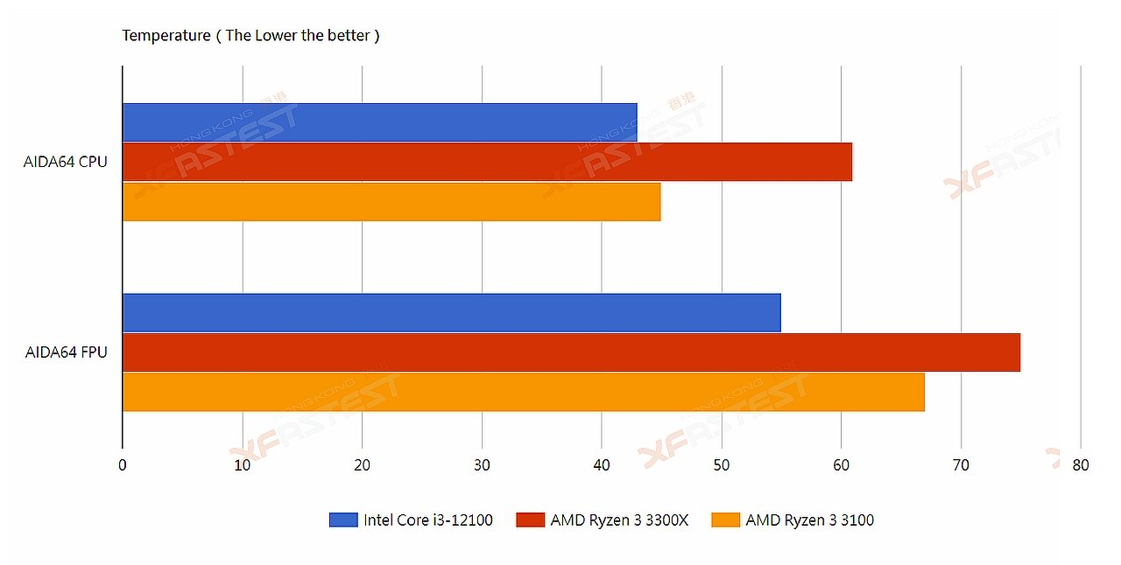

Figure 1 The i3-12100 outperforms competitor's CPUs in a temperature benchmark by a wide margin. (Xfastest, 2021)

## Motherboard

The Asus Pro B760M-CT-CSM motherboard satisfies all the requirements for an office computer. Coming from an excellent brand that has been around the tech industry since 1989, ASUS is the fifth largest PC vendor in the world. They make high quality and durable products. The Pro B760M-CT-CSM motherboard is a motherboard made for businesses. With a LGA 1700 socket that is made ready for the new 13th generation processors in case an upgrade is ever needed. This motherboard also has all the newest and fastest connectivity in a motherboard. With support for DDR5, PCIe 4.0, and USB 3.2 this motherboard will give computers the fast and reliable connectivity. This motherboard is also very versatile containing many features that are used in the day-to-day operation of office employees. This motherboard comes with ASUS boot defender which gives computers an extra level of security: during the boot sequence this built-in software will verify the BIOS code of the given computer to help detect any attacks or any issues with the firmware. This is used to help automatically protect and repair the BIOS if compromised, which provides an extra layer of protection for the computer. This motherboard also comes with an onboard graphic with the supported CPU and has all the ports required built into it. The ASUS Pro B760M-CT-CSM motherboard is an exceptionally reliable motherboard from a strong company.

Figure 2 Asus Pro B760M-CT-CSM motherboard (Asus, n.d.)

This motherboard is the better choice compared to other motherboards. The big reason is this motherboard has all the necessary and required functionality requested such as ECC support, WOL, and has all the proper ports and sockets required for the rest of the components. With addition to having the proper ports and sockets, it also has room to upgrade if needed later. This motherboard has a commonly user Intel socket that many newer and better CPUs will use if upgrades were needed. Since it also supports DDR5, RAM can be upgraded if needed as well. Comparing this motherboard to a similar motherboard of the same form factor, same price range, and same CPU socket such as the ASRock B760M Steel Legend. We can point out that this motherboard does not have all the requirements such as WOL or ECC. This motherboard also does not include some of the required ports such as FireWire. The ASUS Pro B760M motherboard chosen is best motherboard for the price range and to meet the requirements.

## Memory

The Patriot Signature Line Series 8GB Single DIMM is DDR5 with speed of 4800MHz and voltage of 1.1 Volts. This DIMM effortlessly manages power using the IC technology that is onboard, which ensures power stability. This DIMM also has Onboard Temperature Sensors which protect devices from overheating. Lastly, this DIMM also supports ECC (see glossary at end of report) which was one of the features requested and simply just checks for errors while processing the data provided to prevent any mistakes. This DIMM operates from 0 °C – 85 °C and is RoHS compliant.

This DIMM was chosen as it is one of the highest-performing single DIMM’s within the price range that supports ECC. Additionally, it is RoHS compliant, has a limited lifetime warranty, and each DIMM is tested to ensure the highest of qualities. The Patriot DDR5 is also engineered to consume less power which in turn emits less heat regardless of the DIMMS' high frequency and speed. This RAM also supports Power Management IC (PMIC), which locally regulates or stabilizes voltage. Lastly, as stated before, this DIMM has onboard temperature sensors to protect the DIMM from overheating and potentially damaging itself or other components.

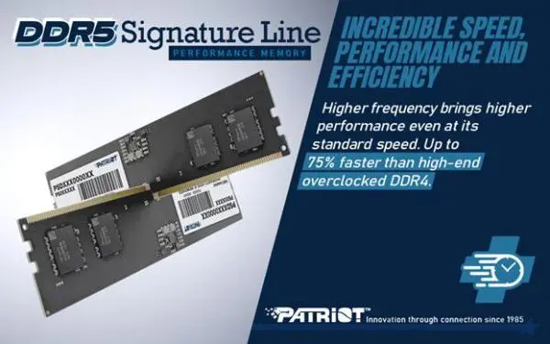

Figure 3 PATRIOT™ announcing their Signature DDR5 memory selected for this build provide up to 75 percent better performance then high-end overclocked DDR4 memory. (Patriot, n.d.)

## Hard Drive

The Seagate BarraCuda 1 TB Hard Drive is an excellent choice for a business computer. Hard disk drives have the best cost per GB of storage currently on the market. Sacrificing a bit of speed that employees would not notice for plenty more space is a good option. Seagate hard drives are known to be reliable and have good speeds. Spinning at 7200 rpm and with SATA 6Gb/s, this is good for burst performance and average daily use. Seagate also has implemented a Self-Encrypting Drive (SED) (see glossary at end of report) security feature that make it quick and easy to perform an Instant Secure Erase feature (see glossary at end of report) that will wipe the drive making drive retirements easy for IT department to handle. The storage of this drive should handle all an average employee's needs. Rather than purchasing a smaller storage SSD and having to upgrade storage in a year, going with an exceptionally good amount of storage right away will keep the computers up and operating for longer.

Figure 4 Seagate BarraCuda 1TB Hard Drive (Seagate, n.d.)

## Power Supply

The power supply is the Thermaltake Smart 430W 80+ White Continuous Power ATX Power Supply. This power supply delivers 430W of power at about 40℃ while remaining compliant with Intel ATX 12V 2.31 & EPS 12V 2.92 standards. This power supply also features Active Power Factor Correction, Over-power Protection, Over-Voltage Protection, Short Circuit Protection, (see glossary at end of report) and comes with a 5-year warranty. The Thermaltake PSU is 80 plus white certified, providing an acceptable level of efficiency for an excellent price.

This power supply provides the highest of quality for the price point provided and has quality features included such as the previously mentioned Intel ATX 12V 2.31 & EPS 12V 2.92 standards, Active Power Factor Correction, Over-power Protection, Over-Voltage Protection, Short Circuit Protection, 5-year warranty, 80+ certification, and remains quiet while in use. The 430 watts the PSU provides is also a perfect match for the PC design as the budget CPU and lack of an external GPU means the PC will not have significant wattage requirements. All these features come together to make a power supply that not only is fit for the job but also keeps the workplace quiet while remaining reliable. Some other factors that indicate reliability (particularly to average users) are the popularity of the Thermaltake brand, and the popularity of this product line on Amazon where it has almost 20,000 reviews, with 74% of them being five stars (See Appendix A: Customer Reviews for details).

Figure 5 Specification sheet set for Thermaltake Smart 430W provided by the manufacturer. (Thermaltake, n.d.)

## Enclosure

The N Series N200 Micro ATX Mini Tower from Cooler Master is a small form factor case that will not take up much space in the workplace. This enclosure comes with plenty of space inside the case to place all the parts needed. This case comes with three two USB 2.0 ports and one 3.0 USB port on the front and having two 3.5mm jacks one being for headphones and the other for a microphone. Additionally, this case has an optical drive slot on the front, allowing users to save some desk space by implementing an internal drive. It also has great airflow with two pre-installed fans, one on the front and one on the back. The front fan is pulling air into the system while the rear fan is pulling air out of the system creating great air flow to cool all the hot components inside the system. This case also comes with plenty of room to upgrade the storage system later with three 3.5-inch drive bays or four 2.5-inch drive bays.

Figure 6 N Series N200 Micro ATX Mini Tower (Cooler Master, n.d.)

## Keyboard

The Microsoft Ergonomic Keyboard is an extremely comfortable ergonomic keyboard. With its split design and large wrist pad, employees will have good posture and be comfortable while working at their workstation. This keyboard also has multiple built in shortcut keys such as keys for Office 365, search, and with easy access to media control keys such as volume, pause, and fast-forwarding keys. This is a A picture containing computer, keyboard, electronics, indoor
full-size keyboard with a number pad on the right-side making inputting large amounts of numbers very quick and easy to do. It is a wired keyboard with a USB 2.0 connection. Although this keyboard has a slightly larger form factor than most it is for a good reason, to bring comfort and productivity to the workplace.

Figure 7 Microsoft Ergonomic Keyboard (Microsoft, n.d.)

## Mouse

The mouse selected is a simple Amazon Basics 3-Button USB Wired Computer Mouse, it has high-definition optical tracking at 1000 dpi and a total of three mouse buttons. It plugs into a device using a simple yet effective USB-A connection and is plug-and-play ready, meaning there is no other setup required to waste precious time in the workday. This mouse is also incredibly lightweight, weighing in at only 12.3 grams.

Figure 8 Amazon Basics 3-Button USB Wired Mouse (AmazonBasics, n.d.)

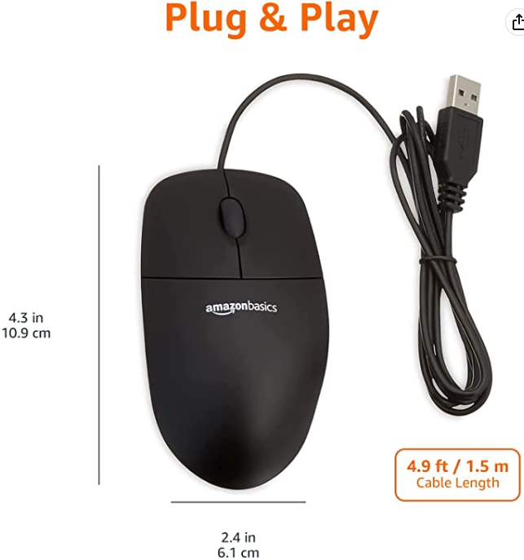

This mouse offers a simple, effective design, ease of use, and the highest of quality for the price point provided. Its cost-effectiveness enables the remaining budget to be devoted to the parts that matter the most. This mouse’s lightweight yet durable design will also help to prevent fatigue in the hands or wrists that may have been there when using previous heavy or bulky mice.

## Optical Drive

The ASUS DRW-24B1ST is capable of reading and writing to different disk formats such as DVD+R/+RW, and DVDRAM. As advertised on ASUS’s website, this optical drive has a read/write speed of 24x DVD which means it is moving data at around 33.36MB/s. This optical drive is green focused saving users up to 50% power usage by automatically closing the drive application when it is not in use. The ASUS DRW-24B1ST also has a disc encryption option with a hidden-file-folder option and a password control access option to make more secure data transfer. This drive also allows for a user to permanently wipe a rewritable disk making the older information on this disk almost impossible to be restored.

Figure 9 ASUS DRW-24B1ST (Asus, n.d.)

## Card Reader

The SmartQ SD card reader is used to read in SD cards to a PC. This card reader is quick and easy to install and simple to use. All a user needs to do is plug the USB 3.0 connector into a USB port on the PC. There is no software needed for this card reader. Once plugged in, taking a SD or micro-SD card and pushing it into its designated slot a user will be able to pull files from the SD on to their computer in little time and little effort. This card reader has a data transfer rate of 5000 megabits per second. It has good speeds for a small form factor. Optionally, if PCs will be tucked away and not easy to access for users, a USB extension cable would be used to pull that USB slot closer to the user. Making it more easily accessible to the employee making their job easier. These USB extension cables are $5.00 to $10.00, cheap and easy to implement cables.

Figure 10 SmartQ SD Card Reader (SmartQ, n.d.)

## Sound

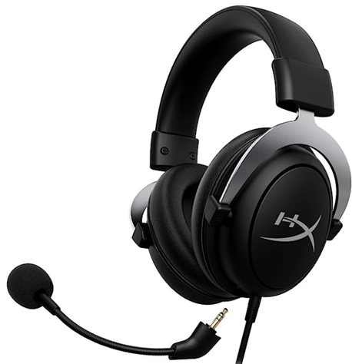The device selected for sound by Citrine Contractors was the HyperX CloudX Memory Foam Ear Cushions Gaming Headset with Detachable Noise-Cancelling Mic. The headset was chosen for its highly comfortable ear cushions and lightweight but robust aluminum frame, ensuring the employees' comfort during the workday. Additionally, the headset has inline audio controls conveniently placed on the auxiliary cable, allowing the user to adjust the volume and mute or unmute the microphone without having to go into settings. The headset also features a completely detachable microphone, making it easy to remove when not needed to prevent obstruction during regular use. Lastly, the headset includes a Y-Splitter to ensure compatibility with a PC.

Figure 11 HyperX CloudX Memory Foam Ear Cushion Headset (HyperX, n.d.)

The decision to choose this headset was based on its high-quality features and affordable price point. The headset's comfortable ear cushions, durable aluminum frame, inline audio controls, detachable microphone, and free Y-Splitter combined to create a practical, highly comfortable, and cost-effective option for employees to use and enjoy.

## Monitor

The monitor chosen was the KOORUI 24-inch Business Computer. This monitor has 99% SRGB coverage of the color Gamut and has an 8-bit gray level over 16.7 million color numbers and has a viewing angle of 178 degrees and the ability to tilt the screen up to 5 degrees forward or 15 degrees backward. The KOORUI monitor also includes Flicker-Free technology, Blue Light Filter, and Adaptive Free Sync (see glossary at end of report) technology that automatically calibrates the frame rate of the monitor. The monitor has an edgeless design and has not only an HDMI port but also a VGA port supporting up to 75hz and 1920x1080p resolution. This monitor also comes with a 3-year warranty, a 12-month replacement service, and a technical support line.

Figure 12 KOORUI monitor with specifications (Koorui, n.d.)

The KOORUI monitor is the highest of quality for the price point provided and has quality of life features included such as the previously mentioned 99% SRGB Coverage, extremely customizable viewing angles, Flicker-Free technology (see glossary at end of report), Blue Light Filter, Adaptive Free Sync technology which drastically reduces eye discomfort and fatigue, edgeless design which means huge bevels taking up valuable desk space would not be an issue, HDMI and VGA ports and supporting 75hz and 1920x1080p resolution, and a 3-year warranty, a 12-month replacement service and technical support line.

# Conclusion

At the time of sending a single PC constructed from the listed components would be priced at $896 taking into account current sales. The total cost for the 250 PCs at $896 each would be $224,000, leaving $26,000 of the allocated budget remaining. Without the sales a single PC would be priced at approximately $925, with the price of the 250 PCs being $231,250.

This PC has the benefits of high performance, utilizing quality, reliable parts while still falling $104 below the recommended budget per PC. Additionally, most of the parts selected are highly popular and widely available, making it easy to arrange orders of 250 for each component. This PC does not compromise in the areas that matter, it comes with a full 24inch 1080p monitor and a strong CPU with integrated graphics that uses little wattage. The goal of this build is to maximize user satisfaction by prioritizing the aspects that will actually affect a standard user. Having a small, low-resolution screen can have a significant negative impact on user, having a slow processor or only 4gb of RAM will also impact a user negatively as their applications or internet browser slow down. On the other hand, how powerful the GPU is will not significantly affect the average user’s experience, hence why this proposal selected integrated graphics. Additionally, an added benefit of not using an external GPU is that the PC runs quieter and cooler, which is another relevant aspect that can actually affect a user.

In summary, the selected components were chosen specifically for BTB Heavy Equipment Inc’s use case, they were designed to maximize performance relevant to a user in an office environment. The build will provide users with a smooth, enjoyable experience as they run applications commonly found in the office environment such as Microsoft Word and internet browsers.

# Budget

The request for proposal asks for new standard desktop computers for 250 end-users by the end of June 2023, with a capital budget of $250,000 CAD. Citrine Contractors ensured that each desktop PC will be less than $1,000 to remain within budget. The following table and pie chart shows the cost breakdown.

Table 1 PC components budget breakdown

|  |  |  |  |  |
| --- | --- | --- | --- | --- |
| Part | Original Cost | x250 | Sale Cost as of April 4, 2023 | x250 |
| CPU | $176.42 | $44,105.00 | $176.42 | $44,105.00 |
| Motherboard | $189.99 | $47,497.50 | $189.99 | $47,497.50 |
| Memory | $37.99 | $9,497.50 | $35.99 | $8,997.50 |
| Card Reader | $10.99 | $2,747.50 | $10.99 | $2,747.50 |
| Hard drive | $57.87 | $14,467.50 | $57.87 | $14,467.50 |
| Keyboard | $69.99 | $17,497.50 | $64.99 | $16,247.50 |
| Mouse | $11.06 | $2,765.00 | $11.06 | $2,765.00 |
| Optical Drive | $26.99 | $6,747.50 | $26.99 | $6,747.50 |
| Sound | $69.99 | $17,497.50 | $69.99 | $17,497.50 |
| Power Supply | $49.99 | $12,497.50 | $49.99 | $12,497.50 |
| Enclosure | $75.79 | $18,947.50 | $75.79 | $18,947.50 |
| Monitor | $147.99 | $36,997.50 | $125.99 | $31,497.50 |
| Cost per Computer | $925.06 |  | $896.06 |  |
| Total Amount | $231,265 |  | $224,015 |  |
| Amount Remaining | $18,735 |  | $25,985 |  |

The team is pleased to report that with $896.06 per computer, the project is within budget. The total amount of the project is $224,015, leaving a balance of $25,985. Two variables that could alter the total amount are the monitor and CPU price, as both are currently on sale, saving $32 per build. If these components were to be purchased at full price each PC would cost $925.06, with the total coming to $231,265, leaving a balance of $18,735. Regardless of the sale, the PC is within budget. By staying within the allotted budget, the desktop computer can still provide each end-user with a high-quality experience. This will allow them to work more efficiently, leading to better productivity, increased output, and greater customer service.

Figure 13 Pie chart detailing how each component makes up the budget.

# References

Amazon Basics. (2014). *Amazon Basics 3-button USB wired computer mouse (black), 1-pack*. Amazon.ca: Electronics. <https://www.amazon.ca/dp/B005EJH6RW/>

Amazon Basics. (n.d.). *Amazon Basics 3-Button USB Wired Mouse* [Photograph]. Retrieved 2023, from <https://m.media-amazon.com/images/I/61s8yFKvk4L._AC_SX679_.jpg>

Asus. (2014). *Asus Drw-24b1st DVD-writer DRW-24b1st/BLK/b/as PC-Canada*. PC-Canada. <https://www.pc-canada.com/item/asus-drw-24b1st-dvd-writer/drw-24b1st-blk-b-as>

Asus. (2022). *Pro B760M-CT-CSM w/ DDR5-6200, 7.1 audio, PCIe 4.0 x16 slot, dual M.2 PCIe 4.0, 2.5g LAN, 36 month CSM*. Boards - Memory Express Inc. <https://www.memoryexpress.com/Products/MX00123985>

Asus. (n.d.). *Asus DRW-24B1ST DVD-Writer* [Photograph]. Retrieved 2023, from <https://www.pc-canada.com/dd2/img/item/A-1500x1500/445225.jpg>

Asus. (n.d.). *Asus Pro B760M-CT-CSM Motherboard* [Photograph]. Retrieved 2023, from <https://media.memoryexpress.com/Images/Products/Large/MX00123985-2.jpg>

Cooler Master Technology Inc. (n.d.). *What are the definitions of OVP, OPP, OCP, SCP, OTP and BOP?.* <https://landing.coolermaster.com/faq/what-are-the-definitions-of-ovp-opp-ocp-scp%20-otp-and-bop/>

Cooler Master. (2013). *Cooler master N series N200 micro ATX mini tower PC Case - Black (NSE-200-KKN1)*. Vuugo. <https://www.vuugo.com/coolermaster-pc-case-NSE-200-KKN1.html?tracking=5108053939762>

Cooler Master. (n.d.). *N Series N200 Micro ATX Mini Tower* [Photograph]. Retrieved 2023, from <https://www.vuugo.com/image/cache/data/products/vuugo-coolermaster-NSE-200-KKN1-5-300x300.jpg>

EECO. (2015, March). *Short-circuit protection or overload protection*. <https://eecoonline.com/inspire/short-circuit-protection-or-overload-protection>

HyperX. (2020). *HyperX cloudx – official Xbox licensed gaming headset, compatible with Xbox One and Xbox series X: S, memory foam ear cushions, detachable noise-cancelling MIC, in-line audio controls, silver, standard*. Amazon.ca: Video Games. <https://www.amazon.ca/HyperX-CloudX-Compatible-Noise-Cancelling-line/dp/B08KS397GY>

HyperX. (n.d.). *HyperX CloudX gaming headset* [Photograph]. Retrieved 2023, from <https://m.media-amazon.com/images/I/61CzXqQLQqL._AC_SX679_.jpg>

IBM. (2022, April 26). *About self-encrypting drives*. Retrieved March 26, 2023, from <https://www.ibm.com/docs/en/psfa/7.2.1?topic=administration-about-self-encrypting-drives>

Intel. (2022). *Intel Core i3 (12th gen) i3-12100 Quad-core (4 core) 3.30 GHz processor - retail pack*. Amazon.ca: Electronics. <https://www.amazon.ca/dp/B09NPHJLPT>

Intel. (2022). *Intel® Core™ I3-12100 processor*. Intel Core i312100 Processor 12M Cache up to 4.30 GHz Product Specifications. <https://ark.intel.com/content/www/us/en/ark/products/134584/intel-core-i312100-processor-12m-cache-up-to-4-30-ghz.html>

Intel. (2023, February). *What is Tjunction max temperature?* Information about temperature for Intel® Processors. <https://www.intel.com/content/www/us/en/support/articles/000005597/processors.html#:~:text=What%20is%20Tjunction%20max%20temperature,reduce%20power%20and%20limit%20temperature>

Intel. (n.d.). *Intel hardware shield-below-the-OS-security*. <https://www.seagate.com/files/www-content/product-content/_cross-product/en-us/docs/how-to-ise-your-drive-tp-644-1-1211-us.pdf>

Intel. (n.d.). *Intel® software guard extensions*. <https://www.intel.com/content/www/us/en/developer/tools/software-guard-extensions/overview.html>

Intel. (n.d.). *Intel® threat detection technology (Intel® TDT)*. <https://www.intel.ca/content/www/ca/en/architecture-and-technology/vpro/hardware-shield/threat-detection-technology.html>

Kan, D. (2021, July 9). *What is adaptive sync?.* ViewSonic Library. <https://www.viewsonic.com/library/tech/explained/what-is-adaptive-sync/#:~:text=Developed%20by%20VESA%2C%20Adaptive%20Sync,game%20stuttering%20and%20screen%20tearing>

Koorui. (2022). *Koorui 24-inch business computer monitor full HD 1920 x 1080p VA display 75Hz 3000:1 contrast ratio with HDMI, VGA, frameless, 75 x 75 mm Vesa Mountable, Ergonomic Tilt, black*. Amazon.ca: Electronics. Retrieved 2023, from <https://www.amazon.ca/KOORUI-Business-Computer-Monitor-Display/dp/B09VD9P2Q3/>

Koorui. (n.d.). *Koorui 24-inch monitor with specifications* [Photograph]. Retrieved 2023, from <https://m.media-amazon.com/images/S/aplus-media-library-service-media/7fe15319-bd05-4b92-88a3-509248410a26.__CR0,0,970,600_PT0_SX970_V1___.jpg>

Kumawat, K. (2019, November 25). *Optimal CPU & GPU temperature [PC & laptops]*. Tech Centurion. <https://www.techcenturion.com/optimal-temperature-of-cpu-and-gpu>

Micron. (n.d.). *Error correction code (ECC) in Micron Single-Level Cell (SLC) NAND*. <https://www.micron.com/-/media/client/global/documents/products/technical-note/nand-flash/tn2963_ecc_in_slc_nand.pdf>

Microsoft. (2019). *Microsoft ergonomic keyboard: wired, comfortable, ergonomic keyboard with cushioned wrist and palm support, split keyboard, dedicated office key (English)*. Amazon.ca: Electronics. <https://www.amazon.ca/dp/B07Y414QXJ>

Microsoft. (n.d.). *Microsoft ergonomic keyboard* [Photograph]. Retrieved 2023, from <https://m.media-amazon.com/images/I/81vObCMjy8L._AC_SX679_.jpg>

Newegg. (n.d.). *ASRock B760M steel legend WiFi LGA 1700 DDR5 micro ATX motherboard*. <https://www.newegg.ca/p/N82E16813162106?Description=ASRock%20B760M%20Steel%20Legend&cm_re=ASRock_B760M%20Steel%20Legend-_-13-162-106-_-Product>

NIBusiness. (n.d.). *Computer hardware for business*. Choosing computer hardware for your business. <https://www.nibusinessinfo.co.uk/content/choosing-computer-hardware-your-business>

Patriot Memory. (2022). *Patriot signature line series DDR5 8GB (1 x 8GB) 4800MHz UDIMM single - PSD58G480041*. Patriot Signature Line Series DDR5 8GB (1 x 8GB) 4800MHz UDIMM single - PSD58G480041Amazon.ca: Electronics. <https://www.amazon.ca/dp/B09P3SKG91/>

Patriot Memory. (2022). *Patriot signature series DDR5 8GB (1x8GB) 4800 MHz UDIMM single module*. <https://assets.website-files.com/62d47b34a77cc16dd813922c/62d47b35a77cc11e87139ae0_PSD58G480041_Sku%20Sheet_111721.pdf>

Patriot Memory. (n.d.). *DDR5 Signature Line Memory* [Photograph]. Retrieved 2023, from [patriot-signature-line-ddr5-memory-04.jpg (960×540) (thepcenthusiast.com)](https://thepcenthusiast.com/wp-content/uploads/2021/11/patriot-signature-line-ddr5-memory-04.jpg)

Seagate Technology. (2016). *Seagate BarraCuda ST1000DM010 1 TB Hard Drive - 3.5" Internal - SATA (SATA/600) - 7200rpm - 2 Year Warranty-RoHS Compliance*. Isanek. <https://isanek.com/shop/product/38543588/1?utm_content=PCPartPicker&utm_campaign=15&ranMID=46412&ranEAID=8BacdVP0GFs&ranSiteID=8BacdVP0GFs-HRuzstxzBPiHoggGShpkAw>

Seagate Technology. (n.d.). *How to ISE your drive*. Seagate. <https://www.seagate.com/files/www-content/product-content/_cross-product/en-us/docs/how-to-ise-your-drive-tp-644-1-1211-us.pdf>

Seagate Technology. (n.d.). *Seagate Barracuda Hard drive* [Photograph]. Retrieved 2023, from <https://cdn.varstreet.com/uploads/large_1035914323.jpg>

Semiconductor Engineering. (2020, February 20). *Power Management IC (PMIC)*. <https://semiengineering.com/knowledge_centers/integrated-circuit/ic-types/power-management-ic-pmic/#:~:text=Description,down%20or%20up%2C%20among%20others>

SmartQ. (2022). *SmartQ C307 SD card reader portable USB 3.0 flash memory card adapter hub for SD, Micro SD, SDXC, SDHC, MMC, Micro SDXC, micro SDHC, UHS-I for mac, windows, Linux, Chrome, PC, Laptop, switch (single)*. Amazon.ca: Electronics. <https://www.amazon.ca/SmartQ-C307-Portable-MicroSDHC-MicroSDXC/dp/B06ZYXR7DL/>

SmartQ. (n.d.). *SmartQ C307 SD card reader* [Photograph]. Retrieved 2023, from <https://m.media-amazon.com/images/I/61BkuVWTrKL._AC_SY355_.jpg>

Texas Instruments. (2020). *Power factor correction (PFC) circuit basics*. TI. <https://www.ti.com/seclit/ml/slup390/slup390.pdf>

Thermaltake. (2018). *Thermaltake smart 430w 80+ white continuous power ATX 12V v2.3/EPS 12V active PFC power supply Ps-SPD-0430NPCWUS-W: Amazon.ca: Electronics*. Amazon.ca: Electronics. <https://www.amazon.ca/dp/B07BFJ91TY>

Thermaltake. (n.d.). [Table of Thermaltake Smart430W specifications]. Retrieved 2023, from <https://www.thermaltake.com/smart-430w.html>

Xfastest. (2021). *Intel Core 13-12100 Temperature in AID64 test*. [Photograph] Videocardz. <https://videocardz.com/newz/intel-core-i3-12100-quad-core-alder-lake-cpu-tested-faster-than-ryzen-3-3300x>

# Glossary

**Active Power factor correction**: “entails the use of a full power converter stage in between the diode bridge and the isolated DC/DC converter.” (Texas Instruments, 2020, Power factor corrections section)

**Adaptive FreeSync**: “adjusts the display’s refresh rate to match the GPU’s outputting frames on the fly.” (Kan, D. 2021)

**Build**: a design for a computer, listing components being used to create a fully functioning computer.

**Error correction code (ECC)**: “encodes data in such a way that a decoder can identify and correct errors in the data.” (Micron, n.d. Software ECC section)

**Instant secure erase**: “designed to protect data on hard disk drives by instantly resetting the drive back to factory settings and changing the encryption key so that any data remaining on the drive is cryptographically erased.” (Seagate Technology, n.d., para. 1)

**Intel Boot Guard**: “verifies the correctness of the code before the CPU runs the IBB.” (Intel, n.d., Intel boot guard section)

**Intel OS Guard**: “protects data in use via unique application isolation technology. By protecting selected code and data from modification, developers can partition their application into hardened enclaves or trusted execution modules to help increase application security.” (Intel, n.d.)

**Intel Threat Detection Technology**: “provides cyberattack monitoring and increased security performance at the hardware level.” (Intel, n.d.)

**Over power protection (OPP)**: “prevents damage resulting from excessive power output.” (Cooler Master Technology, n.d.)

**Over voltage protection**: “a power supply feature which shuts down the unit, or suspends the output, when the voltage exceeds a preset level.” (Cooler Master Technology, n.d.)

**Power management IC (PMIC)**: “used to manage power on an electronic device or in modules on devices that may have a range of voltages.” (Semiconductor Engineering, 2020)

**Self-encrypting drive (SED)**: “encrypts data as it is written to the disk.” (IBM, 2022)

**Short circuit protection**: “protection against excessive currents or current beyond the acceptable current rating of equipment.” (EECO, 2015)

**T Junction**: “the maximum thermal junction temperature that a processor will allow prior to using internal thermal control mechanisms to reduce power and limit temperature.” (Intel, 2023)

# Appendices

## Appendix A: Copy of RFP

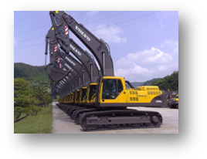 BTB Heavy Equipment, Inc.

PO Box 1520

Saskatoon, SK S7K 3R5

(306) 659 – 4256

(306) 659 – 4267

Request for Proposal (03-2023a)

BTB Heavy Equipment (BTB) was formed in 1999 and contracts out highly automated and customized cranes, bulldozers, and other equipment to construction firms across the country. BTB requires new standard desktop computers, which will be delivered to about 250 end users in June of 2023. The proposal must describe, in detail, the new machines and their component parts. The firm that wins the contract will source and build the new machines and will supervise BTB’s computer systems technicians in their installation.

About BTB: offering contracts for the most reliable brands with exceptional customer service, BTB is here to satisfy your heavy equipment needs. We make it easy for you to get your work done and are committed to deliver the results you need. We are committed to building a trusted relationship with you and supporting Saskatchewan businesses.

Submitted proposals must have the following perimeters:

* **Not exceed the capital budget of $250 000 Cdn1**
* **Describe computers to be built from parts, not bought as an entire package from one vendor**
* **Consist of machines able to run Windows 10 Professional with Office 2019 on a Gigabit Ethernet LAN**

Detailed information (including general and specific user requirements) may be requested from the following contact:

Ben Benson, System Administrator

BTB Heavy Equipment, Inc.

(306) 659 – 4118

[ben.benson@saskpolytech.ca](mailto:ben.benson@saskpolytech.ca)

Proposals will be submitted to the CEO:

Carina Lapointe, CEO

BTB Heavy Equipment, Inc.

(306) 659 – 4157

[carina.lapointe@saskpolytech.ca](mailto:carina.lapointe@saskpolytech.ca)

**Component Selection and Requirements:**

|  |  |  |
| --- | --- | --- |
| **Component:** | **Include in your report:** | **Requirements:** |
| CPU | Manufacturer, slot/socket type, model, speed, cost | Dual core. At least 2.5 GHz. Must match motherboard slot/socket type. |
| Motherboard | Manufacturer, form factor, bus speed, slot/socket type, chip set, on-board ports and connectors, any integrated components (e.g. video, sound or NIC), cost | Must have correct slot/socket for CPU. Must support memory type (correct slot) and speed (see below) and dual-channel architecture. Must have minimum 4 USB ports, and 1 IEEE 1394 port, and also WOL connector if NIC is not integrated (see NIC). |
| Memory | Type (SIMM, DIMM, or RIMM), module size(s), speed, manufacturer, other properties (e.g. buffered vs. unbuffered, voltage used, parity/ECC, etc.), cost | Minimum 4 GB, single DIMM preferred. Must have parity/ECC capabilities. |
| Card reader | Manufacturer, size, and cost | Must support multiple types including CompactFlash™. |
| Hard drive | Manufacturer, size, model, RPMs, ATA standard (e.g. ATA66, ATA100, ATA133, etc.), cost | Minimum 500 GB, attaches to standard IDE or SATA cable. |
| Keyboard | Manufacturer, model, special keys or features, cost | Ergonomic, with standard PS/2 or USB connector. |
| Mouse | Manufacturer, model, connection type, special buttons, cost | Either PS/2 or USB connector, wheel optical mouse preferred. |
| Optical drive | Manufacturer, model, speed(s), supported standards, cost | Must support installation of software and creation of backups. |
| Video card | Manufacturer, model, chip set used, video memory, maximum resolution supported, special features, cost | AGP card (at least 4×), PCI Express, or integrated. No video inputs. Must include standard VGA port. |
| Sound | Manufacturer, model, special features, cost | Jacks for microphone and speakers. Headset must have noise cancellation features. Speakers not included (existing speakers not being replaced). |
| NIC | Manufacturer, model, architecture, speed, special features, cost | Integrated or PCI card. Gigabit Ethernet with Wake on LAN (WOL) support. |
| Power supply | Manufacturer, model, Watt rating, cost | 350 W minimum. Must match motherboard connector type. |
| Enclosure | Manufacturer, model, type, front panel features, cost | Mini-tower, able to hold all other components. Enclosure and power supply may be treated as a unit. |
| Monitor | Manufacturer, model, size, LCD/CRT, dot pitch, maximum resolution, special features, cost | 17-inch or better monitor, supports 1024×768 at 75 Hz or better, best if it supports video card’s maximum resolution. |

## Appendix B: E-mail correspondence

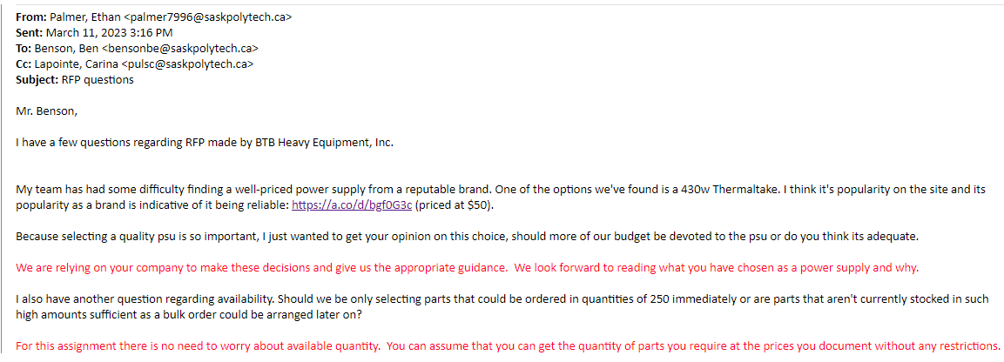

Figure 14 Email correspondence with System Administrator, response is colored in red.

## Appendix C: Customer Reviews

### Thermaltake PSU Reviews

The Thermaltake PSU type earned a 4.5 out of 5-star rating from Amazon and raked in over 19,500 ratings from customers (<https://www.amazon.ca/dp/B07BFJ91TY>). The ratings show how happy customers are with the Thermaltake PSU which further proves that it was a great choice for a power supply. Some of the reviews include:

“Very quiet PSU, barely audible. Nice black finish. The looks and weight of this product suggest a quality build, at least compared to my old PSU, which died after about 10 years. While not modular, it includes all the power, SATA and PCIE connectors most people will ever need unless they own a high-end gaming PC (in which case 500 W is simply not enough anyway). Installation was a breeze. This product even includes a set of cable braces. Very happy so far.” (Amazon Customer, February 2022)

“Has all the power connectors required for most devices & motherboards.  
Clean design.  
Included zip ties for cable management  
Replaced a smaller OEM HP pavilion 300W power supply from HP Pavilion Elite HPE-441f Desktop PC.  
Direct fit. No installation issues.  
Liked the colour of the Power supply. Matched the case.  
This is my second Thermaltake PS. Been happy with both so far..” (James P, December 2020)

### HyperX CloudX Headset Reviews

The HyperX CloudX headset garnered a 4.4 out of 5-star rating from Amazon and over 1,299 ratings from customers (<https://www.amazon.ca/dp/B08KS397GY>). Some of the reviews include:

“Great head set. Build solidly. Mic sounds good. I also like the fact that it's detachable or replaceable. This is where my last head set failed. Good sound quality but not the loudest.” (Marc, November 2022)

“… Sound is also very good. This is a very neutral sounding headset. Without a doubt. There is no emphasis on bass like some of the gaming headsets out there tend to do. That isn't to say there is no bass, far from it. But where this headset shines in is the mid-bass range. Instead of being overwhelmed with constant low end you're presented a neutral sound that re-creates the entire sound mix accurately. I find this very pleasing and not fatiguing like some of the bass heavy headsets I've tried in the past. From a pure gaming perspective it's very accurate and most people will be very happy. Being a neutral sound would also make this headset passable for music listening which is probably why so many people recommend Kingston headset for dual duties. It's such a smooth and accurate sound and with a detachable MIC it can pass as stereo headphones no problem. …” (MAK, November 2021)

### KOORUI Monitor Reviews

The KOORUI Monitor has 4.4 out of 5 stars in Amazon and has 2,357 ratings from customers (<https://www.amazon.ca/dp/B09VD9P2Q3>). Some of the reviews include:

“I purchased these monitors for my home office, primarily for MS Office applications and video conferencing. They’re super light and we’re easy to install on a double monitor stand. Very happy with the performance and quality given the price point.” (Richard S., March 2023)

“Customer service is super proactive and they stand behind their product. I had issues with the power cord and they resolved it very quickly.  
I bought it as a second monitor and the picture quality is SHOCKINGLY good. My main monitor is a 144Hz AOC gaming monitor and the picture quality is almost indistinguishable between the two. I didn’t try gaming on it and to be honest, I have no reason to. For browsing and office work, there is absolutely no complaints…” (Amazon customer, December 2022)