The Poetry of Ted Hughes

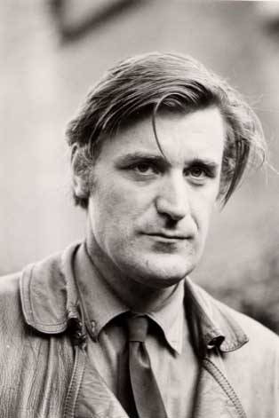

A lecture by Manohar Samuel
- PhD, University of Madras,
- Visiting Scholar, St. Augustine’s College
- Editor of Other Eyes and Other Voices:
An Anthology of Women’s Writing

Thursday, February 19th
Language Building, 223
11:00 AM

