UNT Web-Based Grade Book

Software Requirements Document
September 28, 2006

Cameron Palmer
Robert Thompson
Justin Blaydes
Davud Turkdill

Table of Contents

Table of Contents 3
1. Introduction 1
2. System Requirements 2
2.1. Server Requirements 2
2.2. Client Requirements 2
3. Software Requirements 3
3.1. Design Considerations 3
3.2. System Startup 3
3.3. Course Management 3
3.3.1. Course Creation and Editing 3
3.3.2. Course Category Management 3
3.4. Student Management 4
3.5. Assignment Management 5
3.6. The Grade Book Specifications 5
3.7. Student Import/Export File Format 6
4. Glossary 7

1. Introduction

The web-based grade book will allow instructors to manage their class grades through a web browser. The system will allow instructors to create a profile for each of their classes, including a customizable category creation. The grade book will also allow for the import or export of students from to or from a CSV file, as well as manual entry of individual students.

Management of each class’s grade book will occur through a grid-based layout where the instructor can see all the grades for all the students. The instructor can also hide categories of grades to better manage the grid.

2. System Requirements

2.1. Server Requirements
- x86-compatible system
- Ubuntu Linux 6.06 LTS
- Apache 2
- PHP5
- MySQL

2.2. Client Requirements
- Standards-compliant web browser
- Network access to server

3. Software Requirements

3.1. Design Considerations
- The grade book should follow University North Texas (UNT) color and web design conventions as much as possible.
- Records should be preserved as much as possible. When an instructor first deletes a record, it is actually just hidden. The secondary deletion (similar to emptying the trash can in most operating systems) will be required to actually delete the record.

3.2. System Startup
- System startup, including all grade book-required components on the server side, should start automatically on boot.

3.3. Course Management

3.3.1. Course Creation and Editing
- Adding a course requires the following information (includes examples):
- Title – Software Development I
- Department – CSCE
- Course – 4410
- Section – 002
- Term – Fall
- Year – 2006
- The course add and edit pages will allow letter grade cut-offs to be applied to a class.
- To select a course to edit, a list of the currently active courses should be displayed and selectable.
- A course should be deletable within the edit screen.
- All information that was assigned during course creation should be available to edit within the edit screen.

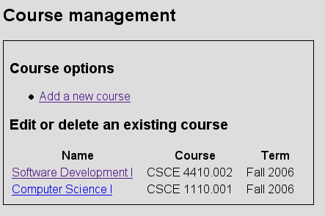
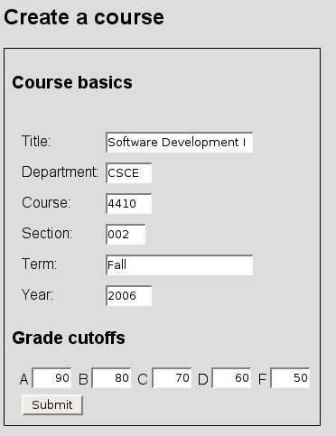

3.3.2. Course Category Management
A course category defines major headings under which assignments and exams will be created. The following requirements apply to course category management:
- The grade book will only handle whole percentages, 1-100.
- Adding a course category will require the following information (includes examples):
- Name – Exams
- Percentage – 20
- Rank – 1
- Rank should be used to determine the order in which to display the categories in the grade book.
- When creating a category, the rank should insert the new item into that position in the list.
- The order of the categories should be editable.
- Course category percentages should always add up to 100%.
- Inserting a new category into a course that is at 100% should be allowed if percentage set to 0%;
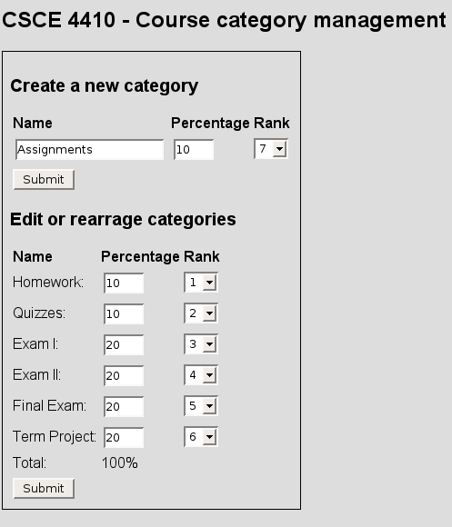

3.4. Student Management
Student management will allow the user to edit all aspects of the user profile. This interface will also allow for import and export of the students to a file.
- Adding a student requires the following information, includes examples
- Name (Last, First Middle) – Palmer, Cameron L
- EUID – clp0147
- EmplID – 10436511
- Email address – clp0147@unt.edu
- Web address – http://cameronpalmer.com
- Phone – 9723751441
- Comments – nice guy.
- Picture
- Mass import of the student portion of the database should be allowed via CSV file. The CSV file format is defined at the end of this document.
- All students should be exportable to a CSV file format that is defined at the end of this document.
- All elements of the student should be editable after creation.
- The student image format will be a jpeg not to exceed 1MB in size.

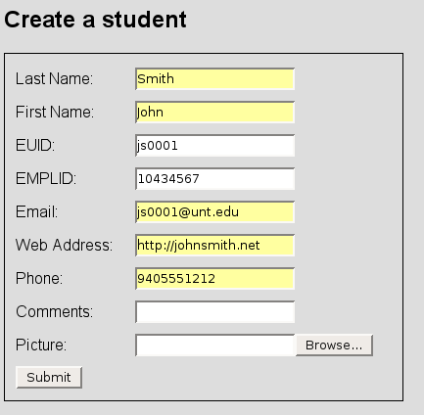

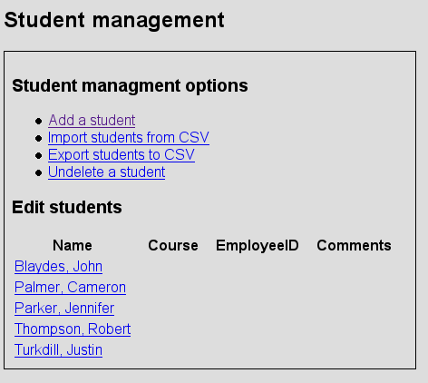

3.5. Assignment Management
- Assignments can be created from the grade book interface or the standalone interface.
- Adding a new assignment requires the following information, includes examples
- Title
- Maximum Points
- Due Date
- Comments

3.6. The Grade Book Specifications
- Blank grades and comments on columns are not averaged.
- Text should be allowed in the grade field.
- Comments on rows are averaged and considered zero.
- An arbitrary number of grades are allowed within each category.
- Students with a populated comments field should provide a visual indicator.
- Categories should be seen if set to viewable.
- The instructor should be able to set any category as hidden.
- When a category is hidden it will appear as a link at the top of the grade book as a link that will re-enable it.
- When the user hovers over the hide-a-category checkbox context sensitive help will appear reminding the user what the checkbox does.
- Assignments should be able to be created and edited with grade book.
- Access to the student’s information should be available from grade book.
- Validation of input should occur so that values entered in grade book outside the maximum points should indicate a warning.
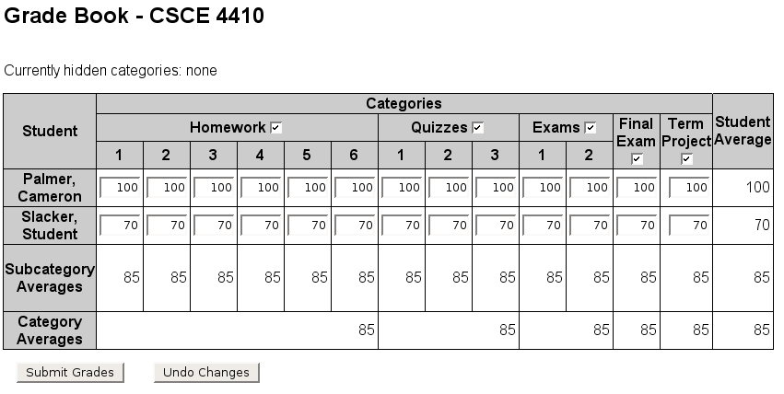

3.7. Student Import/Export File Format
#emplid,first_name,middle_name,last_name,euid,email,phone
10235567,John,Randall,Smith,jrs0147,jrs@example.com,9405551212

4. Glossary

CSV file
X86-compatible system
Standards-compliant web browser
Letter grade cut-offs
Course category
Populated comments field
Validation of input

