______________________________
Introduction
The Ghouly Guide Party Manual is a comprehensive guide for anyone to learn how to plan an entertaining, spooky and safe adult Halloween Party. It starts you with the set up preparations and ends with the day of party arrangements. You will learn ideas on purchasing or creating you own invitations, suggestions for food and drink, plus imaginative ideas for decorations and entertainment all while staying with a _________ budget. You will also learn how to host and quick and easy ways to clean up. You won’t believe how easy it is. Soon you will be on your way to throwing a party so good it’s scary.

_____________________________________________________________
Invitations
Invitations are one of the most important parts of a party. They not only tell the theme, but they give the tone for the Halloween Bash. From the moment they receive their artistic invitations, party guests will know they're in for an unforgettable night of chills and surprises.

Things Necessary for Great Invitations
To notify guest of your party you need to incorporate necessary information in your cards. The four main items to include are:
- The basics: date, time, location, contact information (name, phone number)
- Directions and/or map
- Dress code explaining whether it is a costume party
- Place a RSVP deadline set at least 5 days before date of party. This allows you to find out of the size of the party, so that you can plan and adjust.

Be Creative
Invitations should be fun and original. You can purchase invitations almost anywhere, from grocery stores to specific card and gift shops, such as Hallmark Stores. Alternatives to the store bought cards are, for instance, making your own flyers or emailing your invites in the form of greeting cards. These alternatives will help you cut cost and give your invitations a personal touch.

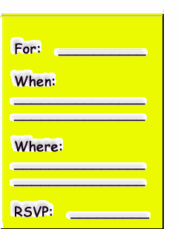
Example of Purchased Card
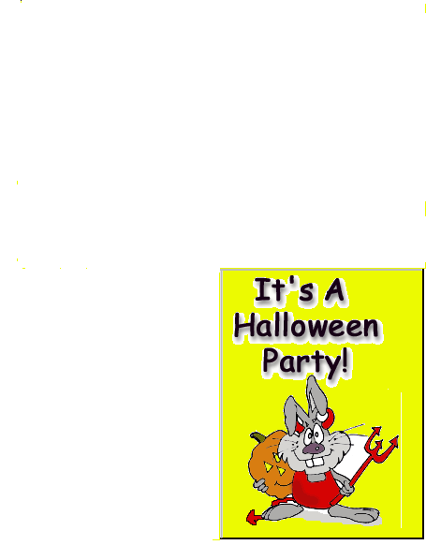
[Note: Make sure card includes headings for all necessary information. If not, write in extra information in space provided in card.]
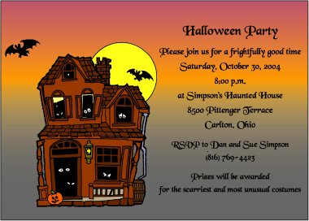
Example of Computer Made Flyer Invitation

Colored paper

Halloween Clip Art

Necessary Information
Simple Rules for Making Flyers
To make a flyer you need to have unity. Unity is a set of visual connections between elements on the page usually displayed through proximity, repetition, or continuation. Following you need to create a focal point which is something that contrasts with its surroundings in either size, color, or shape. Additionally the flyer should be clear and easy to read. Fonts that are sans-serif (example: Arial) are good for header/headings and serif fonts (example: Times New Romans) are great for the body. To emphasize information, try using a bigger size, dark colors, or bold face. Do not underline or capitalize. Lastly, be creative.

To Recreate the Flyer Pictured Above
- Get on your computer and open your word processing system (for example, Microsoft Word)
- Select Halloween inspired clip art from your computers file or find more clip art options on the internet
- Place clip art asymmetrically on the document
- Enter your party information on document (as seen in Things Necessary for Great Invitations)
- Print out on inexpensive colored paper

Emailing Guest
To save money and time, email is a terrific choice. Most email accounts offer free services to their members in the form of greeting cards. Email invitations are also only a mouse click away, making sending cards easy.

Website Suggestions
- www.americangreetings.com
- www.egreetings.com

Example of Email Invitation Registry
Paid or registered members click here to sign in.


  Event: | <Event Name>
  Hosted by: | <Your Name (or Host Name)>
  When: | <Event Date and Time>
  Where: | <Event Location>
  Phone: | <Telephone Number>
  *************
  Hi,
  Your personal message will appear here. Write as much as you'd like -- your message space is unlimited.

Paid or registered members click here to sign in.

