Project I: Finding the Shortest Path Given Constraints
October 10, 2006

Team:
Tyler Chamberlain
Brian Stair
Kristina Ratliff
Cameron Palmer

Member Contribution
Tyler Chamberlain was the primary coder on the Pathfinder GUI.
Cameron Palmer programmed the original starting point of the GUI that generated a window and a grid. Cameron also read the literature and wrote the report.
Kristina Ratliff has been reading the literature and doing research to help write the report.
Brian Stair helped Tyler with the Java programming and read literature related to the project.

Project Plan
Graph problems are hard. From the literature the overarching theme is that most algorithms devised are based upon Dijkstra's work in the late sixties. The majority of the literature deals with single source single target problems. The most interesting work has been done in the field of Quality of Service (QoS) improvements to networking and several novel approaches have been found. The best overview of these algorithms is called An Overview of Constraint-Based Path Selection Algorithms for QoS Routing. This document gets straight into running times of the algorithms and nice high-level explanations of the various approaches.
A key to this project is the multiple targets and channel-sharing that are requirements. Since this adds some complexity, we don't feel that any of the articles we have read completely address our needs. However modifications to the A* algorithm may yield satisfactory results. Since one author discussed waypoints for navigating roads it might be possible to use the intermediary point as a shared channel.

Screenshot
This screenshot is of the Pathfinder GUI

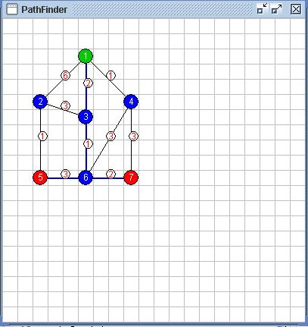

Input file specification
// Data Structures 3110 - Project
// File Format

//GRID_SIZE 20
//NODE <node#> <x pos> <y pos> <0=regular, 1=start node, 2=destination node>
NODE 1 5 2 1
NODE 2 2 5 0
NODE 3 5 6 0
NODE 4 8 5 0
NODE 5 2 10 2
NODE 6 5 10 0
NODE 7 8 10 2
//PATH <path#> <from node#> <to node#> <weight>
PATH 1 1 2 6
PATH 2 1 4 1
PATH 3 1 3 2
PATH 4 2 3 3
PATH 5 2 5 1
PATH 6 3 6 1
PATH 7 4 6 3
PATH 8 4 7 3
PATH 9 5 6 3
PATH 10 6 7 2

Source Code
See attached Java source code.

