I deployed a single honeypot through GCP called mhn-honeypot-2. I believe I had privilege issues so I ended up doing all of the configuration through the GCP ssh tool instead of doing it through my local command line. I created each VM and firewall rule through the GCP GUI which may have been the cause of issues further down the road. Initially I had issues installing and using all of the proper packages (I am inexperienced with linux so I was not exactly sure what I was looking at), so I decided to make a second honeypot VM to start over the process. After doing this I realized my first honeypot was not Ubuntu 14.04 which was why I was unable to use said packages.

As shown in the screenshot, I was able to perform a port scan on my honeypot. The port scan seemed to correctly detect that port 80 and 443 were open for http and https traffic. However, when I checked my admin box, I saw that no attacks were registered, not even from my own port scan.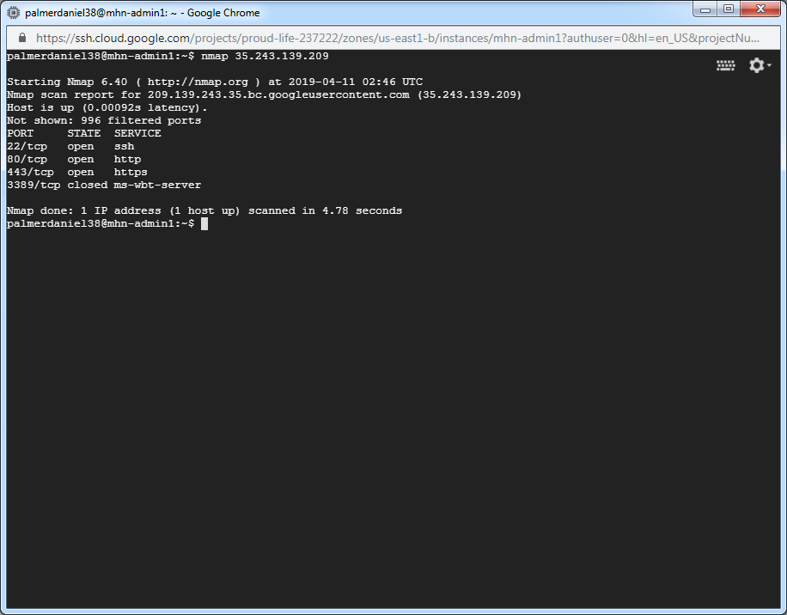

I attempted to troubleshoot (<https://github.com/threatstream/mhn/wiki/MHN-Troubleshooting-Guide>), but I am still unable to register any attacks. I confirmed by going through Dionaea.conf that my server address is correct and that my secrets match, but when I ran the nc command suggested in the guide, it hung suggesting network issues. I believe that my VMs and firewalls are correctly configured because I was able to set up and connect to the honeypot otherwise. I was not able to fix the issues after thorough testing and therefore I did not have any successful attacks.