1a)

max dc

s.t. dg=0

dd-dg <= 2

dh-dg <= 3

db-dh <= 9

da-dh <= 4

df-da <= 10

da-df <= 5

db-da <= 8

db-df <= 7

dc-df <= 3

de-df <= 2

dd-dc <= 3

df-da <= 18

de-dd <= 25

dd-de <= 9

dg-de <= 7

dc-db <= 4

de-db <= 10

**LINDO OUTOUT**

LP OPTIMUM FOUND AT STEP 6

OBJECTIVE FUNCTION VALUE

1) 16.00000 ←shortest path from G→ C

VARIABLE VALUE REDUCED COST

DC 16.000000 0.000000

DA 7.000000 0.000000

DB 12.000000 0.000000

DD 2.000000 0.000000

DE 19.000000 0.000000

DF 17.000000 0.000000

DH 3.000000 0.000000

DG 0.000000 0.000000

ROW SLACK OR SURPLUS DUAL PRICES

2) 0.000000 1.000000

3) 2.000000 0.000000

4) 0.000000 1.000000

5) 0.000000 1.000000

6) 3.000000 0.000000

7) 1.000000 0.000000

8) 14.000000 0.000000

9) 0.000000 0.000000

10) 8.000000 0.000000

11) 0.000000 0.000000

12) 15.000000 0.000000

13) 19.000000 0.000000

14) 9.000000 0.000000

15) 25.000000 0.000000

16) 9.000000 0.000000

17) 7.000000 0.000000

18) 0.000000 1.000000

19) 22.000000 0.000000

NO. ITERATIONS= 6

b) da + db + dc + dd + de + df + dg + dh

Otherwise, the values to other vertices are unreliable.

Eg: distance from G to A is > 4

#### 2) a) Constraints

* tie material than we have available

cost / yards

x11 * x12 + <= 20000  
x21 * x22 + <= 12000  
x31 * x32 + <= 11250

* The product information must be respected (price/min units/max units)

x11 + x21 + x31 + x41 <= 19.42  
x12 + x22 + x32 + x42 <= 35000  
x13 + x23 + x33 + x43 <= 45500

* the amount in yards of each tie must be respected

0.125x11 + 0x12 + 0x13 <= 7000  
0x21 + 0.8x22 + 0x23 <= 13625  
0x31 + 0.05x32 + 0.05x33 <= 13100   
0x41 + 0.03x42 + 0.07x43 <= 8500

b) 3.45(silk)+2.32(polyester)+2.81(blend1)+3.25(blend2)

where the coefficients are the profit for each tie.

c) Highest optimal solution : Profit = $120,196.00

silk ties = 7,000; polyester ties = 13,625; blend1 ties = 13,100; blend2 ties = 8,500

3) This graph was taken from my homework group (Credit to David Vogel). I added it to my page for reference and easier to read/understand than the HW4 graph.

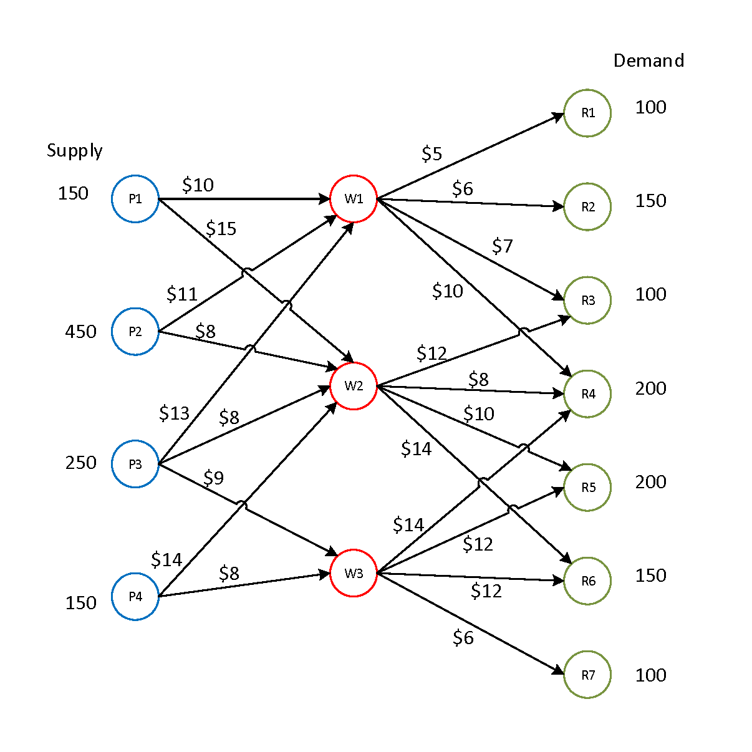a) Constraints

* The product cost

10p11 + 15p12 + 0p13 = 25

11p21 + 8p22 + 0p23 = 19

13p31 + 8p32 + 9p33 = 30

0p41 + 14p42 + 8p43 = 22

* Rough shipment cost (0 = cannot venture somewhere)

5r11 + 6r12 +7r13 + 10r14 + 0r15 + 0r16 + 0r17 = 28

0r21 + 0r22 + 12r23 + 8r24 + 10r25 + 14r26 + 0r27 = 44

0r31 + 0r32 + 0r33 + 14r34 + 12r35 + 12r36 + 6r37 = 44

* Capacity of each plant supply and demand (difference ratio)

150p11 + 150p12 +150p13 + 150p14 + 150p15 + 150p16 + 150p17 ≈ 6.6

450p21 + 450p22 + 450p23 + 450p24 + 450p25 + 450p26 + 450p27 ≈ 2.2

250p31 + 250p32 + 250p33 + 250p34 + 250p35 + 250p36 + 250p37 ≈ 4

150p41 + 150p42 +150p43 + 150p44 + 150p45 + 150p14 + 150p47 ≈ 6.6

b)

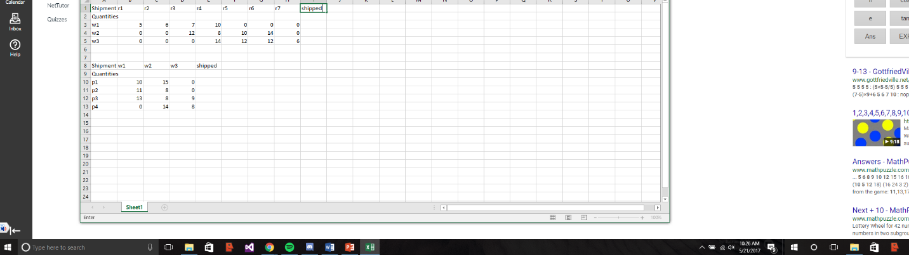

c) For the most optimal routes, I got:

P1W1, P2W1, P2W2, P3W2, P3W3, P4W3, W1R1, W1R2, W1R3, W2R4, W2R5, W3R6 , W3R7

10+11+8+8+9+8+5+6+7+8+10+12+6 ≈ 108