**From:** ALISON CHOUINARD <ALISON.CHOUINARD@co.rock.wi.us>  
**Sent:** Tuesday, August 23, 2022 3:48 PM  
**To:** Nicholas Zupan <Nicholas.Zupan@co.rock.wi.us>; Caitlin Turkowski <Caitlin.Turkowski@co.rock.wi.us>; Christine Gunn <Christine.Gunn@co.rock.wi.us>; Samantha Axon <Samantha.Axon@co.rock.wi.us>; Shari Faber <Shari.Faber@co.rock.wi.us>  
**Subject:** Re: Mortality Data follow-up

Hi Nick,

Here is a screenshot of some revisions.

Priority areas:

-Trends in overall mortality (include Premature death here)

-Chronic diseases, deaths, and neighborhood factors

Secondary:

Alcohol-related deaths

Include the others when you have time.

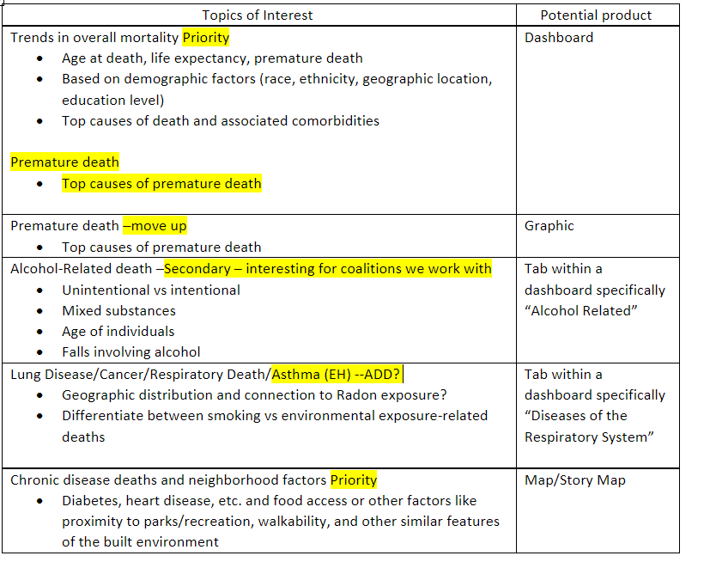

Premature deaths: where would the data come from?

We could create our own score for those who died before the average age at death.

Deliverable:

NOT a report.

Potentially a landscape format with charts and stuff. Updates are based on the mortality data we have available to us.

Frequency of updates? Monthly would be the most frequent. Quarterly or semi-annually (approx. every 6 months).

Challenges:

ID from Nick’s PowerBI data (that Jen Fiske helped with by adding fields) might not be good.

This is for gaining insights more than informing prevention action at the current time.