Tableau Data Connection

Joining two table from dataset

Connection ZipCode from main file to lookup the county from zipCode file.

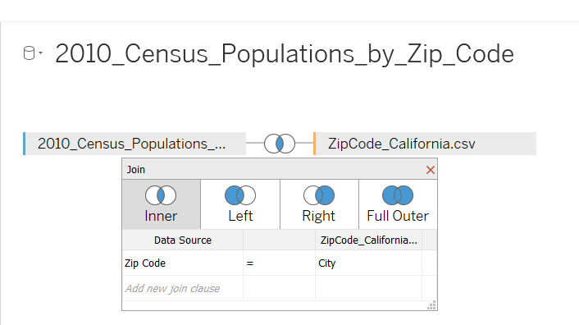

Use LeftJoin to ensure all value from Census Population considered.