### Current DAG

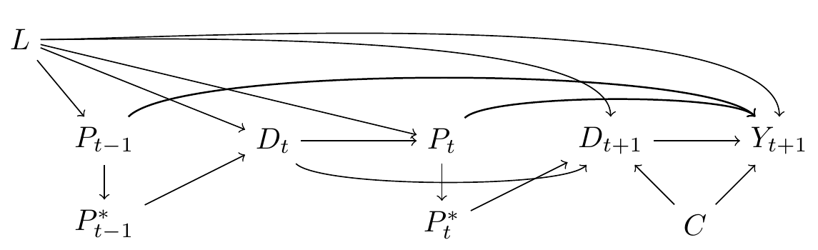

|  |
| --- |
| Changing time and L |
| Changing time, L and proxy |

### Changing time, L and proxy, plus L to C

