Dissecting the causal question underlying the association between cancer and ADRD: an opportunity to understand sources of bias

## 1. Introduction

Many observational studies have consistently found that individuals with cancer have a lower risk of developing of Alzheimer´s disease or related dementias (ADRD) when compared to individuals with no history of cancer [1–4]. These findings have motivated substantial research toward mechanistic explanations, including molecular and genetic pathways that may explain this association[5–12]. These research inquiries inevitably lead to discussions of repurposing or augmenting current cancer chemotherapeutics for ADRD [13].

Nevertheless, inferring any treatment or mechanistic effects from the observed cancer-ADRD inverse association is not straightforward. Researchers have raised concerns related to the competing event of death, unmeasured confounding, and ascertainment error that could explain these results[9,14]. However, understanding these or other sources of bias first requires making explicit the causal question. Moreover, this is one step toward tying a research study to a question that is relevant to decision-making[15,16].

To illustrate the complexities of inferring hypothetical or available treatments’ effects on ADRD from the observed cancer-ADRD association, we focus on a specific question conceptualizing the Pin1 enzyme as the target of intervention. Previous animal studies have shown that Pin1 enzyme over-expression promotes tumorigenesis, while its down-regulation is attributed to mechanisms that contribute to neurodegeneration and amyloid deposition[11,12,17]. If we one day could develop a drug that increases Pin1 expression specifically in brain tissue in hopes of preventing dementia, we could pose the question as: *What is the effect of this Pin1-targeting drug on the risk of ADRD over time compared to standard treatments?*

To explore how we might learn about this effect using real-world data on cancer and ADRD, we progressively build a causal directed acyclic graph to connect this particular causal question to the observable data and the assumptions we rely on to study the effect. We exemplify these challenges and how they translate into the analytic decision using data collected from the Rotterdam Study, a population-based cohort study.

## 2. Methods

### 2.1. Overview of the causal structure

If this hypothetical Pin1-targeting drug was developed, the best way to understand its effect on ADRD risk would be to have a well-conducted randomized trial in which we randomize eligible participants in late midlife (e.g., ages 50-60 years) to receive this drug or not, and closely monitor ADRD over a lengthy follow-up. Since this drug is not currently available, at best we can use observational data on Pin1 expression measurements. For example, suppose that a biomarker test was available to measure Pin1 and we measured this biomarker in stored baseline blood samples from late-midlife participants recruited for a population based-cohort.

In the observational setting, confounding could explain the observed association between Pin1 and ADRD. In the directed acyclic graph [18] of Figure 1, we present Pin1 expression as and ADRD diagnosis over time as . Both nodes may share causes , and to assess the causal relationship between and we would require adjusting for . Previous studies have described age, sex, educational level and race/ethnicity as the minimal adjusting set of covariates[4]. However, environmental and behavioral factors such as smoking may translate into Pin1 over-expression and are also related to the development of ADRD[ref].

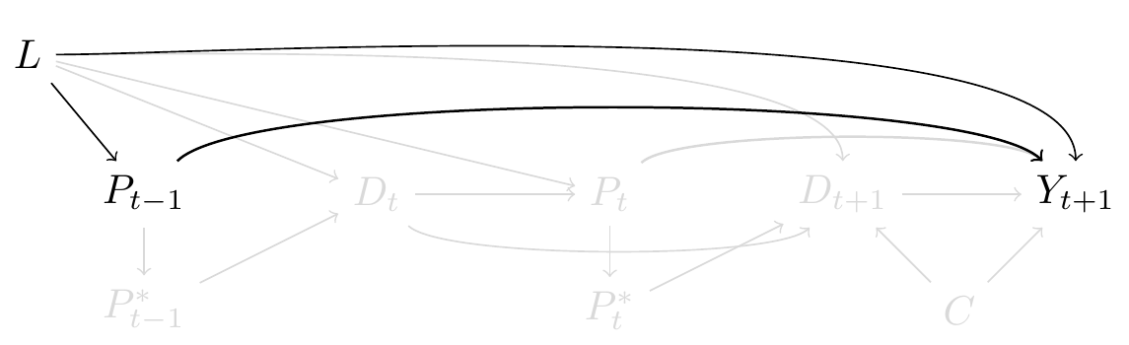

Pin1 as biomarker and risk of dementia

Currently, Pin1 expression is not an available biomarker for population-based research, so at best we can only rely on a proxy for it. Because Pin1 over-expression is present in tumors, and tumors are only measured through diagnosis, previous studies have considered Pin1 over-expression as the explanation behind the inverse association between cancer diagnosis and ADRD, though Pin1 was not explicitly part of the research question[19–26]. Unlike measuring Pin1 at the same time to all participants (thought this would not necessarily mean this would be the ideal time to measure it, we discuss this point further in the discussion section), cancer diagnosis is a collected over time. We depict this feature in Figure 2, where and represent *cancer diagnosis* over time, the measured proxy of and respectively. Although this means we would measure the association between cancer diagnosis over time and ADRD in the observed data, we are assuming that the captured effect is only through the pathway that involves Pin1 expression over time.

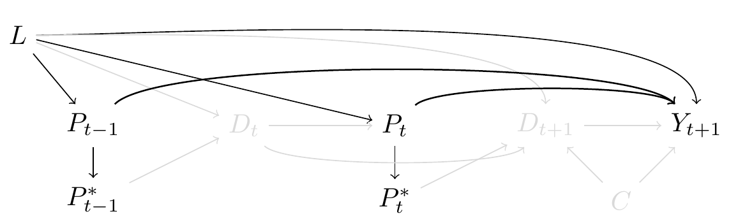

Cancer diagnosis as proxy for Pin1 expression

A challenge that arises by choosing cancer diagnosis as the proxy for Pin1 is defining the time zero, the time where eligibility criteria is met, where exposure is measured and the time where the screening for ADRD would begin after having the exposure measured[27]. The eligibility criteria to participate in a trial for Pin-targeting drug will not necessarily share the same criteria to be recruited for the cohort setting. The latter may not align with the time cancer diagnosis is measured since it happens over follow-up and this situation may introduce inmortal-time bias[27]. For example, a study performed using data from the Framingham study [19] defined the exposed group with cancer as those participants with prevalent or incident cancer diagnosis (alternatively defined as “ever cancer” [2]). This meant that a participant who had cancer diagnosis over follow-up contributed all their person-time to the cancer arm, including the time prior to the cancer diagnosis. By defining the exposure after the time of inclusion to the cohort, only participants who remain alive and free of ADRD diagnosis over follow-up can be defined as “ever cancer” [27].

This problem is avoided by recognizing the time-varying nature of cancer diagnosis. Several studies have considered cancer diagnosis as a time-dependent exposure. In this way, the time prior to cancer diagnosis is allocated to the non-exposed arm, and the time after cancer diagnosis to the exposed arm [2,22,29]. The price we pay with this approximation is that implicitly, this means that Pin1 would over-express at the time of cancer diagnosis and not before, which is biologically implausible. Moreover, cancer diagnosis will only be measured in the subset of participants who are alive over follow-up. Thus, we included death prior to cancer diagnosis as and an arrow between and that represents a deterministic association such as that is only observed if is zero in Figure 3. In addition, we added an arrow between and , since covariates such as smoking may affect Pin1 over-expression but also affect the risk of death due to other causes such as from chronic obstructive pulmonary disease. Although is time-varying in nature, we only depict at one time-point for readability.

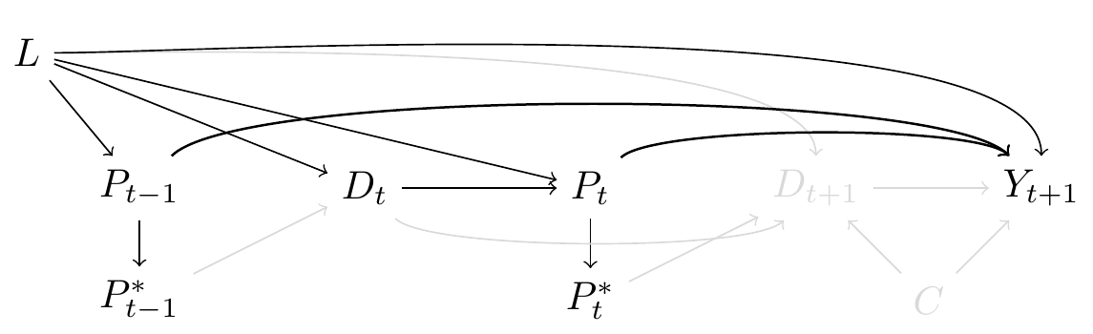

Time-varying cancer diagnosis and inmortal-time bias

We now move to the challenge of death as a competing event for ADRD, represented in Figure 4. For interpretability we exclude the time-varying process of cancer diagnosis and focus on Pin1 (and cancer diagnosis) as it had been measured in all participants at time . Given that some participants may die prior to ADRD diagnosis, we can only measure ADRD over follow-up in the individuals who survive long enough to have an ADRD diagnosis. In the causal diagram of Figure 4 we include a node for death after the exposure has been measured, represented as and which acts as a competing event of because if a participant dies by , the participant cannot subsequently develop dementia. Furthermore, since and are events related to aging and its consequences, represents the shared causes of both events such as cardiovascular conditions. We also include an arrow between and following the argument discussed previously.

In the setting where represented the targeted-drug for Pin1, and if this drug had no systemic beneficial or harmful side-effects such as that there is no arrow between and , a total effect would quantify the effect of on that does not include any pathway mediated through [30]. However, in the context of cancer diagnosis as the proxy for Pin1 over-expression, we cannot rule out the effect of cancer diagnosis on death, represented as the arrow between and . In this setting, a total effect of in would include the causal pathway mediated by the effect of cancer diagnosis in mortality, which may translate into an inverse association[30].

To isolate the direct effect of in through measurement of we have at least two alternatives of causal questions we can ask. We can either imagine a causal question where we decompose the effect of cancer by the different mechanisms that affect dementia and death separately[31]. Alternatively, we can define an scenario where death could have been prevented. The latter is defined as the controlled direct effect, where death is considered as a censoring event and it relies on the assumption that we have measured all to block the pathway . Previous studies have defined death as a censoring event [23], although failed to explicitly define how to comply with the independent censoring assumption. Moreover, adjusting for confounders for dementia (such as only adjusting for ) will be insufficient to block the pathway mediated by death, time-varying covariates that represent , such as cardiovascular conditions should be considered.

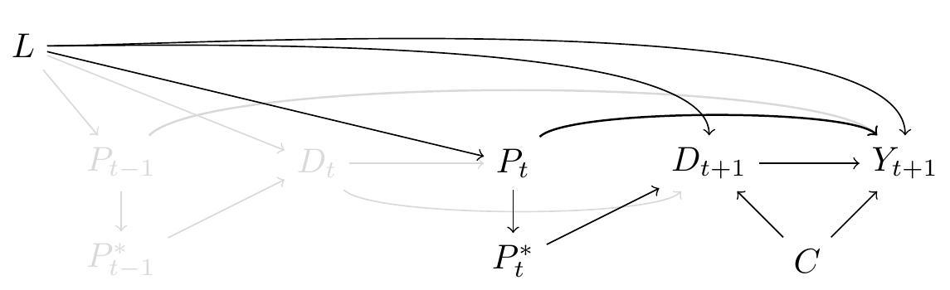

Death as a competing event

To summarize, the complexity of the causal structure that describes the effect of Pin1 through the proxy of cancer diagnosis in the risk of ADRD illustrate the potential sources of bias, as observed in Figure 5. Even so, this is a simplified version since we omitted other sources of measurement error and the time-varying nature of all nodes and feedback loops between them which would further complicate interpretability[18].

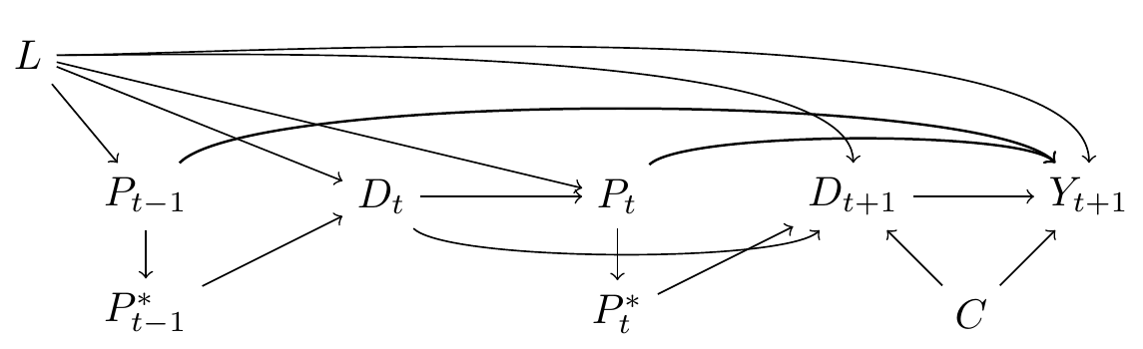

Direct effect of Pin1 in the risk of ADRD

We now turn to an application where we show how these challenges translate into analytic decisions. We will show ways to mitigate or better understand the best of the available data’s abilities to inform the possible effect of Pin1 on all cause-dementia.

## 2.2. The Rotterdam Study

We use data collected in the Rotterdam Study, a population-based prospective cohort study among persons living in the Ommoord district in Rotterdam, the Netherlands. Recruitment and initial assessments were held between 1990 and 1993, a second waive of recruitment was held between 2000 and 2001. Participants from first subcohort had follow-up visits between 1993-1995, 1997-1999, 2002-2005, and 2008-2010, second subcohort had follow-up visits between 2004 and 2005, and between 2011 and 2012[32]. All participants had data on history of cancer and dementia and incident diagnosis through follow-up until 2015, collected from medical records of general practitioners (including hospital discharge letters) and through linkage with national registries. Date and cause of death was collected on a weekly basis via municipal population registries.

We defined as inclusion criteria being between 60 and 70 years old at study entry, without history of cancer diagnosis, free of cognitive decline or with previous history of dementia. Out of 10998 persons who participated at study entry, 3642 were considered eligible. Time to cancer diagnosis, time to dementia diagnosis and death status was measured for all participants. All participants were followed from study entry until dementia diagnosis, death or 20 years after their individual baseline date, whichever occurred first.

### 2.3. Statistical Methods

We illustrate the association between cancer and dementia diagnosis under two scenarios. Scenario A replicates the setting that defines cancer proxy as *“cancer ever vs. never”* [19]. Scenario B defines cancer diagnosis as time-varying. To address confounding we fit inverse probability treatment weights, stabilized and truncated at 99th percentile. In scenario A, weights were defined as the inverse of the probability of cancer diagnosis conditional on baseline covariates such as age at study entry, sex, educational attainment, cohort, smoking status. In contrast, for scenario B weights were defined to represent the product of the inverse probability of being diagnosed with cancer over time, conditional on the time-varying covariate history prior to cancer diagnosis. This recreates a pseudopopulation in which time-varying covariates do not predict the risk of cancer diagnosis at time *t* [33]. Baseline covariates included age at study entry, sex, ApoE4 status, educational attainment and the time-varying covariates such as smoking status, systolic blood pressure, BMI and prevalent and incident comorbidities such as: hypertension and diabetes. Further details on modeling specifications and weights assessment are presented as **Supplementary material x**.

Inverse probability censoring weights for death were calculated to relax the independent censoring assumption. In scenario A, weights represent the inverse of the probability of not dying conditional on cancer diagnosis (ever vs. never) and baseline covariates such as age, educational attainment, ApoE4, and baseline measurements of smoking status, hypertension status, systolic blood pressure, BMI, history of diabetes and cohort. For individuals who died, their censoring weight is zero [18]. In scenario B time-varying weights represent the product of the inverse probability of surviving in each year prior to *t*, conditional on the measured shared causes of death and dementia. For an individual who has died by time *t*, the year *t* censoring weight is zero [30]. Weights were fitted including the same covariates used to estimate weights for time-varying cancer diagnosis, though we additionally added time-varying cancer, stroke, and heart disease diagnosis as predictors for death.

To estimate the controlled direct effect of Pin1 in the risk of ADRD, we compared the complement of a weighted Kaplan-Meier survival estimator for participants who developed cancer versus those who did not, with time indexed in years. The weights are time-varying by follow-up year, defined as a product of the year-specific inverse probability of treatment weights and the inverse probability of censoring by death weights. Estimates of the controlled direct effect at 20 years of follow-up are presented as risk differences (RD) and risk ratios (RR). All 95% confidence intervals were calculated using percentile-based bootstrapping based on 500 bootstrap samples.

For illustrative and comparative purposes we calculated hazard ratios (HR). Hazards, unlike risks, inherently condition on surviving both dementia and death, as such they will not have a causal interpretation in this setting [30]. We additionally calculated the controlled direct effect considering death as an unconditional independent censoring event (as if there were no arrows from to and ).

Since the conditional independent censoring assumption is untestable, we compute Peterson upper and lower bounds [34] to represent: 1) the extreme scenario of independence, that refers to an scenario were those who died would never develop dementia (lower bound) and 2) complete dependency, that refers to an scenario where those who died would have a dementia prior to death (upper bound). The lower bound is calculated with the Aalen-Johansen estimator treating death as a competing event, and the upper bound is calculated with the Kaplan Meier estimator for the combined outcome of dementia or death.

All analysis were performed using R, code is provided in supplementary material and available in <https://github.com/palolili23/2021_cancer_dementia>.

## 3. Results

Participants had a mean age of 64.46 (SD: 2.86), and 54% (n = 1981) were women. Further details on participants are presented in Table 1. Over follow-up, 24% (n = 878) developed cancer and 76% (n = 2764) remain free of cancer diagnosis, the median age of cancer diagnosis was 73 (IQR: 69-77). From the total sample, 12% (n = 431) had dementia over follow-up and median time to dementia was 79 (IQR: 75-83). Among participants with incident cancer, 6% (n = 50) had dementia diagnosis and 63% (n = 549) died over follow-up, 32% (n = 279) remain alive at 20 years since study entry. In contrast, among participants free of cancer diagnosis over follow-up, 14% (n = 385) were diagnosed with dementia and 23% (n = 624) died over follow-up, 63% (n = 1755) were alive at the end of follow-up. Figure 6 shows the proportion of participants in each possible status over follow-up.

Results for all scenarios are present in Table 2. Had we defined the proxy for Pin1 as *ever cancer*, and relying on death as independent censoring event (unconditional), we observe a significant protective effect of ever having cancer in the risk of dementia [RR: 0.7 (0.49,0.93), HR: 0.54(0.4,0.74)]. This effect shifts towards the null after including censoring weights for death [RR: 0.91 (0.65,1.19); HR: 0.76(0.56,1.04)]. In contrast, had we defined cancer diagnosis as a *time-varying* proxy for Pin1 over-expression and had we prevented death conditional on covariates, the risk of dementia had participants had a cancer diagnosis over time is higher [RR: 1.1 (0.86,1.39); HR: 1.09(0.78,1.51)], though confidence intervals cross the null. In addition, the extreme scenarios of dependence between death and dementia over follow-up represented as bounds are wide and include the null value (RR: 0.33, 2.28).

## 4. Discussion

Several observational studies have defined “cancer diagnosis” as exposure, although this does not represent a target for potential intervention or a modifiable risk factor. Instead, this variable is commonly used to represent a mechanism of interest that could not be measured. In this study we define cancer diagnosis as the proxy for Pin1 expression, a potential therapeutic drug-target. By explicitly including Pin1 as part of the research question we connect the unmeasured mechanism of interest to the observed data outlining the data generation process. This practice helps to identify and disentangle potential sources of bias and can guide analytic decisions. We show how results of the association between cancer diagnosis and dementia can change substantially according to alternative, yet explicit, assumptions.

For instance, a key challenge of cancer diagnosis as a proxy for Pin1 is the incapacity of defining a clear time zero[27]. In the setting where cancer diagnosis is defined as “ever vs. never,” this definition implicitly introduces immortal time bias. All results pertaining to this definition showed a substantial inverse association between cancer diagnosis and dementia in contrast to cancer diagnosis as a time-varying process which shifted point estimates close to the null. In line with the latter definition, including time-varying covariates is possible with well-known statistical methods such as inverse probability weighting, as opposed to previous studies that only considered baseline information[lots of refs]. Although we attempt to prevent this bias with statistical methods, we can only fully prevent it by having a clear definition of time-zero. This definition does not depend on the collected data nor in analytic decisions. It relies on a deeper discussion related to when would be the best moment to measure this biomarker and to what purpose. Thus, we hope that these unsolved questions guide future discussions and data collection efforts.

On the other hand, death as competing event is a challenge that has a straightforward solution, which begins by choosing the causal parameters (or estimand) of interest [35]. In this study we chose the controlled direct effect, which represents the effect of Pin1 (or cancer) in a setting where death could have been prevented and relies on the independent censoring assumption since death is treated as a censoring event. As opposed to prior studies that treated censoring as ignorable[23], we show how point estimates change substantially when we include IPCW for death to relax this assumption. In contrast to prior studies who have defined “survival bias” or “competing event bias” and have proposed different estimators to account for them[4], we conceptualize bias as not meeting the independent censoring assumption conditional on covariates[30]. Bounds to assess extreme scenarios of dependence between death and dementia[34] illustrate the wide range of possible point estimates that cross the null. This shows that even with the effort of adjusting for time-varying covariates, we may be far from meeting this assumption and thus better efforts to measure shared causes of dementia and death are needed. In addition, presenting the proportion of participants in each status over time, and the proportion of participants that died prior to ADRD diagnosis in each arm will always provide insights and improve transparency of results and interpretations.

Pin1 is only one of the several mechanisms proposed about the inverse cancer-dementia relationship. We acknowledge that cancer diagnosis represents a complex and heterogeneous health condition that exceeds the representation of Pin1 expression, thus, at best we may test the sharp null hypothesis rather than estimating the causal effect of Pin1. Furthermore, alternative mechanisms underlying cancer diagnosis and its connection to collected data may be represented in different causal representations. For example, if the intention was to explain the effect of different chemotherapeutics and how these affect brain, the eligibility criteria would change and the causal graph would represent the downstream of cancer diagnosis. For this reason, we believe is crucial to have a discussion related to cancer diagnosis as an exposure and how we can shift efforts to collect more suitable data. Furthermore, we consider that this case-study extends to other questions that study the effect of one disease in the risk of another disease to understand the biological mechanisms behind them.

## Tables

### Table 1: Descriptive characteristics of individuals who had a cancer diagnosis and of those free of cancer diagnosis over follow-up.

| Characteristics | Incident cancer | No incident cancer |
| --- | --- | --- |
| n | 878 | 2764 |
| Male (%) | 520 (59.2) | 1141 (41.3) |
| Age at baseline (mean (SD)) | 64.61 (2.87) | 64.42 (2.86) |
| Educational attainment (%) |  |  |
| Higher | 114 (13.0) | 269 (9.7) |
| Intermediate | 412 (46.9) | 1225 (44.3) |
| Lower | 347 (39.5) | 1251 (45.3) |
| Unknown history of diabetes | 5 (0.6) | 19 (0.7) |
| ApoE4 (%) |  |  |
| Not carrier | 622 (73.8) | 1874 (71.1) |
| One allele carrier | 203 (24.1) | 685 (26.0) |
| Two allele carrier | 18 (2.1) | 78 (3.0) |
| Smoking status (%) |  |  |
| Current | 260 (29.6) | 664 (24.0) |
| Former | 425 (48.4) | 1301 (47.1) |
| Never | 193 (22.0) | 799 (28.9) |
| Body Mass Index (mean (SD)) | 26.39 (3.50) | 26.65 (3.80) |
| Systolic blood pressure (mmHg) (mean (SD)) | 138.74 (20.98) | 138.67 (20.80) |
| No history of hypertension (%) | 369 (42.0) | 1141 (41.3) |
| No history of heart disease (%) | 800 (92.6) | 2503 (92.5) |
| No incident heart disease (%) | 665 (75.7) | 1967 (71.2) |
| History of diabetes | 91 (10.4) | 284 (10.3) |
| No history of diabetes | 553 (63.0) | 1981 (71.7) |
| Unknown history of diabetes | 234 (26.7) | 499 (18.1) |
| No incident diabetes (%) | 713 (81.2) | 2215 (80.1) |
| No history of stroke (%) | 863 (98.3) | 2717 (98.3) |
| No incident stroke (%) | 777 (88.5) | 2403 (86.9) |

### Table 2. Risk difference and risk ratio for the risk of dementia

| Proxy | model | Risk Difference | Risk Ratio | Hazard Ratio |
| --- | --- | --- | --- | --- |
| Ever vs. never | Unadjusted | -5.9 (-10.4,-1.1) | 0.71 (0.49,0.95) | 0.55(0.41,0.73) |
| Time-varying | Unadjusted | -0.6 (-4.1,3.9) | 0.97 (0.8,1.21) | 0.98(0.73,1.32) |
| Ever vs. never | IPTW | -6 (-10.6,-1.4) | 0.7 (0.49,0.93) | 0.54(0.4,0.74) |
| Time-varying | IPTW | -0.8 (-4.4,4) | 0.96 (0.78,1.21) | 0.97(0.71,1.31) |
| Ever vs. never | IPTW + IPCW | -2 (-7.7,3.9) | 0.91 (0.65,1.19) | 0.76(0.56,1.04) |
| Time-varying | IPTW + IPCW | 2 (-2.9,7.6) | 1.1 (0.86,1.39) | 1.09(0.78,1.51) |

## Figures

### Figure 6: Distribution of participants under each health status, by age over follow-up

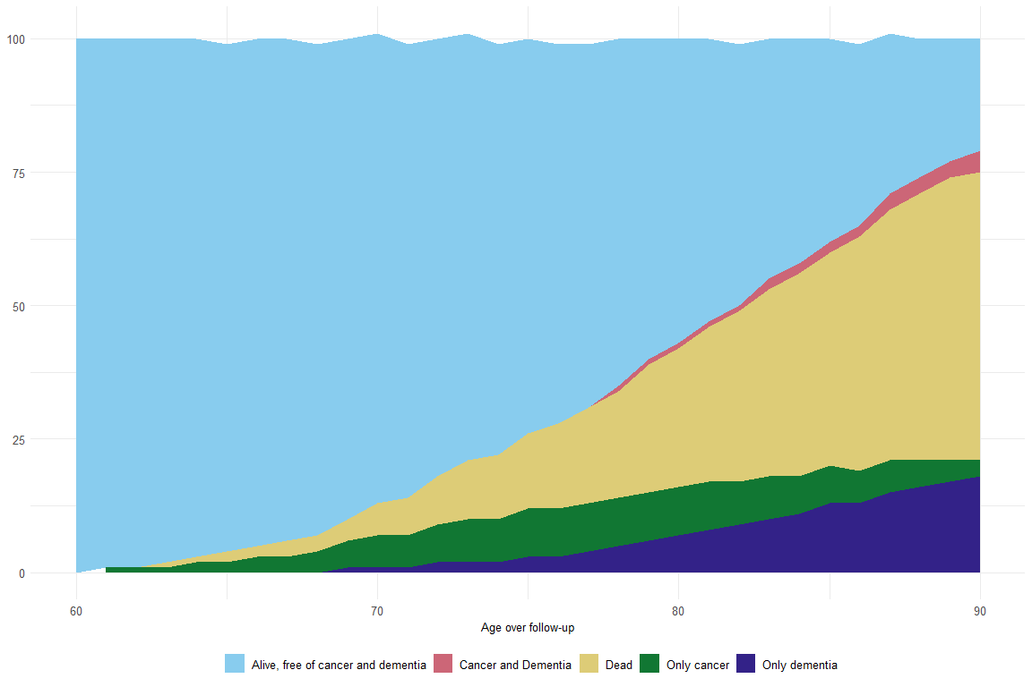

[1] Ma L-L, Yu J-T, Wang H-F, Meng X-F, Tan C-C, Wang C, et al. Association between Cancer and Alzheimer’s Disease: Systematic Review and Meta-Analysis. Journal of Alzheimer’s Disease 2014;42:565–73. <https://doi.org/10.3233/JAD-140168>.

[2] Hanson HA, Horn KP, Rasmussen KM, Hoffman JM, Smith KR. Is Cancer Protective for Subsequent Alzheimer’s Disease Risk? Evidence From the Utah Population Database. The Journals of Gerontology Series B: Psychological Sciences and Social Sciences 2016:gbw040. <https://doi.org/10.1093/geronb/gbw040>.

[3] van der Willik KD, Schagen SB, Ikram MA. Cancer and dementia: Two sides of the same coin? European Journal of Clinical Investigation 2018;48:e13019. <https://doi.org/10.1111/eci.13019>.

[4] Ospina-Romero M, Glymour MM, Hayes-Larson E, Mayeda ER, Graff RE, Brenowitz WD, et al. Association Between Alzheimer Disease and Cancer With Evaluation of Study Biases: A Systematic Review and Meta-analysis. JAMA Network Open 2020;3:e2025515. <https://doi.org/10.1001/jamanetworkopen.2020.25515>.

[5] Behrens M, Lendon C, Roe C. A Common Biological Mechanism in Cancer and Alzheimers Disease? Current Alzheimer Research 2009;6:196–204. <https://doi.org/10.2174/156720509788486608>.

[6] Harris RA, Tindale L, Cumming RC. Age-dependent metabolic dysregulation in cancer and Alzheimer’s disease. Biogerontology 2014;15:559–77. <https://doi.org/10.1007/s10522-014-9534-z>.

[7] Nudelman KNH, McDonald BC, Lahiri DK, Saykin AJ. Biological Hallmarks of Cancer in Alzheimer’s Disease. Molecular Neurobiology 2019;56:7173–87. <https://doi.org/10.1007/s12035-019-1591-5>.

[8] Papin S, Paganetti P. Emerging Evidences for an Implication of the Neurodegeneration-Associated Protein TAU in Cancer. Brain Sciences 2020;10:862. <https://doi.org/10.3390/brainsci10110862>.

[9] Driver JA. Inverse association between cancer and neurodegenerative disease: Review of the epidemiologic and biological evidence. Biogerontology 2014;15:547–57. <https://doi.org/10.1007/s10522-014-9523-2>.

[10] Olson B, Marks DL. Pretreatment Cancer-Related Cognitive ImpairmentMechanisms and Outlook. Cancers 2019;11:687. <https://doi.org/10.3390/cancers11050687>.

[11] Li J, Mo C, Guo Y, Zhang B, Feng X, Si Q, et al. Roles of peptidyl-prolyl isomerase Pin1 in disease pathogenesis. Theranostics 2021;11:3348–58. <https://doi.org/10.7150/thno.45889>.

[12] Driver JA, Zhou XZ, Lu KP. Pin1 dysregulation helps to explain the inverse association between cancer and Alzheimer’s disease. Biochimica Et Biophysica Acta (BBA) - General Subjects 2015;1850:2069–76. <https://doi.org/10.1016/j.bbagen.2014.12.025>.

[13] Snyder HM, Ahles T, Calderwood S, Carrillo MC, Chen H, Chang C-CH, et al. Exploring the nexus of Alzheimer’s disease and related dementias with cancer and cancer therapies: A convening of the Alzheimer’s Association & Alzheimer’s Drug Discovery Foundation. Alzheimer’s & Dementia 2017;13:267–73. <https://doi.org/10.1016/j.jalz.2016.11.002>.

[14] Ganguli M. Cancer and Dementia: It’s Complicated. Alzheimer Disease & Associated Disorders 2015;29:177–82. <https://doi.org/10.1097/WAD.0000000000000086>.

[15] Didelez V. Data always be preceded by specifying a target experimental trial? International Journal of Epidemiology 2016;45:3.

[16] Labrecque JA, Swanson SA. Target trial emulation: Teaching epidemiology and beyond. European Journal of Epidemiology 2017;32:473–5. <https://doi.org/10.1007/s10654-017-0293-4>.

[17] Angelucci F, Hort J. Prolyl isomerase Pin1 and neurotrophins: A loop that may determine the fate of cells in cancer and neurodegeneration. Therapeutic Advances in Medical Oncology 2017;9:59–62. <https://doi.org/10.1177/1758834016665776>.

[18] Hernán MA, Robins JM. Causal Inference: What If. Boca Raton: Chapman & Hall/CRC.; 2020.

[19] Driver JA, Beiser A, Au R, Kreger BE, Splansky GL, Kurth T, et al. Inverse association between cancer and Alzheimer’s disease: Results from the Framingham Heart Study. BMJ 2012;344:e1442–2. <https://doi.org/10.1136/bmj.e1442>.

[20] Musicco M, Adorni F, Di Santo S, Prinelli F, Pettenati C, Caltagirone C, et al. Inverse occurrence of cancer and Alzheimer disease: A population-based incidence study. Neurology 2013;81:322–8. <https://doi.org/10.1212/WNL.0b013e31829c5ec1>.

[21] Freedman DM, Wu J, Chen H, Kuncl RW, Enewold LR, Engels EA, et al. Associations between cancer and Alzheimer’s disease in a U.S. Medicare population. Cancer Medicine 2016;5:2965–76. <https://doi.org/10.1002/cam4.850>.

[22] Bowles EJA, Walker RL, Anderson ML, Dublin S, Crane PK, Larson EB. Risk of Alzheimer’s disease or dementia following a cancer diagnosis. PLOS ONE 2017;12:e0179857. <https://doi.org/10.1371/journal.pone.0179857>.

[23] Frain L, Swanson D, Cho K, Gagnon D, Lu KP, Betensky RA, et al. Association of cancer and Alzheimer’s disease risk in a national cohort of veterans. Alzheimer’s & Dementia 2017;13:1364–70. <https://doi.org/10.1016/j.jalz.2017.04.012>.

[24] Schmidt SAJ, Ording AG, Horváth-Puhó E, Sørensen HT, Henderson VW. Non-melanoma skin cancer and risk of Alzheimer’s disease and all-cause dementia. PLOS ONE 2017;12:e0171527. <https://doi.org/10.1371/journal.pone.0171527>.

[25] Sun M, Wang Y, Sundquist J, Sundquist K, Ji J. The Association Between Cancer and Dementia: A National Cohort Study in Sweden. Frontiers in Oncology 2020;10:73. <https://doi.org/10.3389/fonc.2020.00073>.

[26] Ording AG, Horváth-Puhó E, Veres K, Glymour MM, Rørth M, Sørensen HT, et al. Cancer and risk of Alzheimer’s disease: Small association in a nationwide cohort study. Alzheimer’s & Dementia 2020;16:953–64. <https://doi.org/10.1002/alz.12090>.

[27] Hernán MA, Sauer BC, Hernández-Díaz S, Platt R, Shrier I. Specifying a target trial prevents immortal time bias and other self-inflicted injuries in observational analyses. Journal of Clinical Epidemiology 2016;79:70–5. <https://doi.org/10.1016/j.jclinepi.2016.04.014>.

[28] Anderson JR, Cain KC, Gelber RD. Analysis of survival by tumor response. n.d.:10.

[29] White RS, Lipton RB, Hall CB, Steinerman JR. Nonmelanoma skin cancer is associated with reduced Alzheimer disease risk. Alzheimer Disease 2013:7.

[30] Young JG, Stensrud MJ, Tchetgen Tchetgen EJ, Hernán MA. A causal framework for classical statistical estimands in failure-time settings with competing events. Statistics in Medicine 2020;39:1199–236. <https://doi.org/10.1002/sim.8471>.

[31] Stensrud MJ, Young JG, Didelez V, Robins JM, Hernán MA. Separable Effects for Causal Inference in the Presence of Competing Events. Journal of the American Statistical Association 2020:1–9. <https://doi.org/10.1080/01621459.2020.1765783>.

[32] Ikram MA, Brusselle G, Ghanbari M, Goedegebure A, Ikram MK, Kavousi M, et al. Objectives, design and main findings until 2020 from the Rotterdam Study. European Journal of Epidemiology 2020;35:483–517. <https://doi.org/10.1007/s10654-020-00640-5>.

[33] Hernán MÁ, Brumback B, Robins JM. Marginal Structural Models to Estimate the Causal Effect of Zidovudine on the Survival of HIV-Positive Men: Epidemiology 2000;11:561–70. <https://doi.org/10.1097/00001648-200009000-00012>.

[34] Peterson AV. Bounds for a joint distribution function with fixed sub-distribution functions: Application to competing risks. Proceedings of the National Academy of Sciences 1976;73:11–3. <https://doi.org/10.1073/pnas.73.1.11>.

[35] Rojas-Saunero LP, Young JG, Didelez V, Ikram MA, Swanson SA. Choosing questions before methods in dementia research with competing events and causal goals. 2021. <https://doi.org/10.1101/2021.06.01.21258142>.

[36] van Geloven N, Geskus RB, Mol BW, Zwinderman AH. Correcting for the dependent competing risk of treatment using inverse probability of censoring weighting and copulas in the estimation of natural conception chances: N. VAN GELOVEN *ET AL.* Statistics in Medicine 2014;33:4671–80. <https://doi.org/10.1002/sim.6280>.

[37] Willems S, Schat A, van Noorden M, Fiocco M. Correcting for dependent censoring in routine outcome monitoring data by applying the inverse probability censoring weighted estimator. Statistical Methods in Medical Research 2018;27:323–35. <https://doi.org/10.1177/0962280216628900>.