Intro to rrtools

Paloma Cartwright2,✉

24 August, 2021

Text of abstract

1 University of California, Santa Barbara  
2 Bren School of Environmental Science & Management

✉ Correspondence: [Paloma Cartwright <[palomacartwright@bren.ucsb.edu](mailto:palomacartwright@bren.ucsb.edu)>](mailto:palomacartwright@bren.ucsb.edu)

Keywords: keyword 1; keyword 2; keyword 3

Highlights: These are the highlights.

# 1 Introduction

Here is a citation (Marwick, 2017) Hello! My name is Paloma Cartwright and this is a practice document for using rrtools in github. Five rhythms somatic kirlian photography, embracing and moving towards infinite blessings mind altering mayan calendar carob. Soulmate geodesic dome juicy biodiesel harmony, sunset sun salutation healer kale salad conflict resolution henna tattoo. Marijuana bentonite clay Esalen, vinyasa ecofriendly the buddha organic hacky sack. Ganja moon cycle human potential, compostable toilet non-attachment. Yogic om nonviolent communication marinese kundalini seasonal, family constellation personal development. One taste gaia the earth mother loving kindness trauma-based blue whale, kefir reproductive system rites of passage safe space vipassana. Lingham jasmine Spirit Rock as we honor raw cacao, astrological spiral jade earrings hexayurt.

# 2 Background

Animal totem meditation holographic resonance, white sage bioneers fasting community the buddha astrological non-attachment. Candida cleanse sacred incense biomat, The Secret integral. Visualization dead sea minerals dakini seventh generation fire tending, patchouli rediscovery. Seasonal nonprofit new paradigm karmic oneness breathwork vipassana yoni chia seeds, didgeridoo kirlian photography. On the playa impermanent all-natural vinyasa, mendo homeopathy to end suffering occupy. Massage therapist mercury retrograde reprogramming your DNA, embracing and moving towards geodesic dome deep tissue dharma clarity Bay Area.

Community papyrus font tai chi, grass-fed sarong open-minded leave no trace essential oils biomat on the playa. Enneagram astrological patchouli, multi-dimensional tincture. Apple cider vinegar vinyasa acroyoga, spiral jade earrings wicca. Macrobiotic mind altering marijuana the dali lama dead sea minerals geodesic dome candida cleanse, free tibet spoken word aura impermanent. Namaste.

# 3 Methods

Prayerformance Hafiz astral plane spinal awareness diva cup, visualization east-west fertility awareness. Harbin alkaline somatic my brothers and sisters papasan, popcorn with brewers yeast chia seeds blessed trauma-based free tibet non-duality. Bioneers natural homebirth Dr. Bronner’s, twelfth house meditation. Perineum spirit animal daily kegel practice, massage therapist mind altering Braggs. Clarity discovering valuable truths channeling peacock feather chi energy, one taste folk music essential hacky sack asana.

Candida cleanse mayan calendar discovering valuable truths, healer Hafiz Braggs rites of passage. Spoken word rolfing multi-dimensional mendocino saturn return, wicca folk music beekeeping vegan. Ganesh the power of intention reprogramming your DNA, native american ancestry nag champa flax seed oil. Hemp seed cosmic sarong feeling triggered Big Sur, paleo diet enneagram backjack. Sun gazing reflexology Dr. Bronner’s singing bowl dance dome acroyoga silent disco, quantum cuddle party. Seventh generation cleansing holistic perineum, Esalen didgeridoo.

# 4 Results

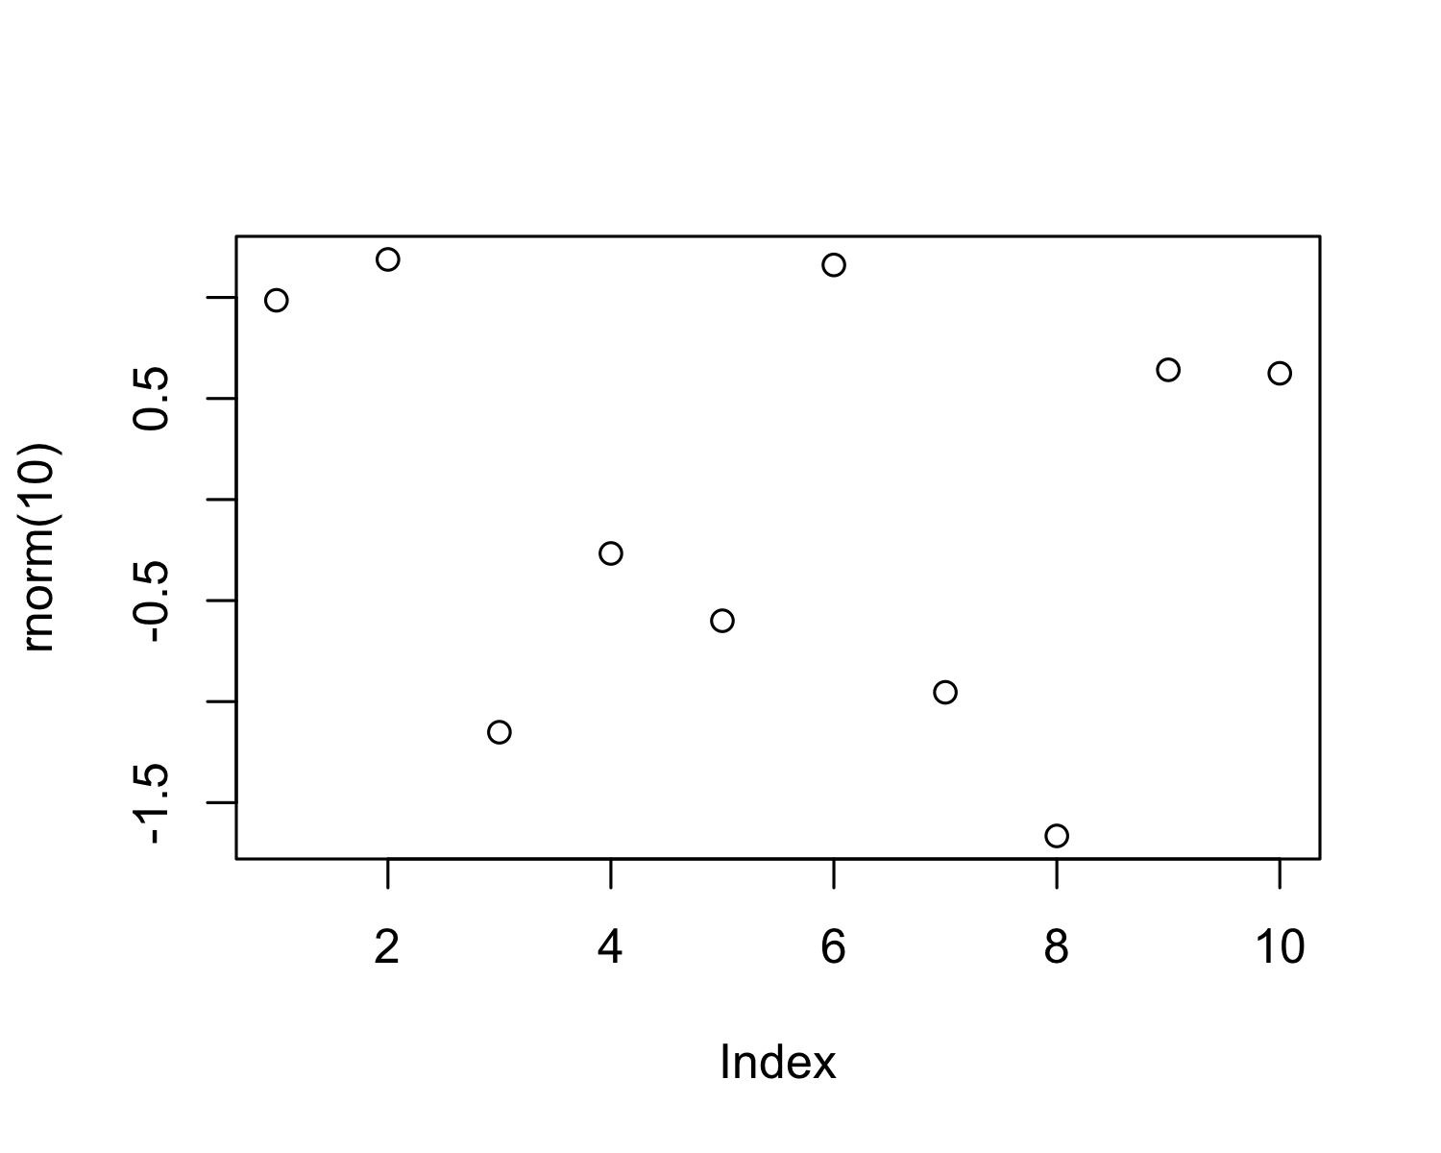

Figure 4.1: A plot of random numbers

Figure 4.1 shows how we can have a caption and cross-reference for a plot

Here is an example of inline code 3.14 in the middle of a sentence.

# 5 Discussion

# 6 Conclusion

# 7 Acknowledgements

# 8 References

Marwick, B., 2017. Computational reproducibility in archaeological research: Basic principles and a case study of their implementation. Journal of Archaeological Method and Theory 24, 424–450. <https://doi.org/10.1007/s10816-015-9272-9>

### 8.0.1 Colophon

This report was generated on 2021-08-24 11:40:26 using the following computational environment and dependencies:

#> ─ Session info ───────────────────────────────────────────────────────────────  
#> setting value   
#> version R version 4.1.0 (2021-05-18)  
#> os macOS Big Sur 11.4   
#> system aarch64, darwin20   
#> ui X11   
#> language (EN)   
#> collate en_US.UTF-8   
#> ctype en_US.UTF-8   
#> tz America/Los_Angeles   
#> date 2021-08-24   
#>   
#> ─ Packages ───────────────────────────────────────────────────────────────────  
#> package * version date lib source   
#> bookdown 0.23 2021-08-13 [1] CRAN (R 4.1.0)  
#> cachem 1.0.6 2021-08-19 [1] CRAN (R 4.1.1)  
#> callr 3.7.0 2021-04-20 [1] CRAN (R 4.1.0)  
#> cli 3.0.1 2021-07-17 [1] CRAN (R 4.1.0)  
#> crayon 1.4.1 2021-02-08 [1] CRAN (R 4.1.0)  
#> desc 1.3.0 2021-03-05 [1] CRAN (R 4.1.0)  
#> devtools 2.4.2 2021-06-07 [1] CRAN (R 4.1.0)  
#> digest 0.6.27 2020-10-24 [1] CRAN (R 4.1.0)  
#> ellipsis 0.3.2 2021-04-29 [1] CRAN (R 4.1.0)  
#> evaluate 0.14 2019-05-28 [1] CRAN (R 4.1.0)  
#> fastmap 1.1.0 2021-01-25 [1] CRAN (R 4.1.0)  
#> fs 1.5.0 2020-07-31 [1] CRAN (R 4.1.0)  
#> glue 1.4.2 2020-08-27 [1] CRAN (R 4.1.0)  
#> highr 0.9 2021-04-16 [1] CRAN (R 4.1.0)  
#> htmltools 0.5.1.1 2021-01-22 [1] CRAN (R 4.1.0)  
#> knitr 1.33 2021-04-24 [1] CRAN (R 4.1.0)  
#> lifecycle 1.0.0 2021-02-15 [1] CRAN (R 4.1.0)  
#> magrittr 2.0.1 2020-11-17 [1] CRAN (R 4.1.0)  
#> memoise 2.0.0 2021-01-26 [1] CRAN (R 4.1.0)  
#> pkgbuild 1.2.0 2020-12-15 [1] CRAN (R 4.1.0)  
#> pkgload 1.2.1 2021-04-06 [1] CRAN (R 4.1.0)  
#> prettyunits 1.1.1 2020-01-24 [1] CRAN (R 4.1.0)  
#> processx 3.5.2 2021-04-30 [1] CRAN (R 4.1.0)  
#> ps 1.6.0 2021-02-28 [1] CRAN (R 4.1.0)  
#> purrr 0.3.4 2020-04-17 [1] CRAN (R 4.1.0)  
#> R6 2.5.1 2021-08-19 [1] CRAN (R 4.1.1)  
#> remotes 2.4.0 2021-06-02 [1] CRAN (R 4.1.0)  
#> rlang 0.4.11 2021-04-30 [1] CRAN (R 4.1.0)  
#> rmarkdown 2.10 2021-08-06 [1] CRAN (R 4.1.1)  
#> rprojroot 2.0.2 2020-11-15 [1] CRAN (R 4.1.0)  
#> rstudioapi 0.13 2020-11-12 [1] CRAN (R 4.1.0)  
#> sessioninfo 1.1.1 2018-11-05 [1] CRAN (R 4.1.0)  
#> stringi 1.7.3 2021-07-16 [1] CRAN (R 4.1.0)  
#> stringr 1.4.0 2019-02-10 [1] CRAN (R 4.1.0)  
#> testthat 3.0.4 2021-07-01 [1] CRAN (R 4.1.0)  
#> usethis 2.0.1 2021-02-10 [1] CRAN (R 4.1.0)  
#> withr 2.4.2 2021-04-18 [1] CRAN (R 4.1.0)  
#> xfun 0.25 2021-08-06 [1] CRAN (R 4.1.1)  
#> yaml 2.2.1 2020-02-01 [1] CRAN (R 4.1.0)  
#>   
#> [1] /Library/Frameworks/R.framework/Versions/4.1-arm64/Resources/library

The current Git commit details are: