Efficient Django Deployment :Dockerized Application on Azure vm

**Django Sample Application Myhelloworld run in local environment:**

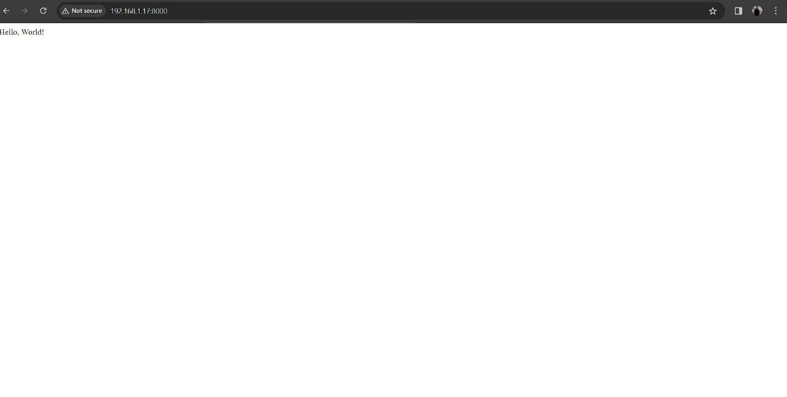**Order and connect vm:**

az vm create \

--resource-group MyResourceGroup \

--name MyVMpriya \

--image Ubuntu2204 \

--admin-username azureuser \

--size Standard_D4s_v3 \

--vnet-name MyVNet \

--subnet MySubnet \

--public-ip-address-dns-name myuniquepublicdnsname \

--authentication-type ssh \

--ssh-key-value @~/.ssh/id_rsa.pub

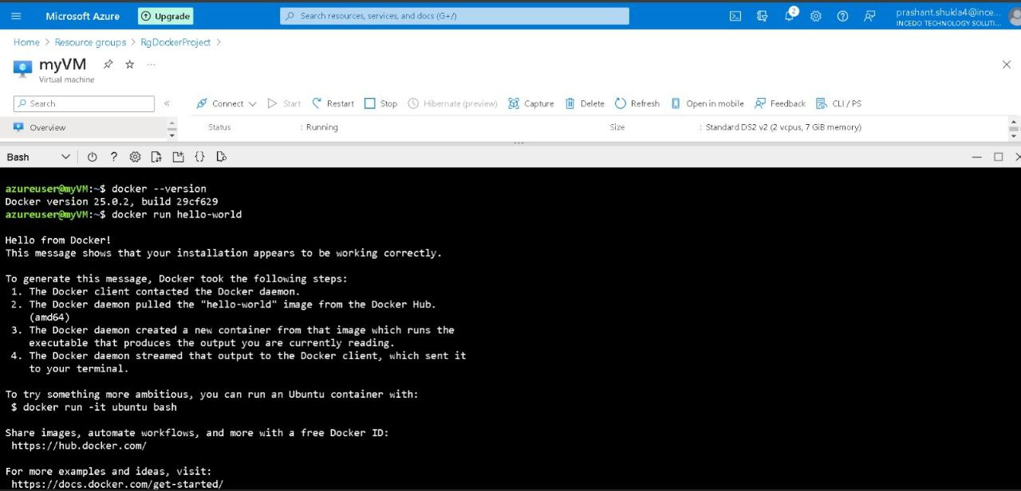

**Connect through ssh key:**

ssh -i ~/.ssh/id_rsa azureuser@myuniquepublicdnsname.eastus.cloudapp.azure.com

**Installing Docker on Azure VM:**

sudo apt-get update

sudo apt-get install apt-transport-https ca-certificates curl software-properties-common

curl -fsSL https://download.docker.com/linux/ubuntu/gpg | sudo apt-key add -

sudo apt-key fingerprint 0EBFCD88

sudo add-apt-repository "deb [arch=amd64] https://download.docker.com/linux/ubuntu $(lsb_release -cs) stable"

sudo apt-get update

sudo apt-get install docker-ce docker-ce-cli containerd.io

sudo usermod -aG docker $USER

sudo docker run hello-world

**Django Application Dockerization using Dockerplayground:**

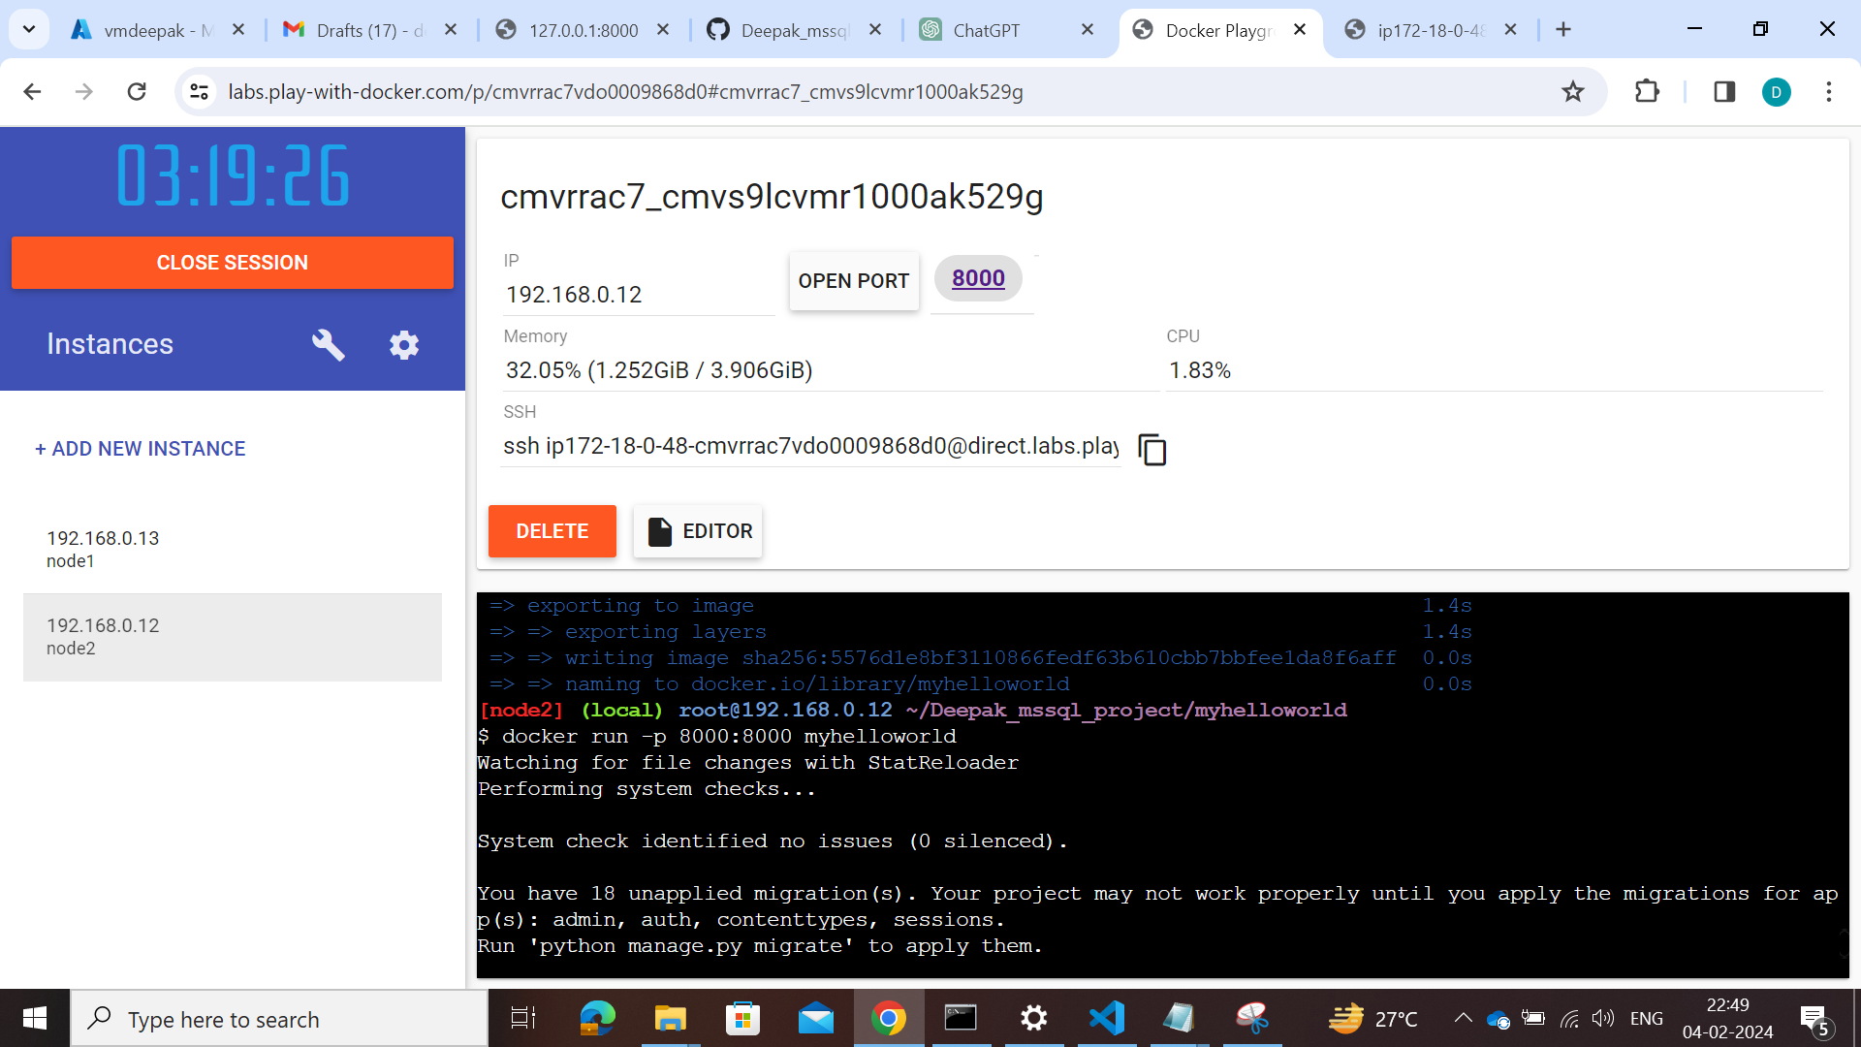

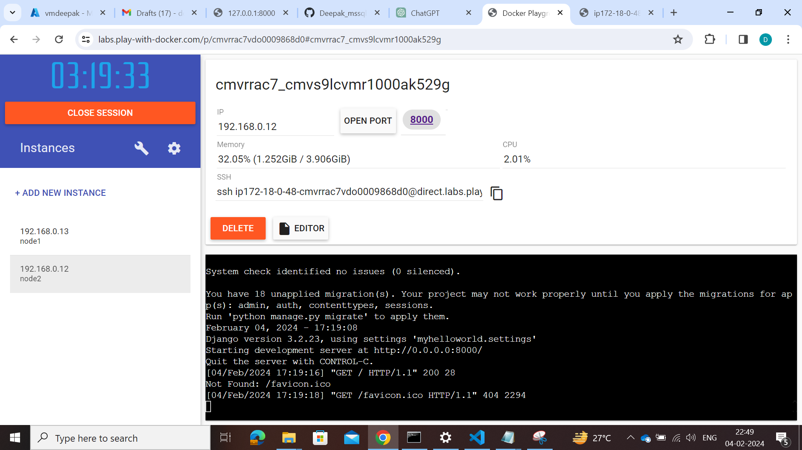

**Output:**

