My goal:

Is to create an iBeacon.

What do I have?

Hardware:

Linkit smart 7688 duo

Software:

Arduino IDE

Adafruit BluefruitLE nRF51 library

Examples -> Adafruit BluefruitLE nRF51 -> beacon

Step 1:

On line 62 set FACTORYRESET_ENABLE to 0

Step 2:

Run the code

Result:

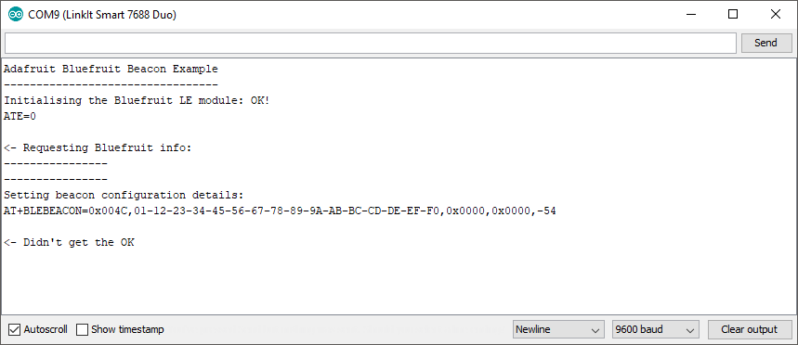

My goal:

Is to create an ibeacon.

What do I have?

Hardware:

Linkit smart 7688 duo

Software:

PuTTY 64-bit 0.70

Preparation:

Connect to the linkit smart7688 duo via wifi using the following tutorial:

<https://docs.labs.mediatek.com/resource/linkit-smart-7688/en/get-started/get-started-with-the-linkit-smart-7688-development-board/sign-in-to-the-web-ui>

Step 1:

Create a python script using the code found on <https://github.com/dburr/linux-ibeacon/blob/master/ibeacon>.

Step 2:

Using the following link

<https://it.cornell.edu/managed-servers/transfer-files-using-putty>

Set the environment to the location of pscp.exe using the following command.

set PATH="C:\Program Files\PuTTY\"

Step 3:

Move the script to the linkit smart 7688 duo using the following command:

pscp D:\School\IoT herkansing\iBeacon.py root@mylinkit.local:/IoT/examples/iBeacon.py



Step 4:

Try again to move the script to the linkit smart 7688 duo using the following command:

pscp -scp D:\School\IoT herkansing\iBeacon.py root@mylinkit.local:/IoT/examples/iBeacon.py



Error apparently caused by bug in putty.

Raspberry pi:

Ip address: 192.168.137.22

Credentials: pi

Password: raspberry

Step 1:

Set up an iBeacon using:

<https://learn.adafruit.com/pibeacon-ibeacon-with-a-raspberry-pi/overview>

Step 2:

Put the commands in the above tutorial into a script.

Step 3:

Write a script that uses a button press using:

<http://razzpisampler.oreilly.com/ch07.html>

Step 4:  
Combine these scripts to run the iBeacon script at button press.

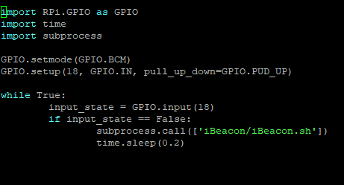

Step 5:

Create a loop that creates a different iBeacon at button press.

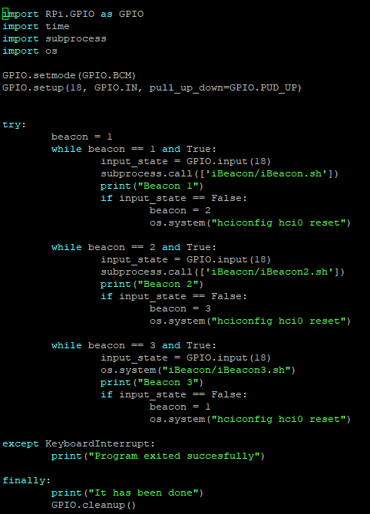

Step 6:

Put everything in aa single while loop to make sure it goes from 3 back to 1.

