YUVAINTERN – WEEK 2
EXPLORATORY DATA ANALYSIS
AND VISUALIZATION
Titanic Dataset • Technical Project Report

PROJECT | Exploratory Data Analysis and Visualization
DATASET | Titanic Dataset
TOOLS | Python • Pandas • Matplotlib • Seaborn
DELIVERABLE | Structured report with Markdown, code, outputs and visualizations

Prepared from the submitted Jupyter Notebook

Exploratory Data Analysis and Visualization – Titanic Dataset

YuvaIntern Internship – Week 2
Project: Exploratory Data Analysis and Visualization
Dataset: Titanic Dataset
Tools: Python, Pandas, Matplotlib, Seaborn
Environment: Jupyter Notebook
---

Objective
The objective of this notebook is to perform Exploratory Data Analysis (EDA) and visualization on the Titanic dataset.
In this analysis, we will:
- Understand the structure of the dataset
- Inspect data types and statistical properties
- Identify missing values
- Check duplicate records
- Handle missing values appropriately
- Analyze numerical and categorical variables
- Identify relationships and correlations
- Detect potential outliers
- Create meaningful visualizations
- Interpret important patterns and trends
- Summarize the major findings from the dataset

1. Import Required Libraries
The following Python libraries are used for data analysis and visualization.
- **Pandas** – data loading, manipulation and analysis
- **Matplotlib** – creating charts and plots
- **Seaborn** – statistical visualization and attractive plots
- **NumPy** – numerical operations
CODE CELL 3
import pandas as pd
import numpy as np
import matplotlib.pyplot as plt
import seaborn as sns
# Display settings
pd.set_option('display.max_columns', None)
# Set Seaborn theme
sns.set_theme(style="whitegrid")
print("Libraries imported successfully.")

OUTPUT • CELL 3
Libraries imported successfully.

2. Load the Dataset
The Titanic dataset is a well-known public dataset containing information about passengers aboard the Titanic.
The dataset contains demographic, travel and survival-related information.
For this project, the dataset is loaded from a local CSV file so that the notebook does not depend on an internet connection while running.
CODE CELL 5
df = sns.load_dataset('titanic')
print("Dataset loaded successfully!")

OUTPUT • CELL 5
Dataset loaded successfully!

Initial Dataset Preview
The `head()` function displays the first five rows of the dataset.
This helps us understand the variables and structure of the data.
CODE CELL 7
df.head()

OUTPUT • CELL 7
survived pclass sex age sibsp parch fare embarked class \
0 0 3 male 22.0 1 0 7.2500 S Third
1 1 1 female 38.0 1 0 71.2833 C First
2 1 3 female 26.0 0 0 7.9250 S Third
3 1 1 female 35.0 1 0 53.1000 S First
4 0 3 male 35.0 0 0 8.0500 S Third
who adult_male deck embark_town alive alone
0 man True NaN Southampton no False
1 woman False C Cherbourg yes False
2 woman False NaN Southampton yes True
3 woman False C Southampton yes False
4 man True NaN Southampton no True

Dataset Shape
The `shape` attribute returns the number of rows and columns
present in the dataset.
CODE CELL 9
df.shape

OUTPUT • CELL 9
(891, 15)

3.2 Column Names
The `columns` attribute displays the names of all variables present in the dataset.
Examining the column names helps us understand what information is available for analysis.
CODE CELL 11
df.columns

OUTPUT • CELL 11
Index(['survived', 'pclass', 'sex', 'age', 'sibsp', 'parch', 'fare',
'embarked', 'class', 'who', 'adult_male', 'deck', 'embark_town',
'alive', 'alone'],
dtype='object')

3.3 Dataset Information
The `info()` function provides information about the dataset, including column names, data types, non-null values, and memory usage.
This is useful for understanding the structure and data quality of the dataset.
CODE CELL 13
df.info()

OUTPUT • CELL 13
<class 'pandas.core.frame.DataFrame'>
RangeIndex: 891 entries, 0 to 890
Data columns (total 15 columns):
# Column Non-Null Count Dtype
--- ------ -------------- -----
0 survived 891 non-null int64
1 pclass 891 non-null int64
2 sex 891 non-null object
3 age 714 non-null float64
4 sibsp 891 non-null int64
5 parch 891 non-null int64
6 fare 891 non-null float64
7 embarked 889 non-null object
8 class 891 non-null category
9 who 891 non-null object
10 adult_male 891 non-null bool
11 deck 203 non-null category
12 embark_town 889 non-null object
13 alive 891 non-null object
14 alone 891 non-null bool
dtypes: bool(2), category(2), float64(2), int64(4), object(5)
memory usage: 80.7+ KB

4. Statistical Summary
The `describe()` function provides descriptive statistics for numerical variables.
It includes count, mean, standard deviation, minimum, quartiles, and maximum values.
These statistics help us understand the central tendency, spread, and range of numerical variables.
CODE CELL 15
df.describe()

OUTPUT • CELL 15
survived pclass age sibsp parch fare
count 891.000000 891.000000 714.000000 891.000000 891.000000 891.000000
mean 0.383838 2.308642 29.699118 0.523008 0.381594 32.204208
std 0.486592 0.836071 14.526497 1.102743 0.806057 49.693429
min 0.000000 1.000000 0.420000 0.000000 0.000000 0.000000
25% 0.000000 2.000000 20.125000 0.000000 0.000000 7.910400
50% 0.000000 3.000000 28.000000 0.000000 0.000000 14.454200
75% 1.000000 3.000000 38.000000 1.000000 0.000000 31.000000
max 1.000000 3.000000 80.000000 8.000000 6.000000 512.329200

5. Missing Value Analysis
Missing values are observations where information is not available.
Identifying missing values is important because they can affect statistical analysis and visualization.
We calculate the number of missing values in each column.
CODE CELL 17
df.isnull().sum()

OUTPUT • CELL 17
survived 0
pclass 0
sex 0
age 177
sibsp 0
parch 0
fare 0
embarked 2
class 0
who 0
adult_male 0
deck 688
embark_town 2
alive 0
alone 0
dtype: int64

CODE CELL 18
missing_percentage = (df.isnull().sum() / len(df)) * 100
missing_percentage.sort_values(ascending=False)

OUTPUT • CELL 18
deck 77.216611
age 19.865320
embarked 0.224467
embark_town 0.224467
survived 0.000000
pclass 0.000000
sex 0.000000
sibsp 0.000000
parch 0.000000
fare 0.000000
class 0.000000
who 0.000000
adult_male 0.000000
alive 0.000000
alone 0.000000
dtype: float64

5.1 Missing Value Visualization
A bar chart is used to visualize the number of missing values in each column.
This makes it easier to identify which variables contain missing information.
CODE CELL 20
missing_values = df.isnull().sum()
missing_values = missing_values[missing_values > 0]
plt.figure(figsize=(8, 5))
sns.barplot(
x=missing_values.index,
y=missing_values.values
)
plt.title("Missing Values by Column")
plt.xlabel("Column")
plt.ylabel("Number of Missing Values")
plt.xticks(rotation=45)
plt.show()

VISUALIZATION • CELL 20
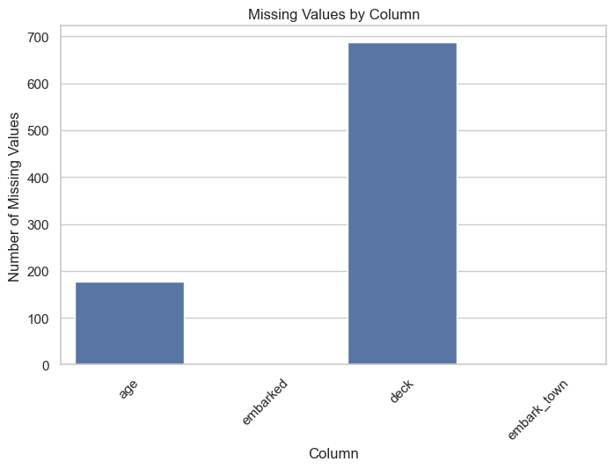

6. Duplicate Value Analysis
Duplicate rows contain repeated records.
We check for duplicate rows because unnecessary duplicates can affect analysis and lead to misleading conclusions.
CODE CELL 22
df.duplicated().sum()

OUTPUT • CELL 22
np.int64(107)

7. Handling Missing Values
After identifying the missing values, we need to decide how they should be handled.
Different techniques can be used depending on the type and importance of the variable.
For this dataset:
- Missing `age` values will be replaced using the median age.
- Missing `embarked` values will be replaced using the most frequent value (mode).
- `deck` contains a large number of missing values, so it will be excluded from the cleaned dataset.
A separate `df_clean` DataFrame is created so that the original dataset remains unchanged.
CODE CELL 24
df_clean = df.copy()
# Fill missing age values with median
df_clean['age'] = df_clean['age'].fillna(df_clean['age'].median())
# Fill missing embarked values with mode
df_clean['embarked'] = df_clean['embarked'].fillna(
df_clean['embarked'].mode()[0]
)
# Remove deck because it contains a large amount of missing data
df_clean = df_clean.drop(columns=['deck'])

8.1 Validation After Missing Value Handling
After handling the missing values, we check the dataset again.
This validation step confirms whether the selected missing-value treatment was successfully applied.
CODE CELL 26
df_clean.isnull().sum()

OUTPUT • CELL 26
survived 0
pclass 0
sex 0
age 0
sibsp 0
parch 0
fare 0
embarked 0
class 0
who 0
adult_male 0
embark_town 2
alive 0
alone 0
dtype: int64

CODE CELL 27
print("Total remaining missing values:",
df_clean.isnull().sum().sum())

OUTPUT • CELL 27
Total remaining missing values: 2

9. Duplicate Handling
Duplicate rows can affect the reliability of an analysis.
We check the cleaned dataset for duplicate records and remove them if necessary.
CODE CELL 29
duplicate_count = df_clean.duplicated().sum()
print("Duplicate rows:", duplicate_count)

OUTPUT • CELL 29
Duplicate rows: 116

CODE CELL 30
df_clean = df_clean.drop_duplicates()
print("Dataset shape after duplicate removal:", df_clean.shape)

OUTPUT • CELL 30
Dataset shape after duplicate removal: (775, 14)

10. Cleaned Dataset Overview
After handling missing values and duplicate records, we inspect the cleaned dataset.
This ensures that the dataset is ready for further exploratory analysis and visualization.
CODE CELL 32
df_clean.head()

OUTPUT • CELL 32
survived pclass sex age sibsp parch fare embarked class \
0 0 3 male 22.0 1 0 7.2500 S Third
1 1 1 female 38.0 1 0 71.2833 C First
2 1 3 female 26.0 0 0 7.9250 S Third
3 1 1 female 35.0 1 0 53.1000 S First
4 0 3 male 35.0 0 0 8.0500 S Third
who adult_male embark_town alive alone
0 man True Southampton no False
1 woman False Cherbourg yes False
2 woman False Southampton yes True
3 woman False Southampton yes False
4 man True Southampton no True

CODE CELL 33
df_clean.info()

OUTPUT • CELL 33
<class 'pandas.core.frame.DataFrame'>
Index: 775 entries, 0 to 890
Data columns (total 14 columns):
# Column Non-Null Count Dtype
--- ------ -------------- -----
0 survived 775 non-null int64
1 pclass 775 non-null int64
2 sex 775 non-null object
3 age 775 non-null float64
4 sibsp 775 non-null int64
5 parch 775 non-null int64
6 fare 775 non-null float64
7 embarked 775 non-null object
8 class 775 non-null category
9 who 775 non-null object
10 adult_male 775 non-null bool
11 embark_town 773 non-null object
12 alive 775 non-null object
13 alone 775 non-null bool
dtypes: bool(2), category(1), float64(2), int64(4), object(5)
memory usage: 75.1+ KB

11. Survival Distribution
The `survived` variable represents the survival status of passengers:
- `0` = Did not survive
- `1` = Survived
We first examine the overall distribution of survival outcomes.
CODE CELL 35
df_clean['survived'].value_counts()

OUTPUT • CELL 35
survived
0 455
1 320
Name: count, dtype: int64

CODE CELL 36
plt.figure(figsize=(7, 5))
sns.countplot(data=df_clean, x='survived')
plt.title('Survival Distribution')
plt.xlabel('Survival Status')
plt.ylabel('Number of Passengers')
plt.show()

VISUALIZATION • CELL 36
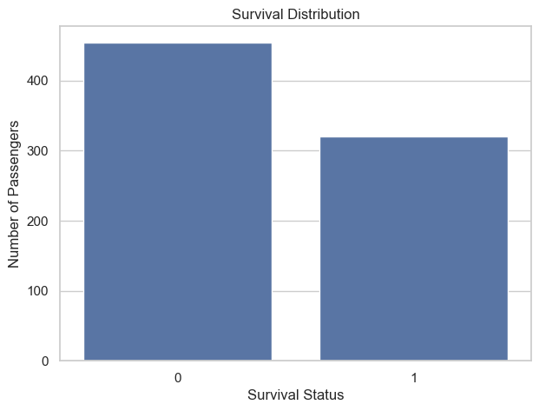

Observation
The count plot compares the number of passengers who survived with those who did not survive.
The visualization shows that the number of non-survivors was higher than the number of survivors.

12. Survival by Gender
Gender is an important categorical variable in the Titanic dataset.
We compare survival outcomes between male and female passengers to identify differences in survival patterns.
CODE CELL 39
pd.crosstab(df_clean['sex'], df_clean['survived'])

OUTPUT • CELL 39
survived 0 1
sex
female 76 216
male 379 104

CODE CELL 40
plt.figure(figsize=(7, 5))
sns.countplot(
data=df_clean,
x='sex',
hue='survived'
)
plt.title('Survival by Gender')
plt.xlabel('Gender')
plt.ylabel('Number of Passengers')
plt.show()

VISUALIZATION • CELL 40
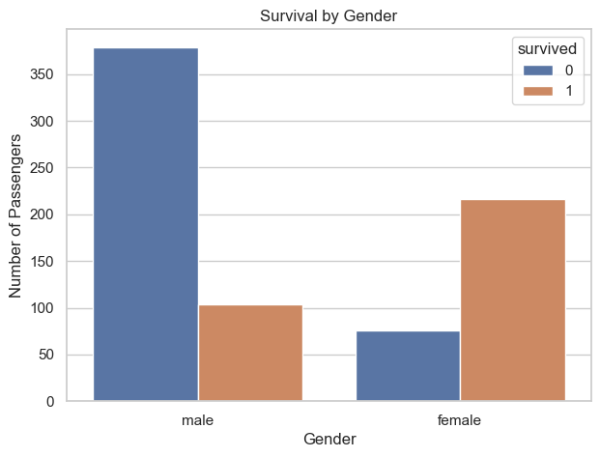

Observation
The visualization shows a clear difference in survival outcomes between male and female passengers.
Female passengers had a noticeably higher number and proportion of survivors compared with male passengers.

13. Survival by Passenger Class
The Titanic dataset contains passengers from three passenger classes.
We compare survival outcomes across first, second, and third class to investigate whether passenger class was associated with survival.
CODE CELL 43
pd.crosstab(df_clean['class'], df_clean['survived'])

OUTPUT • CELL 43
survived 0 1
class
First 77 133
Second 81 83
Third 297 104

CODE CELL 44
plt.figure(figsize=(8, 5))
sns.countplot(
data=df_clean,
x='class',
hue='survived'
)
plt.title('Survival by Passenger Class')
plt.xlabel('Passenger Class')
plt.ylabel('Number of Passengers')
plt.show()

VISUALIZATION • CELL 44
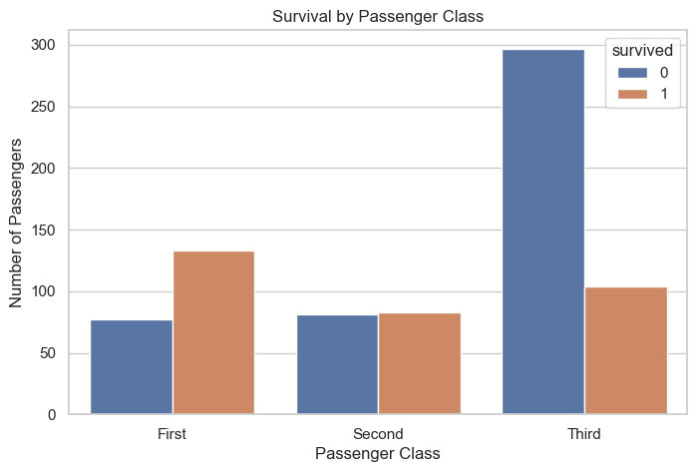

Observation
The plot shows different survival patterns across passenger classes.
First-class passengers generally had better survival outcomes, while third-class passengers had a larger number of non-survivors.

14. Age Distribution
Age is a numerical variable in the dataset.
A histogram is used to understand the distribution of passenger ages and identify the age ranges in which most passengers were concentrated.
CODE CELL 47
plt.figure(figsize=(8, 5))
sns.histplot(
data=df_clean,
x='age',
bins=30,
kde=True
)
plt.title('Age Distribution of Titanic Passengers')
plt.xlabel('Age')
plt.ylabel('Number of Passengers')
plt.show()

VISUALIZATION • CELL 47
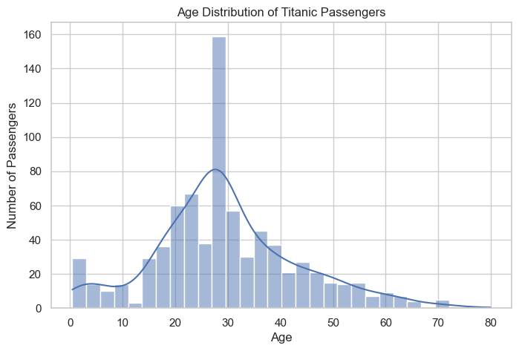

Observation
The histogram shows the distribution of passenger ages.
Most passengers were concentrated in the younger and middle-age ranges, while relatively fewer passengers were present at very high ages.

15. Fare Distribution
The `fare` variable represents the amount paid by passengers for their tickets.
A histogram is used to understand the distribution of fares and identify whether the variable contains extreme values.
CODE CELL 50
plt.figure(figsize=(8, 5))
sns.histplot(
data=df_clean,
x='fare',
bins=30,
kde=True
)
plt.title('Fare Distribution')
plt.xlabel('Fare')
plt.ylabel('Number of Passengers')
plt.show()

VISUALIZATION • CELL 50
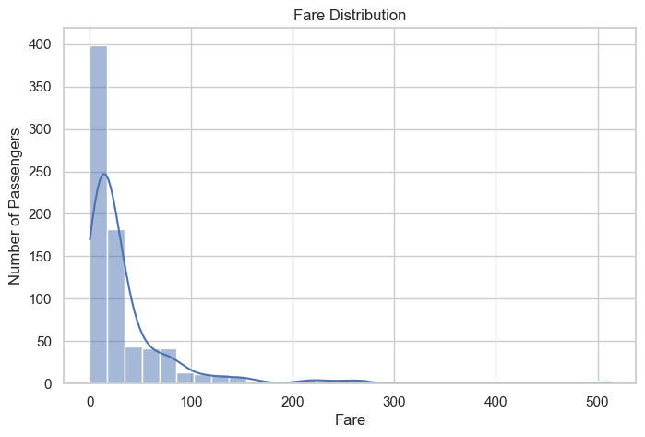

Observation
The fare distribution is strongly right-skewed.
Most passengers paid relatively lower fares, while a smaller number of passengers paid considerably higher fares.

16. Fare by Passenger Class
Passenger class and ticket fare are expected to be related because different classes generally had different ticket prices.
A box plot is used to compare fare distributions across passenger classes.
CODE CELL 53
plt.figure(figsize=(8, 5))
sns.boxplot(
data=df_clean,
x='class',
y='fare'
)
plt.title('Fare Distribution by Passenger Class')
plt.xlabel('Passenger Class')
plt.ylabel('Fare')
plt.show()

VISUALIZATION • CELL 53
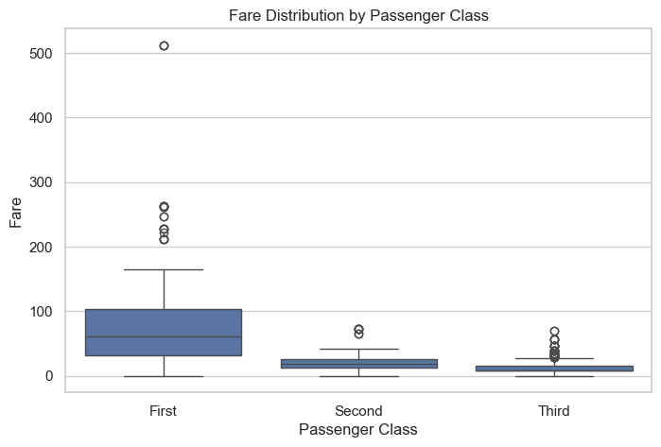

Observation
The box plot shows that passengers in higher classes generally paid higher fares.
The fare distributions also contain some unusually high values, which may represent potential outliers.

17. Age Distribution by Survival
We compare the age distributions of passengers who survived and those who did not survive.
A box plot allows us to compare the median age and overall spread of age between the two survival groups.
CODE CELL 56
plt.figure(figsize=(8, 5))
sns.boxplot(
data=df_clean,
x='survived',
y='age'
)
plt.title('Age Distribution by Survival')
plt.xlabel('Survival Status')
plt.ylabel('Age')
plt.show()

VISUALIZATION • CELL 56
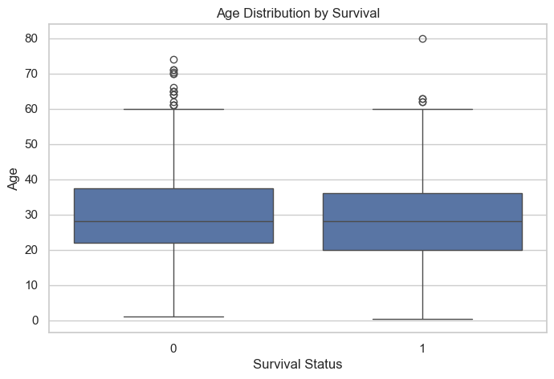

Observation
The box plot allows us to compare the age distributions of survivors and non-survivors.
The two groups show some overlap, indicating that age alone does not completely separate passengers based on survival.

18. Survival by Port of Embarkation
The `embarked` variable represents the port from which passengers boarded the Titanic.
We compare survival outcomes across the different embarkation ports.
CODE CELL 59
pd.crosstab(df_clean['embarked'], df_clean['survived'])

OUTPUT • CELL 59
survived 0 1
embarked
C 65 90
Q 38 20
S 352 210

CODE CELL 60
plt.figure(figsize=(8, 5))
sns.countplot(
data=df_clean,
x='embarked',
hue='survived'
)
plt.title('Survival by Port of Embarkation')
plt.xlabel('Port of Embarkation')
plt.ylabel('Number of Passengers')
plt.show()

VISUALIZATION • CELL 60
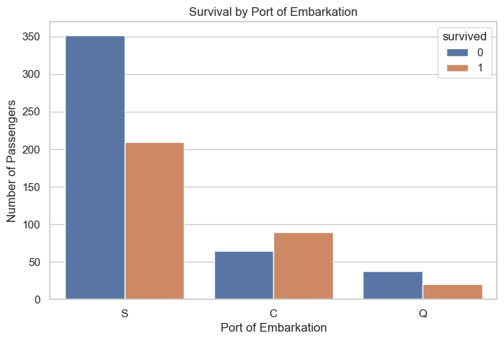

Observation
The plot shows differences in survival outcomes across the three embarkation ports.
However, these differences should not be interpreted as a direct causal relationship because other passenger characteristics may also influence survival.

19. Feature Transformation – Family Size
Feature transformation means creating a new variable from existing variables to obtain additional information.
In the Titanic dataset, `sibsp` represents the number of siblings/spouses aboard and `parch` represents the number of parents/children aboard.
We create a new variable called `family_size`.
Family Size = SibSp + Parch + 1
The value 1 represents the passenger themselves.
This new feature helps us investigate whether travelling with family members was associated with survival.
CODE CELL 63
df_clean['family_size'] = df_clean['sibsp'] + df_clean['parch'] + 1
df_clean[['sibsp', 'parch', 'family_size']].head()

OUTPUT • CELL 63
sibsp parch family_size
0 1 0 2
1 1 0 2
2 0 0 1
3 1 0 2
4 0 0 1

20. Family Size Distribution
We examine the distribution of the newly created `family_size` variable.
This helps us understand whether passengers generally travelled alone or with family members.
CODE CELL 65
plt.figure(figsize=(8, 5))
sns.countplot(
data=df_clean,
x='family_size'
)
plt.title('Family Size Distribution')
plt.xlabel('Family Size')
plt.ylabel('Number of Passengers')
plt.show()

VISUALIZATION • CELL 65
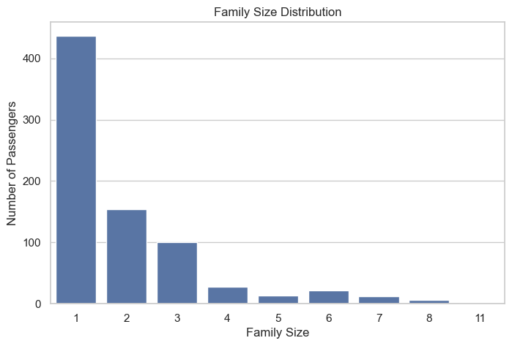

Observation
The distribution shows how many passengers travelled alone or as part of different family sizes.
Very large family sizes are less common compared with smaller family groups.

21. Family Size and Survival
We now investigate whether family size is associated with survival.
The survival rate is calculated for each family size rather than only comparing the number of survivors.
CODE CELL 68
family_survival = (
df_clean.groupby('family_size')['survived']
.mean()
.mul(100)
)
family_survival

OUTPUT • CELL 68
family_size
1 33.638444
2 55.194805
3 57.425743
4 71.428571
5 23.076923
6 13.636364
7 33.333333
8 0.000000
11 0.000000
Name: survived, dtype: float64

CODE CELL 69
plt.figure(figsize=(10, 5))
sns.barplot(
x=family_survival.index,
y=family_survival.values
)
plt.title('Survival Rate by Family Size')
plt.xlabel('Family Size')
plt.ylabel('Survival Rate (%)')
plt.show()

VISUALIZATION • CELL 69
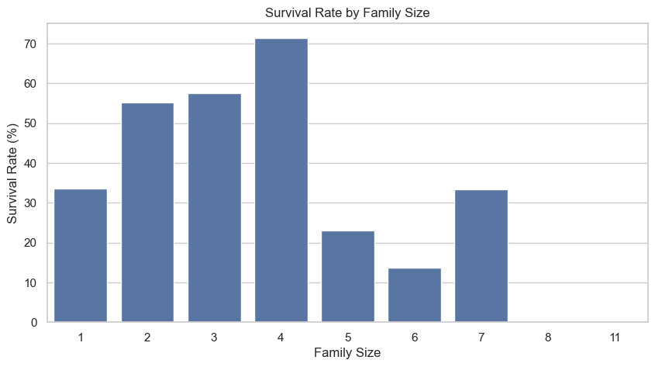

Observation
The survival rate varies across different family sizes.
Very small and very large family groups may show different survival patterns. However, family size alone cannot be considered the only factor affecting survival.

22. Correlation Analysis
Correlation measures the strength and direction of a linear relationship between numerical variables.
The correlation coefficient generally ranges from -1 to +1.
- A positive value indicates a positive relationship.
- A negative value indicates a negative relationship.
- A value close to zero indicates a weak linear relationship.
Correlation shows association between variables and does not necessarily imply causation.
CODE CELL 72
numeric_df = df_clean.select_dtypes(include=np.number)
correlation_matrix = numeric_df.corr()
correlation_matrix

OUTPUT • CELL 72
survived pclass age sibsp parch fare \
survived 1.000000 -0.331388 -0.078114 -0.037841 0.069864 0.247159
pclass -0.331388 1.000000 -0.342745 0.087050 0.038998 -0.554649
age -0.078114 -0.342745 1.000000 -0.279316 -0.182697 0.092503
sibsp -0.037841 0.087050 -0.279316 1.000000 0.379535 0.133807
parch 0.069864 0.038998 -0.182697 0.379535 1.000000 0.190823
fare 0.247159 -0.554649 0.092503 0.133807 0.190823 1.000000
family_size 0.013954 0.078134 -0.282479 0.859784 0.798767 0.192341
family_size
survived 0.013954
pclass 0.078134
age -0.282479
sibsp 0.859784
parch 0.798767
fare 0.192341
family_size 1.000000

23.1 Correlation Heatmap
A heatmap provides a visual representation of the correlation matrix.
The values inside the heatmap show the correlation coefficient between numerical variables.
This makes it easier to identify relatively strong positive or negative relationships.
CODE CELL 74
plt.figure(figsize=(10, 7))
sns.heatmap(
correlation_matrix,
annot=True,
fmt='.2f',
cmap='coolwarm'
)
plt.title('Correlation Heatmap')
plt.show()

VISUALIZATION • CELL 74
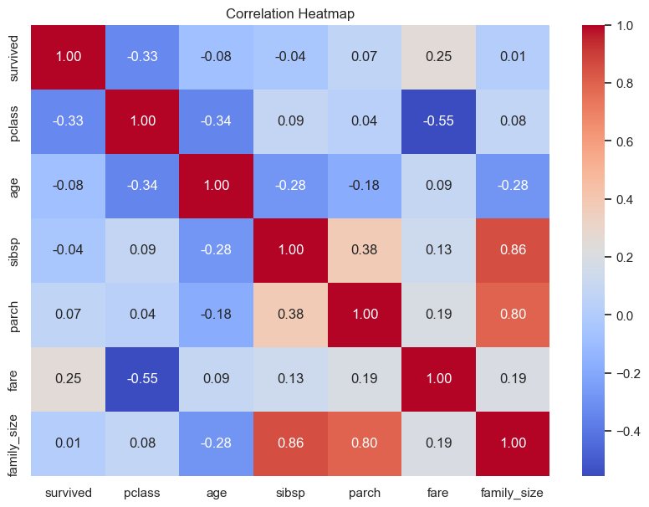

Observation
The heatmap provides an overall view of the relationships among numerical variables.
Some variables show stronger associations than others. In particular, passenger class and fare show a noticeable relationship, while several other variables have weaker linear relationships.

24. Outlier Analysis
An outlier is an observation that is unusually far from the majority of observations.
Outliers can influence statistical measures such as the mean and standard deviation.
Box plots are used to visually identify potential outliers in numerical variables.
We will examine `age` and `fare`.
CODE CELL 77
plt.figure(figsize=(7, 5))
sns.boxplot(
data=df_clean,
y='age'
)
plt.title('Age Outlier Analysis')
plt.ylabel('Age')
plt.show()

VISUALIZATION • CELL 77
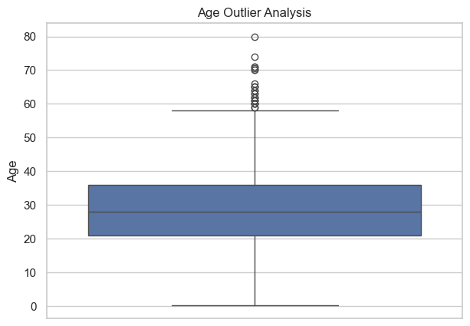

Observation
The box plot shows the spread of passenger ages and highlights observations that may lie outside the typical range.
Potential outliers should not automatically be removed because they may represent genuine observations.
CODE CELL 79
plt.figure(figsize=(7, 5))
sns.boxplot(
data=df_clean,
y='fare'
)
plt.title('Fare Outlier Analysis')
plt.ylabel('Fare')
plt.show()

VISUALIZATION • CELL 79
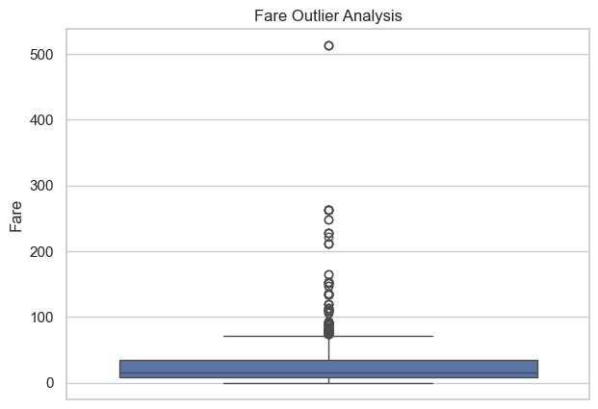

Observation
The fare variable contains several potential high-value outliers.
These values may represent passengers who paid considerably higher fares and should not automatically be removed without understanding their context.

27.1 IQR-Based Outlier Detection
The Interquartile Range (IQR) provides a statistical method for identifying potential outliers.
IQR = Q3 − Q1
Potential outlier boundaries are calculated as:
Lower Bound = Q1 − 1.5 × IQR
Upper Bound = Q3 + 1.5 × IQR
CODE CELL 82
Q1 = df_clean['fare'].quantile(0.25)
Q3 = df_clean['fare'].quantile(0.75)
IQR = Q3 - Q1
lower_bound = Q1 - 1.5 * IQR
upper_bound = Q3 + 1.5 * IQR
print("Q1:", Q1)
print("Q3:", Q3)
print("IQR:", IQR)
print("Lower Bound:", lower_bound)
print("Upper Bound:", upper_bound)

OUTPUT • CELL 82
Q1: 8.05
Q3: 34.197900000000004
IQR: 26.147900000000003
Lower Bound: -31.171850000000003
Upper Bound: 73.41975000000001

CODE CELL 83
fare_outliers = df_clean[
(df_clean['fare'] < lower_bound) |
(df_clean['fare'] > upper_bound)
]
print("Number of potential fare outliers:", len(fare_outliers))

OUTPUT • CELL 83
Number of potential fare outliers: 102

28. Final Data Quality Check
After completing the cleaning, transformation, and exploratory analysis, we perform a final validation of the working dataset.
We check:
- Dataset dimensions
- Remaining missing values
- Duplicate records
- Data types
- Newly created features
CODE CELL 85
print("Final dataset shape:", df_clean.shape)
print("Total missing values:", df_clean.isnull().sum().sum())
print("Total duplicate rows:", df_clean.duplicated().sum())

OUTPUT • CELL 85
Final dataset shape: (775, 15)
Total missing values: 2
Total duplicate rows: 0

CODE CELL 86
df_clean.info()

OUTPUT • CELL 86
<class 'pandas.core.frame.DataFrame'>
Index: 775 entries, 0 to 890
Data columns (total 15 columns):
# Column Non-Null Count Dtype
--- ------ -------------- -----
0 survived 775 non-null int64
1 pclass 775 non-null int64
2 sex 775 non-null object
3 age 775 non-null float64
4 sibsp 775 non-null int64
5 parch 775 non-null int64
6 fare 775 non-null float64
7 embarked 775 non-null object
8 class 775 non-null category
9 who 775 non-null object
10 adult_male 775 non-null bool
11 embark_town 773 non-null object
12 alive 775 non-null object
13 alone 775 non-null bool
14 family_size 775 non-null int64
dtypes: bool(2), category(1), float64(2), int64(5), object(5)
memory usage: 81.1+ KB

29. Key Findings
The exploratory analysis of the Titanic dataset produced several important findings:
- The dataset contains both numerical and categorical variables.
- Missing values were identified in several columns and were handled using appropriate techniques.
- The overall number of passengers who did not survive was higher than the number of passengers who survived.
- Survival outcomes differed considerably between male and female passengers.
- Passenger class showed noticeable differences in survival outcomes, with first-class passengers generally having better survival outcomes.
- Passenger fares were strongly right-skewed, with several potential high-value outliers.
- Passenger class and fare showed a noticeable relationship.
- The newly created `family_size` feature allowed us to investigate the relationship between family travelling patterns and survival.
- The correlation heatmap provided an overview of relationships between numerical variables.
- Box plots and IQR analysis helped identify potential outliers in numerical variables.

30. Conclusion
Exploratory Data Analysis was performed on the Titanic dataset using Python, Pandas, Matplotlib, and Seaborn.
The analysis began with understanding the structure, size, columns, data types, and statistical characteristics of the dataset. Missing values and duplicate records were then identified and handled using appropriate data-cleaning techniques.
Several visualizations were created to understand passenger survival, gender, passenger class, age, fare, embarkation port, and family size. Relationship analysis and correlation analysis were also performed to identify associations between numerical variables.
A new `family_size` feature was created from existing variables to provide an additional perspective on passenger travel patterns. Outlier analysis was performed using box plots and the Interquartile Range method.
Overall, the EDA process helped transform the raw dataset into meaningful information and provided a better understanding of the patterns, relationships, distributions, and anomalies present in the Titanic dataset.

31. Project Summary

Dataset
Titanic Dataset

Programming Language
Python

Libraries Used
- Pandas
- NumPy
- Matplotlib
- Seaborn

Analysis Performed
- Initial data exploration
- Statistical analysis
- Missing value analysis
- Missing value treatment
- Duplicate analysis
- Categorical analysis
- Numerical analysis
- Feature transformation
- Survival analysis
- Relationship analysis
- Correlation analysis
- Outlier detection

Visualizations Created
- Survival distribution
- Survival by gender
- Survival by passenger class
- Age distribution
- Fare distribution
- Fare by passenger class
- Age by survival
- Survival by embarkation port
- Family size distribution
- Family size vs survival
- Correlation heatmap
- Age boxplot
- Fare boxplot

Final Outcome
The project demonstrates how Exploratory Data Analysis can be used to inspect, clean, visualize, and interpret a real-world dataset before applying further statistical or machine-learning techniques.

32. Final Project Validation
Before submitting the project, the final dataset and analysis are validated to ensure that the required EDA steps have been completed successfully.
CODE CELL 91
print("Final Dataset Shape:", df_clean.shape)
print("Total Missing Values:", df_clean.isnull().sum().sum())
print("Total Duplicate Rows:", df_clean.duplicated().sum())

OUTPUT • CELL 91
Final Dataset Shape: (775, 15)
Total Missing Values: 2
Total Duplicate Rows: 0

CODE CELL 92
df_clean.head()

OUTPUT • CELL 92
survived pclass sex age sibsp parch fare embarked class \
0 0 3 male 22.0 1 0 7.2500 S Third
1 1 1 female 38.0 1 0 71.2833 C First
2 1 3 female 26.0 0 0 7.9250 S Third
3 1 1 female 35.0 1 0 53.1000 S First
4 0 3 male 35.0 0 0 8.0500 S Third
who adult_male embark_town alive alone family_size
0 man True Southampton no False 2
1 woman False Cherbourg yes False 2
2 woman False Southampton yes True 1
3 woman False Southampton yes False 2
4 man True Southampton no True 1

33. Overall Conclusion
This project successfully performed Exploratory Data Analysis and Visualization on the Titanic dataset.
The analysis included initial dataset exploration, descriptive statistics, missing-value analysis, data cleaning, duplicate checking, categorical and numerical analysis, feature transformation, visualization, correlation analysis, and outlier detection.
Multiple visualizations were used to identify important patterns and relationships within the dataset. The analysis also demonstrated how data-cleaning and feature-transformation techniques can improve the quality and usefulness of a dataset for further analysis.
The results obtained from this EDA provide a clear understanding of the major characteristics and patterns present in the Titanic dataset and provide a foundation for further machine-learning analysis.

Submission Note
This DOCX is the presentation-ready report version of the Jupyter Notebook. The original .ipynb file should also be submitted because it is the executable source that can be inspected and evaluated for the technical implementation.

