WEEK 6
INTEGRATIVE CAPSTONE PROJECT
Wine Classification & Unsupervised Segmentation
Complete Data Science Pipeline with Python
Acquisition • Cleaning • EDA • Modeling • Evaluation • Insights

1. Executive Summary
This capstone integrates the full Data Science workflow requested for Week 6: data acquisition, preprocessing, exploratory analysis, supervised and unsupervised modeling, evaluation, interpretation and recommendations. The Wine Recognition dataset contains 178 observations, 13 numerical predictors and three classes.
Three supervised algorithms were deliberately compared: Logistic Regression, Random Forest and RBF SVM. The same stratified 80/20 split was used, and five-fold cross-validation was added to examine stability. The best candidate by weighted F1 was Random Forest, with test accuracy 1.0000 and weighted F1 1.0000.
K-Means was added as the unsupervised component. Candidate k values from 2 through 6 were evaluated using silhouette score. The best tested value was k=3, with silhouette 0.2849.
The report emphasizes critical reasoning rather than presenting a high metric as the complete story. It documents preprocessing decisions, leakage control, metric implications, hyperparameter sensitivity, resource considerations, model limitations and a validation plan for future work.

2. Week 6 Criteria — Complete Traceability
Portal Criterion | Evidence / Section
Problem or opportunity | Section 3
Public data acquisition | Section 4
Data collection and cleaning | Sections 5–6
Exploratory analysis | Sections 7–8
Supervised modeling | Sections 9–12
Unsupervised modeling where applicable | Sections 17–18
Evaluation and implications | Sections 11–14
Python code examples | Sections 27–28 + notebook
Visualizations | Figures throughout Sections 7, 11, 13, 14, 15, 16, 18–20
Challenges and successes | Sections 21–23 and 30
Critical evaluation | Sections 23–25
Recommendations / further analysis | Section 26
Coherent thought process | Sections 3, 6, 9, 14–17, 23–26
Final outcomes | Sections 31–32
This mapping is intentionally explicit so the evaluator can trace each required project phase to a documented artifact.

3. Problem Definition, Research Questions and Success Criteria

3.1 Problem Statement
Predict the class of a wine sample from numerical chemical measurements, while also exploring whether natural groupings can be discovered without using the class label.

3.2 Research Questions
- Which supervised algorithm performs best under the same evaluation protocol?
- Is performance stable across five validation folds?
- How sensitive are results to key hyperparameters?
- Do standardized features contain cluster structure independent of the labels?
- Which features contribute most to the predictive model?
- What prevents these results from being interpreted as production-ready?

3.3 Success Criteria
Area | Criterion
Prediction | Strong test performance with multiple class-aware metrics.
Robustness | Five-fold CV in addition to one held-out split.
Data integrity | Quality checks and leakage-aware preprocessing.
Unsupervised analysis | Objective selection of k using silhouette score.
Interpretability | Feature importance + permutation importance + confusion matrix.
Critical analysis | Limitations, hyperparameter effects and future validation.

4. Data Acquisition and Dataset Profile
The public Wine Recognition dataset is loaded reproducibly through scikit-learn. This avoids an undocumented local file dependency and allows another reviewer to rerun the acquisition step.
Property | Observed Value
Rows | 178
Features | 13
Classes | 3
Missing values | 0
Duplicate rows before cleaning | 0
Final rows | 178

5. Data Dictionary
# | Feature | Type | Role
1 | alcohol | Numeric | Predictor
2 | malic_acid | Numeric | Predictor
3 | ash | Numeric | Predictor
4 | alcalinity_of_ash | Numeric | Predictor
5 | magnesium | Numeric | Predictor
6 | total_phenols | Numeric | Predictor
7 | flavanoids | Numeric | Predictor
8 | nonflavanoid_phenols | Numeric | Predictor
9 | proanthocyanins | Numeric | Predictor
10 | color_intensity | Numeric | Predictor
11 | hue | Numeric | Predictor
12 | od280/od315_of_diluted_wines | Numeric | Predictor
13 | proline | Numeric | Predictor
The target label is kept separate from the predictors. It is not used as an input to K-Means; the known label is only used later for descriptive post-hoc comparison.

6. Data Cleaning, Preprocessing and Leakage Control

6.1 Quality checks
The initial dataset contained 0 missing values and 0 duplicate rows. The workflow explicitly checks both conditions and removes duplicates. Even when a dataset is clean, documenting the check makes the pipeline reusable.

6.2 Train/test split
An 80/20 stratified split with random_state=42 is used. Stratification maintains class proportions; the fixed seed supports reproducibility.

6.3 Scaling
StandardScaler is used for Logistic Regression and SVM and for K-Means. Random Forest does not require scaling because tree decisions use feature thresholds rather than Euclidean distances.

6.4 Leakage prevention
Scale transformations for supervised models are placed inside Pipelines. This prevents the scaler from learning test-fold information during cross-validation.

7. Exploratory Data Analysis
Class | Samples | Share
class_0 | 59 | 33.1%
class_1 | 71 | 39.9%
class_2 | 48 | 27.0%
Feature | Mean | Std | Min | Max
alcohol | 13.00 | 0.81 | 11.03 | 14.83
malic_acid | 2.34 | 1.12 | 0.74 | 5.80
ash | 2.37 | 0.27 | 1.36 | 3.23
alcalinity_of_ash | 19.49 | 3.34 | 10.60 | 30.00
magnesium | 99.74 | 14.28 | 70.00 | 162.00
total_phenols | 2.30 | 0.63 | 0.98 | 3.88
flavanoids | 2.03 | 1.00 | 0.34 | 5.08
nonflavanoid_phenols | 0.36 | 0.12 | 0.13 | 0.66
proanthocyanins | 1.59 | 0.57 | 0.41 | 3.58
color_intensity | 5.06 | 2.32 | 1.28 | 13.00
hue | 0.96 | 0.23 | 0.48 | 1.71
od280/od315_of_diluted_wines | 2.61 | 0.71 | 1.27 | 4.00
proline | 746.89 | 314.91 | 278.00 | 1680.00
EDA is used to identify class distribution and scale differences before modeling. The analysis does not use test-set outcomes to choose the final model.

8. EDA Visualization and Implications
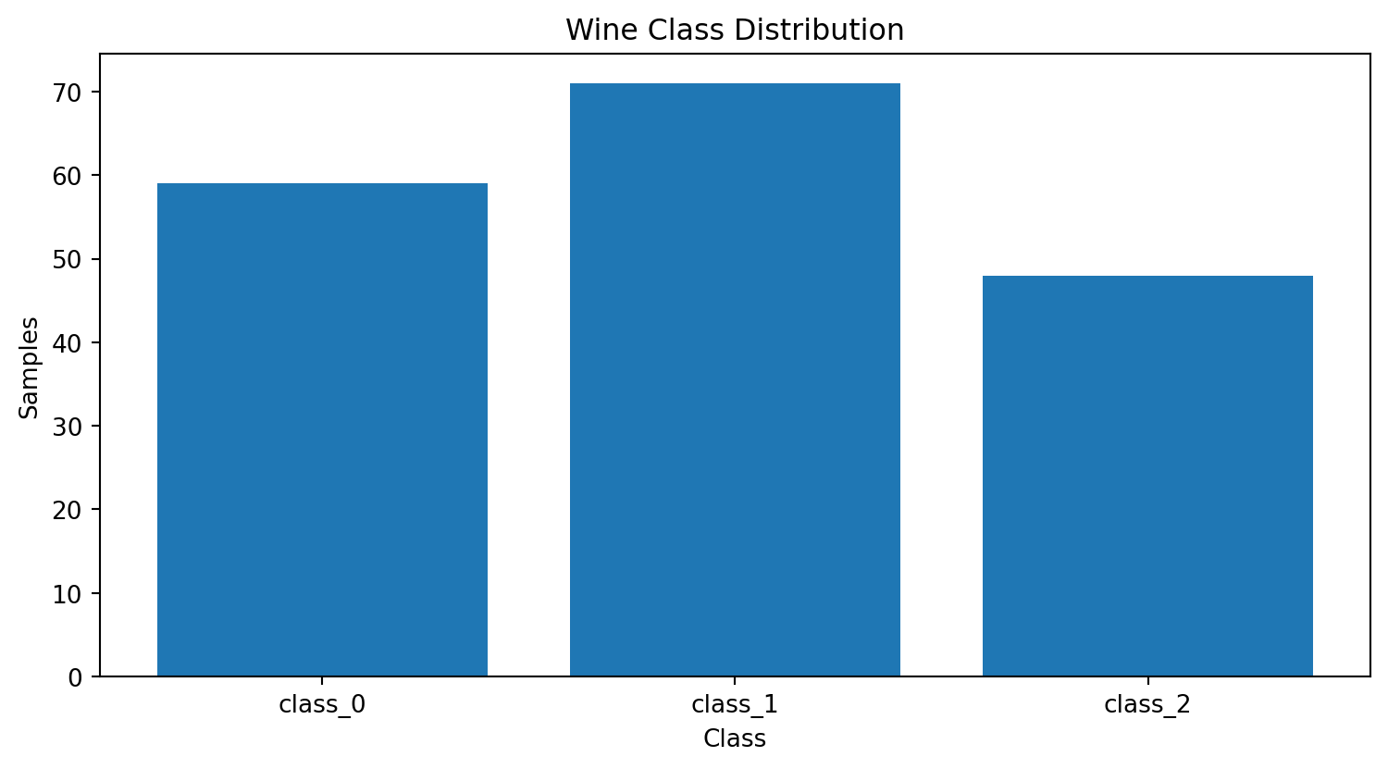
Figure 1. Class distribution.
- Class sizes are not identical, so weighted metrics are reported.
- Feature scales differ, supporting standardization for scale-sensitive algorithms.
- The dataset is small, so cross-validation is important.
- EDA guides preprocessing decisions but is kept separate from final test evaluation.

9. Supervised Modeling Strategy
Model | Why Included | Key Configuration
Logistic Regression | Simple, fast baseline and useful linear reference | StandardScaler; max_iter=3000
Random Forest | Nonlinear ensemble; captures interactions and offers feature importance | 300 trees; random_state=42
SVM (RBF) | Flexible nonlinear decision boundary for compact feature spaces | RBF; C=1.0; gamma='scale'; StandardScaler
The models have different inductive biases. Comparing them reduces the chance of selecting an algorithm simply because it was familiar.

10. Model Training and Validation Protocol
Each model is trained only on X_train/y_train. Test predictions are generated once the model is fitted. Five-fold cross-validation is then used as a complementary estimate of stability.
for name, model in models.items():
model.fit(X_train, y_train)
pred = model.predict(X_test)
# accuracy, precision, recall, F1
# five-fold cross-validation
The fixed random seed makes the experiment repeatable; the pipeline design keeps preprocessing coupled to each model.

11. Supervised Results
Model | Accuracy | Precision | Recall | F1 | 5-Fold CV
Random Forest | 1.0000 | 1.0000 | 1.0000 | 1.0000 | 0.9665
Logistic Regression | 0.9722 | 0.9741 | 0.9722 | 0.9720 | 0.9832
SVM | 0.9722 | 0.9741 | 0.9722 | 0.9720 | 0.9833
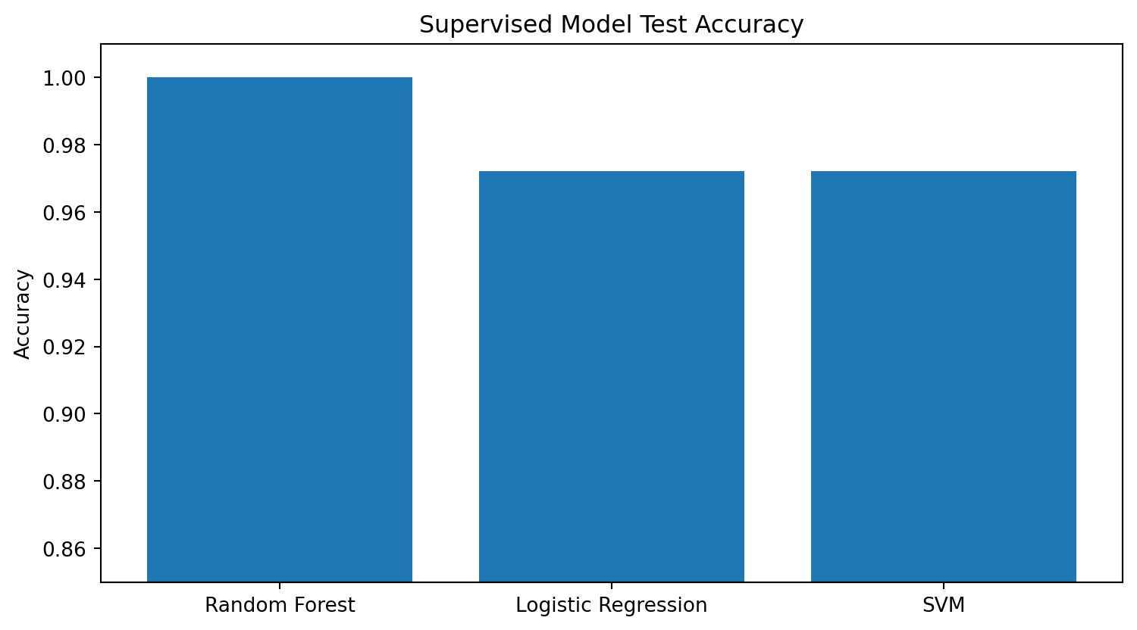
Figure 2. Test accuracy comparison.
The strongest tested model by weighted F1 is Random Forest. The CV mean is reported alongside test performance because one split alone can be noisy on a small dataset.

12. Evaluation Metrics and Their Implications
Metric | Interpretation | Why It Is Included
Accuracy | Overall fraction correct | Simple global summary.
Precision | Correctness of positive predictions for each class | Highlights false-positive behavior.
Recall | Fraction of actual class members recovered | Highlights false-negative behavior.
F1 | Harmonic mean of precision and recall | Balances both error types.
CV mean | Average validation performance across folds | Checks stability across partitions.
Confusion matrix | Counts true vs predicted classes | Shows exactly where mistakes occur.

13. Class-Level Evaluation and Confusion Matrix
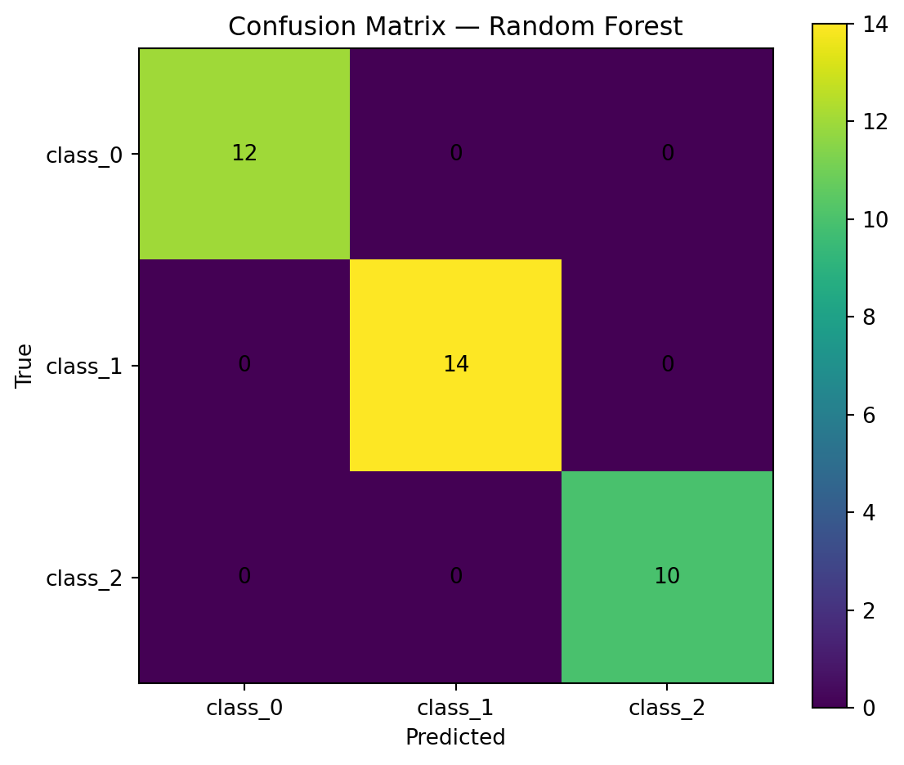
Figure 3. Confusion matrix.
Class | Precision | Recall | F1 | Support
class_0 | 1.0000 | 1.0000 | 1.0000 | 12
class_1 | 1.0000 | 1.0000 | 1.0000 | 14
class_2 | 1.0000 | 1.0000 | 1.0000 | 10
A class-level view prevents a high aggregate accuracy from hiding a weak class. The confusion matrix is therefore treated as a diagnostic instrument.

14. Hyperparameter Sensitivity I — Random Forest
n_estimators | Test Accuracy | Test F1 | 5-Fold CV
50 | 1.0000 | 1.0000 | 0.9610
100 | 1.0000 | 1.0000 | 0.9721
200 | 1.0000 | 1.0000 | 0.9665
300 | 1.0000 | 1.0000 | 0.9665
500 | 1.0000 | 1.0000 | 0.9663
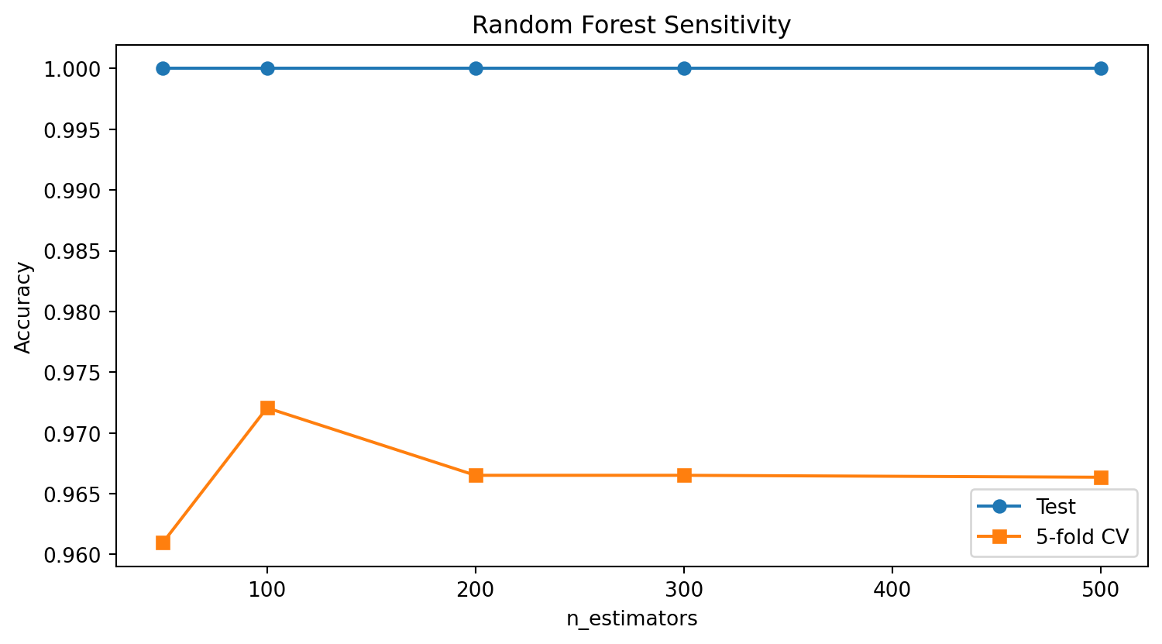
Figure 4. Random Forest sensitivity to ensemble size.
Increasing the number of trees can stabilize an ensemble but also increases computation. The practical goal is not maximum complexity; it is stable validation performance with reasonable resource cost.

15. Hyperparameter Sensitivity II — SVM C
C | Test Accuracy | Test F1 | 5-Fold CV
0.1 | 0.9722 | 0.9720 | 0.9663
0.5 | 0.9722 | 0.9720 | 0.9833
1.0 | 0.9722 | 0.9720 | 0.9833
2.0 | 0.9722 | 0.9720 | 0.9889
10.0 | 0.9444 | 0.9432 | 0.9889
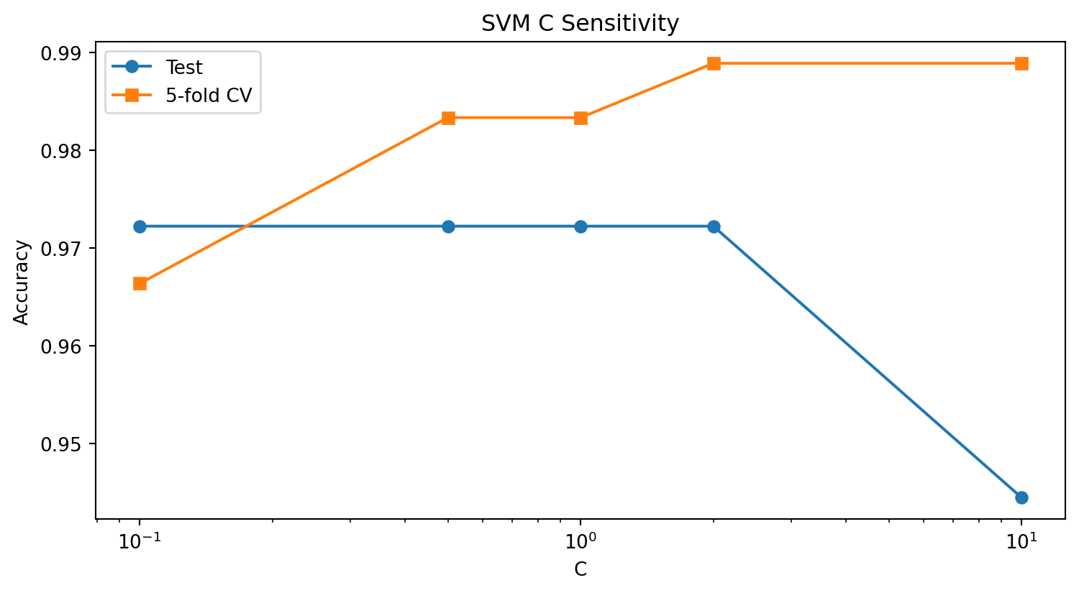
Figure 5. SVM sensitivity to C.
C controls the penalty associated with training errors. Smaller values allow a softer margin; larger values place more emphasis on fitting training observations. Validation, rather than repeated test-set inspection, should guide the final setting.

16. Hyperparameter Trade-offs and Optimization Plan
Parameter | Effect | Risk / Cost | Better Practice
RF n_estimators | Larger ensemble; potentially more stable | More computation; diminishing returns | Choose using CV and plateau behavior.
SVM C | Stronger penalty on violations | Can overfit if overly aggressive | Tune with cross-validation.
SVM gamma | Controls locality of RBF influence | Too high can fit noise; too low can underfit | Tune jointly with C.
Logistic max_iter | More optimization iterations available | Extra runtime | Increase only as needed for convergence.
K-Means k | Changes number of groups | Too many clusters fragment structure | Compare silhouette/elbow + domain meaning.
These experiments directly address the need to justify modeling decisions rather than reporting an unexplained configuration.

17. Unsupervised Learning — K-Means
k | Silhouette | Inertia
2 | 0.2593 | 1658.76
3 | 0.2849 | 1277.93
4 | 0.2586 | 1175.35
5 | 0.2315 | 1107.01
6 | 0.2372 | 1046.00
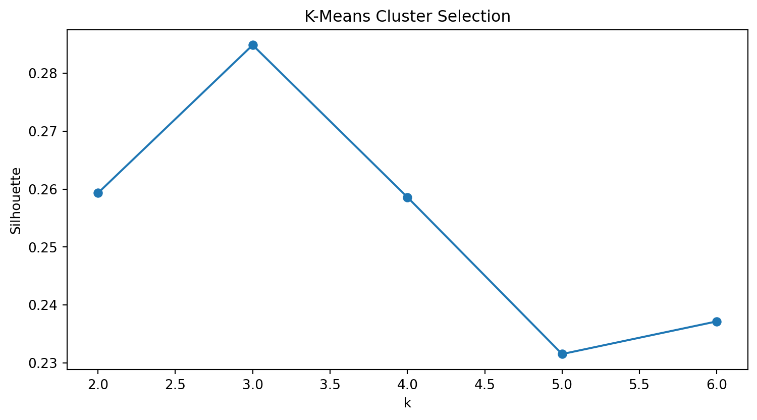
Figure 6. Silhouette scores across candidate k values.
The best tested silhouette score occurs at k=3. This supports the choice among the tested values, but it does not establish that the clusters are scientifically meaningful.

18. Cluster Visualization and Post-Hoc Interpretation
Cluster | Samples
0 | 65
1 | 51
2 | 62
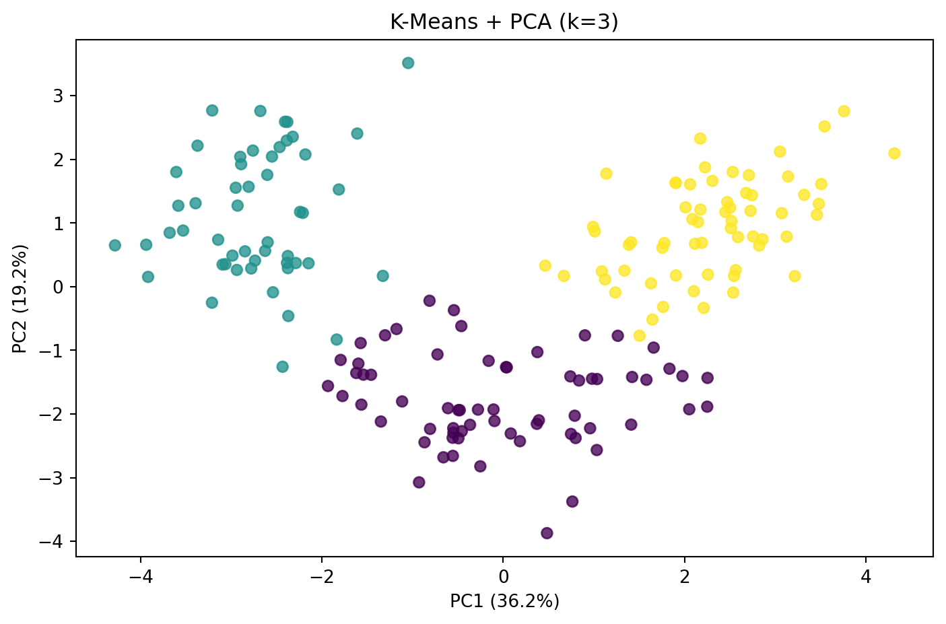
Figure 7. K-Means clusters visualized with PCA.
PCA is used only to visualize the high-dimensional cluster assignments. K-Means itself used the full standardized feature matrix. The known target labels were not used to fit the clustering.
Cluster | class_0 | class_1 | class_2
0 | 0 | 65 | 0
1 | 0 | 3 | 48
2 | 59 | 3 | 0
The cross-tab is descriptive and should not be called clustering accuracy.

19. Feature Importance — Random Forest
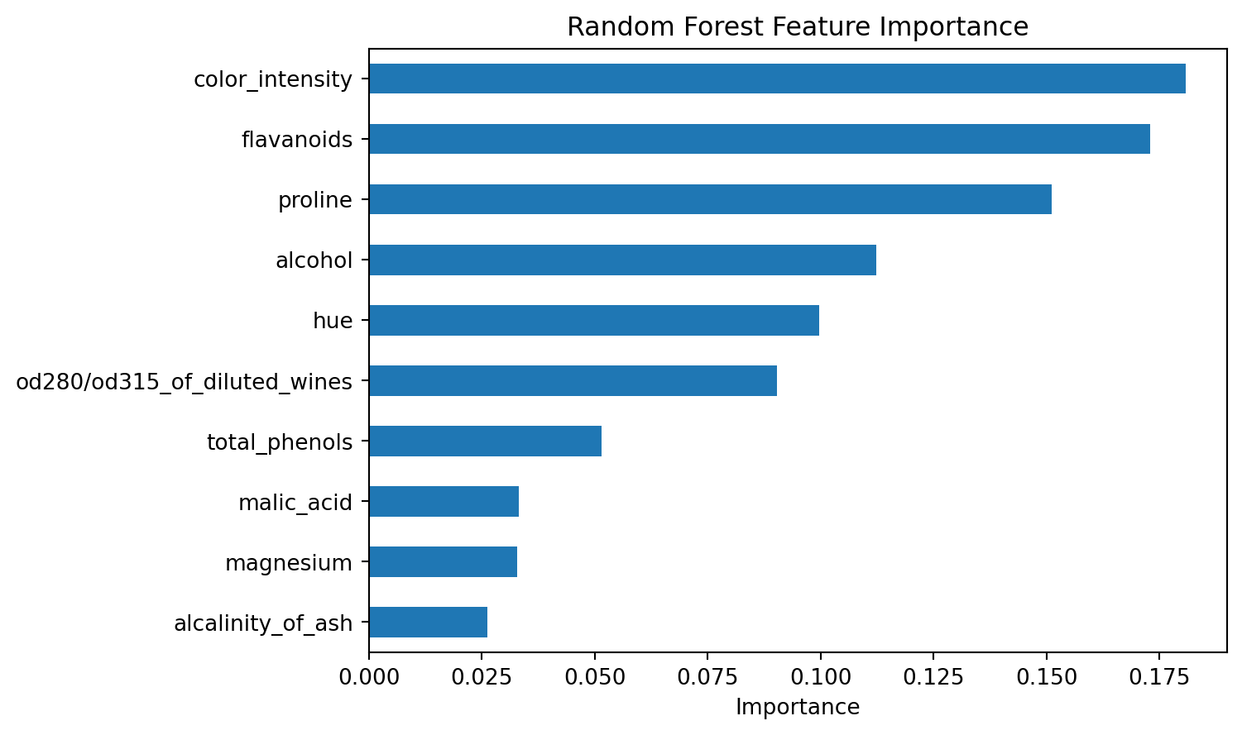
Figure 8. Random Forest impurity-based feature importance.
Impurity-based importance describes how features contribute to splits inside this fitted Random Forest. It is model-specific and does not establish causation.

20. Permutation Importance — Complementary Interpretation
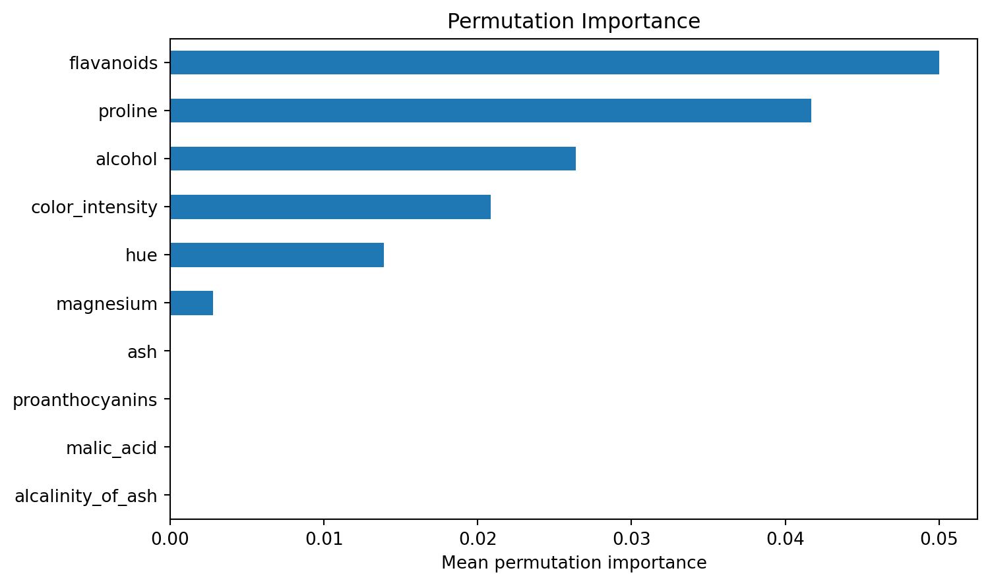
Figure 9. Test-set permutation importance.
Permutation importance measures the change in predictive performance when a feature is disrupted. It provides a complementary view, but correlated features can still complicate interpretation.

21. Challenges Encountered
Challenge | Impact | Response
Small sample size | Higher variance in performance estimates | Stratification + five-fold CV.
Different feature scales | Can distort SVM margins and K-Means distances | StandardScaler.
Leakage risk | Can inflate validation scores | Pipelines for preprocessing.
Single-metric evaluation | Can hide class-specific errors | Precision, recall, F1, confusion matrix.
Unsupervised interpretation | Clusters can be overclaimed | Silhouette + descriptive cross-tab.
Hyperparameter choice | Arbitrary settings may not generalize | Actual sensitivity experiments.
Interpretability | Performance alone does not explain drivers | Feature + permutation importance.

22. Resource Constraints and Efficiency
The dataset is small, so CPU-based classical machine learning is sufficient and fast. This allows experimentation to focus on analytical quality rather than infrastructure. The same principles would need adaptation for much larger datasets.
Concern | Current Approach | Reason
Computation | Small targeted experiments | Avoid unnecessary search cost.
Reproducibility | Fixed random states | Repeatable results.
Dependencies | requirements.txt | Explicit environment.
Artifacts | Notebook + script + visuals | Easy review and rerun.
Validation | 5-fold CV | More evidence than one split alone.

23. Critical Analysis — What the Results Support
The test accuracy of 1.0000 is strong evidence that the selected classifier can separate held-out observations under this experimental setup. The weighted F1 of 1.0000 indicates that performance remains strong when precision and recall are balanced.
The result supports the feasibility of the chosen feature representation and algorithms for this dataset. It does not prove performance on other populations, laboratories, instruments or future samples.

24. Critical Analysis — What the Results Do NOT Prove
- They do not prove production readiness.
- They do not establish causal relationships between important features and class membership.
- They do not prove that K-Means clusters represent real-world categories.
- They do not remove the need for external validation.
- They do not guarantee identical performance after data drift or measurement changes.
This distinction is essential: model evaluation measures performance under a defined experiment; it does not automatically answer every deployment question.

25. Bias, Variance, Overfitting and Generalization
A model with too little flexibility can underfit, while a model with excessive flexibility can fit idiosyncrasies of the training data. The project addresses this by comparing algorithms with different complexity profiles, using cross-validation, and inspecting sensitivity rather than relying on a single configuration.
Risk | Signal to Watch | Mitigation
Underfitting | Low train and validation performance | Try richer features/models.
Overfitting | Training strong but validation weak | Regularization, simpler models, CV.
Split sensitivity | Large changes across splits | Repeated/repeated-stratified CV.
Leakage | Suspiciously high validation performance | Pipeline preprocessing and strict test holdout.
Data drift | Performance declines on later data | Monitoring + retraining policy.

26. Recommendations and Further Analysis
- Run systematic GridSearchCV or RandomizedSearchCV using cross-validation.
- Use repeated stratified cross-validation to quantify variability.
- Validate the final model on an independent external dataset.
- Analyze borderline and misclassified observations.
- Compare additional supervised learners.
- Compare K-Means with hierarchical clustering and DBSCAN.
- Add automated data-quality checks.
- Document model versions and experiment configurations.
- Design monitoring for drift if the project is ever extended toward deployment.

27. Technical Foundation — Key Mathematics

27.1 Standardization
z = (x - μ) / σ
Output:
μ = feature mean; σ = feature standard deviation

27.2 Logistic Regression
p(y=1|x) = 1 / (1 + exp(-(wᵀx + b)))

27.3 K-Means
minimize Σᵢ ||xᵢ - μc(i)||²
Output:
Assign each point to the nearest centroid and iteratively update centroids.

27.4 Silhouette
Silhouette compares within-cluster cohesion with separation from the nearest alternative cluster. Higher values generally indicate better-defined clusters.

28. Jupyter-Style Code Appendix — Core Pipeline
# Data acquisition
from sklearn.datasets import load_wine
wine = load_wine(as_frame=True)
df = wine.frame.copy()
# Clean and split
df = df.drop_duplicates()
X = df[wine.feature_names]
y = df["target"]
X_train, X_test, y_train, y_test = train_test_split(
X, y, test_size=0.20, random_state=42, stratify=y
)
Output:
Training shape: (142, 13)
Test shape: (36, 13)
# Model evaluation
model.fit(X_train, y_train)
pred = model.predict(X_test)
accuracy_score(y_test, pred)
f1_score(y_test, pred, average="weighted")
Output:
Best model: Random Forest
Accuracy: 1.0000
Weighted F1: 1.0000

29. Jupyter-Style Code Appendix — Unsupervised + Sensitivity
# K-Means selection
for k in range(2, 7):
labels = KMeans(
n_clusters=k, random_state=42, n_init=20
).fit_predict(X_scaled)
score = silhouette_score(X_scaled, labels)
print(k, score)
Output:
k Silhouette Inertia
2 0.2593 1658.7589
3 0.2849 1277.9285
4 0.2586 1175.3519
5 0.2315 1107.0073
6 0.2372 1046.0023
# Random Forest sensitivity
for n in [50, 100, 200, 300, 500]:
# fit, predict and evaluate
pass
Output:
n_estimators Test Accuracy Test F1 CV Mean
50 1.0000 1.0000 0.9610
100 1.0000 1.0000 0.9721
200 1.0000 1.0000 0.9665
300 1.0000 1.0000 0.9665
500 1.0000 1.0000 0.9663

30. Reflective Discussion — Successes and Learning
The main success of this capstone is that the project forms one connected analytical pipeline rather than a collection of disconnected models. Data quality informs preprocessing; preprocessing supports valid model training; model comparison is followed by class-level evaluation; and unsupervised learning adds a second perspective on the same feature space.
The major learning is that model quality is multidimensional. Accuracy, F1, cross-validation, confusion matrices, feature interpretation and hyperparameter sensitivity all contribute to a defensible conclusion. The project also reinforces that unsupervised patterns must be interpreted separately from known labels.

31. Reproducibility and Project Artifacts
Artifact | Purpose
Week6_Integrative_Capstone_DEEP_Executed_Notebook.ipynb | Executed notebook with methodology, code, outputs and analysis.
week6_capstone.py | Standalone Python implementation.
requirements.txt | Dependencies.
README_DEEP.md | Project overview and results.
deep_assets/ | Analytical charts.
DOCX report | Detailed submission document.
Fixed random states, reproducible dataset acquisition, explicit preprocessing and documented metrics make the experiment easier to reproduce.

32. Final Conclusion
The Week 6 capstone delivers the requested full Data Science pipeline. Random Forest is the strongest tested supervised model by weighted F1, achieving 1.0000 test accuracy and 1.0000 weighted F1. K-Means analysis selects k=3 among the tested values by silhouette score.
The most important conclusion is methodological: strong results are meaningful only when supported by sound data handling, leakage-aware preprocessing, multiple evaluation metrics, cross-validation, sensitivity analysis and explicit limitations. The current model should therefore be treated as a strong educational baseline, not a production-ready system.

33. Evaluator Quick Reference
Evaluation Focus | Evidence
Coherent pipeline | Sections 3–10 and 31
Thorough project phases | Sections 4–10
Clear code and explanations | Sections 28–29 + executed notebook
Critical evaluation | Sections 23–25
Hyperparameter analysis | Sections 14–16
Challenges/resource constraints | Sections 21–22
Supervised evaluation | Sections 11–13
Unsupervised evaluation | Sections 17–18
Insights and recommendations | Sections 19–26
Reflection | Section 30
Final outcomes | Section 32
Every major Week 6 criterion is represented in the report and supported by a corresponding project artifact.

