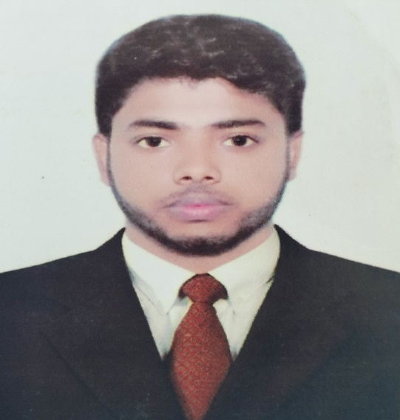

Motivated IT student with strong knowledge of data structures, algorithms and object-oriented programming (OOP). Excellent communicator and team player, eager to apply technical skills and contribute to innovative projects. with strong knowledge of data structures, algorithms and object-oriented programming (OOP). Excellent communicator and team player, eager to apply technical skills and contribute to innovative projects.contribute to innovative projects.-oriented programming (OOP). Excellent communicator and team player, eager to apply technical skills and contribute to innovative projects.Motiva Motivated IT student with strong knowledge of data structures, algorithms and object-oriented programming (OOP). Excellent communicator and team player, eager to apply technical skills and contribute to innovative projectsted IT student with strong knowledge of data structures, algorithms and object-oriented programming (OOP). Excellent communicator and team player, eager to apply technical skills and contribute to innovative projects

PROFILE SUMMARY UMMARY

Sourov pal

EDUCATION

SSC: HOMLAND IDEAL SCHOOL (2017-2018).

GPA: 4.56/5.

HSC: NOBIGONJ GOVT COLLEGE (2019-2020).

GPA: 4.33/5.

BSC: METROPOLITAN UNIVERSITY in Computer Science and Engineering (2022- 2025).

* **Technologies Used :** Arduino, Ultrasonic Sensors, Servo Motors, LCD Display, Motors, C Programming
* Developed an Automatic Parking System using Arduino to automate the parking process in a limited space. The system uses ultrasonic sensors to detect available parking spaces and a servo motor to guide the car into the correct parking slot. The system provides real-time feedback through an LCD display

Automatic Parking System

* **Technologies Used** : HTML , CSS , Bootstrap , JavaScript , PHP , MySQL

Key Features:

* **User Management:** Login and registration system for both students and librarians.
* **Book Search & Borrowing:** Students can search for books by title, author, or genre, and borrow them for a specified period.
* **Overdue Book Tracking:** Automatic calculation of overdue books and fine collection.
* **Inventory Management:** Librarians can add, update, or remove books from the library's collection.

Digital Library Management System

PROJECTS

* TRAVELLING
* READING
* SPORTS

**TRAVELLING**

HOBBIES:

SkILLS:

* C/C++
* HTML,CSS
* Bootstrap
* JavaScript
* PHP
* Python
* JAVA
* React

CONTACT:

Phone: 01827498462

Email: [sourovpal070@gmail.com](mailto:sourovpal070@gmail.com)

Location: Bangladesh, Sylhet,

Shporan