Assignment Summary Document

Saptarshi Pal

# Problem Statement

To analyze the impact of COVID 19 lockdowns on the air quality index during the month of April 2021 near three air quality monitoring stations, namely Mandir Marg, Delhi – DPCC (77.201064323640779, 28.636429), Chandni Chowk, Delhi – IITM (77.227234, 28.656756) and Loni, Ghaziabad – UPPCB (77.278792, 28.757294), present in the Delhi, India region.

Delhi lockdown dates in 2021 from April 19 onwards

https://www.thehindu.com/news/cities/Delhi/delhi-lockdown-extended-till-may-31/article34625962.ece

# Solution Summary

Air quality index in a region can be dependent on multiple factors. Among them, forest cover, industries and highways are the factors which have been considered as driving factors. The assumptions behind the considerations are as follow.

1. Highways are directly linked to human mobility. Dense network of highways is linked with more pollution.
2. Industrial activity is often known to cause pollution in the nearby environment.
3. Forest covers are sinks which can soak in pollution.

The dataset collected is AQI data of the three regions mentioned in the problem statement from the CPCB platform. Apart from the ground data, Landsat 8 aerosol images is also collected during lockdown period (17th to 24th April) and a no lockdown period (1-9th April).

Lockdown Date: 2021-04-19 00:00:00

Locations Mean AQI

Mandir Marg, Delhi - DPCC=164.85

Chandni Chowk, Delhi - IITM=216.57142857142858

Loni, Ghaziabad - UPPCB=269.0

Mean AQI after full lockdown period started

Mandir Marg, Delhi - DPCC=183.1

Chandni Chowk, Delhi - IITM=172.0

Loni, Ghaziabad - UPPCB=271.9166666666667

Mean AQI before full lockdown period started

Mandir Marg, Delhi - DPCC=146.6

Chandni Chowk, Delhi - IITM=250.0

Loni, Ghaziabad - UPPCB=266.8125

Observations from the data

* The highest mean AQI is for the location of Loni, Ghaziabad region.
* The mean AQI of Mandir Marg and Loni is lower before the lockdown starts.
* The mean AQI of Chandni Chowk decreases significantly during the lockdown period.

The region of interest is a buffer of 0.02 degrees (approx. 2 km) is taken around the ground sensors. The assumption is that near things affect more than distant things. The highway, railway, industry and forest cover density in the region of interest is as follows.

Road Density Values

Mandir Marg, Delhi - DPCC=2.483152797382156

Road Density Values

Chandni Chowk, Delhi - IITM=2.266370100077988

Road Density Values

Loni, Ghaziabad - UPPCB=0.07730455236204287

Forest density

Mandir Marg, Delhi - DPCC=0.00024191357230874682

Forest density

Chandni Chowk, Delhi - IITM=3.0886444917354208e-06

Forest density

Loni, Ghaziabad - UPPCB=0.0

Industry density

Mandir Marg, Delhi - DPCC=2.64257285501008e-06

Industry density

Chandni Chowk, Delhi - IITM=0.0

Industry density

Loni, Ghaziabad - UPPCB=0.0

Observations from the above analysis

* Mandir Marg has the maximum highway and railway density in the region.
* Loni, Ghaziabad has the least highway and railway density in the region.
* Mandir Marg has the highest forest density cover.
* Loni Ghaziabad has the least forest density cover.
* Mandir Marg has highest density of industries among the other two regions.

Fire occurrence data has been collected from the FIRMS Nasa web portal also for the analysis of nearby fire events. The results are as follows.

During Lockdown Stages

Total number of firespots: 35

Min Distance of fires from Mandir Marg, Delhi - DPCC: 0.051342879966421756

Min Distance of fires from Chandni Chowk, Delhi - IITM: 0.019378902471530596

Min Distance of fires from Loni, Ghaziabad - UPPCB: 0.06484997939861163

During no lockdown Stages

Total number of firespots: 20

Min Distance of fires from Mandir Marg, Delhi - DPCC: 0.06584397077840266

Min Distance of fires from Chandni Chowk, Delhi - IITM: 0.033417587599974874

Min Distance of fires from Loni, Ghaziabad - UPPCB: 0.04566881651630366

Observations from the above data:

* Firespots are near to Chandni Chowk, Delhi - IITM station than others.
* Number of firespots during the lockdown is more than during no lockdown.

The analysis of the aerosol levels using the Landsat 8 Aerosol imagery gives the following results.

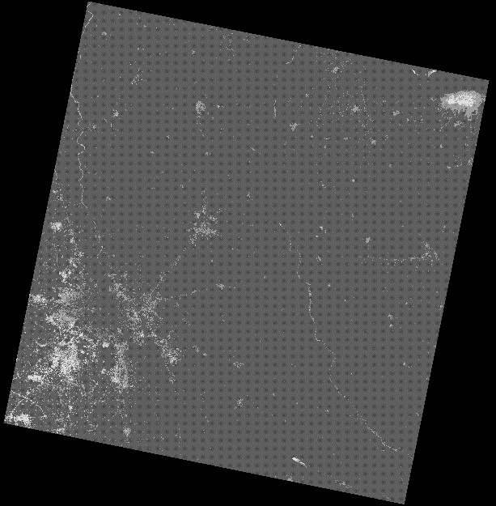

On the left, the image is dated between 01-09 April. On the right-hand side, the image is dated 17-24th April. The pearson correlation values between proximity and the aerosol levels are given as follows.

Aerosol Levels before lockdown

Mean aerosol level: 102.24962809858812

Aerosol-Proximity from Forests: 0.14268556434569138

Aerosol-Proximity from Highways: -0.07375337222317922

Aerosol-Proximity from Industries: 0.1001126599546994

Aerosol Levels after lockdown

Mean aerosol level: 196.16566732100327

Aerosol-Proximity from Forests: 0.03981260856901198

Aerosol-Proximity from Highways: 0.11509387417381903

Aerosol-Proximity from Industries: 0.03501992670922746

Observations

* Mean aerosol levels in the region are higher during the lockdown period.
* The pearson correlation between aerosol and proximity from forests is higher during no lockdown.
* The pearson correlation between aerosol and proximity from highways is negative during no lockdown.
* The pearson correlation between aerosol and proximity from highways is positive and higher during lockdown.

## Key Outcomes and Takeaways

Observations from the Data

* The highest mean AQI is for the location of Loni, Ghaziabad region.
* The mean AQI of Mandir Marg and Loni is lower before the lockdown starts.
* The mean AQI of Chandni Chowk decreases during the lockdown period.
* Mandir Marg has the maximum highway and railway density in the region.
* Loni, Ghaziabad has the least highway and railway density in the region.
* Mandir Marg has the highest forest density cover.
* Loni Ghaziabad has the least forest density cover.
* Mandir Marg has highest density of industries among the other two regions.
* Fire occurrences are near to Chandni Chowk, Delhi - IITM station than others.
* Number of fire occurrences during the lockdown is more than during no lockdown.
* Mean aerosol levels in the region are higher during the lockdown period.
* The pearson correlation between aerosol and proximity from forests is higher during no lockdown.
* The pearson correlation between aerosol and proximity from highways is negative during no lockdown.
* The pearson correlation between aerosol and proximity from highways is positive and higher during lockdown.

Based on the above observations, we might derive the following takeaways.

* With increase in the number of fire occurrences, the Mean aerosol levels can rise.
* With increase in distance from forest cover, the aerosol levels also increase.
* Even when there is limited mobility, the aerosol levels can be higher because of nearby fires and absence of forest cover.

## Geospatial Data

Both raster as well as vector data have been used for the project. List of such data sources are as follows.

* Landsat 8 aerosol raster data.
* Open street maps features.
* FIRMS fire occurrences.
* CPCB air quality data.

## Improvements in methodology

* Spatial autocorrelation can be studied for the variables.
* Clustering algorithms might be used to study the satellite data.
* Time series data for a longer period of time could be used.