**3.5 Data Dictionary**

|  |  |  |  |  |  |
| --- | --- | --- | --- | --- | --- |
| **Table:User Profile** |  | | | | |
| **Name** | **Data Type** | **Nullable** | **Primary Key** | **Foreign Key** | **Default** |
| id | BIGINT (20) | No | Yes | No | None |
| name | VARCHAR (100) | No | No | No | None |
| email | VARCHAR (254) | Yes | Yes | No | None |
| user type | VARCHAR (20) | No | No | No | None |
| password | VARCHAR (100) | Yes | No | No | NULL |
| username | VARCHAR (100) | Yes | Yes | No | NULL |
| Language preference | VARCHAR (30) | No | No | No | None |

|  |  |  |  |  |  |
| --- | --- | --- | --- | --- | --- |
| **Table: Collaborator** |  |  |  |  |  |
| **Name** | **Data Type** | **Nullable** | **Primary Key** | **Foreign Key** | **Default** |
| id | BIGINT (20) | No | Yes | No | None |
| first\_name | VARCHAR (50) | No | No | No | None |
| last\_name | VARCHAR (50) | No | No | No | None |
| email | VARCHAR (254) | No | No | No | None |
| role | VARCHAR (50) | No | No | No | NULL |

|  |  |  |  |  |  |
| --- | --- | --- | --- | --- | --- |
| **Table:Password Token** |  |  |  |  |  |
| **Name** | **Data Type** | **Nullable** | **Primary Key** | **Foreign Key** | **Default** |
| id | BIGINT (20) | No | Yes | No | None |
| email | VARCHAR (30) | No | No | No | None |
| otp | VARCHAR (8) | No | No | No | None |
| timestamp | DATETIME (6) | No | No | No | None |

|  |  |  |  |  |  |
| --- | --- | --- | --- | --- | --- |
| **Table: repository** | |  |  |  |  |
| **Name** | **Data Type** | **Nullable** | **Primary Key** | **Foreign Key** | **Default** |
| id | BIGINT (20) | No | Yes | No | None |
| name | VARCHAR (100) | No | No | No | None |
| description | longtext | No | No | No | None |
| created\_at | date | No | No | No | None |
| last\_updated\_at | date | No | No | No | None |
| owner\_id | int(11) | No | Yes | No | None |

|  |  |  |  |  |  |  |  |  |  |
| --- | --- | --- | --- | --- | --- | --- | --- | --- | --- |
| **Table: task** |  |  |  | |  | | |  |  |
| **Name** | **Data Type** | **Nullable** | **Primary Key** | **Foreign Key** | | **Default** | | | **Status** |
| id | BIGINT(20) | No | Yes | No | | | None | | 1 |
| title | VARCHAR(200) | No | No | No | | | None | | Python |
| description | LONGTEXT | No | No | No | | | None | | Do it well |
| created\_at | DATE | No | No | No | | | None | | 25/10/2024 |
| updated\_at | DATE | No | No | No | | | None | | 26/10/2024 |
| assign\_to | VARCHAR (100) | No | Yes | No | | | None | | Om |
| status | VARCHAR(200) | No | No | No | | | None | | Completed |

**4.Development**

**4.1 Screenshots**

**1.Index Page**

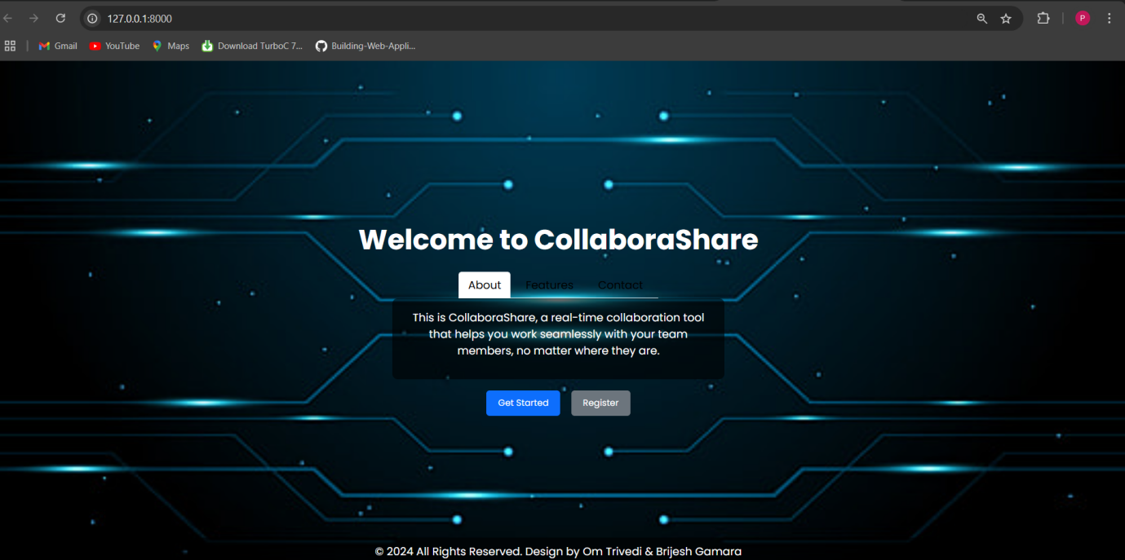

1. **RegistrationPage**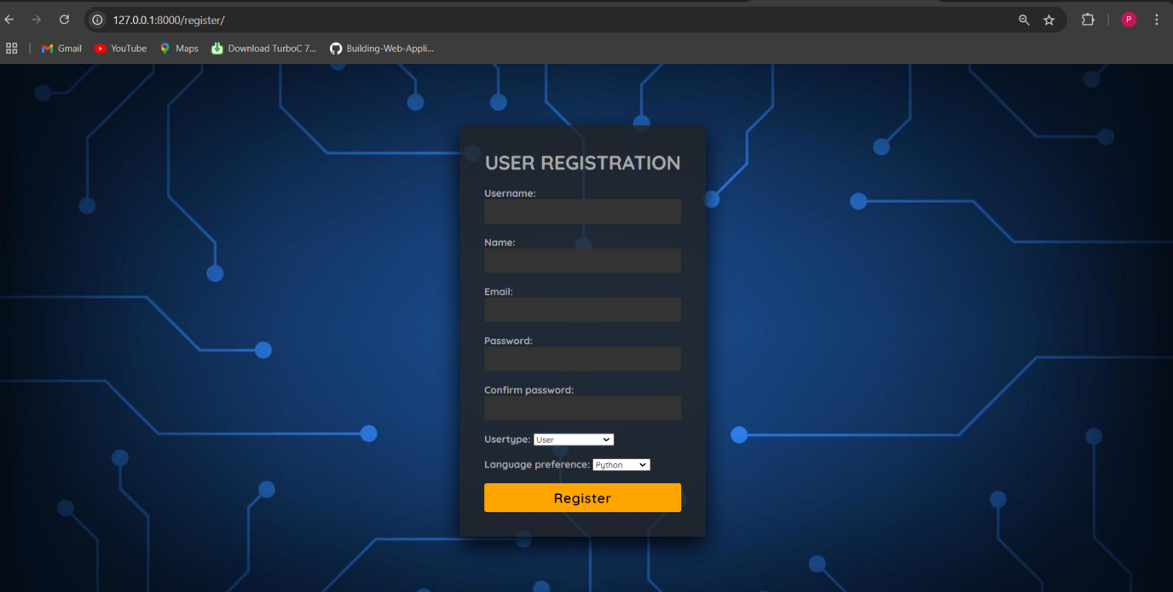

**5.4 User Story**

|  |  |  |  |
| --- | --- | --- | --- |
| **USER STORY ID** | AS A<type of User> | I Want To<perform some task> | So That I Can<achieve some goal> |
| 1 | Admin | Create an account | Login and Access The Collobration |
| 2 | Admin | view a status report from each team member | Ensure the project stays on track |
| 3 | Project Manager | Assign a task to end user | They can complete the task |
| 4 | User | Login | I can use the system as existing user |
| 5 | Admin | Manage Collaborator | I can control the user task and account activities |
| 6 | Project Manager | Manage Tools | I can control the user task and activities of task |
| 7 | User | Manage Profile | I can edit my profile account & review profile |
| 8 | Admin | View Feedback | I can view feedback of users |
| 9 | Project Manager | Manage workspace | I can control the workspace of the users |
| 10 | User | Give Feedback | I can give the feedback for system |
| 11 | User | View Task | I can view task that assign from the project manager |

**5.6 Sprint Backlog**

|  |  |  |  |  |
| --- | --- | --- | --- | --- |
| **TASK NAME** | **STORY POINTS** | **PRIORITY** | **STATUS** | **ORIGINAL ESTIMATE** |
| **Sprint 1** | **8** |  |  |  |
| Registration & Login Form | 4 | High | DONE | 7 |
| Make task CRUD request for creating task | 3 | High | DONE | 3 |
| provide search form based on task | 1 | Medium | DONE | 1 |
| **SPRINT 2** | **5** |  | DONE |  |
| Designing Dashboard | 2 | Medium | DONE | 3 |
| Bulk upload in task CRUD | 1 | Medium | DONE | 3 |
| Make collaborator CRUD Request for managing collaborator | 2 | High | DONE | 2 |
| **SPRINT 3** | **8** |  | DONE |  |
| Make workspace crud Request for managing workspace | 4 | High | DONE | 8 |
| Re post generation of workspace | 2 | Medium | Pending | 3 |
| Forgot password | 1 | Low | DONE | 6 |
| Make repository CRUD request for managing repository | 1 | High | DONE | 2 |
| **SPRINT 4** | **16** |  | DONE |  |
| Update profile | 1 | Medium | DONE | 9 |
| Changing of design and forms of the system | 3 | Low | DONE | 6 |
| Make feedback | 3 | Low | DONE | 6 |
| View of task | 2 | High | DONE | 0.5 |
| View of collaborator | 1 | High | DONE | 2 |
| View of workspace | 3 | High | Pending | 6 |
| Visualize the usage of user | 1 | Low | DONE | 9 |
| Refactor the code with new Technology | 2 | High | DONE | 0.5 |

**5.8 Burn Chart**

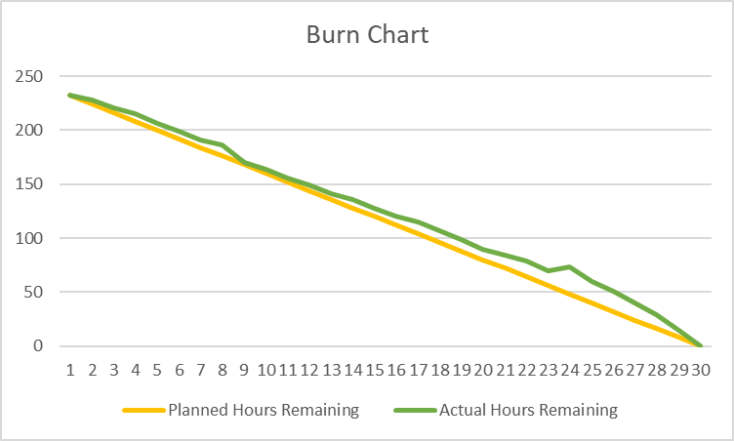

* This burn chart illustrates the comparison between **Planned Hours Remaining** (yellow line) and **Actual Hours Remaining** (green line) over a **30-day timeline**.

It shows how closely the actual progress aligns with the planned schedule, highlighting minor deviations in certain intervals.

**6.Proposed Enhancement**

* **User Guides:** Create step-by-step guides for main tasks like registering, job searching, and applying.
* **Role-Specific Sections**: Organize content for job seekers, and admins, so each user finds relevant info quickly.

**7.Conclusion**

* The Project Collaboration System provides an integrated platform that facilitates seamless teamwork and project management.
* The system’s user-friendly interface and robust features simplify project oversight, enhancing both productivity and accountability within teams.

**8.Bibliography**

*<https://github.com/topics/realtime>collaboration*

* The GitHub [Real-Time Collaboration](https://github.com/topics/realtimecollaboration" \t "_new) page serves resources, repositories, and tools for building and managing real-time collaborative applications.
* It provides source code, project structure, and functionality

**3.4(3)Apply Job Activity**

**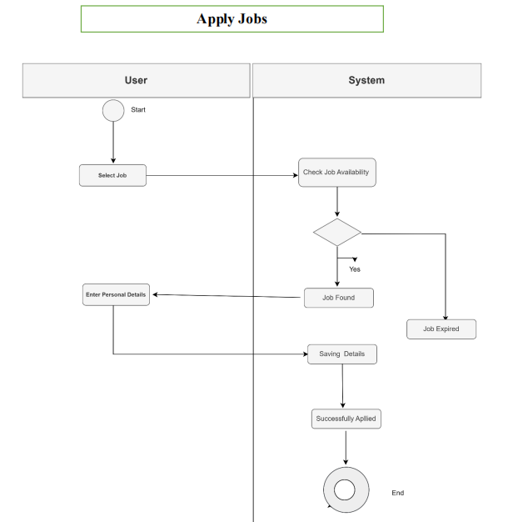**

**3.5 Data Dictionary**

|  |  |  |  |  |
| --- | --- | --- | --- | --- |
| **Field** | **Datatype** | **Constraints** | **Description** | **Sample** |
| Last\_login | Datetime(6) | Null | Last login |  |
| Is\_superuser | Tinyint(1) | Not Null |  |  |
| Id | Bigint(20) | Primary key | Id of user | 1 |
| Email | Varchar(30) | Foreign key | Email of user | [Kanii1607@gmail.com](mailto:Kanii1607@gmail.com) |
| Password | Varchar(128) | Not null | Password of user |  |
| First name | Varchar(20) | Not null | First name of user | Kanisha |
| Last name of User | Varchar(20) | Not null | Last name of user | Shah |
| Img | Varchar(255) | Null | Image of user |  |
| Phone | Varchar(10) | Foreign key | Phone number of user | 9712125314 |
| Date\_joined | Datetime(6) | Not null | Date of joining | 20-01-2023 |
| Address\_id | Int(11) | Foreign key | Address of user | Ahmedabad |
| Is\_active | Tinyint(1) | Not null | User is active or not |  |
| Is\_staff | Tinyint(1) | Not null | User is already staff or not |  |

|  |  |  |  |  |
| --- | --- | --- | --- | --- |
| **Table:Job** |  |  |  |  |
| **Field** | **Datatype** | **Constraints** | **Description** | **Sample** |
| Id | Bigint(20) | Not null | Id of the user | 1 |
| Title | Varchar(255) | Not Null | Title of the job | Software Engineering |
| Company\_name | Varchar(255) | Not null | Name of the company | Njoy solution |
| Location | Varchar(255) | Not null | Location of the company | Ahmedabad |
| Job\_type | Varchar(20) | Not null | Type of the job | Software engineer |
| Description | Longtext | Not null | Description of the job | Testing and designing of the application |
| Who\_can\_apply | lontgext | Not null | Which candidates can apply job | I.T specializes in SE |
| Posted\_at | Dateandtime | Not null | Date and time of the post | 12-05-2000 |
| Last\_date\_to\_ | Date | Not null | ]last date to apply the job | 31-6-2000 |

|  |  |  |  |  |
| --- | --- | --- | --- | --- |
| **Table:Job\_Application** | |  |  |  |
| **Field** | **Datatype** | **Constraints** | **Description** | **Sample** |
| Id | Bigint(20) | Not null | Id of the user | 1 |
| First name | Varchar(100) | Not Null | First name of the user | Kanisha |
| Last name | Varchar(100) | Not null | Last name of the user | Shah |
| Email | Varchar(254) | Not null | Email of user | [Kanii1607@gmail.com](mailto:Kanii1607@gmail.com) |
| Highest\_qualification | Varchar(50) | Not null | Qualification of the user | Master degree |
| Course\_qualification | Varchar(200) | Not null | Course qualification of the user | MSCIT |
| Experience | Varchar(10) | Not null | Experience user have | 2 |
| Company | Varchar(100) | Not null | Name of the company | Njoy Solution |
| CV | Varchar(100) | Not null | CV of the user |  |
| Applied\_on | Datetime(6) | Not null | Date of applied | 20-01-2023 |
| Job\_id | Bigint(20) | Not null | 1191 | |

|  |  |  |  |  |  |
| --- | --- | --- | --- | --- | --- |
| 11 | 20-08-2024 | View Admin Dashboard | Display overview of website metrics | Admin dashboard displays | PASS |
| 12 | 25-08-2024 | View User Profile | Display user profile information | Error in displaying user name | FAIL |
| 13 | 30-08-2024 | Apply Job | User can apply for job | Successful to apply for job | PASS |
| 14 | 05-09-2024 | Change Password | Successful password change and confirmation | Password changed successfully | PASS |
| 15 | 10-09-2024 | View Applied Jobs | Display list of all jobs the user applied to | Applied jobs list displayed correctly | PASS |

**5.8 Burn-chart**

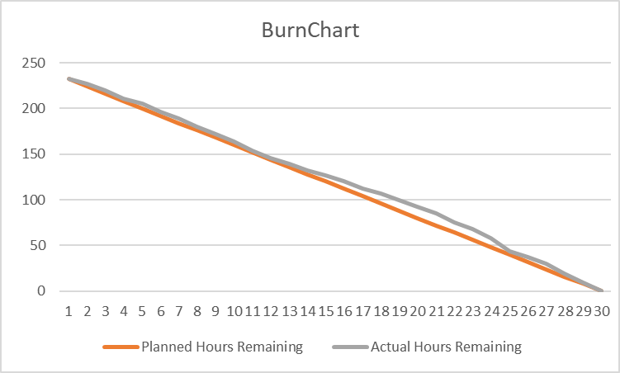

* This burn chart compares **Planned Hours Remaining** (orange line) with **Actual Hours Remaining** (gray line) over a **30-day period**.
* It visually tracks project progress, showing alignment or deviations between planned and actual work.

1. **Proposed Enhancement**

* **User Guides:** Create step-by-step guides for main tasks like registering, job searching, and applying.
* **Role-Specific Sections**: Organize content for job seekers, and admins, so each user finds relevant info quickly.

**7.Conclusion**

* The job portal **connects** job seekers and employers in an easy and effective way.
* It offers simple **job searches** and a user-friendly design to improve the hiring experience.
* The portal helps users **take control** of their careers.

**8.Bibliography**

*<https://github.com/fulfilen/job-portal>*

* The GitHub repository mention above serves as a resource for implementing and understanding job portal systems.
* This repository has been referred for ideas, code snippets, and design inspirations for building efficient and scalable job portal systems.