Nowcasting Recession Risk in the Euro Area: A Hierarchical Approach
  - Policy Brief & Econometric Report
Automated Macroeconomic Monitor
2026-06-01
Table of contents

1 Executive Summary
This note presents a real-time nowcasting framework to assess recession risk in the Euro Area (EA) and its four largest member states: Germany (DE), France (FR), Italy (IT), and Spain (ES). Extending the methodology of Furno and Giannone (2024), we build a Hierarchical Bayesian Logit model that combines macroeconomic sentiment and financial stress indicators. The hierarchical framework pools statistical information across geographies, improving the precision and stability of country-level recession risk estimates.

2 Theoretical Background and Literature
Traditional business cycle dating relies on retrospective indicators and committees (such as the CEPR in Europe or the NBER in the US) that officially announce recessions with significant publication lags of several months. For policymakers and market participants, waiting for official confirmation is suboptimal. Consequently, the macroeconometric literature has focused on two branches: 1. Nowcasting and real-time tracking: Projects such as Giannone, Reichlin, and Small (2008) and Bańbura et al. (2013) demonstrate how high-frequency data can be aggregated to track current GDP growth in real time. 2. Predicting binary business cycle states: Probit and logit models (e.g., Estrella and Mishkin (1998), Chauvet and Piger (2008)) estimate the probability of being in a recession.
This project merges these two streams by applying a Bayesian logit structure to nowcast the binary recession state ($h=0$). We build on the “Growth-at-Risk” framework popularized by Adrian, Boyarchenko, and Giannone (2019), which shows that financial conditions are essential for characterizing the downside risks to economic activity. We incorporate the Composite Indicator of Systemic Stress (CISS) introduced by Holló, Kremer, and Lo Duca (2012) to capture systemic financial distress alongside the Economic Sentiment Indicator (ESI) to capture macroeconomic sentiment.

3 Methodological Innovation: Hierarchical Pooling
While Furno and Giannone (2024) evaluate recession risk for individual jurisdictions independently, this exercise introduces a Hierarchical Bayesian structure. In a classic panel logit setup, one either estimates independent coefficients per country (which suffers from high variance and overfitting) or assumes identical coefficients across all countries (which ignores structural differences).
Our hierarchical model strikes a balance by allowing country-specific parameters to be drawn from a common global distribution:
$$\text{logit}\left(P\left(y_{i,t}=1\right)\right)=α_{i}+β_{1,i}{\text{CISS}}_{i,t}+β_{2,i}{\text{ESI}}_{i,t}$$
where the parameters for geography $i$ are specified as: - $α_{i}=α_{0}+u_{0,i}$ (Country-specific intercept) - $β_{1,i}=β_{1}+u_{1,i}$ (Country-specific sensitivity to financial stress) - $β_{2,i}=β_{2}+u_{2,i}$ (Country-specific sensitivity to sentiment)
The vector of country-level random deviations follows a joint normal distribution:
$$u_{i}=\left(u_{0,i},u_{1,i},u_{2,i}\right)′∼N\left(0,Σ\right)$$
This structure induces shrinkage, borrowing statistical strength from the aggregate Euro Area to stabilize individual country estimates. This is particularly valuable for countries like Spain or Italy where the history of distinct recession regimes under the Euro is relatively short, leading to more robust out-of-sample nowcasts.

4 Data and Variables
The model utilizes quarterly observations constructed from monthly indicators: - Target ($y_{i,t}$): A binary technical recession indicator defined as two consecutive quarters of negative quarter-on-quarter real GDP growth ($Δ{\text{GDP}}_{i,t}<0∧Δ{\text{GDP}}_{i,t−1}<0$), sourced from Eurostat (namq_10_gdp, unit CLV_PCH_PRE). - Macroeconomic Predictor (${\text{ESI}}_{i,t}$): The Economic Sentiment Indicator from Eurostat (ei_bssi_m_r2), representing expectations across sectors. - Financial Predictor (${\text{CISS}}_{i,t}$): The Composite Indicator of Systemic Stress from the ECB, capturing systemic financial risk (CISS.D..Z0Z.4F.EC.SS_CIN.IDX).
All predictors are standardized prior to model estimation.

5 Estimation Results and Empirical Findings
The fixed effects (population-level averages) estimated by the model indicate a strong and statistically significant relationship between the predictors and the probability of being in a recession: - Systemic Stress (CISS): A higher level of financial stress is positively associated with a higher probability of recession (positive logit coefficient). - Economic Sentiment (ESI): Higher economic sentiment is strongly associated with a lower probability of recession (negative logit coefficient).

5.1 Nowcast Visualizations
The chart below shows the estimated recession probabilities along with the 95% Bayesian credible intervals (shaded areas) and historical CEPR/technical recessions (grey shaded bars). The vertical red dashed line separates the in-sample training period from the out-of-sample inference period (the last five years).
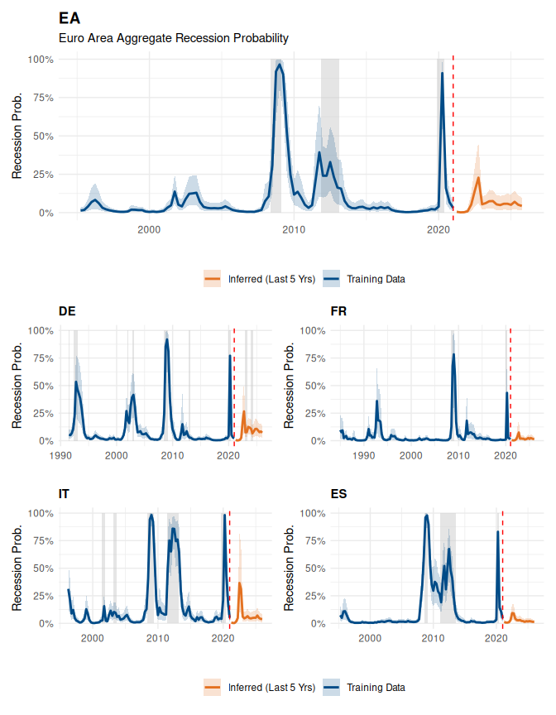

5.2 Interpretation of Results
- Euro Area: The model successfully nowcasts all major historical recessions in-sample (the Global Financial Crisis of 2008-2009, the Sovereign Debt Crisis of 2011-2013, and the COVID-19 shock of 2020) with high probability spikes.
- Out-of-Sample Performance: During the out-of-sample period (past 5 years, represented in orange), the model reflects the increased economic pressure and stagnation since 2022, capturing the differences in resilience across states. Germany (DE), for instance, shows a more elevated and persistent probability of recession, consistent with its manufacturing sector downturn, compared to the relatively stronger performance in Spain (ES).
- Value of Shrinkage: The credible intervals for the country-level estimates remain tight despite the shorter country-specific time series, illustrating how the hierarchical structure prevents extreme, volatile estimates by regularizing the parameters.

6 References
Adrian, Tobias, Nina Boyarchenko, and Domenico Giannone. 2019. “Vulnerable Growth.” American Economic Review 109 (4): 1263–89. https://doi.org/10.1257/aer.20161923.
Bańbura, Marta, Domenico Giannone, Michèle Modugno, and Lucrezia Reichlin. 2013. “Now-Casting and the Real-Time Data Flow.” In Handbook of Economic Forecasting, edited by Graham Elliott and Allan Timmermann, 2:195–237. Elsevier. https://doi.org/10.1016/B978-0-444-53683-9.00004-9.
Chauvet, Marcelle, and Jeremy Piger. 2008. “A Comparison of the Real-Time Performance of Business Cycle Dating Methods.” Journal of Business & Economic Statistics 26 (1): 42–49. https://doi.org/10.1198/073500107000000296.
Estrella, Arturo, and Frederic S. Mishkin. 1998. “Predicting u.s. Recessions: Financial Variables as Leading Indicators.” The Review of Economics and Statistics 80 (1): 45–61. https://doi.org/10.1162/003465398557320.
Furno, Francesco, and Domenico Giannone. 2024. “Nowcasting Recession Risk.” Research Methods and Applications on Macroeconomic Forecasting. https://www.amazon.science/publications/nowcasting-recession-risk.
Giannone, Domenico, Lucrezia Reichlin, and David Small. 2008. “Nowcasting: The Real-Time Informational Content of Macroeconomic Data.” Journal of Monetary Economics 55 (4): 665–76. https://doi.org/10.1016/j.jmoneco.2008.05.010.
Holló, Dániel, Manfred Kremer, and Marco Lo Duca. 2012. “CISS–a Composite Indicator of Systemic Stress in the Financial System.” Working Paper Series 1426. Frankfurt am Main, Germany: European Central Bank.

