June 20, 2018

Course: CIS570 – Business Intelligence

Name: Robert Palumbo

Assignment: BI Project Part1 - Submission Answers

Due Date: Wednesday, June 20 @ 11:59pm

1. Multi-part answers:
   1. For the product, Bear and Cub, what was the total dollar sales amount for November 2017?

The total sales amount is: $145,847.52

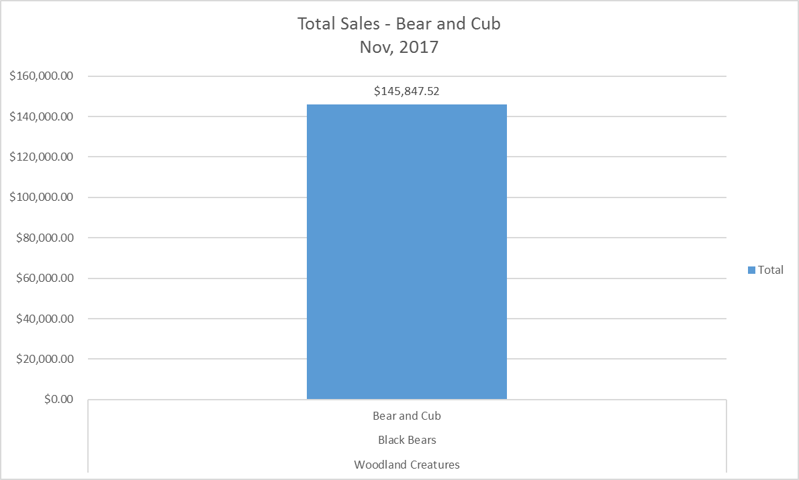

* 1. Which Product Subtype had the least number of units sold for the 2rd Quarter of 2015? How many units?

Guiding Lights World Lighthouses sold the least number of units at 8,195.

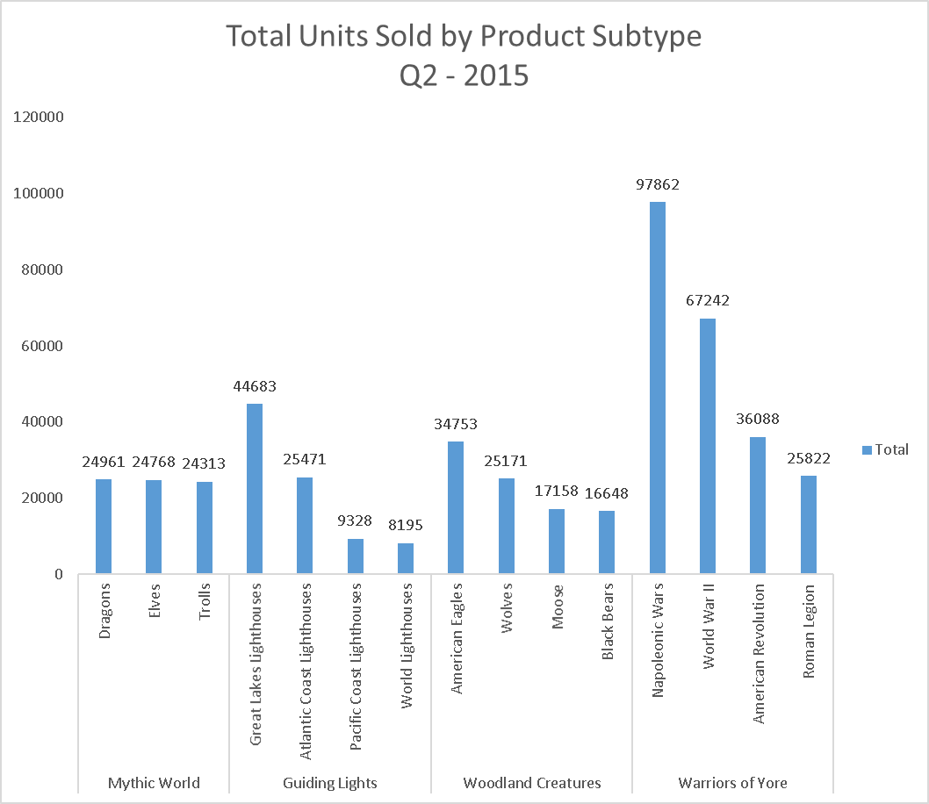

* 1. Excluding the “Unknown” promotion type, which promotion type(s) generated more than $500,000 in Online sales for Mythic World products in 2016? What was/were the amount(s)?

The President’s Day Sale and Holiday Sale both generated Online sales of more than $500,000.

President’s Day Sale generated: $555,596.46

Holiday Sale generated: $511,610.40

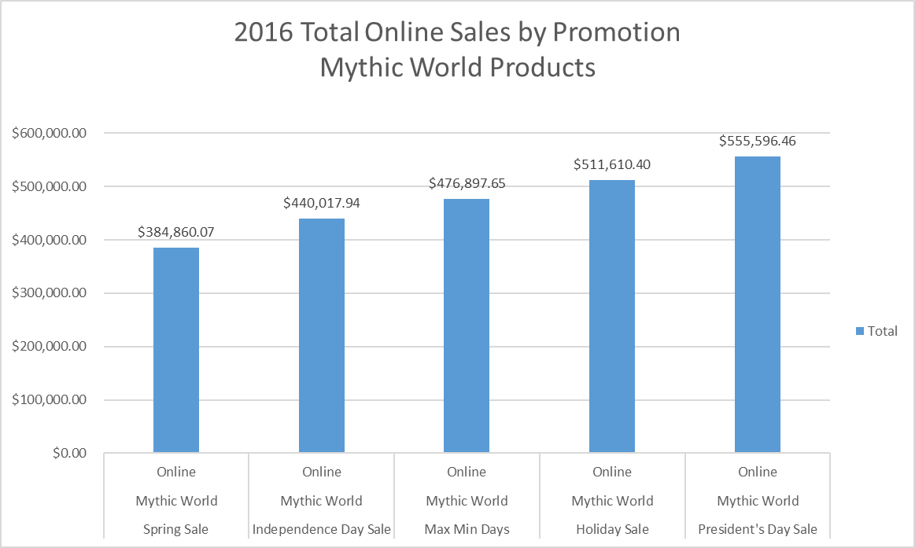

* 1. What was the total number of units of RAF Pilots sold in Xavier, IL through retail outlets for March 2017?

The total number retail of RAF Pilots sold in Xavier, IL for March 2017 was 2 units.

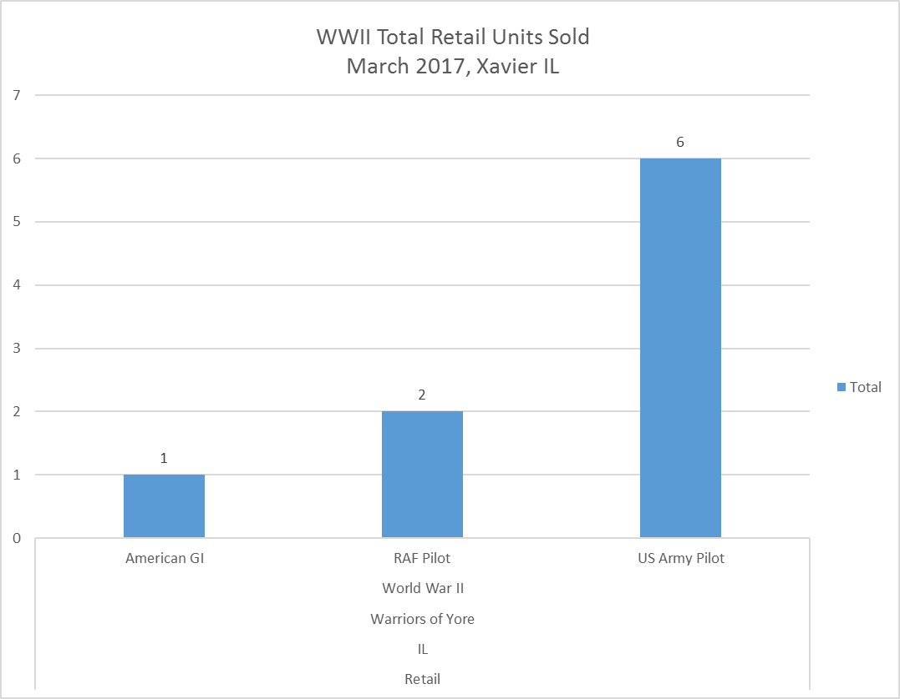

* 1. Which salesperson(s) had dollar sales amount(s) greater than $20,000 for the product, Manitowoc, WI Lighthouse, in the 1st quarter of 2015? What was/were the amount(s)?

The salesperson(s) with Q1, 2015 sales amounts > $20,000 for the Manitowoc, WI Lighthouse are:

Eddie: $28,329.76

Briggette: $24,163.60

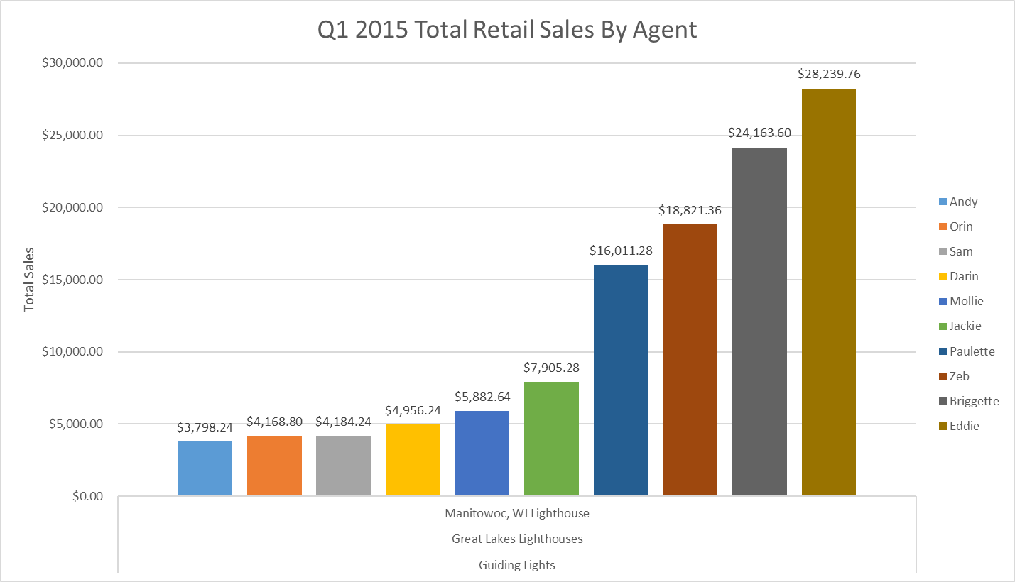

1. Slice and dice the cube to find information (**minimum of three**) that is of interest to you. For example, you can discover the promotion type that is most effective for a specific product in a particular city.
   1. The top selling product series in revenue for 2017 in Colorado by Promotion type:
      1. Guiding Lights, President’s Day Sale, $18,279.88
      2. Woodland Creatures, President’s Day Sale, $28,247.28
      3. Mythic World, Max Min Days, $29,817.55
      4. Warriors of Yore, President’s Day Sale, $37,325.81

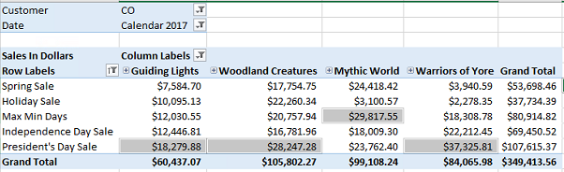

* 1. The salesperson with the highest revenue for 2017 in Colorado and Wyoming for the Mythic World product line:
     1. Briggette, $63,556.47

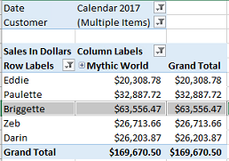

* 1. The top selling Guiding Light lighthouse in units sold for each product class in 2017 for the Independence Day promotion:
     1. Atlantic Coast Lighthouses, Portland ME Lighthouse, 2,951 units.
     2. Great Lakes Lighthouses, Marblehead OH Lighthouse 3,123 units.
     3. Pacific Coast Lighthouses, Yuquina Bay WA Lighthouse, 2,908 units.
     4. World Lighthouses, Eddistone Lighthouse, 2,957 units.

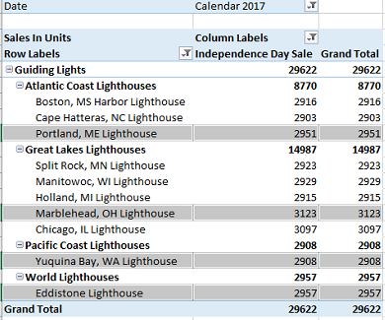

1. Create any **two** Pivot Charts with your choice of categories, series and filters. Add suitable titles and labels and format the charts as you see fit. Copy and paste the charts into a document (e.g., Word) file. For each chart, provide a short (two to five sentences) narrative that describes the purpose of the graph and the insight(s) that could be gained from it.
   1. The following chart shows the total number of wholesale units sold in the state of Colorado over the years 2015-2017. This chart gives insights as to what the most popular type of product is being purchased by consumers. The business could use this information to perhaps use a different marketing strategy to promote the less popular products or even discontinue the product line if deemed necessary.

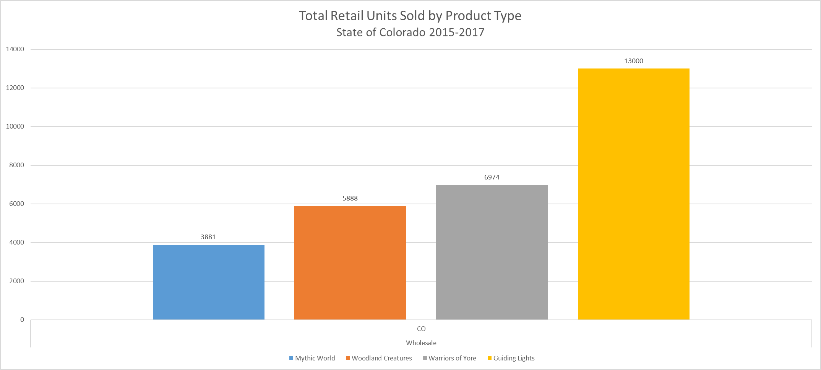

* 1. The following chart shows the total sales in dollars by agent by product type for the state of Colorado in year 2017. The chart provided insights as to which sales agent(s) generate higher revenues and for which product type. Additional insights can be gained for example, consulting with Briggette on her Mythic Worlds sales to better understand why she is outperforming the other agents in the same product category. This knowledge can potentially be used to train the other agents and perhaps increase their sales capabilities. Similarly, for those agents that do not generate much revenue in a particular product line (e.g. Jackie with Guiding Lights) it would be beneficial to understand the low revenue output and to perhaps address ways or methods to increase sales if so warranted.

