July 8, 2018

Course: CIS570 – Business Intelligence

Name: Robert Palumbo

Assignment: BI Project Part2

Due Date: Sunday, July 8@ 11:59pm

Re: SAS Visual Analytics – Answers to Part 2 Questions

Question a)

What is the product sale for each country in Africa for the year 2010?

Refer to the following table:

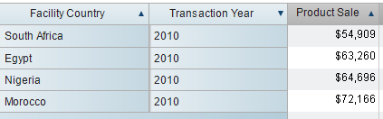

Which chart in your opinion works best in answering the question?

I created 3 charts: 1) bar chart 2) tree map 3) Geo Map

In my opinion the bar chart was by far the easiest visual to convey the desired message. Each bar displayed the actual total product sales for the country and by visual inspection it was easy to identify the *tallest* bar indicating the country with the highest product sales as shown in the following figure:

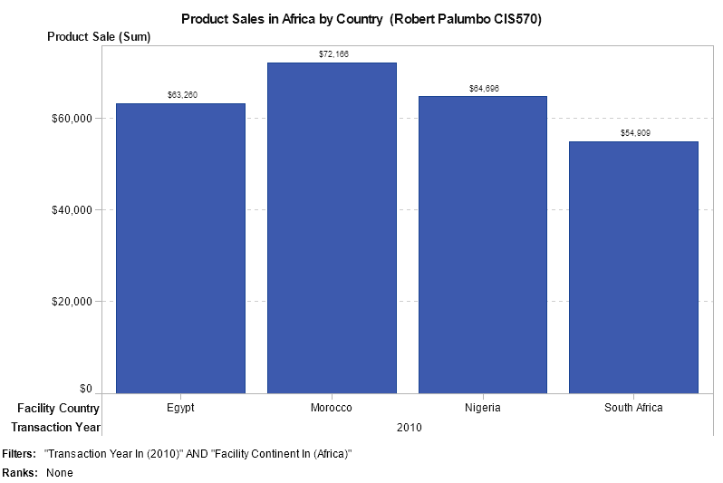

Question b)

How much was the product sales of "Plush" product line in Beijing and Valencia for years 2010, 2011 and 2012? Refer to following bar chart.

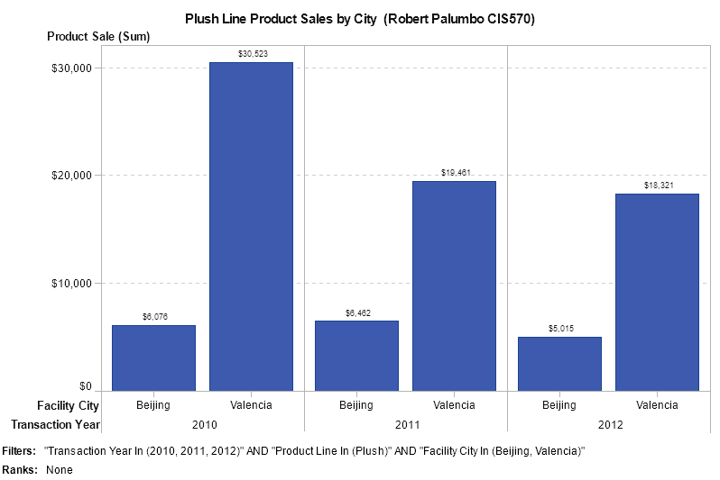

Question c)

In which month of 2011 was the *average product cost of sale* highest in Oslo? January

What was the average product cost of sale for this month? $27.00

