July 11, 2018

Course: CIS570 – Business Intelligence

Name: Robert Palumbo

Assignment: Final Exam

Due Date: Wednesday, July 11@ 11:59pm

Re: PowerBI Visuals

Table of Contents

Domestic Flight Routes – Sankey Diagram 2

All Routes 2

United Airline Routes 3

JFK-LGA Airline Routes 4

Global Earthquake Locations 5

Top-Level 5

Western North America Selection 6

Eastern Asia Selection 7

## Domestic Flight Routes – Sankey Diagram

### All Routes

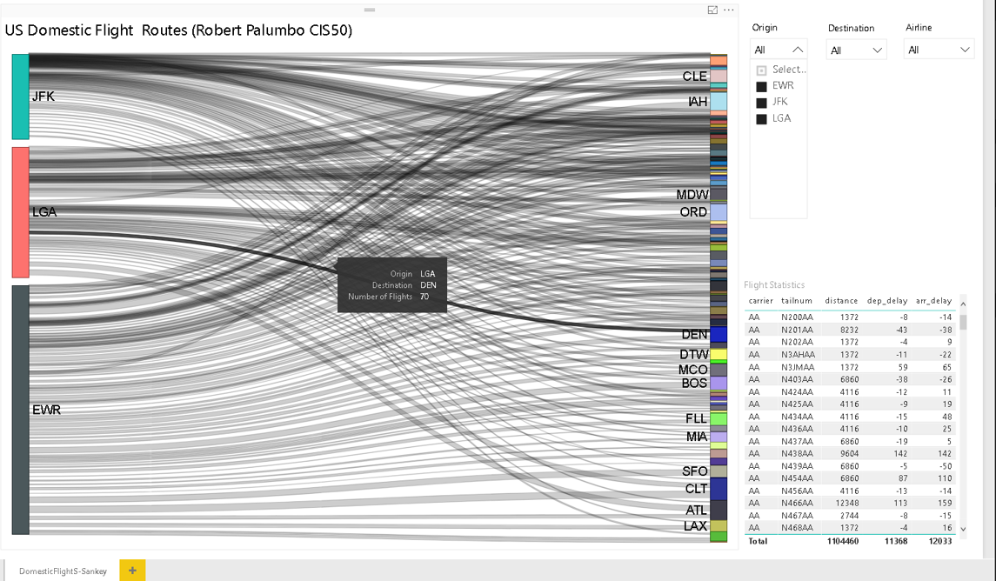

### United Airline Routes

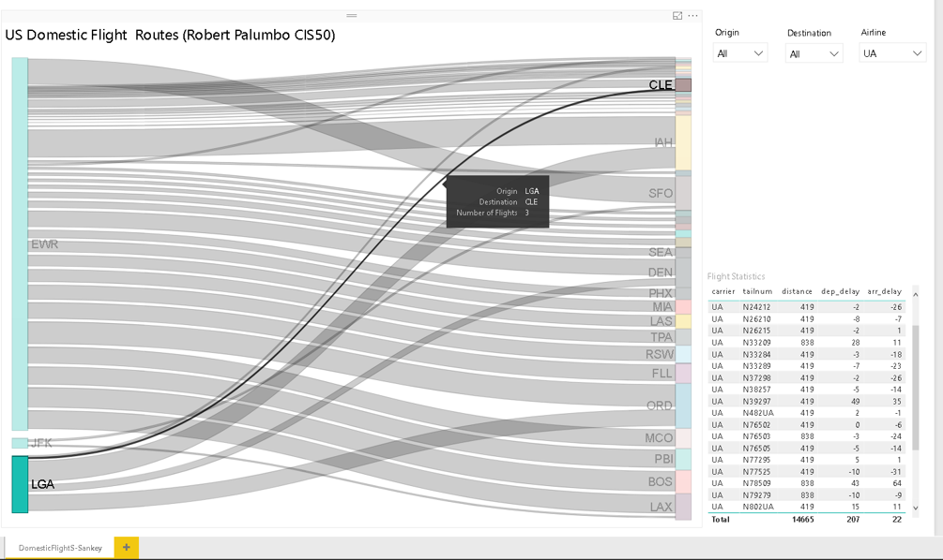

### JFK-LGA Airline Routes

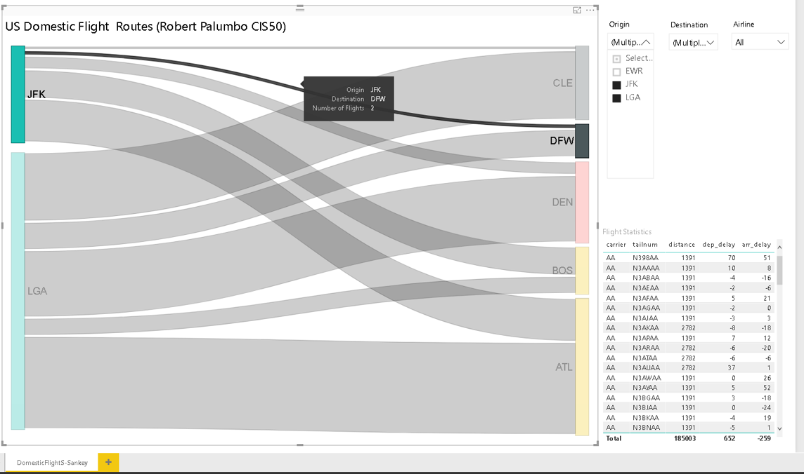

## Global Earthquake Locations

### Top-Level

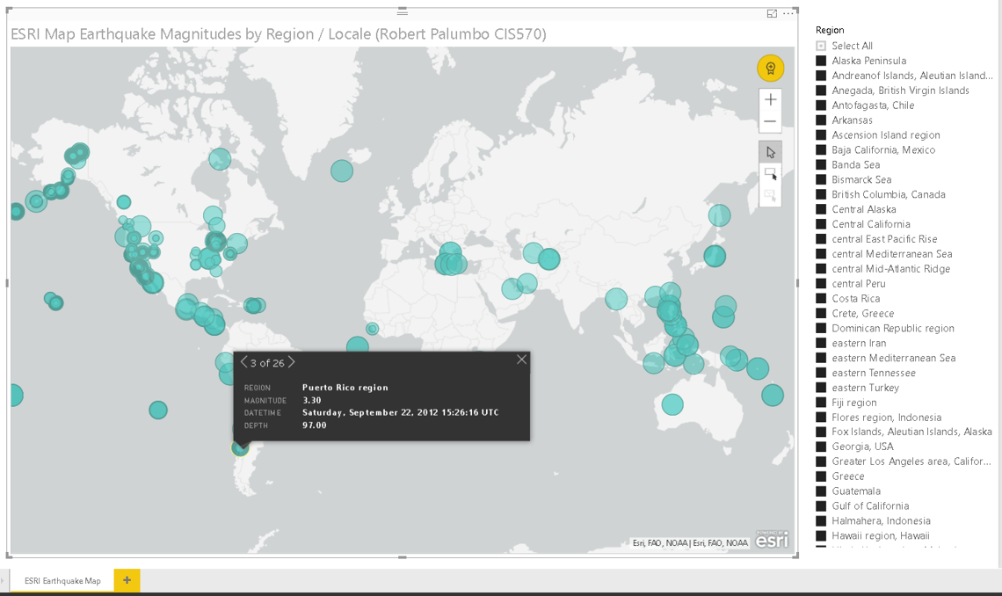

### Western North America Selection

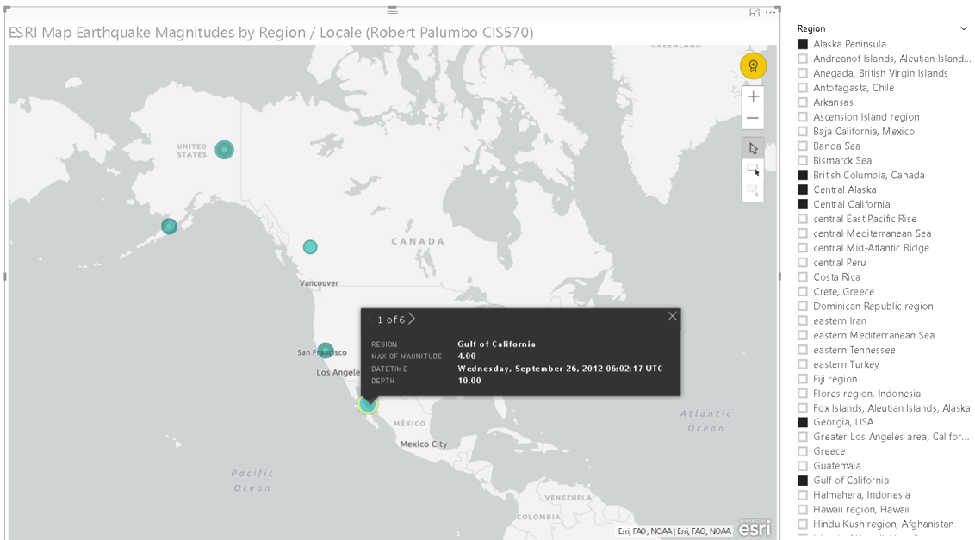

### Eastern Asia Selection

